# POKEMON BATTLE SIMULATOR

Name: Will Farmer

School: Kingswood School

Centre Number: 50715

Candidate Number: 2775

Table of Contents

POKEMON BATTLE SIMULATOR 1

ANALYSIS 6

Problem Identification 6

Design Model 6

Stakeholders 7

Graphical advisers 7

Why it is suited to a computational problem 7

Computational methods that the solution lends itself to: 8

Interview with stakeholders 10

Interview Questions 10

Casual players using program as alternative 11

Casual player using program to improve and enjoy actual game more 13

Competitive player using program to edge ahead of competition 13

Research 15

Pokémon Red and Blue 15

Pokémon Diamond and Pearl 16

Pokémon X and Y 18

Pokémon Sword and Shield 19

Alternative solutions 22

Features from research i will add into my solution 23

Interview with graphic advisOrs 24

Questions 24

Further meeting with stakeholders 26

Here is an email I sent to them following my interviews with my graphical advisers 26

Received responses 26

Possible limitations to my solution 27

Requirements 28

Software and Hardware requirements 28

Stakeholder requirements 28

Success criteria 29

DESIGN 35

Programming paradigm 35

Test Plan 36

Usability Features 52

Prototyping 53

Prototype 1 54

Prototype 2 65

Prototype 3 71

Prototype 4 79

Prototype 5 87

Pseudocode 94

Prototype 6 97

Prototype 7 102

Prototype 8 108

Summary of design section 117

Stakeholder Interview 118

Casual Players using game as alternative 118

Casual Players using game to improve and enjoy game 118

Competitive Player looking for challenge 118

DEVELOPMENT 119

Prototype 1 119

Evidencing Solution 119

Testing 125

Evaluation 136

Prototype 2 137

Evidencing Solution 137

Testing 143

The program so far 150

Evaluation 152

Prototype 3 153

Evidencing Solution 153

Testing 159

The program so far 164

Evaluation 169

Prototype 4 170

Evidencing Solution 170

Testing 181

The program so far 184

Evaluation 191

Prototype 5 192

Evidencing Solution 192

Testing 203

The program so far 209

Evaluation 217

Prototype 6 218

Evidencing solution 218

Testing 223

The program so far 224

Evaluation 231

Prototype 8 232

Prototype 8.1 233

Prototype 8.2 250

Prototype 8.3 258

Testing 300

The Program 309

Evaluation 329

Was anything changed from the design section? 330

Evaluation 331

Black-Box Testing 331

Evidencing Test Results 345

Has the program met the success criteria? 361

Stakeholder interview and Usability testing 365

Stakeholder interviews 365

Graphical Advisor interviews 366

Conclusion 367

Limitations and how they could be overcome 368

Time Constraints 368

Pygame 368

Maintainability 369

Maintenance issues 370

Potential improvements 371

Final comments 372

# ANALYSIS

## Problem Identification

My end goal for this project is that I can create a functioning Pokémon battle simulator, where the user battles against a very intelligent AI. I plan on making the AI beatable, but it will always choose the best move in any situation. It will be in the Single Battle Format, where one battler is out at a time fighting the opposition’s battler. They shall both have 6 in total, however, so if they desire to make a change or one Pokémon has no health they may switch (or be forced to switch) battler.

There will be brief animations when a move is selected to show the move being completed. The order at which the battlers may use their moves and how much damage these moves do depends on their stats, which will be assigned to the Pokémon via instantiation, which each Pokémon being an object.

### Design Model

I am certain that the model I will be using will be either the Spiral Model or the Agile Model. Both models are focussed on achieving the requirements, but I think the right one to choose is the Spiral Model. The Spiral Model follows the four basic steps of analysis, design, implementation and evaluation. These phases are passed through repeatedly and each successive loop ‘round the spiral’ generates a new, more refined prototype (which will be given to my stakeholders) until my software meets all the requirements. I believe this model is perfect, as the well-defined steps make the project easy to manage and added functionality can be added during the process. My stakeholders will be giving me feedback after every model and therefore the end result is likely to be nearly exactly what the stakeholders want. However, this model is more time-consuming than the agile model, but I believe that drawback is counteracted by the fact that that is only because of the user feedback I would be receiving, which in turn improves the program.

This is, in my opinion, a better option than the Agile Model, though the Agile Model is also a somewhat suitable option. My stakeholders and I would constantly interact with one another, with working software delivered frequently to my stakeholders. Even late changes in requirements can be implemented. However, there is a lack of emphasis on necessary design and documentation that I think is vital to have. In addition, I do not fully believe I will consistently make the correct decision, and therefore I have opted with the Spiral Model.

In addition, I also very briefly considered the Waterfall Model. In the model, each stage would be completed and documented before the next is begun, but my stakeholders would not see the end product until it was completed and any change to be made would likely mean in the entire project being restarted. While this may be suitable for a simple or short project, it is definitely not suitable for this project. Furthermore, there is barely any user involvement after the Specification document is agreed and the stakeholders are only presented with the finished project at the end, and if it is not what was required it is simply too late to change. This is definitely not what I want – in my model I desire as high user interaction as possible to ensure I am getting as close to the desired program as possible, ensuring high user satisfaction, hence why it was only a very brief consideration.

To conclude, it is seemingly very clear to me that the Spiral Model is the perfect design model for this program, and therefore it is the one I am choosing.

### Stakeholders

This game’s demographic will be young children and teens who perhaps want to practice against an AI or do not possess any of the actual Pokémon games and can thus use this as an alternative. Depending on the reasoning for playing, this can either be a game for the casual players or the competitive, wanting to try their luck against an AI that always chooses the move that inflicts most damage to the player’s battler.

The stakeholders for this game mostly represent the casual gaming side, but there is also a stakeholder representing the competitive side.

The stakeholders for the casual side who simply wish to play this game as an alternative are Robert (Bertie) Phillipson, Alexander (Xander) Bushell. They are all casual gamers who have played videogames for many years – playing titles such as Minecraft, Fortnite, and Call of Duty – but not Pokémon. This is ideal, as they fit exactly into the demographic – casual gamers who wish to play the full game but cannot, so use this as an alternative. As this aspect of the game is more crucial, they will be asked to review the game more frequently than the stakeholder for the competitive side, as all their opinions will be invaluable to the creation of the game. As of the 18th of September 2020, Xander is 17 and Bertie is 16.

My stakeholder for the competitive side of the game is Jonathon (Jonny) Lester, who has the most recent Pokémon game and has played games from the franchise for a decade. Once again, this is ideal as he fits into the (slightly less central) demographic, and so will be able to provide feedback on another aspect of the game that I may make more central to the game’s purpose as a result. As of the 18th of September 2020, Jonny is 16.

I have another stakeholder, Cal Levitt, who fits into neither of the aforementioned demographics but may for that reason be more valuable than those that do. Cal is new to Pokémon, having only played the most recent game, and so would like to play my simulator in order to improve his ability and thus enjoy the game itself more – not for a competitive reason like Jonny. As of the 18th of September, Jonny is 16.

### Graphical advisers

While not a stakeholder, another important person in the development of this program is Annie Davis (16 as of 19/09/2020), who is very interested in the graphical design of games so she will be helping me design the game, pointing out what isn’t aesthetically pleasing and advising on what approaches to take with the layout of the menus. In addition, she will be supported by Sophie Farmer (15, as of 19/09/20) who will also be giving me graphical advice. They both have great interests in real life design and are growing every more interested in virtual design as well.

### Why it is suited to a computational problem

This problem lends itself to computational methods of finding and implementing a solution for a variety of reasons. The solution will be a game that uses user-inputted instructions to perform mathematical and logical calculations to work out damage and move order, which only a computer can do quickly and efficiently. Furthermore, the graphics and animations created are only able to be generated by a computer, therefore it is essential that a computer is used.

The aspects of the solution that would be controlled by the computer would be the calculations and image generation.

### Computational methods that the solution lends itself to:

#### Problem recognition

The overall problem is being able to generate the images and animations necessary to make this game image-based instead of text-based, and to succeed with creating smooth transitions to ensure that it looks like a genuine video, instead of images being replaced by more images. This can be insured by the new frames being displayed milliseconds after the previous to make transitions and animations seem fluid.

#### Problem decomposition

This problem can be decomposed into a series of sub-problems, which is incredibly beneficial to any program, as it allows me to easily separate tasks and complete the whole project much quicker.

This is an initial idea of said steps:

1. Using file handing to:
   1. Read in the move-sets of each Pokémon
   2. Read in the stats of each Pokémon
2. Calculate the damage done by a move onto each Pokémon
   1. Using a formula
3. Display:
   1. The sprites of each Pokémon
   2. The background
   3. The moves available being shown on the screen
   4. The animation for each move
   5. The animation for a Pokémon taking damage
   6. The animation for a Pokémon fainting
   7. The animation for a Pokémon being sent out
   8. The animation for a Pokémon being withdrawn from battle
   9. Show an animation for the health bar going down after taken damage
4. The AI:
   1. Chooses the optimum move for each scenario
      1. Is still beatable
   2. If forced to, send out the best Pokémon to counter the player’s battler

When this is done the battle will be able to be carried out smoothly (in terms of graphics) and will mimic the real Pokémon games in terms of both how it plays out (damage, type matchups, etc) and how they look, with even the same messages appearing that do in the real games (such as “[name of Pokémon] fainted”.

#### Dividing up tasks

While the file handling and calculations should be quite straightforward, the AI and Display aspect of the game will likely still be challenging, but, as a set of sub-problems, much more doable. I will split the file handling and calculation parts of the game into modules, while splitting each sub-task under Display into its own module and likewise for the AI. While they will be split into different modules they will remain very linked in terms of being called frequently from modules that come under the same aspect (for example, the module containing the animation for the health bar going down will likely call – and be called from – the animation for the Pokémon fainting.)

#### Abstraction

Abstraction is the removal of all unnecessary information, in order to focus on the key issues that need solving in order for the program to work.

While a lot of information is required at separate stages of the game, there is little overlap between said separate stages. For example, when the background is being generated the stats of each Pokémon will not be required, likewise when the stats and move-sets are being read in at the start of the program nothing else is required save said stats and move-sets from the files.

However, there is quite a lot that is intertwined throughout the game and thus abstraction needs to be carefully applied. While effectively anything in Display is, as an action, independent when being carried out, it requires a trigger for the action to be initially carried out, for example the Pokémon needs to have no health for the fainting animation to occur. While the animation as an action is independent, it needs a trigger (the fact it has zero health) for it to occur.

## Interview with stakeholders

### Interview Questions

The purpose of these interviews are to see what my stakeholders’ views are on the key parts of the project before development in order to make the project as close to the desired product as possible.

**Casual players using program as alternative**

1. Would you prefer the game to be played on a single screen or split up into a top screen and bottom screen?
2. Would you prefer it to mimic the actual Pokémon games’ battle scenes?
3. Would you prefer to have a single mode or an easy, medium or hard mode?
4. Would you prefer to type in what you wanted to do or click an option?
5. How do you think you’ll benefit from playing this game?
6. Anything else?

**Casual player using game to improve and enjoy actual game more**

1. Would you prefer the game to be played on a single screen or split up into a top screen and bottom screen?
2. Would you prefer it to mimic the actual Pokémon games’ battle scenes?
3. Would you prefer to have a single mode or an easy, medium or hard mode?
4. Would you prefer to type in what you wanted to do or click an option?
5. Do you think you’ll be able to improve significantly enough to make a difference in the enjoyability of your playthrough of the main games?
6. Anything else?

**Competitive player using game to edge ahead of competition**

1. Would you prefer the game to be played on a single screen or split up into a top screen and bottom screen?
2. Would you prefer it to mimic the actual Pokémon games’ battle scenes?
3. Would you prefer it to have a single mode or an easy, medium or hard mode?
4. Would you prefer to type in what you wanted to do or click an option?
5. What do you wish to achieve from playing this game and do you think this game will allow you achieve this?
6. Anything else?

### Casual players using program as alternative

**Xander**

1. **Would you prefer the game to be played on a single screen or split up into a top screen and bottom screen?**

* “Single screen”

1. **Would you prefer it to mimic the actual Pokémon games’ battle scenes?**

* “I don’t know what they look like” *and after I show him examples of previous games and ones of other copies* “Oh yes – that other one looks disgusting”

1. **Would you prefer to have a single mode or an easy, medium or hard mode?**

* “I will go with the three modes”

1. **Would you prefer to type in what you wanted to do or click an option?**

* “Click”

1. **How do you think you’ll benefit from playing this game?**

* “I can try out Pokémon before I commit to buying the whole game if I want to”

1. **Anything else?**

* Not that I can think of right now but I think of anything I will let you know

**Bertie**

1. **Would you prefer the game to be played on a single screen or split up into a top screen and bottom screen?**

* “Single screen”

1. **Would you prefer it to mimic the actual Pokémon games’ battle scenes?**

* “Yeah”

1. **Would you prefer to have a single mode or an easy, medium or hard mode?**

* “Easy medium hard”

1. **Would you prefer to type in what you wanted to do or click an option?**

* “Oh click all the way”

1. **How do you think you’ll benefit from playing this game?**

* “I will feel the nostalgia from when I played the main game years and years ago and hopefully get good too”

1. **Anything else?**

* “How many will I have in my team?”
  + *I told him that he’ll have 6 in his team, which is the limit in all version of Pokémon.*

#### Analysis

All of the casual gamers have agreed on a single screen, which I too agree with. Not only do I think it’ll look nicer but I think it’ll also work better functionality-wise with how pygame works – generating an individual window. In addition, I also agree with how they all want the game to mimic the actual Pokémon games’ battle screens, albeit they all have their different reasons for wanting it to be the same. This interview has proved mightily useful as all stakeholders have agreed on every question, and I too agree with all of them. The 3 different modes of easy medium and hard will likely contain different levels for Pokémon, the ability to use items and whether or not you can switch out a Pokémon upon the fainting of the AI’s Pokémon. It’s a promising sign that they all believe they’ll benefit from playing the game and I hope to be able to fulfil all their wishes, providing there aren’t any clashes in ideas, in which case I will opt with whatever the majority decide or, in case of a draw, I will go with my own personal opinion. The mouse-oriented interface would also be my own choice and therefore I’m happy everyone else. I’ve answered everyone’s questions and will also attempt to implement as many of their requests as possible.

|  |  |
| --- | --- |
| **Question** | **General Response** |
| Would you prefer the game to be play on a single screen or split up into a top and bottom screen | Single Screen |
| Would you prefer it to mimic the actual Pokémon games’ battle scenes? | Yes |
| Would you prefer to have a single mode or an easy, medium or hard mode? | Easy, medium, hard |
| How do you feel you’ll benefit from playing this game? | Experience before committing to paying, nostalgia, improving |
| Would you prefer to type in what you wanted to do or click an option | Click |

### Casual player using program to improve and enjoy actual game more

1. **Would you prefer the game to be played on a single screen or split up into a top screen and bottom screen?**

* “One screen I would say”

1. **Would you prefer it to mimic the actual Pokémon games’ battle scenes?**

* “I would prefer it to be close to the actual game but with some additional features from online simulators like Pokémon Showdown”

1. **Would you prefer to have a single mode or an easy, medium or hard mode?**

* “A couple different modes. So yeah like easy median or hard”

1. **Would you prefer to type in what you wanted to do or click an option?**

* “I think clicking my option would be a quicker and easier way”

1. **Do you think you’ll be able to improve significantly enough to make a difference in the enjoyability of your playthrough of the main games?**

* “I think the program will allow me nicely to improve my ability and improve my adequacy in Pokémon battles”

1. **Anything else?**

* “Will I get to choose my team?”
  + *I told him my current plan was for the user to select one of two teams, based on characters from the main series games (Trainer Red and Trainer Blue)*

### Competitive player using program to edge ahead of competition

**Jonny**

1. **Would you prefer the game to be played on a single screen or split up into a top screen and bottom screen?**

* “Split into a top and bottom screen”

1. **Would you prefer it to mimic the actual Pokémon games’ battle scenes?**

* “Mimic the actual games’ battle sequences”

1. **Would you prefer it to have a single mode or an easy, medium or hard mode?**

* “The range of easy, medium and hard modes”

1. **Would you prefer to type in what you wanted to do or click an option?**

* “Click an option”

1. **What do you wish to achieve from playing this game and do you think this game will allow you achieve this?**

* “I want to enhance my decision making skills whilst in battle, to help me improve in the competitive scene in the real Pokémon games. I think that will be possible in this simulator”

1. **Anything else?**

* “Are you going to mimic the character designs, or come up with your own?”
  + I responded by telling him that I will be downloading sprites from online resources that don’t breach copyright laws and using them in my game to keep with the feel of the real games.
* “Yeah I would like that more”

I told them all at the end that I would be asking them more questions as the game progressed and I will probably give them an early version of the program as well to test and feedback ideas.

#### Analysis

Both players have a desire to improve, though Cal desires to improve in order to enjoy the game more, whereas Jonny wants to climb higher in the competitive scene of the game. Jonny is the only person to choose a split-screen format, so I will be talking to him soon about what his opinions of a single-screen game are as everyone else has voted for a large single-screen. As with the casual gamers, both players have opted for a battle interface similar to the original games, a mouse-based interface and 3 different difficulties. All this should be easy to implement as there is only one clash currently. I’m going to send them an email shortly after interviewing my graphical advisers and researching existing solutions, relaying what information my research and further interviews.

|  |  |
| --- | --- |
| **Question** | **General Response** |
| Would you prefer the game to be played on a single screen or split up into a top screen and a bottom screen? | One response was one screen, one response was split into a top and bottom screen |
| Would you prefer it to mimic the actual Pokémon game’s battle scenes? | Yes |
| Single mode or an easy, medium and hard mode? | Easy medium and hard |
| Wait do you aim to achieve by playing this game | Enhance decision making |

## Research

### Pokémon Red and Blue[1]

**Overview**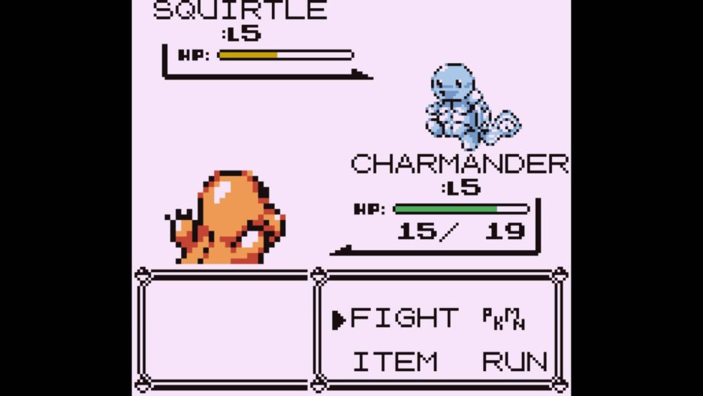[2]

The first Pokémon games (red and blue had simultaneous release) had a very simple battle scene. The health points of each Pokémon is indicated under their name and level by a bar, which is proportionally filled by either red, yellow, or green. If the Pokémon is above half health, a green bar is shown; if the Pokémon is between half health and 20% health, a yellow bar is shown and if the Pokémon is below 20% health then the bar is red. The graphical display of the Pokémon’s health is above what their health currently (in number form) followed by what their maximum health could be. Then in the box below are four options: FIGHT, ITEM, PKMN and RUN. The FIGHT option displays a new box with the Pokémon’s four moves. The ITEM option allows you to select an item to be used. The PKMN option allows the player to switch to a different Pokémon and the RUN option allows the player to run from battle, but only if against a wild Pokémon. The opposing Pokémon is displayed opposite, with its name, level and HP bar to its left.

#### Parts I can apply to my game:

As this was the first Pokémon game, its graphics are very simple and not too aesthetically pleasing. While the basic key parts of the display will remain (name, level, health, FIGHT, PKMN, ITEM, Pokémon sprite) their layout will change. Furthermore, as all battles will be against the AI (i.e. a trainer, not a wild Pokémon) the RUN button will not be present, for it has no function.

### Pokémon Diamond and Pearl[3]2

**Overview**

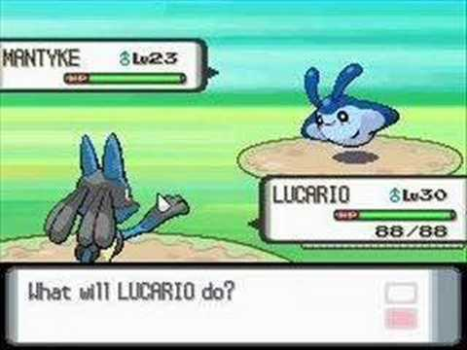

As the Nintendo DS was a 2-screen console, the top screen displayed the battle. The box at the bottom narrates the battle, stating whether moves missed, are super-effective, neutral, not very effective or non-effecting and whether the Pokémon has fainted or not. It also announces when a Pokémon is sent out to battle or withdrawn. The HP bar remains the similar but more aesthetically pleasing, and the sex of the Pokémon is now displayed. There is an experience points bar just underneath where the current and maximum HP is displayed. The Pokémon’s name is now in line with the Pokémon’s level instead of above it. There is now colour.

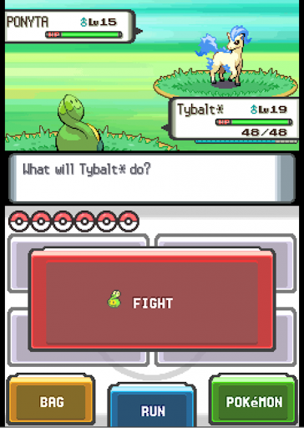

The pokéballs indicate the number of remaining Pokémon. The BAG box has replaced the ITEM box but has the same functionality. The POKéMON box has replaced the PKMN box, but once again have the same functionality. The RUN box is unchanged but will not be present in my program. The FIGHT box has become more central and larger as it the most important part of the menu, with a little image of the Pokémon currently being used next to it.

#### Features that I can implement into my program

The narrative box at the bottom of the top screen is a very nice that I can add to my program. The coloured background and Pokémon is almost a necessity as well, and I also display the sex (if applicable) of the Pokémon in the health box. However, the XP bar will not be implemented as that is only used in the progression/campaign part of the game and so will not be applicable in my program.

The large and central FIGHT box with the little Pokémon sprite next to it is also something I will likely implement and it looks better than the old display. Once again, the RUN box will not be present.

### Pokémon X and Y[4]

**Overview:**

The bottom screen looks generally the same, just with the boxes becoming rounded and slightly more vibrant colours.

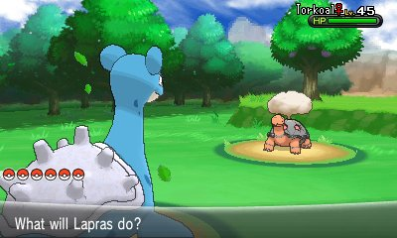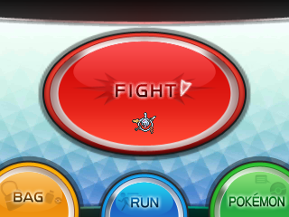

The top screen has changed quite visibly, however. The narrative box has a shallow curve inward and is semi-transparent which I think looks better. The number of Pokémon left is displayed by the Pokéballs. The Pokémon’s name, gender and level are now on top of the HP box, which has also become slightly more rounded. The sprites have become 3-dimensional (as was the upgrade from the Nintendo DS and the Nintendo 3DS) which I will try and implement but making the background 3-dimensional may pose more of a challenge.

#### Features that I can implement into my solution

I very much prefer the rounded HP bar and layout of the narrative box and pokéballs, as well as the new location of the name, gender and level of the Pokémon. The 3D sprites will likely be added to my game and I will attempt to make the background 3D but I don’t view it as a necessity.

### Pokémon Sword and Shield[5]

**Overview:**

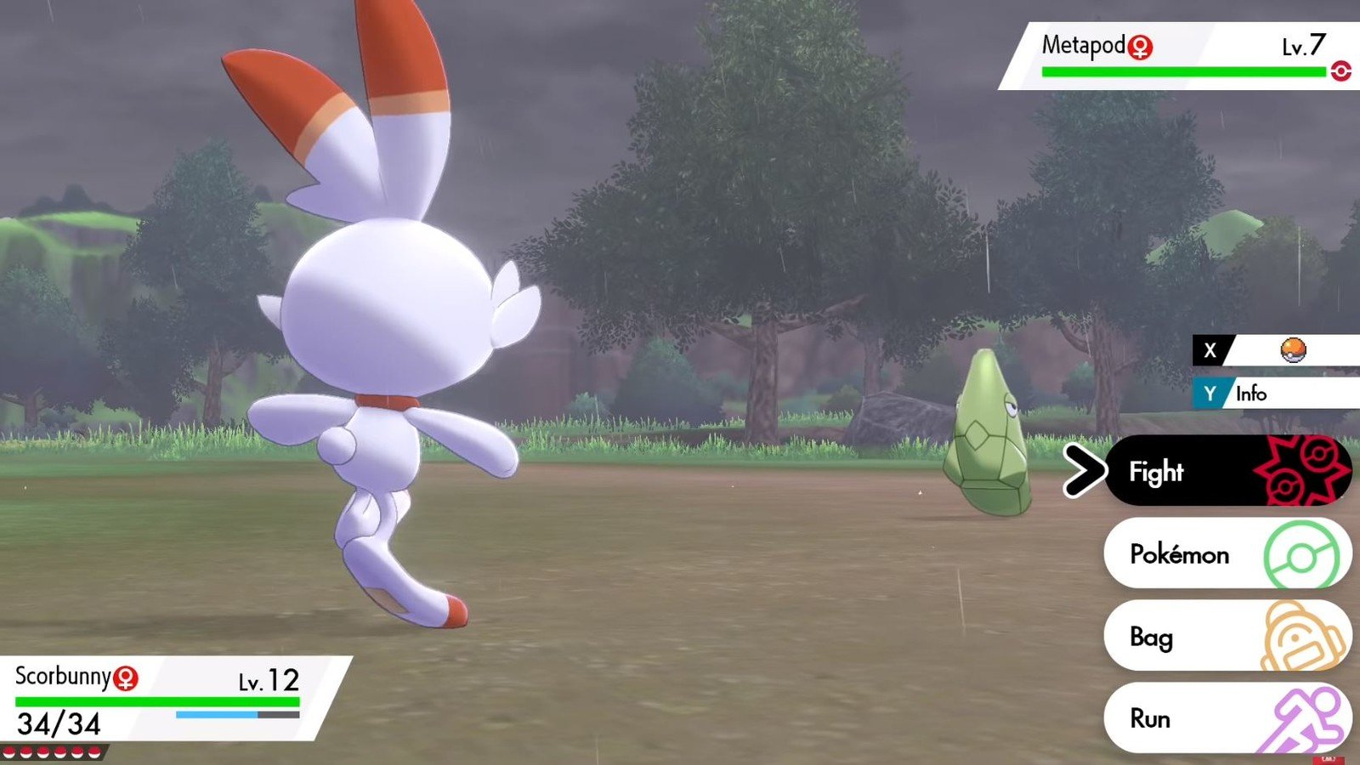

Pokémon sword and shield were the first main series Pokémon games on the Nintendo Switch, where only one screen was present. This means I will likely have a display more similar to these games than the games on the Nintendo DS and 3DS as they were dual-screen. The HP box has returned but looks much sharper with its straight edges but trapezium shape. The name, gender and level of Pokémon are once again in the box on top of the HP bar, but the XP bar has also returned (the small blue line underneath the HP bar). The pokéballs have become smaller and encased in a black box with a similar shape to the HP box, which I also prefer to X and Y. The main change is the location and layout of the Fight, Pokémon, Bag and Run box. They are rounded in shape stacked on top of each other with little icons of each option, with fight having two pokéballs, Pokémon having a large green pokéball, Bag having a bag and Run having a person running, though it will not be implemented in my program. The red pokéball in the opposition’s HP box indicates whether the Pokémon has been caught by the user or not. The little pokéball next to the X and the “info” next to Y are new implementations, with the former having a short-cut for catching Pokémon and the latter seeing whether the Pokémon’s stats have been raised or lowered.

When you press Fight the following screen appears:

This is positioned exactly where the Fight, Pokémon, Bag and Run boxes were so as to not fill up any more of the screen than necessary. If the Pokémon has been battled against before, it will tell you what moves are effective or not, but I won’t add that into my game for no campaign exists. The numbers indicate maximum times you can use that move and how many times left you can use it.

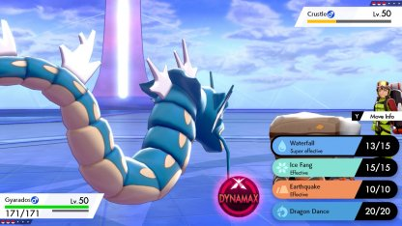

When you press Pokémon the following screen appears:

It indicates the Pokémon’s names, gender, HP, level and a little sprite of them. You click on the one you wish to send out and then confirm and the Pokémon currently out is withdrawn and the one you selected replaces it on the battlefield. You can also inspect each Pokémon’s stats and moves in this menu.

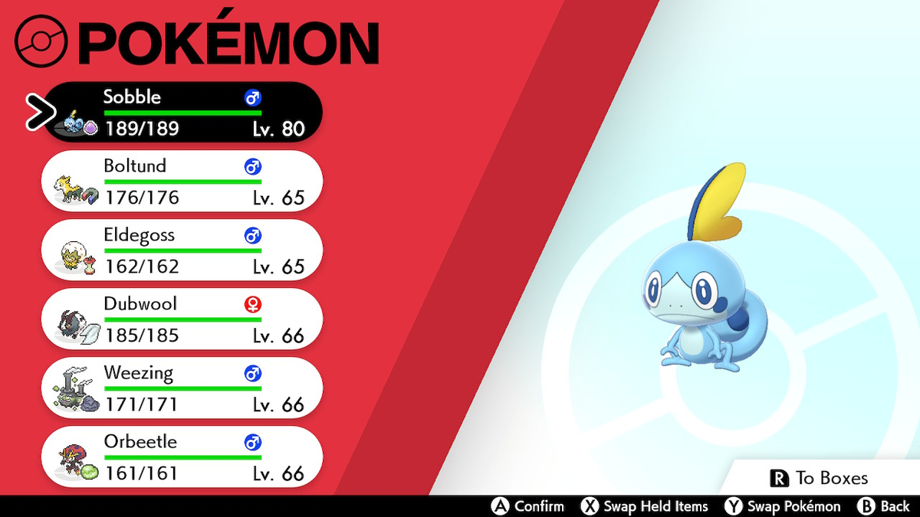

When you press Bag the following screen appears:

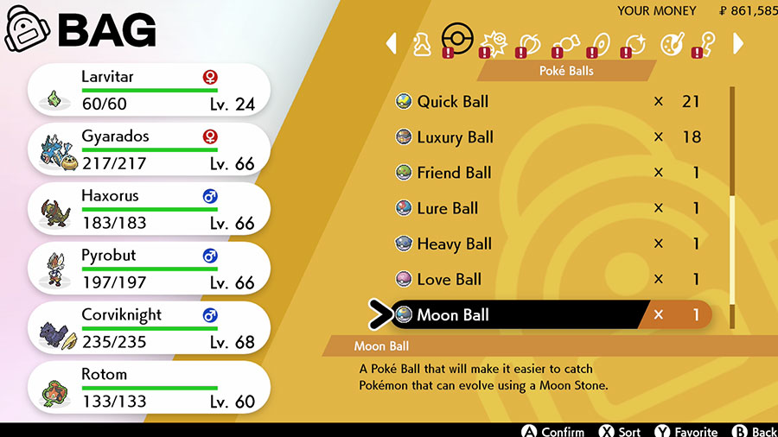

The Pokémon are displayed on the left so you can choose who to give the item to. The options at the top are medicine, pokéballs, battle items, berries, general items, TMs, treasures, food and key items. Given that only medicine, battle items and specific items within general items are usable in battle they are the only that will be present.

#### Features that I can implement into my solution

The new HP boxes look much nicer as well as the pokéball display so I will implement those. In addition, the new layout for Fight, Pokémon and Bag look much better and work better with the functionality of a single-screen device so I will add those. The actual Fight, Pokémon and Bag screens will also be implemented

### Alternative solutions

#### Pokémon showdown[6]

**Overview:**

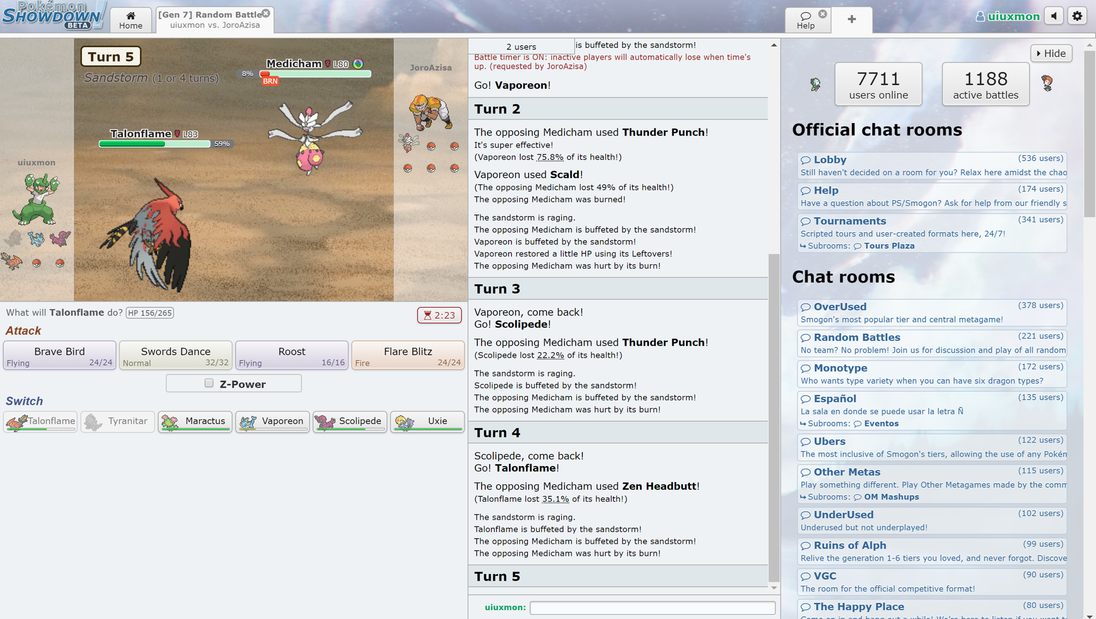

Pokémon showdown is an online battle simulator. There is no box for fight, bag nor Pokémon. The option for the bag doesn’t exist so no items can be used. The available Pokémon to switch into are at the bottom with the moves for the current Pokémon just above. There HP bar displays the percentage health left whereas the physical health in number form is displayed just above the moves in the light blue box. The Pokémon are displayed in the middle with 2D sprites and the available Pokémon are to the left for the user and to the right for the opponent. The narrative box is instead displayed on the right hand side away from the actual battle screen. This site is purely for competitive playing.

#### Features I can implement into my solution

While this is an example of a pre-existing solution, I much prefer the design of the real Pokémon games over this one. It changes too much and takes away from the real Pokémon playing experience instead just focusing on numbers and competitivity, which I understand some players may enjoy; I just simply prefer the look and feel of the proper games, as do my stakeholders – even those on the competitive side.

### Features from research i will add into my solution

|  |  |  |
| --- | --- | --- |
| Feature | Description | Justification for inclusion |
| Single Screen | Some of the Pokémon were dual-screen, but I want mine to have the battle display on the same screen as the Fight, Pokémon and bag buttons | This is because pygame operates with a single window. If I were to implement two "screens", they would still be on the same window and would therefore not look aesthetically pleasing. Hence, I am going to have all of the information on one individual screen |
| Narrative Box | This will describe everything that occurs during the game, such as attacks, damage outputs, which Pokémon is being switched in and prompting the user to make inputs | This is a core inclusion in the real Pokémon games, which I want to mimic. Furthermore, it will be much easier to understand what is happening in the game with a central location for all informative outputs, such as the narrative box |
| The same fight, Pokémon and bag menu as Sword and Shield | The aforementioned buttons will be on the same screen as the main battle, as this is how it was done in Sword and Shield | Not only is Sword and Shield the most recent game (at this time), but it is also single-screen. Hence, it would make sense to utilise the same features as this given that my game is also single-screen |
| Coloured background and sprites | The background will be RGB colour, as will the trainer and Pokémon sprites | Colour is essential to any modern-day game, and therefore I will not be using black-and-white backgrounds and sprites like the first games, but instead RGB colour in my game. |
| No XP bar or RUN button | In all campaign Pokémon games there is an XP (so the Pokémon can increase their levels) and a RUN button (so the user can escape from wild Pokémon). They will not be included in this game | This is because the Pokémon will be at a set level to prevent any advantages and disadvantages throughout the battle. In addition, there is no RUN button as there are no wild Pokémon in this game, and therefore it would never be able to be used. Adding it would just be the addition of a button that does nothing, and hence it will not be implemented. |
| Identical game mechanics | Faster Pokémon will go first, priority moves will go before normal moves, stats will work the same way, the damage formula will be identical, type matchups will be the same | This is because the users are meant to experience a game as close to the originals as possible. Therefore, having the game inkeep with these mechanics is vital to ensure the user feels as though they are playing something very similar to the real games |
| Display HP bar, level, sex and name of Pokémon | For the current battlers, there will be box containing their HP bar, numerical HP value, level and their sex | This is so the user can make informed judgements, e.g. if the user has low health, they may choose to switch their Pokémon out instead of keeping it in. if there was no health bar or numerical value displayed, how would they be able to know what their health was? |

## Interview with graphic advisOrs

### Questions

1. Do you think the game looks better on a single screen or a screen split into top and bottom screens?
2. What would you like to implement from Pokémon Red and Blue?
3. What would you like to implement from Pokémon Diamond and Pearl?
4. What would you like to implement from Pokémon X and Y?
5. What would you like to implement from Pokémon Sword and Shield?
6. What would you like to implement from Pokémon Showdown?
7. What would you like to implement into this game that isn’t present in any of the existing solutions?
8. Anything else?

**Annie**

1. **Do you think the game looks better on a single screen or a screen split into top and bottom screens?**

* One big screen

1. **What would you like to implement from Pokémon Red and Blue?**

* I like how the lack of colour in the background adds more to the sprites

1. **What would you like to implement from Pokémon Diamond and Pearl?**

* I’m going to contradict my last statement and say that I like the coloured background. I like how the Pokémon’s names are capitalised.

1. **What would you like to implement from Pokémon X and Y?**

* I like how it’s 3D and the big circular fight stands out a lot more, emphasising that it’s the most important aspect.

1. **What would you like to implement from Pokémon Sword and Shield?**

* I like how the background is more realistic and less cartoony and that its on one big screen. I also love how the menu is replaced by moves when Fight is selected too. The HP box also seems sharper too.

1. **What would you like to implement from Pokémon Showdown?**

* I really don’t like any of it. All the text takes away from the imagery which is bad anyway in my opinion. The sprites looks like drawings instead of pictures which I also don’t like and the graphics are dark and dull compared to the original games which are vibrantly coloured.

1. **What would you like to implement into this game that isn’t present in any of the existing solutions?**

* Maybe simplifying graphics but adding more vibrancy and colours and perhaps making the Pokémon seem slightly angrier and ready to fight.

1. **Anything else?**

* Maybe add a customizable Pokémon name option. Like in the games you can name Pokémon instead of having their default species name.

**Sophie**

1. **Do you think the game looks better on a single screen or a screen split into top and bottom screens?**

* one screen

1. **What would you like to implement from Pokémon Red and Blue?**

* The animals – the sprite-work

1. **What would you like to implement from Pokémon Diamond and Pearl?**

* The nice colourful background

1. **What would you like to implement from Pokémon X and Y?**

* I like how this game looks newer – more modern – than the others

1. **What would you like to implement from Pokémon Sword and Shield?**

* The options on the right looks really neat

1. **What would you like to implement from Pokémon Showdown?**

* I like how you can see the other Pokémon on the left and right hand side

1. **What would you like to implement into this game that isn’t present in any of the existing solutions?**

* Not really

1. **Anything else?**

* Maybe add an option for shiny Pokémon?
  + *I informed her that this may be implemented once the core game was finalised, like giving Pokémon nicknames.*

## Further meeting with stakeholders

### Here is an email I sent to them following my interviews with my graphical advisers

“Hi guys,

I’ve done some research into the interfaces of actual Pokémon games as well as some into alternative online solutions, such as Pokémon showdown, as well as your inputs from our earlier interview and have some specific ideas now. When the game is launched a screen will appear with the pictures of 2 trainers (Trainer Red and Trainer Blue) and their Pokémon. You will select the trainer you want to use and then what difficulty you want to play. It will then display the Pokémon battle scene. It will be single screen as that’s what the vast majority of you voted for and it will be based on mouse clicks instead of typing in inputs. The Pokémon sprites will be the 3D ones from the most recent games but the background cannot be 3 dimensional due to the limitations of pygame. I will be sending you copies of the game throughout development so you can provide feedback. It won’t take much processing power so whatever computer you chose to do it on will allow smooth playing of the game.

If you have any concerns or questions please reply to this email.

Thank you,

Will”

### Received responses

**Cal:**

“I like the sound of your ideas I just personally think you should add a third option for the trainer/ battles to add more variety into the game and keep interest in the game”

*I responded by asking if I could add the initial 2 characters and then add a third in after the rest of the program was completed, to which he said*

*“*Yes that’s fine I was just wondering if that could be in there for a bit of variety so I don’t really mind when it’s added”

## Possible limitations to my solution

As I am using the pygame GUI framework, my game isn’t going to be particularly graphically complex. It should still be able to compete with older Pokémon games, but I will not be able to have 3D sprites in my program. I still think this is still the best framework to code in, at least for just this project, as pygame is the GUI framework I am most secure in my knowledge with, having used it briefly before. I have already been able to get a vague idea of what my game will be able to look like with the pygame library and I am happy with the idea I have of the solution currently.

## Requirements

### Software and Hardware requirements

#### Software:

**Python interpreter:** the game will be written in python and therefore a python interpreter is required. The program will be coded in python because it is the language I am confident coding in.

**Pygame interpreter:** this game will run using the pygame interpreter in order to create the GUI, so a pygame interpreter is required. This is because pygame is the python GUI framework I am most confident in, and I also think it is the best GUI framework for animations and the quality of the graphics that is appropriate for this game.

#### Hardware:

**Any computer that can run python 3.8 –** this is the version of python the game is coded in, and so a computer that can run this software is needed in order to play the game.

**A computer with a working trackpad or mouse, or any other touchscreen device:** a mouse, trackpad or touchscreen device is needed because the game’s menus is navigated by clicking buttons. Hence, the game requires hardware that can register clicks and therefore the above hardware components are required. The reason I have chosen to make the game click-based is because my stakeholders decided that would be best.

### Stakeholder requirements

#### Design

|  |  |
| --- | --- |
| **Requirement** | **Explanation** |
| 1. Easy-to-use menus | This game is designed for people of all ages who may find it difficult to understand and navigate complex menus. In addition, the actual Pokémon games have basic menus and so I will once more be sticking close to the original versions. |
| 1. Easy to distinguish between user’s and AI’s Pokémon | If the user doesn’t know which Pokémon is there’s it is going to be quite difficult for them to successfully play and enjoy the game |
| 1. Display of HP, sex, and level | Imperative that HP is displayed so the user can choose their next move based on whether their opponent’s or their own Pokémon has little or lots of health |

#### Functionality

|  |  |
| --- | --- |
| **Requirement** | **Explanation** |
| 1. Detecting when a mouse click occurs and what is clicked is correct | The entire program is based around the fact that the user can navigate the menus and select their desired option by clicking different options, so this is a necessity |
| 1. When health gets to 0 the Pokémon faints | Once again, if the Pokémon doesn’t faint when they run out of health the game will end almost immediately as it will only be a 1v1 battle, instead of 6v6 |
| 1. An option to choose difficulty | So the game can be made easier or more difficult |
| 1. The correct move is selected by the AI | The AI should select the optimum move for each situation otherwise the game would simply be impossible to lose to |

## Success criteria

1. Use OOP to:
   1. Store the following information as attributes in an object
      1. Name, which will be the name of the object
      2. Read in the move-sets of each Pokémon which will all be attributes
         1. Correct power
         2. Correct element
         3. Correct name of moves
      3. Read in the base stats of each Pokémon which will also be attributes
         1. HP, attack, Special attack, defence, Special defence and speed
         2. And calculate the correct stats for the Pokémon depending on their level
            1. Formula for HP[7]:

[](https://bulbapedia.bulbagarden.net/wiki/File:HPStatCalcGen34.png)

* + - * 1. Formula for every other stat[8]:

[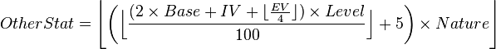](https://bulbapedia.bulbagarden.net/wiki/File:OtherStatCalcGen34.png)

1. Calculate the damage done by a move onto each Pokémon
   1. Look at attacker’s attack/special attack stat depending on type of move and defender defence/special defence attack depending
   2. Using the formula

Damage = ((((((2*level[9])/5)+2)*power[10]*attack[11]/defence[12])/50)+2)*modifier

Where modifier = critical [13]*random[14]*STAB[15]*effectiveness[16]

1. Display:
   1. The sprites of each Pokémon, from imported images
   2. HP bar, narrative box, Pokémon level and sex of Pokémon
   3. The background, coded using pygame
   4. The moves available being shown on the screen
   5. A brief animation for each move
   6. A visual decrease in the health, via the HP bar
   7. The animation for a Pokémon fainting, showing the HP turn to zero
   8. The animation for a Pokémon being sent out
   9. The animation for a Pokémon being withdrawn from battle
   10. An animation for the health bar going down after taken damage, with the numerical value of health also displayed
2. The AI:
   1. Chooses the optimum move for each scenario by checking which move would do the most damage
      1. Is still beatable
   2. If forced to, send out the best Pokémon to counter the player’s battler
3. Difficulty:
   1. Allow user to choose difficulty
   2. Easy mode will:
      1. Allow user to use Bag
      2. Allow user to see which opposing Pokémon will be sent out, and be granted an option to change battler
      3. Be level 100, compared to the opponent’s level 75
   3. Medium mode will:
      1. Allow user to see which opposing Pokémon will be sent out, and be granted an option to change battler
      2. Allow no use of Bag
      3. Be level 100, which would be the same level as the opponent’s Pokémon
   4. Hard mode will:
      1. Allow no use of bag
      2. The user will not know what opposing Pokémon is to be sent out and therefore will not be able to pre-emptively change battler
      3. Be level 90, in comparison to the opposing Pokémon’s level of 100
4. Select trainer
   1. Ensure correct Pokémon are assigned to Trainer Red and Trainer Blue post-selection
   2. Display trainer and associated Pokémon
5. End game when all Pokémon from one side have fainted
   1. Display a win message if victorious
   2. Display a defeat message if defeated
6. User can (during battle sequence):
   1. Select bag on easy mode
   2. Switch Pokémon
   3. Choose a move

|  |  |  |
| --- | --- | --- |
| **Criterion** | **Justification** | **How it will be evidenced** |
| 1.1.1 | So the user knows which Pokémon is doing what | Screenshots of output |
| 1.1.2.1 | Needed so moves do correct damage | Screenshots of print statements during testing |
| 1.1.2.2 | So correct bonuses and multipliers are applied | Comparisons to expected damage output |
| 1.1.2.3 | So the user knows what move they are selected when they choose to fight the opponent | Screenshots of the possible moves being displayed and of the same move being used |
| 1.1.3.1 | So the correct stats are calculated | Output stats during testing phase to ensure they are correct |
| 1.1.3.2 | So the correct Pokémon goes first and the correct damage is inflicted upon each Pokémon | Screenshots of order of fighting and damage infliction(s) |
| 2.1 | Special moves use special defence and special attack in the calculation rather than defence and attack. Therefore the correct stat has to be used in the claculation so the correct damage is inflcited upon the opponent | Screenshots of the correct damage being applied. If the wrong stats were used, the damage wouldn't match the expected output |
| 2.2 | This is the formula used in the real games. I want to mimic the games as closely as possible, and so I will be using the games' formula | If the damage is not as expected, then the formula would be wrong. Hence, screenshots of the correct damage being applied is evidence of the right formula being used |
| 3.1 | The user needs to be able to see their Pokémon in the battle | screenshots of the Pokémon being displayed |
| 3.2 | The user will be able to make more informed decisions when they can see their and their opponent's health. The narrative box will be able to narrate the game clearly, so the user understands what is going on throughout the fight | Screenshots of the narrative box narrating the battle, as well as screenshots of the information box |
| 3.3 | There needs to be a stage for the battle to occur on, otherwise the Pokémon will appear to be floating | Screenshots of the background |
| 3.4 | The user needs to be able to see the moves so that they can choose to use it against the opponent. Otherwise they won't be able to fight | screenshots of the possible moves being displayed and of the same move being used |
| 3.5 | Non-essential, but would be aesthetically pleasing to see a visual representation of what the move is actually doing | A series of screenshots of the animation occurring |
| 3.6 | The user needs to be able to see their health to make better decisions, and so it needs to be able to be updated to display the HP after damage is inflicted upon it | screenshots before and after taking damage |
| 3.7 | HP needs to turn to zero so that the user knows the Pokémon has correctly fainted. The animation is just to see a visual representation of what the narrative box is describing, but is non-essential. | Screenshots of the health bar being empty and the user being prompted to switch their Pokémon out. There will also be screenshots of the fainting animation |
| 3.8 | So that the user can see a visual representation of what the narrative box is describing. Non-essential, but would be a nice feature | A series of screenshots showing the animation occurring |
| 3.9 | So that the user can see a visual representation of what the narrative box is describing. Non-essential, but would be a nice feature | A series of screenshots showing the animation occurring |
| 3.10 | So that the user can see the new updated healt bar which represents the battler's health. This is so the user can make more informed decisions with this information. The numerical value is so that the user can health extra accurayc in their decisions | Screenshots showing the health-bar and numerical health value before and after receiving damage |
| 4.1 | So that the AI is actually an opponent worth fighting against and thus making the game worth playing | Screenshots of the AI using the best move in different scenarios |
| 4.1.1 | So that there is a point to playing the game; if you cannot win then it would not be enjoyable | Screenshots of the winning message |
| 4.2 | So that when the AI's current battler faints, a suitable one is ready to take it's place. If the AI kept sending out the wrong Pokémon to deal with the user's battler, the game would be very easy and boring | Screenshots of the user sending out the best Pokémon to deal with the user's current battler |
| 5.1 | Non-essential, but would broaden the player-base of game, welcoming players of all skill levels | Screenshots of the game asking the user what difficulty they want to play |
| 5.2.1 | So the user has an advantage, which is desired in easy mode | Screenshots of the user being able to open the bag and apply items |
| 5.2.2 | So the user has an advantage, which is desired in easy mode | Screenshots of the game informing the user of the battler about to be switched in against them, and asking the user if they want to switch out their current battler or remain battling with them |
| 5.2.3 | So the user has an advantage, which is desired in easy mode | Screenshots of both of the battlers' information boxes, with one showing level to be 75 and the other showing it to be 100 |
| 5.3.1 | So the user has the option to change their battler to one more suited to the opponent's new battler | Screenshots of the game informing the user of the battler about to be switched in against them, and asking the user if they want to switch out their current battler or remain battling with them |
| 5.3.2 | So the user is on an equal playing field to the AI | Screenshots of the game telling the user that they cannot access the bag in their selected difficulty |
| 5.3.3 | So the user is on an equal playing field to the AI | Screenshots of both of the battlers' information boxes, with box showing that their level is 100 |
| 5.4.1 | Force the user into employing more advanced tactics | Screenshots of the game telling the user that they cannot access the bag in their selected difficulty |
| 5.4.2 | So the user is at a disadvantage, which is desired on hard mode | Screenshots of the game telling the user which Pokémon has been switched out, rather than asking if they want to switch battler |
| 5.4.3 | So the user is at a disadvantage, which is desired on hard mode | Screenshots of both of the battlers' information boxes, with the user's level being 90 and the opponent's being 100 |
| 6 | To give the user a choice of what team they want to fight with, which allows the game to hold greater variety | Screenshots of the game displaying the trainers alongside their Pokémon awaiting a choice |
| 6.1 | So the user gets the team they chose to play with | Screenshots of the whole team (minus the current battler) being able to be switched to at the beginning |
| 6.2 | To confirm the trainer that the user selected | Screenshots of the trainer being displayed alongside his team |
| 7 | So the game can end when one team can no longer fight. This is because otherwise there would be no opponents to fight, and therefore nothing would happen | Screenshots of the 'GAME OVER' message at the end of the game |
| 7.1 | So the user can see for sure that they won the game, and congratulate them on this achievement | Screenshots of the congratulatory message |
| 7.2 | So the user can see for sure that they lost the game, and get commiserated | Screenshots of the commiserations message |
| 8.1 | So that the user can make choices in the battle (and utilise the benefits of easy mode) | Screenshots of the user applying an item to their Pokémon |
| 8.2 | So that the user can use a more suited Pokémon to their current opponent, increasing the strategical variety of the game | Screenshots of the user selected a Pokémon to switch out, and that Pokémon being switched out |
| 8.3 | So that the user can actually fight against the opponent and therefore play the game | Screenshots of the possible moves being displayed, and of the move being used by the user |

# DESIGN

## Programming paradigm

I have decided to opt with both the procedural paradigm, as well with object-oriented programming. Procedural programming, specifically structured programming, is going to be very useful in my program as the key constructs of sequence, selection and iteration are going to be used a lot throughout the program. In addition, my program is going to be split into at least 7[17] modules, and modularisation is very prevalent in Structured (and by extension Procedural) Programming.

However, Object-Oriented programming will be the main paradigm in my project. The only functional way I can use python to display images is by using Object-Oriented Programming via the Pygame interpreter. In addition, the use of Classes will be infinitely useful, as instead of having to code individual buttons I will be able to create a class for them all. Classes are blueprints for objects, defining attributes and methods that capture the common characteristics and behaviours of objects. This will massively reduce development time. In addition, related objects will be use inheritance so a sub-class can share all of their attributes and methods with a parent class, also reducing development time. Moreover, polymorphism (another feature exclusive to OOP), allows an inherited class to have methods and attributes that do not exist in the parent class, as well as being able to redefine methods that are defined in the parent class. This might be useful if I decide to make the Pokémon fit into a class, having different methods for their move-sets, types, etc.

Declarative programming was a paradigm I never put much thought into; after research I knew it wouldn’t be suitable for this program, as there is extremely use of databases, and everything requiring databases in this program can be performed by procedural programming.

In conclusion, Object-Oriented Programming and Procedural Programming are the most suitable paradigms to use in my program, and hence are the paradigms I am using, as they are extremely beneficial in terms of efficiency, as well as functionality.

## Test Plan

|  |  |  |  |  |  |
| --- | --- | --- | --- | --- | --- |
| Test number | Test type | Testing success criteria… | Accepted input | Expected output | Justifying need for test |
|  | Normal | 1.1.1 | No user input, values are instantiated using OOP | During the testing phase, the Pokémon’s names will be output, however in later stages this will be removed once it has been tested to work | It is essential that the names of each Pokémon are assigned to the correct object so the user gets given the correct Pokémon they chose at different points in the game |
|  | Normal | 1.1.2 and sub-criteria | No user input, values are instantiated using OOP | When in battle the user will be able to see name of move in order to make an informed decision about their choice. However, in the testing phase I will have the program output these values earlier in order to speed up development | This test is required so that the powers and elements of each move are correct so that the correct damage is applied, otherwise the user could gain an advantage or disadvantage when they shouldn’t. the name also needs to be correct because otherwise they could select the wrong move through no fault of their own. |
|  | Normal | 1.1.3 and sub-criteria | No user input, values are instantiated using OOP | During the testing phase, the Pokémon’s stats will be output upon instantiation, but this has been thoroughly tested to work the stats will be hidden | This test is required to ensure that the correct damage is applied at all times, ensuring that the user doesn’t gain an advantage or disadvantage when they shouldn’t. |
|  | Normal | 2 and sub-criteria | No user input, the values are instantiated using OOP | The correct damage should be inflicted upon the opponent. This will be checked by me using the formula mentioned in 2.2 myself and comparing it to the program to ensure no mathematical errors have occurred. | This test is required to ensure that the correct damage is applied at all times, ensuring that the user doesn’t gain an advantage or disadvantage when they shouldn’t. |
|  | Normal | 2.2 | Have arcanine use flamethrower | A 1.5x multiplier should be applied to the damage | This test is required to ensure that the correct damage is applied at all times, ensuring that the user doesn’t gain an advantage or disadvantage when they shouldn’t. |
|  | Erroneous | 2.2 | Have a pikachu use iron tail | A 1x multiplier should be applied to the damage | This test is required to ensure that the correct damage is applied at all times, ensuring that the user doesn’t gain an advantage or disadvantage when they shouldn’t. |
|  | Normal | 3.1 | *When asked to enter trainer:*  ‘red’ or ‘blue’ | Display sprites in correct location, e.g. if user inputted ‘red’ then placed next to Trainer Red on screen, and vice versa if user chose Trainer Blue. This test is only testing for display, the functionality is checked in a different test. | This is required so that the user can easily see who is on their team and who they are fighting against. |
|  | Normal | 3.2 | No user input required; values are calculated using values that have been instantiated and further calculations that require no user input | Display HP, level, sex in information box (see research) and narrative box at the bottom of the screen which will narrate the game accordingly | This is test is required as having all the information together in one place clearly would make the game even more easy to understand. Hence, this test ensures that this is the case. |
|  | Normal | 3.3 | No user input required; background will be hard-coded | A suitable background, likely a grassland setting | This test is required to ensure that the scene is set for the user to tell that this  is definitely a battle |
|  | Normal | 3.4 | No direct user input required, however will be affected by the Trainer the user chooses | The four moves in boxes, displaying the name of each move | This test is required to ensure that the user can definitely attack the opponent. If the user cannot see their moves, they can’t participate in the game. Therefore, this test is necessary. |
|  | Normal | 3.5 | The user will select shadow ball | A beam-like projection will be  Displayed from the user’s Pokémon to the opponents | The functionality is optional, but if implemented, the test is required to ensure the animations are working as intended. |
|  | Normal | 3.6 | The user will select a move to inflict damage. | The visible HP bar will decrease | The HP bar needs to change when Pokémon have damage inflicted to display that they have in fact received the damage. Otherwise, the user could be unsure whether their attack even connected. |
|  | Erroneous | 3.6 | The user will select a super potion and apply it to their current battler | The opponent’s HP should NOT decrease, but the user’s should increase by 50 (or to max health if the current battler is less than 50 health points away from their maximum | The test ensures that the item is correctly applied and that even if the user doesn’t choose to attack the opponent, the opponent still attacks the user. This is required because it is pointless having items available if they don’t work, and the AI needs to be able to damage the opponent every turn, no matter what the user is choosing to do (unless the user has fainted the opponent’s battler) |
|  | Normal | 3.7 | The user should select a move or item or Pokémon switch | The HP bar should decrease to empty and the Pokémon should shrink and return to pokéballs. It should then not be able to be used by the user or opponent (depending on whose Pokémon fainted) | The functionality is optional, but if implemented, the test is required to ensure the animations are working as intended. |
|  | Boundary | 3.7 | The user should select a move or item or Pokémon switch | If the Pokémon has 1HP it should NOT faint | This test is required because otherwise the user or the opponent could unfairly lose a battler, which could give the user an advantage or disadvantage when they shouldn’t. |
|  | Normal | 3.8 and 3.9 | Choose Trainer Blue when option given. Then once in battle, click ‘Pokémon’ then ‘Exeggutor’ then ‘swap’ | The Pokémon currently out switches with exeguttor | This test ensures that the Pokémon button is definitely working, and that the user can switch in their Exeggutor for another one. |
|  | Normal | 3.8 and 3.9 | Choose Trainer Blue when option given. Then once in battle, click ‘Pokémon’ then ‘Arcanine’ then ‘swap’ | The Pokémon currently out switches with arcanine | This test ensures that the Pokémon button is definitely working, and that the user can switch in their Arcanine for another one. |
|  | Normal | 3.8 and 3.9 | Choose Trainer Blue when option given. Then once in battle, click ‘Pokémon’ then ‘Rhydon’ then ‘swap’ | The Pokémon currently out switches with rhydon | This test ensures that the Pokémon button is definitely working, and that the user can switch in their Rhydon for another one. |
|  | Normal | 3.8 and 3.9 | Choose Trainer blue when option given. Then once in battle, click ‘Pokémon’ then ‘Gyarados’ then ‘Swap’ | The Pokémon currently out switches with gyarados | This test ensures that the Pokémon button is definitely working, and that the user can switch in their Gyarados for another one. |
|  | Normal | 3.8 and 3.9 | Choose Trainer Blue when option given. Then once in battle, click ‘Pokémon’ then ‘Machamp’ then ‘swap’ | The Pokémon currently out switches with Machamp | This test ensures that the Pokémon button is definitely working, and that the user can switch in their Machamp for another one. |
|  | Normal | 3.8 and 3.9 | Choose Trainer Blue when option given. Then once in battle, click ‘Pokémon’ then ‘Pidgeot’ then ‘swap’ | The Pokémon currently out switches with Pidgeot | This test ensures that the Pokémon button is definitely working, and that the user can switch in their Pidgeot for another one. |
|  | Normal | 3.8 and 3.9 | Choose Trainer Red when option given. Then once in battle, click ‘Pokémon’ then ‘Charizard’ then ‘swap’ | The Pokémon currently out switches with Charizard | This test ensures that the Pokémon button is definitely working, and that the user can switch in their Charizard for another one. |
|  | Normal | 3.8 and 3.9 | Choose Trainer Red when option given. Then once in battle, click ‘Pokémon’ then ‘Blastoise’ then ‘swap’ | The Pokémon currently out switches with Blastoise | This test ensures that the Pokémon button is definitely working, and that the user can switch in their Blastoise for another one. |
|  | Normal | 3.8 and 3.9 | Choose Trainer Red when option given. Then once in battle, click ‘Pokémon’ then ‘Venusaur’ then ‘swap’ | The Pokémon currently out switches with Venusaur | This test ensures that the Pokémon button is definitely working, and that the user can switch in their Venusaur for another one. |
|  | Normal | 3.8 and 3.9 | Choose Trainer Red when option given. Then once in battle, click ‘Pokémon’ then ‘Pikachu’ then ‘swap’ | The Pokémon currently out switches with pikachu | This test ensures that the Pokémon button is definitely working, and that the user can switch in their Pikachu for another one. |
|  | Normal | 3.8 and 3.9 | Choose Trainer Red when option given. Then once in battle, click ‘Pokémon’ then ‘Snorlax’ then ‘swap’ | The Pokémon currently out switches with snorlax | This test ensures that the Pokémon button is definitely working, and that the user can switch in their Snorlax for another one. |
|  | Normal | 3.8 and 3.9 | Choose Trainer Red when option given. Then once in battle, click ‘Pokémon’ then ‘Mewtwo’ then ‘swap’ | The Pokémon currently out switches with mewtwo | This test ensures that the Pokémon button is definitely working, and that the user can switch in their Mewtwo for another one. |
|  | Normal | 3.10 | Choose a ground-type move against a flying-type Pokémon | The narrative box say it did no damage and no damage should be inflicted upon the opponent | This test ensures that the effectiveness multiplier is working as intended. The multiplier for non-affecting moves (such as ground types moves against flying types) is 0, and hence no damage should be inflicted |
|  | Normal | 3.10 | Use thunderbolt with Pikachu against Rhydon | The narrative box should say it did no damage and no damage should be inflicted upon the opponent | This test ensures that the effectiveness multiplier is working as intended. The multiplier for non-affecting moves (such as electric types moves against ground types) is 0, and hence no damage should be inflicted. This test also checks that even if the attack affects one of the opponent’s types (rock in this case) but not the other (ground in this case), then still no damage is inflicted. |
|  | Normal | 3.10 | Choose petal blizzard against Blastoise. | The narrative box should output the damage and a 2x multiplier should be applied to the damage | This test ensures that the effectiveness multiplier is working as intended. The multiplier for super-effective moves (such as grass types moves against water types) is 2, and hence twice as much damage should be inflicted |
|  | Erroneous | 3.10 | Choose petal blizzard against Gyarados | The narrative box should output the damage and a 1x multiplier should be applied to the damage | This test ensures that the effectiveness multiplier is working as intended. The grass type attack is super-effective against Gyarados's water type, but not very effective against its flying type, and hence the multipliers cancel out to 1x |
|  | Normal | 3.10 | Choose earthquake against Pikachu | The narrative box should output the damage and a 2x multiplier should be applied to the damage | This test ensures that super-effective moves have the 2x multiplier working, and therefore that the effectiveness multiplier is operational. |
|  | Erroneous | 3.10 | Choose a ground-type move against a Pokémon that is a fire- and flying-type | The narrative box should say ‘it doesn’t affect the foe’ and no damage should be inflicted upon the opponent | This test ensures that the effectiveness multiplier is working as intended. The multiplier for non-affecting moves (such as ground types moves against flying types) is 0, and hence no damage should be inflicted. This is important because the attack would normally be super-effective against Charizard’s fire type, but the flying type’s multiplier ensures that still no damage is output. |
|  | Normal | 3.10 | Choose a fire-type attack against a Pokémon who **only** has the fire-type | The narrative box should output the damage and a 0.5x multiplier should be applied to the damage | This is done to ensure that types that resist their own type still have the appropriate 0.5x not-very-effective multiplier intact. |
|  | Erroneous | 3.10 | Choose a fighting-type attack against a Pokémon who **only** has the fighting type | The narrative box should output the damage a 1x multiplier should be applied to the damage | This is done to ensure that types that don’t resist their own type still have the appropriate 1x neutral multiplier intact. |
|  | Normal | 3.10 | Choose a grass-type attack against a Pokémon that is a grass- and poison- type | The narrative box should output the damage and 0.25x multiplier should be applied to the damage | This is done to ensure that types that resist their own type still have the appropriate 0.5x not-very-effective multiplier intact, while also still having the 0.5x not-very-effective multiplier against the poison type intact |
|  | Normal | 3.10 | Choose a move with less than 100 accuracy until it misses | The narrative box should say ‘The attack missed!’ and the target should not take any damage | Moves that miss should not inflict any damage, otherwise there is no point in having the accuracy attribute. Moves with lower accuracy tend to be more powerful to help balance out the strength |
|  | Erroneous | 3.10 | Choose a move with 100 accuracy 10 times | The move should never miss, and the appropriate messages above should be displayed in the narrative box | Moves with 100% accuracy should never miss, as that contradicts the notion that they have 100% accuracy |
|  | Normal | 3.11 | Choose a fire-type move against any Pokémon | The HP bar should go down according to the damage calculated and verified in previous testing. | This test is to ensure that the damage calculation is in-keeping with the original formula, otherwise the user could be seriously misled. |
|  | Erroneous | 3.11 | Choose a ground-type attack against a flying-type Pokémon | The HP should not go down as no damage should have been inflicted | This test is once again be completely certain that the effectiveness multiplier is functioning and that it appropriately affects the damage calculation. |
|  | Normal | 4.1.1 | Battle the AI and win | No output: this test exists solely to prove that the AI is beatable | The game needs to be able to be beaten for the user to have an enjoyable playing experience, hence this test is required to ensure this can be done. |
|  | Normal | 4.1 | Choose Trainer Blue and choose Arcanine when the AI has Blastoise out | The AI should use Surf, which is the best move in that situation given that it would do more damage to Arcanine than any other of Blastoise’s moves | Surf is the most damaging  Move, and is therefore the one the AI should use. This is because the AI should use the best move in any given situation. This test is required to check that the AI does in fact use the best move in each situation |
|  | Erroneous | 4.1 | Choose Trainer Blue and choose Arcanine when the AI has Blastoise out, but then switch to any other Pokémon | The AI should use Surf, which would be the best move against Arcanine, which it should check against – not the Pokémon who had just been switched in | Surf is the most damaging  Move, and is therefore the one the AI should use. This is because the AI should use the best move in any given situation. This test is required to check that the AI does in fact use the best move in each situation, but doesn’t check what Pokémon the user is going to send in, as this creates an unbeatable advantage |
|  | Erroneous | 4.1 | Choose to switch out any Pokémon into any other Pokémon | The AI should use a move, which should damage the Pokémon that was just switched in, not the Pokémon who has just been substituted | The old battler is no longer in battle, and hence can no longer be damaged. This test ensures that only the battling Pokémon can be damaged |
|  | Normal | 4.2 | Select trainer Blue then choose Pidgeot. Defeat any of the opponent’s Pokémon apart from Pikachu | The AI should then switch out Pikachu, as it could do the most damage to Rhydon | This is to ensure that the AI not only chooses the best attacking move in each situation, but also sends in the Pokémon that can then choose the best attacking move in the situation |
|  | Erroneous | 4.2 | Select trainer Blue then choose Pidgeot once Pikachu has already been defeated. | The AI would normally decide to choose Pikachu, but as it has been defeated it cannot be used. The Pokémon sent out should then be mewtwo. Pidgeot and then Gyarados. | This test ensures that when the best Pokémon is unable to be sent out, the next best one is. This is because fainted Pokémon cannot fight, and so the AI has to choose a different Pokémon to use |
|  | Normal | 5.1, 5.2 and sub-criteria | When prompted, enter easy | The game will confirm that the easy mode has been selected. Allow user to use Bag. Allow user to see which opposing Pokémon will be sent out and be granted an option to change battler.  User’s Pokémon will be level 100, compared to the AI’s Pokémon, which will be level 75 | This is to give the user an advantage. The game confirms the difficulty so the user is certain they haven’t accidentally chosen the wrong difficulty. |
|  | Normal | 5.1, 5.2 and sub-criteria | When prompted, enter medium | The game will confirm that the medium mode has been selected.  Allow user to see which opposing Pokémon will be sent out, and be granted an option to change battler  Allow no use of Bag  User’s and AI’s Pokémon will be level 100 | This is to give the user and the AI a level playing field. The game confirms the difficulty so the user is certain they haven’t accidentally chosen the wrong difficulty. |
|  | Normal | 5.1, 5.3 and sub-criteria | When prompted, enter hard | The game will confirm that the hard mode has been selected. User will not be able not be granted an option to switch Pokémon when the AI’s next Pokémon is revealed. There will be no use of Bag. User’s Pokémon will be level 90 compared to the AI’s Pokémon, which will be level 100 | This is to give the user a disadvantage. The game confirms the difficulty so the user is certain they haven’t accidentally chosen the wrong difficulty. |
|  | Erroneous | 5.1 | When prompted, enter 2 | The game will ask the user to re-enter either Easy, Medium or Hard. This will loop continuously until the user selects one of the options | This is to ensure no invalid inputs are accepted. This is to prevent crashes or random assignment of the difficulty. |
|  | Erroneous | 5.1 | When prompted, enter asdfghjkl; | The game will ask the user to re-enter either Easy, Medium or Hard. This will loop continuously until the user selects one of the options | This is to ensure no invalid inputs are accepted. This is to prevent crashes or random assignment of the difficulty. |
|  | Erroneous | 5.1 | When prompted, enter nothing but press enter | The game will ask the user to re-enter either Easy, Medium or Hard. This will loop continuously until the user selects one of the options | This is to ensure no invalid inputs are accepted. This is to prevent crashes or random assignment of the difficulty. |
|  | Normal | 6 and 6.2 | Click trainer Red when prompted (only once final prototype completed – beforehand type in ‘red’ when prompted) | The game should confirm choice. If the final prototype has been completed then Trainer Red will be displayed with Charizard, Venusaur, Blastoise, Pikachu, Mewtwo and Snorlax alongside. Otherwise, the game will print out ‘red’ and the above Pokémon | This is to ensure that the user is able to check that they have selected their desired team, and not accidentally chose the wrong one. |
|  | Normal | 6 and 6.2 | Click trainer Blue when prompted (only once final prototype completed – beforehand type in ‘blue when prompted) | The game should confirm choice. If the final prototype has been completed then Trainer Blue will be displayed with Pidgeot, Gyarados, Rhydon, Arcanine, Exeggutor and Machamp alongside. Otherwise, the game will print out ‘blue and the above Pokémon | This is to ensure that the user is able to check that they have selected their desired team, and not accidentally chose the wrong one. |
|  | Erroneous and robustness | 6 and 6.2 | Click nothing. If final prototype hasn’t been completed then enter nothing | If the final prototype has been completed nothing should happen until the user clicks one of the trainers. If it hasn’t been completed, the game should ask the user to re-enter either ‘red’ or ‘blue’ | This is because the user hasn’t selected a trainer. The battle cannot commence until a trainer has been selected and so nothing should happen until this point |
|  | Normal | 6.1 | Choose Trainer Blue when prompted | The user should be given all 6 of Trainer Blue’s Pokémon in battle | This is because these are the Pokémon the user selected to use. This test is required because we need to ensure that the user gets the team they chose. |
|  | Normal | 6.1 | Choose Trainer Red when prompted | The user should be given all 6 of Trainer Red’s Pokémon in battle | This is because these are the Pokémon the user selected to use. This test is required because we need to ensure that the user gets the team they chose. |
|  | Normal | 7.1 | Defeat the AI | A big message should appear saying “You defeated your opponent! Congratulations!” | This is because an appropriate message needs to be displayed at the end of the game. This test is required because we need to be certain that this occurs. |
|  | Normal | 7.1 | Lose to the AI | A message should appear saying “Your opponent defeated you! Commiserations. Come back again and defeat them next time!” | This is because an appropriate message needs to be displayed at the end of the game. This test is required because we need to be certain that this occurs. |
|  | Normal | 8.1 | Select bag on easy mode | The contents of the bag should pop up, allowing the user to select an item to apply | This is because the bag is available on easy mode. This test is required to ensure the user is allowed to make full use out of their freedoms in each difficulty. |
|  | Erroneous | 8.1 | Select bag on medium or hard mode | The program should output “this action is not available in this mode” and not allow the user to apply an item | This is because the bag is available on medium or hard mode. This test is required to ensure the user is not allowed to use restricted choices |
|  | Normal | 8.2 | At the beginning of the user’s turn, the user clicks ‘Pokémon’ | The program should ask the user which Pokémon they want to switch in. | This is because the user should be allowed to switch in a more suitable battler. This test ensures that the this is the case. |
|  | Normal | 8.2 | The user should pick a non-fainted Pokémon after clicking ‘Pokémon’ at the beginning of their turn | The Pokémon the user currently has out should switch with the one that was just selected | This is because the user should be allowed to switch in a more suitable battler, provided that they have not fainted. This test is required because we need to ensure that this is the case. |
|  | Erroneous | 8.2 | The user should pick a fainted Pokémon after clicking ‘Pokémon’ at the beginning of their turn | The program should output “this battler has no energy left to battle” and not let that Pokémon be sent out. | This is because the user should be allowed to switch in a more suitable battler, provided that they have not fainted. This test is required because we need to ensure that this is the case. |
|  | Normal | 8.3 | The user should select ‘fight’ at the beginning of their turn | The program should output the current battler’s four moves, and await an input | This is because the user needs to be able to see what moves they can choose so they can click them and therefore choose them. If they couldn’t choose their move then they couldn’t even fight the opponent, meaning that the game would not be able to be played. |
|  | Normal | 8.3 | The user should input one of the four moves and selecting ‘fight’ | The program should say which move the user used, how much damage it did, and how much HP the opponent has left and whether it was a critical hit. | This is so the user can see the direct impact of their move. This will let them know whether it’s worth doing the move again or making a different choice next time. This test is required to help the user make more informed decisions. |
|  | Erroneous | 8.3 | After selecting ‘fight’, input a move that isn’t one of the four available moves | The program should NOT use a move, and tell the user to enter a valid move, and loop. | This test is only valid in the text-based game. This test is required to ensure that the input isn’t accepted so the game doesn’t crash or the user doesn’t just have a void turn. |
|  | Robustness | N/A | Right-click (ctrl-click on Mac) the trainer at the beginning of the game | The game should register it as a normal click | This test is required to ensure that no commands or additional menus appear, and that it is registered as just a normal click |

## Usability Features

|  |  |  |
| --- | --- | --- |
| **Requirement** | **Justification for inclusion** | **How will it be evidenced?** |
| Easy to tell which Pokémon belongs to which trainer | So the user doesn't accidentally choose the wrong trainer | Screenshots of the display and interviews with graphic advisors |
| Sprites of a good quality | So the game looks aesthetically pleasing and to make the Pokémon easily identifiable | Interviews with graphic advisors and screenshots of display |
| Well designed information box | So the user can clearly see the HP, name and level of the enemy | Interview with graphic advisors |
| Clear and easy-to-understand buttons | So the user can navigate the game easily and don't accidentally the wrong decision | Interviews with stakeholders and graphic advisors |
| Suitable background | So the game fully gives the sense of a battle arena | Interview with graphic advisors |
| Narrative box is well designed | So the user can easily differentiate it from the Pokémon's information box | Interviews with stakeholders and graphic advisors |
| Narrative box clearly describes what's happening | So the user receives prompts if they are at all unsure what to do and to describe what's happening throughout the game | Interviews with stakeholders and graphic advisors |
| Easy to tell between user and enemy battlers | So the user knows they received the Pokémon and trainer they selected at the beginning of the game | Interviews with stakeholders and graphic advisors and screenshots of the display |

## Prototyping

|  |  |  |
| --- | --- | --- |
| **Prototype Number** | **Covers Criterion…** | **Why this order** |
|  | 1 | It will be the first step when playing the game; all battle aspects of the game require this step in order to function |
|  | 6 | Builds directly off of previous prototype and is equally as important to the functionality of the game, however, needs prototype 1 to be complete in order to work, hence is the second prototype to be completed |
|  | 2 | Requires prototype 1 and 2 to be completed in order to function; will combine to allow the user to battle, but only against an opponent that doesn’t fight back |
|  | 4 | It will allow the AI to switch in a Pokémon or use a move. Can be done before or after prototype 5 but decided to put it beforehand |
|  | 8 | Allows a full battle to take place; with the user and the AI choosing what to do |
|  | 7 | The game can be fully played (albeit at a very simple level) and so should be able to end |
|  | 5 | Adds complexity to the game; the base game needs to be complete before complexity can be added |
|  | 3 | I want the game to be fully operational in text before a GUI is implemented, so this is the final prototype to be implemented |

### Prototype 1

Prototype 1 will completely support success criteria 1. This prototype will be completely text-based; no graphics will have been implemented. I will know I have succeeded because I’m intending to print out the Pokémon with their stats and move-sets and affiliated types. This is only to be implemented to check that the right attributes are assigned to the right Pokémon, with only move-sets and their type being displayed in the final version of the game.

This will be the first step in the game. It is independent from all non-battle parts of the game, but without it all battle aspects of the game would simply not function. It is the most important part of the game.

All stats are from the official Pokémon games.

#### Test Plan

|  |  |  |  |  |  |
| --- | --- | --- | --- | --- | --- |
| Test Number | Test Type | Testing Success Criteria… | Justification for use | Accepted Input | Expected Output |
|  | Normal | 1.1.1 | The correct name of the Pokémon needs to be made so the user can tell which Pokémon is which when making decisions | No input required; process performed solely by code | Correct name of Pokémon |
|  | Normal | 1.1.2.1 | The correct power of each move needs to be made so the user can make informed decisions about what move to use in battle. If the move power is wrong, they could lose the battle from no fault of their own | No input required; process performed solely by code | Correct power of move |
|  | Normal | 1.1.2.2 | The element of each move needs to be right so that the bonuses and multipliers are correctly applied. This is so moves do the correct amount of damage, so no uninformed decisions are made by the user which could lead them to lose or win the game when they shouldn't | No input required; process performed solely by code | Correct element of move |
|  | Normal | 1.1.3 | Moves must have the right name, otherwise the user might select the wrong use through no fault of their own. This could end up doing less damage than the user wanted, causing them to lose the game | No input required; process performed solely by code | Correct name of move |
|  | Normal | 1.2.1 | This is so the correct stats are calculated for each Pokémon. These need to be correct for damage calculations | No input required; process performed solely by code | Correct base stats for that Pokémon |
|  | Normal | 1.2.2 | This is so all damage calculations are accurate. If the damage inflicted is wrong, the user could lose or win the game when they shouldn't | No input required; process performed solely by code | Correctly calculated stats for that Pokémon |
|  | normal | 1.2.2 | Pikachu needs to have the correct stats so that the correct damage is inflicted and the correct Pokémon goes first. This is so the user can make informed decisions throughout their playing experience and don't select a move that allows them to gain an advantage or disadvantage when they shouldn't | No input required; the following is for Pikachu. | HP: 180  Spd: 185  Atk: 230  SpAtk: 210  Def: 85  SpDef: 105 |
|  | Normal | 1.2.2 | Charizard needs to have the correct stats so that the correct damage is inflicted and the correct Pokémon goes first. This is so the user can make informed decisions throughout their playing experience and don't select a move that allows them to gain an advantage or disadvantage when they shouldn't | No input required; the following is for Charizard | HP: 266  Spd: 205  Atk: 173  SpAtk: 223  Def: 161  SpDef: 175 |
|  | Normal | 1.2.2 | Blastoise needs to have the correct stats so that the correct damage is inflicted and the correct Pokémon goes first. This is so the user can make informed decisions throughout their playing experience and don't select a move that allows them to gain an advantage or disadvantage when they shouldn't | No input required, following is for Blastoise | HP: 268  Spd: 161  Atk: 171  SpAtk: 175  Def: 205  SpDef: 215 |
|  | Normal | 1.2.2 | Venusaur needs to have the correct stats so that the correct damage is inflicted and the correct Pokémon goes first. This is so the user can make informed decisions throughout their playing experience and don't select a move that allows them to gain an advantage or disadvantage when they shouldn't | No input required, following is for Venusaur | HP: 270  Spd: 165  Atk: 169  SpAtk: 205  Def: 171  SpDef: 205 |
|  | Normal | 1.2.2 | Snorlax needs to have the correct stats so that the correct damage is inflicted and the correct Pokémon goes first. This is so the user can make informed decisions throughout their playing experience and don't select a move that allows them to gain an advantage or disadvantage when they shouldn't | No input required, following is for Snorlax | HP: 430  Spd: 65  Atk: 225  SpAtk: 135  Def: 135  SpDef: 225 |
|  | Normal | 1.2.2 | Mewtwo needs to have the correct stats so that the correct damage is inflicted and the correct Pokémon goes first. This is so the user can make informed decisions throughout their playing experience and don't select a move that allows them to gain an advantage or disadvantage when they shouldn't | No input required, following is for Mewtwo | HP: 322  Spd: 265  Atk: 225  SpAtk: 313  Def: 185  SpDef: 185 |
|  | Normal | 1.2.2 | Pidgeot needs to have the correct stats so that the correct damage is inflicted and the correct Pokémon goes first. This is so the user can make informed decisions throughout their playing experience and don't select a move that allows them to gain an advantage or disadvantage when they shouldn't | No input required, following is for Pidgeot | HP: 276  Spd: 207  Atk: 165  SpAtk: 145  Def: 155  SpDef: 145 |
|  | Normal | 1.2.2 | Arcanine needs to have the correct stats so that the correct damage is inflicted and the correct Pokémon goes first. This is so the user can make informed decisions throughout their playing experience and don't select a move that allows them to gain an advantage or disadvantage when they shouldn't | No input required, following is for Arcanine | HP: 290  Spd: 195  Atk: 225  SpAtk: 205  Def: 165  SpDef: 165 |
|  | Normal | 1.2.2 | Machamp needs to have the correct stats so that the correct damage is inflicted and the correct Pokémon goes first. This is so the user can make informed decisions throughout their playing experience and don't select a move that allows them to gain an advantage or disadvantage when they shouldn't | No input required, following is for Machamp | HP: 290  Spd: 115  Atk: 265  SpAtk: 135  Def: 165  SpDef: 175 |
|  | Normal | 1.2.2 | Gyarados needs to have the correct stats so that the correct damage is inflicted and the correct Pokémon goes first. This is so the user can make informed decisions throughout their playing experience and don't select a move that allows them to gain an advantage or disadvantage when they shouldn't | No input required, following is for Gyarados | HP: 300  Spd: 167  Atk: 255  SpAtk: 125  Def: 163  SpDef: 205 |
|  | Normal | 1.2.2 | Rhydon needs to have the correct stats so that the correct damage is inflicted and the correct Pokémon goes first. This is so the user can make informed decisions throughout their playing experience and don't select a move that allows them to gain an advantage or disadvantage when they shouldn't | No input required, following is for Rhydon | HP: 320  Spd: 85  Atk: 265  SpAtk: 95  Def: 245  SpDef: 95 |
|  | Normal | 1.2.2 | Exeggutor needs to have the correct stats so that the correct damage is inflicted and the correct Pokémon goes first. This is so the user can make informed decisions throughout their playing experience and don't select a move that allows them to gain an advantage or disadvantage when they shouldn't | No input required, following is for Exeggutor | HP: 300  Spd: 115  Atk: 195  SpAtk: 255  Def: 175  SpDef: 155 |

#### Flowchart

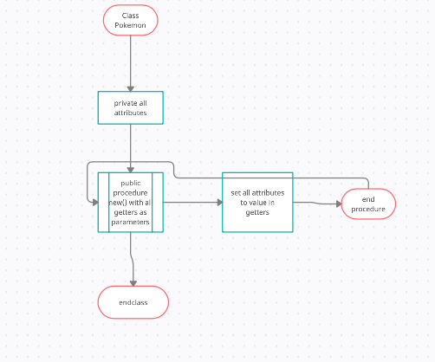

##### Inheritance diagram

|  |
| --- |
| Pokemon |
| * name * spAtk * atk * spDef * defence * spd * move1 * movetype1 * movepower1 * move2 * movetype2 * movepower2 * move3 * movetype3 * movepower3 * move4 * movetype4 * movepower4 * hp * type1 * type2 |
| *No methods at this stage of development* |

|  |
| --- |
| BluePokemon |
| * level |
| *No methods at this stage of development* |

|  |
| --- |
| RedPokemon |
| * level |
| *No methods at this stage of development* |

*While there is no intrinsic difference between the two subclasses, they are separated more as a matter of convenience when programming the project. If, when programming, I find that they don’t need to be separate, I will combine them once again*

#### Table of variables

|  |  |  |  |
| --- | --- | --- | --- |
| **Variable Name** | **Data Type** | **Purpose** | **Validation** |
| getName | String | To set the attribute name to the correct value in the constructor | Will be displayed throughout the program so easy to check. This variable is instantiated with the object and never changed from then on, and so requires no further validation. |
| getSpAtk | int | To set the attribute spAtk to the correct value in the constructor to be used in damage calculations | Will be checked easily as calculations will be checked to ensure correct damage is inflicted. This variable is instantiated with the object and never changed from then on, and so requires no further validation. |
| getAtk | Int | To set the attribute atk to the correct value in the constructor to be used in damage calculations | Will be checked easily as calculations will be checked to ensure correct damage is inflicted. This variable is instantiated with the object and never changed from then on, and so requires no further validation. |
| getDefence | Int | To set the attribute defence to the correct value in the constructor to be used in damage calculations | Will be checked easily as calculations will be checked to ensure correct damage is inflicted. This variable is instantiated with the object and never changed from then on, and so requires no further validation. |
| getSpDef | Int | To set the attribute spDef to the correct value in the constructor to be used in damage calculations | Will be checked easily as calculations will be checked to ensure correct damage is inflicted. This variable is instantiated with the object and never changed from then on, and so requires no further validation. |
| getSpd | Int | To set the attribute spd to the correct value in the constructor to be used in determining which fighter goes first | Will be checked easily as I will test each combination of Pokémon against each other to ensure they go in the correct order. This variable is instantiated with the object and never changed from then on, and so requires no further validation. |
| getMovex | String | To store the name of a move to be used in battle | It will appear when selecting move and when move is being used, so easy to check. This variable is instantiated with the object and never changed from then on, and so requires no further validation. |
| getMovetypex | String | To store the element of the move to be used in damage calculations | It will appear when selecting move and be used in damage calculations. This variable is instantiated with the object and never changed from then on, and so requires no further validation. |
| getMovepowerx | Int | To store the power of the move to be used in damage calculations | It will appear when selecting the move and be used in damage calculations. This variable is instantiated with the object and never changed from then on, and so requires no further validation. |
| getTypex | String | Will store the Pokémon’s element(s), if the Pokémon only has one type then getType2 will be the same as getType1 | Will be used in damage calculations. This variable is instantiated with the object and never changed from then on, and so requires no further validation. |

#### pseudocode

Class Pokemon

Private name

Private spAtk

Private atk

Private spDef

Private defence

Private spd

Private hp

Private move1

Private movetype1

Private movepower1

Private move2

Private movetype2

Private movepower2

Private move3

Private movetype3

Private movepower3

Private move4

Private movetype4

Private movepower4

Private type1

Private type2

Public procedure new(getname,getspAtk,getatk,getspDef,getdef,getspd,gethp,getmove1,getmovetype1,getmovepower1,getmove2,getmovetype2,getmovepower2,getmove3,getmovetype3,getmovepower3,getmove4,getmovetype4,getmovepower4,gettype1,gettype2)

name=getName

spAtk=getSpAtk

atk=getatk

spDef=getSpDef

defence=getDefence

spd=getspd

hp=gethp

move1=getmove1

movetype1=getmovetype1

movepower1=getmovepower1

move2=getmove2

movetype2=getmovetype2

movepower2=getmovepower2

move3=getmove3

movetype3=getmovetype3

movepower3=getmovepower3

move4=getmove4

movetype4=getmovetype4

movepower4=getmovepower4

type1=gettype1

type2=gettype2

endprocedure

endclass

class RedPokemon inherits Pokemon

private level

public procedure new(getname,getspAtk,getatk,getspDef,getdef,getspd,gethp,getmove1,getmovetype1,getmovepower1,getmove2,getmovetype2,getmovepower2,getmove3,getmovetype3,getmovepower3,getmove4,getmovetype4,getmovepower4,gettype1,gettype2,getLevel)

level=getLevel

hp = (2(gethp*level)/100)+level+10

atk = [(2*getatk*level)/100]+5

defence = [(2*getdef*level)/100]+5

spAtk = [(2*getspAtk*level)/100]+5

spDef = [(2*getspDef*level)/100]+5

spd = [(2*getspd*level)/100]+5

super.new(getname,getspAtk,getatk,getspDef,getdef,getspd,gethp,getmove1,getmovetype1,getmovepower1,getmove2,getmovetype2,getmovepower2,getmove3,getmovetype3,getmovepower3,getmove4,getmovetype4,getmovepower4,gettype1,gettype2)

endprocedure

endclass

class BluePokemon inherits Pokemon

private level

public procedure new(getname,getspAtk,getatk,getspDef,getdef,getspd,gethp,getmove1,getmovetype1,getmovepower1,getmove2,getmovetype2,getmovepower2,getmove3,getmovetype3,getmovepower3,getmove4,getmovetype4,getmovepower4,gettype1,gettype2,getLevel)

level=getLevel

hp = (2(gethp*level)/100)+level+10

atk = [(2*getatk*level)/100]+5

defence = [(2*getdef*level)/100]+5

spAtk = [(2*getspAtk*level)/100]+5

spDef = [(2*getspDef*level)/100]+5

spd = [(2*getspd*level)/100]+5

super.new(getname,getspAtk,getatk,getspDef,getdef,getspd,gethp,getmove1,getmovetype1,getmovepower1,getmove2,getmovetype2,getmovepower2,getmove3,getmovetype3,getmovepower3,getmove4,getmovetype4,getmovepower4,gettype1,gettype2)

endprocedure

endclass

* I made RedPokemon and BluePokemon two separate sub-classes purely for differentiation purposes. This will help me keep track of where each Pokémon is stored and consequently what each Pokémon’s stats are. This will be extremely helpful towards the end of development when I want to make the function that ends the game, as I will be able to differentiate between red’s Pokémon and blue’s Pokémon and hence check their HPs to see if a whole team has fainted or not, and thus whether or not the game should end. They both inherit the Pokémon class because they all have the same attributes. The Pokémon class stores all the information any Pokémon in this game will ever require, and so I have inherited from it instead of just creating two standalone class for RedPokemon and BluePokemon.
* The importance of OOP here cannot be understated. The amount of time that will be saved creating these objects instead of having to use dictionaries or 2D lists is vast, and it makes it extremely easy to know what attribute I’m trying to use. For example, if I wanted to use Pidgeot's attack stat, I can write pidgeot.atk, but I if used a list I would have to memorise the index of the list where the attack stat was stored.
* The Level attribute is kept separate from the parent class as on medium difficulty all Pokémon are level 100. This means that level is equal for everyone and doesn’t change, so it will be used as a constant instead in this scenario.
* This helps form a complete solution by creating a base foundation to the game; the Pokémon need to have the stats created in order for them to inflict and receive damage of varying degrees, and for the user to therefore play the game.

### Prototype 2

Prototype 2 will partially support success criterion 6, allowing the user to choose which trainer, and by extension the Pokémon, they want to use, but without graphics at this stage. The two trainers (Trainer Red and Trainer Blue) will be displayed with their Pokémon alongside, clearly indicating which Pokémon belong to which trainer. The user will be asked to click the trainer they want and will then be asked to confirm their choice.

Initially, however, it will be text-based, with me typing in what trainer I want to use and then having the program print out the trainer chosen and the assigned Pokémon in order to check it’s correct. The flowchart will be using click-based choices as the final prototype will be click-based instead of typing in options, but the pseudocode will be for the initial prototype with Prototype 6 having the updated pseudocode. This test plan is for the finished prototype:

#### Test plan

|  |  |  |  |  |  |
| --- | --- | --- | --- | --- | --- |
| Test Number | Test Type | Testing Success Criteria… | Justifying reason for test | Acceptable Input | Accepted Output |
|  | Normal | 6.2 | The user needs to be able to see which Pokémon belong to which trainer so they can make an informed choice about who they want to battle with. This is the most important choice of the game, and so it must be a completely informed decision | No input required; process performed solely by code | BLUE:  Arcanine  Pidgeot  Machamp  Gyarados  Rhydon  Exeggutor  RED:  Pikachu  Charizard  Blastoise  Venusaur  Snorlax  Mewtwo |
|  | Normal | 6.1 | The user needs to be able to choose the trainer they want to battle with so that they have a team to battle with. This test also checks that the user doesn’t change their mind, ensuring that they are definitely making their desired decision, given its importance. | ‘red’ | Enter yes if you are sure you want to choose this trainer. If you want to change, enter no. Case does not matter |
|  | Normal | 6.1 | The user needs to be able to choose the trainer they want to battle with so that they have a team to battle with. This test also checks that the user doesn’t change their mind, ensuring that they are definitely making their desired decision, given its importance. | ‘blue’ | Enter yes if you are sure you want to choose this trainer. If you want to change, enter no. Case does not matter |
|  | Normal | 6.1 | This test ensures that if the user does change their mind, they have their team changed to their desired team. It is very important that the user has the team they want, as it is with them for the rest of the program | *(after choosing red):* ‘no’ | Trainer has been switched to Trainer Blue  Pidgeot, Machamp, arcanine, rhydon, gyarados, Exeggutor |
|  | Normal | 6.1 | This test ensures that if the user does change their mind, they have their team changed to their desired team. It is very important that the user has the team they want, as it is with them for the rest of the program | *(After choosing blue):* ‘no’ | Trainer has been switched to Trainer Red  Pikachu, Charizard, Blastoise, Venusaur, snorlax, mewtwo |
|  | Normal | 6.1 | This test ensures that the user keeps the team they originally chose. It is very important that the user has the team they want, as it is with them for the rest of the program | *(after choosing red): “yes”* | Pikachu, Charizard, Blastoise, Venusaur, snorlax, mewtwo |
|  | Normal | 6.1 | This test ensures that the user keeps the team they originally chose. It is very important that the user has the team they want, as it is with them for the rest of the program | *(after choosing blue)*: ‘yes’ | Pidgeot, Machamp, arcanine, rhydon, gyarados, Exeggutor |
|  | Erroneous | 6.1 | This test ensures that invalid inputs are not accepted, so that the user gets a team of Pokémon | ‘green’ | Enter blue for Trainer Blue and red for Trainer Red. Case does not matter.”) |
|  | Erroneous | 6.1 | This test ensures that invalid inputs are not accepted, so that the user gets a team of Pokémon | *(after choosing red):* ‘asdf’ | Enter yes if you are sure you want to choose this trainer. If you want to change, enter no. Case does not matter |
|  | Erroneous | 6.1 | This test ensures that invalid inputs are not accepted, so that the user gets a team of Pokémon | *(after choosing blue):* ‘asdf’ | Enter yes if you are sure you want to choose this trainer. If you want to change, enter no. Case does not matter |

#### FLOWCHART

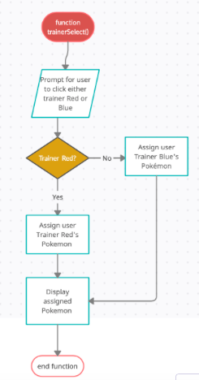

#### Table of variables

|  |  |  |  |
| --- | --- | --- | --- |
| **Variable Name** | **Data Type** | **Purpose** | **Validation** |
| **Trainer** | String | Stores the trainer the user chooses (either red or blue) | The program will continuously loop until the user select either red or blue. Not case sensitive. This is needed because otherwise the user will not be assigned a team, and therefore would not be able to play the game. |
| **yn** | String | Determines whether the switch the trainer after the user’s initial choice. E.g. if they select trainer Red but want to switch, they will enter ‘no’ when asked if they are sure they chose the right trainer. This stands for ‘yes/no’ as these are the only valid inputs | The program will continuously loop until the user enters ‘yes’ or ‘no’. the variable is not case sensitive. This is needed so that the user confirms they are happy with their choice. If they cannot do this, then they won’t be assigned a team, and therefore the game loops until a valid input is received. |

#### pseudocode

print(“Trainer Blue:”,pidgeot.name, machamp.name, rhydon.name, gyarados.name, exeggutor,name, arcanine.name)

print(“Trainer Red:”,pikachu.name, mewtwo.name, snorlax.name, venusaur.name, charizard.name, blastoise.name)

trainer=str(input(“Enter blue for Trainer Blue and red for Trainer Red. Case does not matter.”)

trainer=trainer.lower()

WHILE trainer <> “red” or trainer <> “blue” THEN

trainer=input(“Enter blue for Trainer Blue and red for Trainer Red. Case does not matter.”)

End while

print(“You have chosen trainer”,trainer)

yn=str(input(“Enter yes if you are sure you want to choose this trainer. If you want to change, enter no. Case does not matter”)

While yn.lower() <> ‘yes’ or yn.lower() <> ‘no’ THEN

yn=str(input(“Enter yes if you are sure you want to choose this trainer. If you want to change, enter no. Case does not matter”)

endwhile

IF yn.lower() == “no” THEN

IF trainer == ‘red’ THEN

trainer = ‘blue’

ELSE THEN

trainer=‘red’

print(“Trainer has been switched to Trainer”,trainer)

endif

endif

IF trainer ==‘red’ THEN

print(pikachu.name,”\n”,mewtwo.name,”\n”,snorlax.name,”\n”,venusaur.name,”\n”,charizard.name,”\n”,blastoise.name)

ELSE THEN

print(pidgeot.name,”\n”,machamp.name,”\n”,rhydon.name,”\n”,gyarados.name,”\n”,exeggutor,name,”\n”,arcanine.name)

endif

* First two statements are to help user make an informed decision when choosing trainer, clearly stating which Pokémon belong to which trainer.
* Trainer is set to lowercase so that the user doesn’t have to keep re-entering their desired trainer just because they put a capital letter in their input
* The two while loops are so the user will be continually asked to enter and re-enter an input until it fits the previously stated preconditions, so that a valid team is selected
* The team they chose is then re-output so that the user receives confirmation of their choice. This is also why the trainer they have chosen is re-output before being asked if they are certain they have selected the right one
* I can use IF..ELSE statements instead of ELIF because the while loop will only be broken out of if the input is yes or no, and hence the IF and the ELSE will always be valid and, considering there are only two options, there will never be an extra case that gets put in the wrong condition
* This helps form a complete solution, as the user needs to be able to choose which team they are battling with in order to battle at all. Therefore, without the above algorithm, the game wouldn’t be able to even start.

### Prototype 3

Prototype 3 will be completely covering success criterion 2 and all its subsequent sub-criteria, checking the relevant stats of the Pokémon depending on the type of move (special or physical) being used; if a physical move is being used then the attack and defence stats are used in the damage calculation, whereas if a special move is being used then the special attack and special defence stats are used. Once that is checked, the damage calculation will be performed (see criterion 2.2).

#### Test Plan

|  |  |  |  |  |  |
| --- | --- | --- | --- | --- | --- |
| Test number | Test type | Testing success criteria… | Justifying need for test | Accepted input | Expected output |
|  | Normal | 2.1 | To ensure that the correct stat is used in the damage calculation. If the wrong stat is used, then the user might accidentally gain an advantage or disadvantage when they shouldn’t have | Use a special move, e.g. thunderbolt with pikachu | For the purposes of testing, the program will output “sp atk” |
|  | Normal | 2.1 | To ensure that the correct stat is used in the damage calculation. If the wrong stat is used, then the user might accidentally gain an advantage or disadvantage when they shouldn’t have | Use a physical move, e.g. body slam with snorlax | For the purposes of testing, the program will output “attack” |
|  | Normal | 2.1 | To ensure that the correct stat is used in the damage calculation. If the wrong stat is used, then the user might accidentally gain an advantage or disadvantage when they shouldn’t have | Use a physical move, e.g. body slam with snorlax | For the purposes of testing, the program will output ‘defence’ |
|  | Normal | 2.1 | To ensure that the correct stat is used in the damage calculation. If the wrong stat is used, then the user might accidentally gain an advantage or disadvantage when they shouldn’t have | Use a special move, e.g. thunderbolt with pikachu | For the purposes of testing, the program will output “sp defence” |
|  | Normal | 2.2 | This checks that the correct damage is inflicted in neutrally effective moves. This is to ensure that the user doesn’t gain an advantage or disadvantage when they shouldn’t, ensuring the game remains fair | Use psystrike with mewtwo against arcanine | Inflict one of the following damage in a uniform distribution:  204, 207, 210, 211, 214, 215, 216, 219, 222, 223, 226, 228, 231, 234, 235, 238, 241  depending on the random multiplier used in calculations |
|  | Normal | 2.2 | This checks that the correct damage is inflicted in 4x super effective moves. This is to ensure that the user doesn’t gain an advantage or disadvantage when they shouldn’t, ensuring the game remains fair | Use stone edge with rhydon against charizard | The move, unless missed the target, should cause the Charizard to always faint |
|  | Normal | 2.2 | This checks that the correct damage is inflicted in not very effective moves. This is to ensure that the user doesn’t gain an advantage or disadvantage when they shouldn’t, ensuring the game remains fair | Use petal blizzard with venusaur against arcanine | Possible damage amounts: (50, 50, 51, 51, 52, 53, 53, 54, 54, 55, 56, 56, 57, 57, 58, 59)  Depending on the random variable used in calculation |

#### flowchart

##### For main function

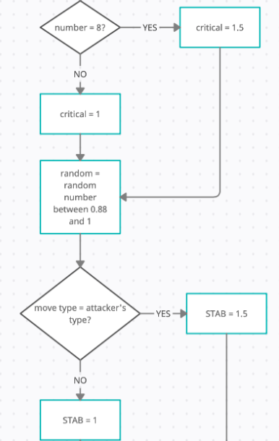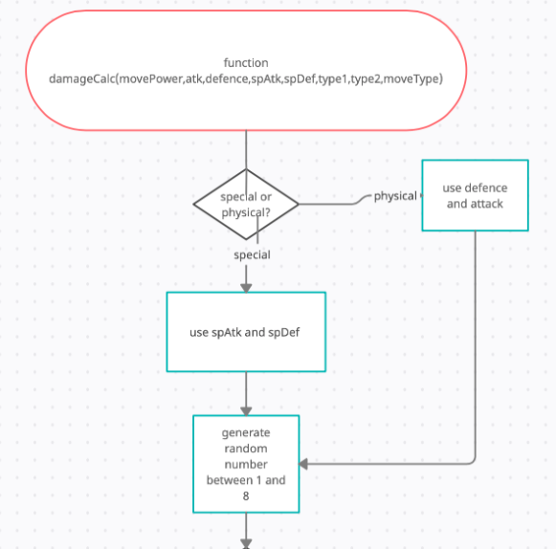

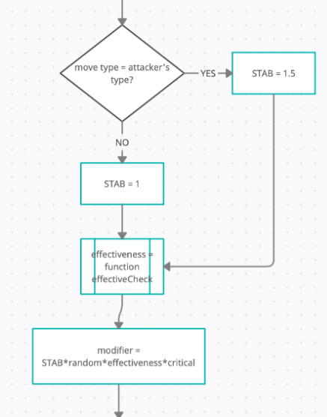

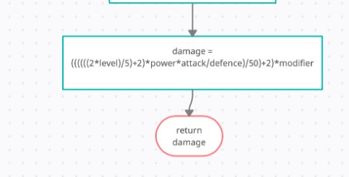

##### For calculating effectiveness multiplier

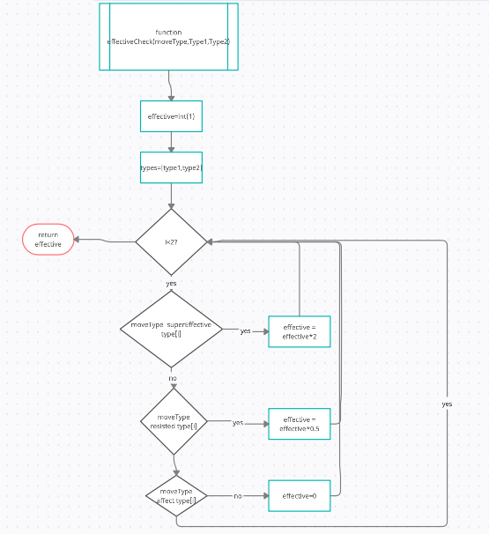

#### Table of variables

|  |  |  |  |
| --- | --- | --- | --- |
| **Variable Name** | **Data Type** | **Purpose** | **Validation** |
| moveType | String | To store the type of the move being used | No validation required, is an instantiated attribute. This is so the user cannot accidentally change the information, as their inputs have no effect on it whatsoever |
| movePower | Integer | To store the power of the move being used | No validation required, is an instantiated attribute. This is so the user cannot accidentally change the information, as their inputs have no effect on it whatsoever |
| Atk | Integer | To store the attack stat of the attacking Pokémon | No validation required, is an instantiated attribute. This is so the user cannot accidentally change the information, as their inputs have no effect on it whatsoever |
| spAtk | Integer | To store the special attack stat of the attacking Pokémon | No validation required, is an instantiated attribute. This is so the user cannot accidentally change the information, as their inputs have no effect on it whatsoever |
| Defence | Integer | To store the defence stat of the defending Pokémon | No validation required, is an instantiated attribute. This is so the user cannot accidentally change the information, as their inputs have no effect on it whatsoever |
| spDef | Integer | To store the special defence stat of the defending Pokémon | No validation required, is an instantiated attribute. This is so the user cannot accidentally change the information, as their inputs have no effect on it whatsoever |
| Type1 | String | To store the primary type of the defending Pokémon | No validation required, is an instantiated attribute. This is so the user cannot accidentally change the information, as their inputs have no effect on it whatsoever |
| Type2 | String | To store the secondary type of the defending Pokémon | No validation required, is an instantiated attribute. This is so the user cannot accidentally change the information, as their inputs have no effect on it whatsoever |
| Critical | Real | To store the critical hit multiplier | No validation required, is a value determined by a random number generator. The user cannot make an input at any time that changes this variable |
| Random | Real | To store the random damage multiplier | No validation is required, is a value generated by a random number generator. The user cannot make an input at any time that changes this variable |
| STAB | Real | To store the Same-Type-Attack-Bonus multiplier | No validation, is determined by the program and the program only – no user input required. The user cannot make an input at any time that changes this variable |
| Effectiveness | Real | To store the effectiveness multiplier | No validation, is determined by the program and the program only – no user input required. The user cannot make an input at any time that changes this variable |
| Modifier | Real | To store the overall damage multiplier | No validation, is determined by the program and the program only – no user input required. The user cannot make an input at any time that changes this variable |
| Damage | Integer | To store the damage being dealt to the opponent | No validation, is determined by the program and the program only – no user input required. The user cannot make an input at any time that changes this variable |

#### Pseudocode

Function damageCalc(movePower, atk, defence, spAtk, spDef, atkType1, atkType2, defType1, defType2, moveType)

IF move is physical THEN

use atk //so the physical stats are used in calc

use defence

ELSE THEN

use spAtk //so the special stats are used incalc

use spDef

endif

randNum=random number between 1 and 8

IF randNum == 8 THEN

critical = 1.5 //creates the 1/8 of boosting damaage

ELSE THEN

critical == 1

endif

randNum= random number between 0.88 and 1 //add variation

IF moveType == atkType1 or moveType == atkType2 THEN

STAB = 1.5 //add damage boost for same type attack bonus

ELSE THEN

STAB = 1 //not same type as attack, so no bonus

endif

effectiveness = effectiveCheck(moveType,defType1,defType2)

//^^for use in calculation

modifier=STAB*randNum*effectiveness*critical

//^^for use in calculation

damage = ((((((2*level)/5)+2)*power*attack/defence)/50)+2)*modifier

return damage //so can be inflicted against battler

endfunction

Function effectiveCheck(moveType,type1,type2) //create //effectiveness multiplier

effective=real(1) //base multiplier is 1

types=[type1,type2] //for use in for loop

for i = 0 to 1 /checks both

IF moveType super effective against type[i] THEN

effective=effective*2 //applies SE multiplier

ELSEIF moveType not very effective against type[i] THEN

effective=effective/2 //applies NFE multiplier

ELSEIF moveType doesn’t affect type[i] THEN

effective=0 //doesn’t affect, so no damage applied

endif

next i //increments i

return effective //to be used in damage calc

endfunction

* I feel as though having a separate function for effectiveCheck is necessary, as it helps split up the main damage calculation and generally makes code more efficient and less messy
* The reason I haven’t done this for finding if a move is physical or not or if it’s a critical hit or not is because it is determined by a single IF statement, whereas effectiveCheck has a FOR loop involved, so in my opinion it makes more sense to be separate
* However, I would not be opposed to perhaps splitting up the statements that determine the modifier variable in the future
* In addition I felt as though a FOR loop was more appropriate than a while or do… until loop simply because FOR loops are neater and require fewer lines of codes to perform the same task in this scenario. This makes the code more maintainable
* This helps form a complete solution, as damage needs to be inflicted on the user and the opponent in order for the game to be played; they can’t battle if they can’t damage each other. Therefore, this algorithm is required to form a complete solution to the game.

### Prototype 4

Prototype 4 will be completely covering success criterion 4, as well as its sub-criteria. This will probably be the hardest prototype to make but I am doing it at this stage because I want the AI to be able to make moves before I can code the easier part of the battle sequence (the user’s options). The AI will check a Pokémon’s four moves and see which one would do the most damage to a Pokémon, whilst also factoring in safety of the move (checking accuracy and depending on the health of the defending Pokémon will change move).

In practicality, this would be implemented as the AI dealing either

* The most damaging move or
* The highest-accuracy move that will cause the opposing Pokémon to faint
* If it can be made the faint in the next turn and the opposing Pokémon is faster than it, the AI will use a priority move if one is available

This is so the AI doesn’t make easily preventable errors, while still being beatable

#### Test Plan

|  |  |  |  |  |  |
| --- | --- | --- | --- | --- | --- |
| Test no. | Test Type | Testing Success Criteria… | Acceptable Input | Accepted Output | Justification |
|  | Normal | 4.1 | User sends out Arcanine vs Blastoise | Blastoise used Surf! | Surf is the most damaging  Move, and is therefore the one the AI should use. This is because the AI should use the best move in any given situation. This test is required to check that the AI does in fact use the best move in each situation |
|  | Normal | 4.1 | User Sends out Machamp vs Snorlax | Snorlax used Giga Impact! | Giga Impact is the most  Damaging move, and is therefore the one the AI should use. This is because the AI should use the best move in any given situation. This test is required to check that the AI does in fact use the best move in each situation |
|  | Erroneous | 4.1 | User sends out Mewtwo vs Pidgeot | Pidgeot used Quick Attack! | Mewtwo can out-speed and  Cause Pidgeot to faint in one  Turn. Therefore, the AI inflicts some more damage because it knows that if it uses a different move it won’t inflict any. This is a necessary test, because I need to ensure that the AI does the best move in any given situation. |
|  | Erroneous | 4.1 | User sends out Pidgeot vs Pikachu | Pikachu used Thunderbolt! | Volt Tackle is most damag-  ing, but can miss. Thunder-  bolt can OHKO and  never miss, and so the AI chooses thunderbolt to have the highest success of hitting the target. This test is necessary to ensure that the AI does the best move in each scenario |
|  | Normal | 4.2 | User Snorlax causes Pokémon to faint | Trainer Blue sent out Machamp | Machamp is the optimum  Choice against Snorlax because it can deal the most damage to it, and outspeed. This test is necessary, as we need to ensure that it also switches out the best Pokémon when the current battler is no longer able to battle. |

#### FlowChart

##### Main Procedure

##### Switch-In Procedure

#### Table of Variables

|  |  |  |  |
| --- | --- | --- | --- |
| **Variable Name** | **Data Type** | **Purpose** | **Validation** |
| moveDamages | List | To store the different damages for the four moves the Pokémon has | No validation required, created and edited without user input. |
| movePowers | List | To store the different powers of the four moves the Pokémon has | No validation required, created and edited without user input |
| faintMoves | 2D list | Store the power and accuracies of each move that does enough damage to cause the opponent to faint | No validation required, created and edited without user input |
| movepower1 | Integer | Stores the power of one move | No validation required, created and edited without user input |
| movepower2 | Integer | Stores the power of one move | No validation required, created and edited without user input |
| movepower3 | Integer | Stores the power of one move | No validation required, created and edited without user input |
| movepower4 | Integer | Stores the power of one move | No validation required, created and edited without user input |
| moveaccuracy1 | Real | Stores the accuracy of one move | No validation required, created and edited without user input |
| moveaccuracy2 | Real | Stores the accuracy of one move | No validation required, created and edited without user input |
| moveaccuracy3 | Real | Stores the accuracy of one move | No validation required, created and edited without user input |
| moveaccuracy4 | Real | Stores the accuracy of one move | No validation required, created and edited without user input |
| fainted | Boolean | Says whether the current Pokémon is fainted | No validation required, created and edited without user input |
| moveType | String | To store the type of the move being used | No validation required, is an instantiated attribute |
| atk | Integer | To store the attack stat of the attacking Pokémon | No validation required, is an instantiated attribute |
| spAtk | Integer | To store the special attack stat of the attacking Pokémon | No validation required, is an instantiated attribute |
| Defence | Integer | To store the defence stat of the defending Pokémon | No validation required, is an instantiated attribute |
| spDef | Integer | To store the special defence stat of the defending Pokémon | No validation required, is an instantiated attribute |
| Type1 | String | To store the primary type of the defending Pokémon | No validation required, is an instantiated attribute |
| Type2 | String | To store the secondary type of the defending Pokémon | No validation required, is an instantiated attribute |
| empty | Boolean | To check if faintMoves is empty or not | No validation required, is created and edited solely by the program without user input |
| hp | Integer | To store the hp of the user’s Pokémon | No validation required, is an instantiated attribute |
| maxDamage | Integer | To store the value of the index of the list[moveNames] the move that does the most damage is in | No validation required, is created and edited without user input |
| maxAcc | Integer | To store the value of the index of the list[moveNames] the move that has the highest accuracy is in | No validation required, is created and edited without user input |
| Trainer | String | Stores which trainer the AI is | See prototype 1 |

#### Pseudocode

Function AI (movename1,movename2,movename3,movename4,movepower1,movepower2,movepower3,movepower4,moveaccuracy1,moveaccuracy2,moveaccuracy3,moveaccuracy4,fainted,atk,defence,spAtk,spDef,type1,type2,moveType,hp)

IF fainted == True THEN //needs to switch out current battler

procedure switch() //if they have no health left

endif

moveNames=array[movename1,movename2, movename3, movename4]

moveDamages=list[]

movePowers=array[movepower1,movepower2,movepower3,movepower4]

moveAccuracies=array[moveaccuracy1,moveaccuracy2,moveaccuracy3,moveaccuracy4]

faintMoves=[[][],[][],[][],[][]]

FOR i = 0 to 3

moveDamages[i] = damageCalc(movePowers[i],atk,defence,spAtk,spDef,type1,type2,moveType)

IF moveDamages[i] >= hp THEN

faintMoves[i][0] = moveNames[I]

faintMoves[i][1] = moveAccuracies[i]

endif

next i

empty=True

FOR x = 0 to 3

IF faintMoves[x][0] <> “ “ THEN

empty=False

next x

IF empty == False THEN

IF ‘quick attack’ in faintMoves THEN

use quick attack

ELSE THEN

maxAcc=0

FOR x = 0 to 3

IF faintMoves[x][1] > maxAcc THEN

maxAcc=x

endif

next x

use faintMoves[maxAcc][0]

endif

ELSE THEN

maxDamage=0

FOR x = 0 to 3

IF moveDamages[x] > maxDamage

maxDamage=x

endif

next x

use moveNames[maxDamage]

endif

endfunction

Procedure switch(hp,atk,defence,spAtk,spDef,type1,type2,trainer)

IF (damageCalc(40,atk,defence,spAtk,spDef,type1,type2,normal,trainer)) > hp THEN

IF Pokemon that knows quick attack <> fainted THEN

send out a Pokemon that knows quick attack

ELSE THEN

send out Pokemon that does most damage

ELSE THEN

send out Pokemon that does most damage

endprocedure

* I decided that two subroutines was more appropriate than just one as the algorithm for deciding who to switch in was going to be used up to 10 times and thought it better to isolate it
* I decided to make moveAccuracies, moveNames and movePowers arrays as they act as static data structures. Of course, python doesn’t have arrays but I thought I should make it clear they will behave in the actual program
* I made faintMoves a 2D list as I need to check what the moves are called and how accurate they are and I found out this would be easier in a 2D list rather than 2 separate lists
* I prioritise checking if ‘quick attack’ does enough damage to faint as it will always out-speed the opponent (unless the opponent is quicker and also uses quick attack) and so would be the optimum move for the AI that does fall under the standard move-selection operation.
* I used the Boolean variable empty as a way of checking if there are any moves that can cause the opponent to faint.
* This helps form a complete solution, as the game requires an AI for the user to fight against. If there was no opponent, the user wouldn’t be able to battle anyone and therefore the game wouldn’t be able to be played. Therefore, the above algorithm is required to form a complete solution to the problem.

### Prototype 5

This prototype completely covers Success Criterion 8 and its subsequent sub-criteria. This is where the bulk of the user’s input in the game is coded; allowing the user to choose a move, switch out their battler, or (when on easy mode) choose and apply an item from the bag. With this prototype complete, this project will be a fully-operational text-based Pokémon battle simulator. However, there are further prototypes to add complexity.

#### Test Plan

|  |  |  |  |  |  |
| --- | --- | --- | --- | --- | --- |
| Test no. | Test Type | Testing Success Criteria… | Acceptable Input | Accepted Output | Justification |
|  | Normal | 8.1 | Select bag on easy mode | The contents of the bag should pop up, allowing the user to select an item to apply | The bag is available on easy  mode, and so the user needs to be able to access it. This test ensures that this is possible. |
|  | Erroneous | 8.1 | Select bag on medium or hard mode | The program should output “this action is not available in this mode” and not allow the user to apply an item | The bag is not available on  medium or hard mode, and so this test ensures that this is the case |
|  | Normal | 8.2 | At the beginning of the user’s turn, the user clicks ‘Pokémon’ | The program should ask the user which Pokémon they want to switch in. | To show the user which  Pokémon they have available so that they can switch to one. This test is necessary to ensure that the user can in fact switch Pokémon |
|  | Normal | 8.2 | The user should pick a non-fainted Pokémon after clicking ‘Pokémon’ at the beginning of their turn | The Pokémon the user currently has out should switch with the one that was just selected | A fainted Pokémon can no longer fight. This means that it must be switched out for a different Pokémon. This test ensures that the game forces the user to switch to a new Pokémon in order to progress |
|  | Erroneous | 8.2 | The user should pick a fainted Pokémon after clicking ‘Pokémon’ at the beginning of their turn | The program should output “this battler has no energy left to battle” and not let that Pokémon be sent out. | The user cannot use a  fainted Pokémon in battle, as this goes against the very fundamental rules of the game. This test is in place to ensure these rules cannot be broken, and therefore that the user cannot fight with a fainted Pokémon. |
|  | Normal | 8.3 | The user should select ‘fight’ at the beginning of their turn | The program should output the current battler’s four moves, and await an input | Show the user what moves  they have at their disposal so they can make an informed decision of what to do this turn. This test is necessary as the user needs to be able to always make well-informed decisions throughout the game. |
|  | Normal | 8.3 | The user should input one of the four moves and selecting ‘fight’ | The program should say which move the user used, how much damage it did, and how much HP the opponent has left, whether it was a critical hit, and if it was non-affecting, super-effective, or ineffective. | This is so the user can make more informed judgements about their next move, and also see what effect the move they just used did to reaffirm their belief that they made the right decision or not. This test is necessary, as the user needs to be able to make informed judgements throughout the game |
|  | Erroneous | 8.3 | After selecting ‘fight’, input a move that isn’t one of the four available moves | The program should NOT use a move, and tell the user to enter a valid move, and loop. | The user can’t use a move  that the battler doesn’t  possess. This would go against the very fundamental rules of the game, and therefore this test is required to ensure these fundamental rules do not get broken |
|  | Normal | 8.4 | AI KOs user’s battler | The user’s available Pokémon pop up to allow the user to switch in a new Pokémon | The user cannot use a  fainted battler, as this defeats the purpose of fighting against each other; if a defeated battler can keep battling, then what’s the point in defeating them? Therefore, this test is necessary to ensure that once a battler has been defeated, they cannot battle unless healed. |

#### Flowchart

##### Main function

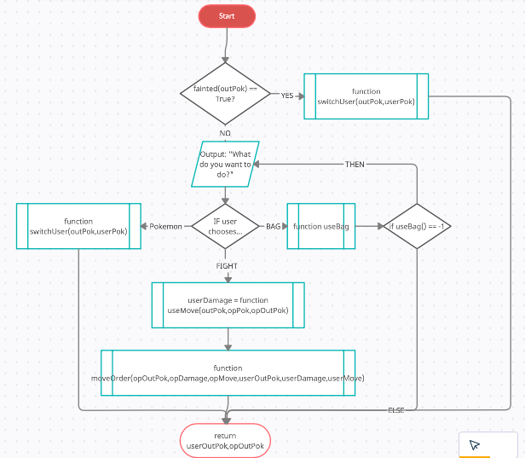

##### Bag function

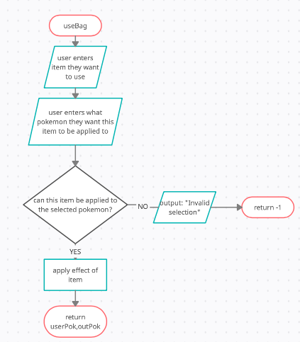

##### Switch function

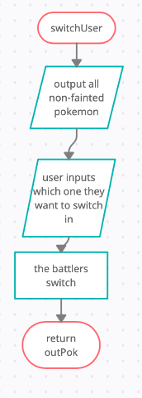

##### Battle function

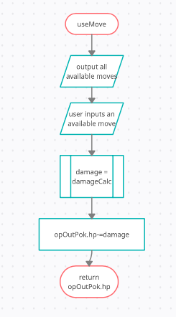

##### Move Ordering function

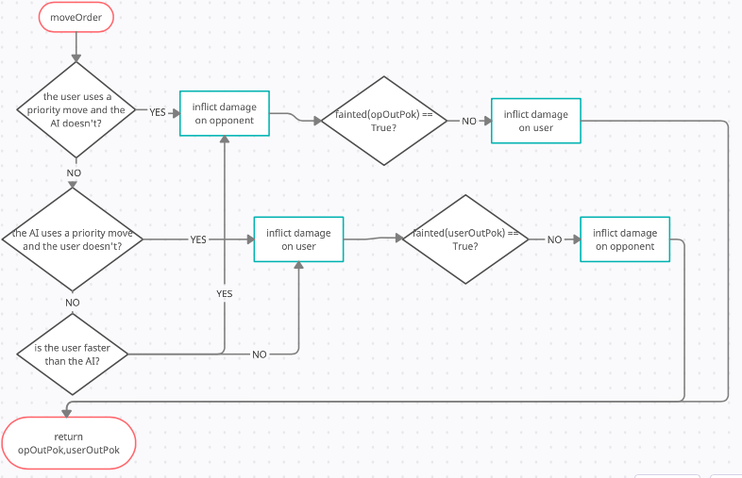

#### Table Of Variables

|  |  |  |  |
| --- | --- | --- | --- |
| **Variable Name** | **Data Type** | **Purpose** | **Validation** |
| opOutPok | Object | To store all information about the opponent’s current battler | None required, all process involving this object are performed by the program and so the user cannot make an input to be validated |
| userOutPok | Object | To store all information about the user’s current battler | The game loops if the user tries to make their current battler a fainted Pokémon and asks them to re-enter. This is required because otherwise the user would have no battler and would therefore not be able to continue in the game |
| userMove | String | To store the name of the user’s move being used | Must be one of the available moves; will loop until an available move is chosen. This is required to allow the user to progress with the game. |
| possibleMoves | Array | Store all of the user’s possible moves | None required; the user cannot make an input regarding this variable, and so there is nothing to be validated |
| userDamage | Integer | Store the damage the user is inflicting | None required; the user cannot make an input regarding this variable, and so there is nothing to be validated |
| opDamage | Integer | Store the damage the opponent is inflicting | None required; the user cannot make an input regarding this variable, and so there is nothing to be validated |
| opMove | String | Stores the name of the move the opponent is using | None required; the user cannot make an input regarding this variable, and so there is nothing to be validated |
| apply | Boolean | Stores True if the item can be applied, else stores false | None required; the user cannot make an input regarding this variable, and so there is nothing to be validated |
| possibleItems | Array | Stores all of the available items | None required; the user cannot make an input regarding this variable, and so there is nothing to be validated |
| applyTo | String | Name of Pokémon having the item applied to | None required; the user cannot make an input regarding this variable, and so there is nothing to be validated |
| userOutPok.hp | Integer | Stores the health of the user’s current batter | Cannot battle if below 1, cannot be healed by a healing item if at max HP. This is necessary to prevent invalid items being applied or invalid switches from occuring |
| itemChosen | String | Stores the name of the item being used | None required; the user cannot make an input regarding this variable, and so there is nothing to be validated |
| maxHP | Integer | The max health of the Pokémon that is having the item applied to | None required; the user cannot make an input regarding this variable, and so there is nothing to be validated |

### Pseudocode

#### Function User

Function user(userPok,userOutPok,opOutPok,opDamage,opMove)

IF fainted(userOutPok)==True THEN

userOutPok = function switchUser(userOutPok,userPok)

ELSE THEN

flag=-1

WHILE flag == -1 THEN

choice=input(“What do you want to do?”)

WHILE choice.lower() <> ‘bag’ or choice.lower() <> ‘fight’ or choice.lower() <> ‘pokemon’ THEN

choice=input(“Please enter a valid input: bag, fight, or pokemon”)

endwhile

IF choice.lower() == fight THEN

possibleMoves=2D array storing move names, accuracies, powers, types and physicalities

userMove=input(‘Which move will you choose?”)

WHILE userMove not in possibleMoves[0] THEN

userMove=input(“Please enter a valid move”)

endwhile

userDamage=function(useMove(userOutPok,opPok,opOutPok)

moveOrder(opOutPok,opDamage,opMove,userOutPok,userDamage,userMove)

ELSEIF choice.lower() == bag THEN

flag,userPok = useBag(userPok)

ELSE THEN

userOutPok=switchUser(outPok,userPok)

ENDIF

ENDWHILE

ENDIF

return userOutPok,opOutPok

ENDFUNCTION

* Forces the user to switch to a new battler if their current one has fainted
* Uses a flag variable to keep the game looping until a valid input has been detected
* All inputs are set to lower case to ensure no valid inputs are incorrectly rejected
* The users’ current battler and the opponent’s current battler are returned to the main while loop to ensure the stats of both battlers are updated.
* This helps form a complete solution by giving the user a choice to either fight the opponent, use the bag or switch to a new Pokémon. This is essential to the game, as otherwise the user wouldn’t be able to actually have a say in the game they would supposedly be playing. Therefore, this algorithm is required to form a complete solution to the problem.

*The need for validation as seen in this pseudocode does later become invalid upon the creation of the final prototype, where everything is click-based and so the only valid inputs are the ones available. However, at this stage of the game, the user’s inputs are limitless and so the while loops are a necessary implementation.*

#### Function useBag

Function useBag(userPok)

names=names of all of users pokemon

print(“You can use one of these items:”,possibleItems)

itemChosen=input(“Enter which item you want to use”)

applyTo=input(“Which battler are you applying this item too?”)

IF itemChosen not in possibleItems or applyTo not in names or applyTo.hp == 0 or applyTo.hp == maxHP THEN

return -1,userPok

ELSE

apply effect of item

return 0,userPok

ENDIF

ENDFUNCTION

* This allows the user to apply an item to any Pokémon in their team, given that they fit the conditions to have the item applied to them
* The items are output so the user can see what is available and input their decision
* The game loops if the user enters an invalid item or Pokémon, otherwise the item is applied
* This helps form a complete solution by allowing the user to choose and apply an item, which was outlined as very important in the success criteria. Hence, this algorithm is required to form a complete solution to the problem

#### Function switchUser

Function switchUser(outPok,userPok)

unfainted=all unfainted Pokemon

switch=input(“Enter which pokemon you want to switch in”)

WHILE switch not in unfainted THEN

switch=input(“Enter a valid pokemon”)

ENDWHILE

outPok=switch

return outPok

ENDFUNCTION

* This function is required to allow the user to switch in a Pokémon during their turn, or to forcefully switch in a new Pokémon if their current battler has fainted
* This helps forms a complete solution as the game would not be able to progress once the user had lost a Pokémon. This would be very boring, and very difficult, as it would be a 1v6 in the AI’s favour. Furthermore, the ability to be able to switch in a more suitable Pokémon was outlined in the success criteria as very important, and hence the above algorithm is required to form a complete solution to the problem.

*Once again, validation is required so as to not crash the program. This function works for when the user’s current battler has fainted and needs to be switched in, and when the user wants to change their current (healthy) battler, for another.*

#### Function useMove

Function useMove(userOutPok,opPok,opOutPok)

userDamage=damageCalc(opOutPok,userOutPok,userMove)

return userDamage

ENDFUNCTION

* The function returns the damage the user is inflicting upon the opponent to be used in damage calculation
* This algorithm is required to form a complete solution, as the damage needs to be calculated and applied to the opponent in order for the game to actually be a better game.

*I changed it from the flowchart as I realised it made more sense to just isolate this aspect of the program to keep it simpler, as the rest of the program made sense being the in User function*

#### Function moveOrder

Function moveOrder(opOutPok,opDamage,opMove,userOutPok,userDamage,userMove)

IF ((userMove == ‘Quick Attack’ or userMove == ‘Extreme Speed’) AND (opMove <> ‘Quick Attack’ AND opMove<> ‘Extreme Speed’ )) OR (userOutPok.spd > opOutPok.spd) THEN

opOutok.hp-=userDamage

IF fainted(opOutPok) == False THEN

userOutPok.hp-=opDamage

ENDIF

ELSE THEN

userOutPok.hp-=opDamage

IF fainted(userOutPok) == False THEN

opOutPok-=userDamage

ENDIF

ENDIF

return opOutPok,userOutPok

ENDFUNCTION

* This function decides which order the Pokémon attack in, and has the actual infliction of the damage upon the user and the opponent
* Fainted Pokémon cannot attack, and hence the above IF statements were added in
* This algorithm is required to form a complete solution, as the game needs to decide which order the Pokémon attack in, as either one team will always go first or the other will, which would be extremely unfair

*This just ensures that the faster Pokémon, or the Pokémon using a priority move, goes first. If both Pokémon use a priority move, then the faster Pokémon will move first.*

### Prototype 6

Prototype 6 will completely cover success criterion 7, which allows the game to end. It will check if all 6 Pokémon from either side have fainted, displaying a celebratory message if the user wins and a defeat message if the AI wins. This allows a fully complete text-based game, but of course I am set to add two more prototypes after this to increase complexity. I have realised that there is no possible way for both the AI and the user to have all their Pokémon faint, so there is no need to test if that works or not.

#### Test Plan

|  |  |  |  |  |  |
| --- | --- | --- | --- | --- | --- |
| Test no. | Test Type | Testing Success Criteria… | Acceptable Input | Accepted Output | Justification for needing test |
|  | Standard | 7.1 | User faints all AI’s Pokémon | Congratulations! You have bested the opponent. Come back soon! | To ensure an appropriate message is sent, confirming whether the user won or lost the battle, creating an appropriate ending to the game |
|  | Standard | 7.2 | User loses to AI | Unlucky! This time, the opponent has beaten you, but come back and show them what you’re really made of! | To tell the user that they lost the battle, and to create an appropriate ending for the game. |
|  | Standard | 7 | One side loses | “Game Over” // *this is then followed by the appropriate message from one of the above tests* | To start the game ending process. This informs the user that the battle is completed. Without this test, the game would either crash, or the battle scene would just be frozen on the screen. |

#### Flowchart

##### Diagram Description automatically generatedmain Procedure

##### Diagram Description automatically generatedFaint-checking and game-ending procedures

#### Table of Variables

|  |  |  |  |
| --- | --- | --- | --- |
| **Variable Name** | **Data Type** | **Purpose** | **Validation** |
| opPok | Array | To store the objects of all the AI’s Pokémon | No validation needed; the array is created without user input so there is place where validating the variable can occur |
| userPok | Array | To store the objects of all the user’s Pokémon | No validation needed the array is created without user input |
| userFaintCount | Integer | To count how many of the user’s Pokémon have fainted | No validation needed as the creation and editing of the variable is done without user input so there is place where validating the variable can occur |
| opFaintCount | Integer | To count how many of the AI’s Pokémon have fainted | No validation needed as the creation and editing of the variable is done without user input so there is place where validating the variable can occur |
| x | Integer | Used as an index for a for loop | None needed, generated and incremented using for loop so there is place where validating the variable can occur |
| Pok | Object | To check if either the AI’s or user Pokémon in that slot has fainted in the fainted() function | None needed, instantiated at beginning of game so there is place where validating the variable can occur |
| hp | Attribute | To check if the User’s or AI’s Pokémon is below or equal to 0, in which case they’ve fainted | None needed, included in instantiated at start of game and edited solely by the program so there is place where validating the variable can occur |
| User | Integer | To see if the user won or lost | No validation needed as the creation and editing of the variable is done without user input so there is place where validating the variable can occur |

#### Pseudocode

Function fainted(Pokemon)

IF pok.hp <= 0 THEN

return True

ELSE

return False

Endfunction

Procedure gameOver(user)

IF user == 6 THEN

print(“Unlucky! This time, the opponent has beaten you,”)

print(“but come back again and show them what you’re really made of!”)

ELSE THEN

print(“Congratulations! You have bested the opponent.”)

print(“Come back soon!”)

pass

endprocedure

Procedure endCheck(opPok,userPok)

opFaintCount=int(0)

userFaintCount=int(0)

for x = 0 to 5

IF fainted(opPok[x])==True THEN

opFaintCount+=1

IF fainted(userpok[x])==True THEN

userFaintCount+=1

next x

IF opFaintCount==6 or userFaintCount ==6 THEN

gameOver(userFaintCount)

endprocedure

* I decided to split this prototype up into 3 subroutines as the *endCheck* procedure would be the main one, making use of the other two. I prefer having *fainted* as a function rather than inputting a further IF/ELSE statement as I may decide to use *fainted* in other subroutines upon later development
* I also decided that the IF/ELSE statement determining who won the game should be in the gameOver procedure instead of within the endCheck procedure just as a way of increasing coherency
* This helps form a complete solution, because with no ending no game is complete. Furthermore, without these algorithms, the program would either crash or freeze, neither of which are desirable outcomes. Hence, these algorithms are required in order to form a complete solution.

### Prototype 7

Prototype 7 completely covers success criterion 5 and its sub-criteria, as well as partially covering success criterion 8 as difficulty setting implement certain restrictions on the user. In addition, it will affect success criterion 1 as each difficulty will have the Pokémon at different levels, thus influencing the Pokémon’s states. This is because the base game has been completed, and now additional complexity is able to be implemented. Giving the user an opportunity to choose easier or harder modes is essential in drawing in a greater audience; allowing the more experienced users to be challenged, while also allowing the new or casual players to develop their skills. This is the final part of the text-based version of the game.

#### Test Plan

|  |  |  |  |  |  |
| --- | --- | --- | --- | --- | --- |
| Test no. | Test Type | Testing Success Criteria… | Acceptable Input | Accepted Output | Justifying need for test |
|  | Normal | 5.1 | One of:  ‘Easy’  ‘Medium’  ‘Hard’ | With respect to input:  ‘You have chosen easy’  ‘You have chosen medium’  ‘You have chosen hard’ | To ensure that the correct difficulty is set upon input. This is necessary because otherwise the user will not get the playing experience they requested |
|  | Erroneous | 5.1 | ‘difficult’ | ‘Select a valid difficulty’ and asks the user again | To ensure that a difficulty is set; if I allow an invalid input the game would try to run without a difficulty setting and would therefore crash |
|  | Normal | 5.2.1 | ‘bag’ | Opens the bag so the user can choose items | This ensures that the bag can be used. This is necessary, as without the bag the user’s options are very limited, making an incomplete game |
|  | Normal | 5.2.1 | ‘bag’ then ‘max potion then ‘gyarados’ | Opens the bag and applies a full restore item to gyarados, which gets it back to full health | This test is required to ensure that items are correctly applied. Otherwise, the user may be put at a disadvantage or advantage when they shouldn’t have |
|  | Erroneous | 5.2.1 | ‘bag’ then ‘rare candy’ | Rare candy is an item that will not be in this game. The program will tell the user to select an available item. This test will become obsolete once the GUI is created in the next prototype | This test is required to ensure that only valid items are accepted as inputs. This item doesn’t exist and therefore cannot be applied, and so the test is required to ensure that it isn’t. |
|  | Normal | 5.2.2 and 5.3.2 | Fainting the opponent’s Machamp with mewtwo | ‘The opposition is going to send out []. Do you want to switch your Pokémon?” where [] is the Pokémon to be sent out | This test is required to ensure that on medium or hard difficulty the user gets a warning and opportunity to switch out their Pokémon. This is needed because otherwise the difficulties may not be working as intended. |
|  | Normal | 5.2.3 | None required | All user Pokémon level 100, all AI Pokémon level 75 | This test is required to ensure that the user has the advantage that easy mode should give them |
|  | Erroneous | 5.3.2 and 5.4.1 | ‘bag’ | ‘You are not permitted to use this function in this mode’ | This test is required to ensure that the bag is not available to the user on medium or hard mode. |
|  | Normal | 5.3.3 | None required | All user Pokémon level 100, all AI also level 100 | This test is required to ensure that the battlers are on an even playing field, given that its medium difficulty |
|  | Normal | 5.4.2 | Fainting the opponent’s Pokémon | ‘Trainer % sends out *’ where % is the opposing trainer and * is the Pokémon being sent out | This is to ensure that on hard mode, the user is unable to get a warning of what opposition battler they are facing next. This was outlined in the success criteria. |
|  | Normal | 5.4.3 | None required | All user Pokémon level 90, all AI Pokémon level 100 | Condition of hard mode as outlined in success criteria. This test is needed to ensure that hard mode is in-keeping with it’s original design. |

#### Flowchart

The main effect of this prototype is changing other modules of the program. The only new module being created is the following:

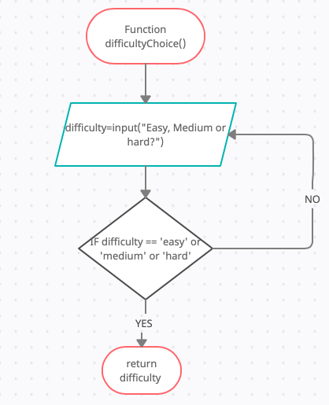

I will not include the updated flowcharts for every altered prototype, but the following pseudocode section will contain all altered.

#### Table of variables

This contains only variables changed, or added, by this prototype; all others serve the same purpose as they did in the previous prototypes

|  |  |  |  |
| --- | --- | --- | --- |
| **Variable Name** | **Data Type** | **Purpose** | **Validation** |
| difficulty | String | To store the user’s difficulty | Repeatedly asks user until they enter either easy, medium or hard. This is required, because if an invalid input is not validated, the game would either crash or randomly assign the user a difficulty. This would not be a desirable outcome, and so validation has been implemented. |

#### Pseudocode

##### Selecting Difficulty

Function difficultyChoice()

do

difficulty=input(“Easy, medium or hard?”)

until difficulty.lower() == ‘easy’ or difficulty.lower() == ‘medium’ or difficulty.lower() == ‘hard’

return difficulty

endfunction

##### Implementing difficulty to other modules where necessary

Function AI (movename1,movename2,movename3,movename4,movepower1,movepower2,movepower3,movepower4,moveaccuracy1,moveaccuracy2,moveaccuracy3,moveaccuracy4,fainted,atk,defence,spAtk,spDef,type1,type2,moveType,hp)

IF fainted == True THEN

procedure switch()

endif

moveNames=array[movename1,movename2, movename3, movename4]

moveDamages=list[]

movePowers=array[movepower1,movepower2,movepower3,movepower4]

moveAccuracies=array[moveaccuracy1,moveaccuracy2,moveaccuracy3,moveaccuracy4]

faintMoves=[[][],[][],[][],[][]]

FOR i = 0 to 3

moveDamages[i] = damageCalc(movePowers[i],atk,defence,spAtk,spDef,type1,type2,moveType)

IF moveDamages[i] >= hp THEN

faintMoves[i][0] = moveNames[I]

faintMoves[i][1] = moveAccuracies[i]

endif

next i

empty=True

FOR x = 0 to 3

IF faintMoves[x][0] <> “ “ THEN

empty=False

next x

IF empty == False THEN

IF ‘quick attack’ in faintMoves THEN

use quick attack

ELSE THEN

maxAcc=0

FOR x = 0 to 3

IF faintMoves[x][1] > maxAcc THEN

maxAcc=x

endif

next x

use faintMoves[maxAcc][0]

endif

ELSE THEN

maxDamage=0

FOR x = 0 to 3

IF moveDamages[x] > maxDamage

maxDamage=x

endif

next x

use moveNames[maxDamage]

endif

endfunction

Procedure switch(hp,atk,defence,spAtk,spDef,type1,type2,trainer,difficulty)

IF (damageCalc(40,atk,defence,spAtk,spDef,type1,type2,normal,trainer)) > hp THEN

IF Pokemon that knows quick attack <> fainted THEN

send out a Pokemon that knows quick attack

ELSE THEN

send out Pokemon that does most damage

ELSE THEN

send out Pokemon that does most damage

IF difficulty==’easy’ or difficulty==’medium’ THEN

Output the Pokémon being sent out

Endprocedure

* The highlighted code is the only new addition
* This is because the rest of the module is independent of difficulty as the AI is of the same intelligence no matter the difficulty; the variations only occur in levels, accessibility of the bag and the ability to see which Pokémon is being sent out by the opponent
  + Hence why there is no condition for hard mode
* The only other implementation at this time takes place when instantiating the Pokémon, setting the level to either 75, 100, or 90 depending on the difficulty and the team the Pokémon are on. This will be implemented as so:

IF trainer==’red’ THEN

IF difficulty==’easy’ or difficulty==’medium’ THEN

getLevel=100

ELSE THEN

getLevel=90

ELSE THEN

IF difficulty==’easy’ THEN

getLevel=75

ELSE THEN

getLevel=100

This will run before the objects are instantiated

* While this prototype is optional, it still helps form a complete solution to the game. This provides an opportunity for the user to make the game more suited to their needs or desires, and consequently improves playing experience. Therefore, the above algorithms help form a complete solution to the problem.

### Prototype 8

This is the largest prototype in this project, as this is where all of the graphics are implemented. Consequently, this is where the program changes from type-based inputs to click-based inputs. This prototype should completely meet success criterion 3 and all its sub-criteria, as well as partially meeting success criteria 6 and 7, where the trainers will be displayed with the Pokémon sprites rather than their printed-out names, and the winning and losing message will be output into the pygame window. After this prototype, the game should be finished, though I will likely have more additions upon completion in order to create a game I will be fully satisfied with. This is why there are some parts of previous prototypes that could require validation but have none implemented – erroneous user inputs are not possible in click-based games, as the only possible inputs are the valid ones. There will be no table of variables as all variables used in this prototype are from other prototype; this is simply just the addition of graphics. All validation for these variables will be the same as originally mentioned.

#### Test Plan

|  |  |  |  |  |  |
| --- | --- | --- | --- | --- | --- |
| Test no. | Test Type | Testing Success Criteria… | Acceptable Input | Accepted Output | Justifying need for test |
|  | Normal | 3.1 | Running the program | All Pokémon should be displayed alongside their associated trainer | So the user can clearly see which Pokémon belong to which trainer, ensuring they are able to make an informed decision |
|  | Normal | 3.2 | Selecting trainer, which consequently starts the battle sequence | HP bars in top right and bottom left corners, narrative box at the bottom, Pokémon level in the HP box and sex of Pokémon alongside | This test is required as the game needs to be able to start. The narrative box and information box are required to help prompt the user into making a decision and allow the user to make informed decisions throughout their playtime. |
|  | Normal | 3.3 | Selecting trainer, which consequently starts the battle sequence | The background | This test is required to ensure that the scene is set for the user to tell that this  is definitely a battle |
|  | Normal | 3.4 | Selecting trainer and clicking ‘FIGHT’ | The Pokémon’s moves | This test is required to ensure that the user can definitely attack the opponent. If the user cannot see their moves, they can’t participate in the game. Therefore, this test is necessary. |
|  | Normal | 3.5 | Any move | A small explosion on the opposing Pokémon | The functionality is optional, but if implemented, the test is required to ensure the animations are working as intended. |
|  | Erroneous | 3.5 | Choosing an item from the bag in easy mode | No animation | The functionality is optional, but if implemented, the test is required to ensure the animations are working as intended. |
|  | Erroneous | 3.5 | Switching out a Pokémon | No animation, Pokémon out is replaced | The functionality is optional, but if implemented, the test is required to ensure the animations are working as intended. |
|  | Normal | 3.6 | Any move that affects the target | The HP bar visibly decreases for the afflicted Pokémon | This is so the user can make informed decisions; once damage is inflicted, the health of the afflicted Pokémon changes. This needs to be displayed so the user can modify their strategy accordingly. |
|  | Normal | 3.6 | Select either bag, switch Pokémon or a move that doesn’t cause opponent to faint | HP bar of user’s Pokémon decreases | This is because even when the user doesn’t attack the opponent, the opponent can still attack them. This test is required to ensure that this definitely happens |
|  | Normal | 3.7 | A move that causes opponent Pokémon to faint | Pokémon falls over, showing it has fainted  HP bar goes empty | The functionality is optional, but if implemented, the test is required to ensure the animations are working as intended. |
|  | Normal | 3.7 | Allows AI to faint user Pokémon | Pokémon falls over, showing it has fainted  HP bar goes empty | The functionality is optional, but if implemented, the test is required to ensure the animations are working as intended. |
|  | Normal | 3.8 | Chooses to send out a Pokémon | Pokémon appears small, grows in size | The functionality is optional, but if implemented, the test is required to ensure the animations are working as intended. |
|  | Normal | 3.9 | Chooses to switch a Pokémon out | Pokémon shrinks, before disappearing. | The functionality is optional, but if implemented, the test is required to ensure the animations are working as intended. |
|  | Normal | 3.10 | Use psystrike against Arcanine | ‘Mewtwo used psystrike’  ‘it did *x* damage’ | This is required to ensure that the user can clearly see what move they chose and how much damage it did, helping confirm whether they made the right choice or not for future reference in the game. |
|  | Normal | 3.10 | Use giga impact until it misses | ‘The attack missed…” | This test is required to ensure that moves that aren’t 100% accurate CAN miss, as this is the purpose of the accuracy attributes.  In these scenarios, no damage is inflicted upon the opponent. |
|  | Normal | 3.11 | Use any move that has an effect on the opponent | The HP bar should decrease, and the numerical value of the HP should as well | The HP bar needs to change when Pokémon have damage inflicted to display that they have in fact received the damage. Otherwise, the user could be unsure whether their attack even connected. |

#### Flowchart

##### trainerSelect()

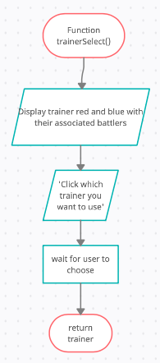

##### switch()

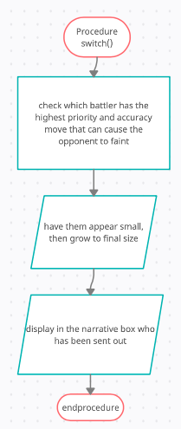

##### endCheck()

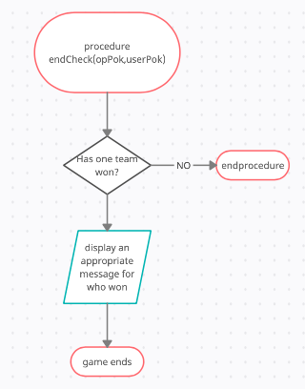

##### difficultyCheck()

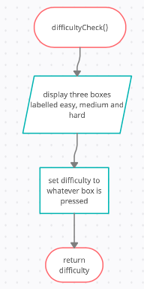

##### Finished Program Flowchart

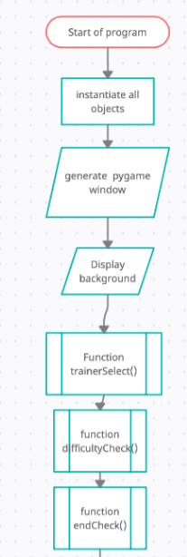

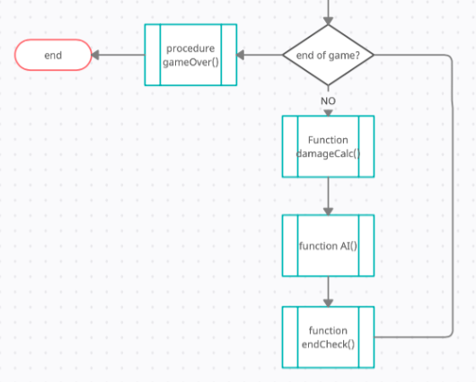

All the parameters for the subroutines in this flowchart are the same as when they were referenced in their respective prototypes. Subroutines that are called within other subroutines have been unincluded but are obviously in use as they are called within included subroutines. This simply shows the logic and path of the program, not any of the functionality as that has all been covered in the prototypes’ flowcharts.

#### Pseudocode

##### Function trainerSelect

Function trainerSelect()

display trainer red and blue with their associated Pokemon

output onto screen: “Click which trainer you want to use”)

trainer=input() //input being the clicked trainer

return trainer

endfunction

##### Procedure switch

Procedure switch(hp,atk,defence,spAtk,spDef,type1,type2,trainer)

IF (damageCalc(40,atk,defence,spAtk,spDef,type1,type2,normal,trainer)) > hp THEN

IF Pokemon that knows quick attack <> fainted THEN

send out a Pokemon that knows quick attack

display Pokemon starting small then grow

ELSE THEN

send out Pokemon that does most damage

display Pokemon starting small then grow

ELSE THEN

send out Pokemon that does most damage

display Pokemon starting small then grow

endprocedure

##### Procedure endCheck

Pseudocode remains the same as when written in prototype 5

##### Function difficultyChoice

Function difficultyChoice()

output ‘easy’, ‘medium’ and ‘hard’ onto the window

difficulty=input() // input is a click

return difficulty

endfunction

##### Main Program

Define Pokemon class and instantiate all objects

Create pygame window

Display background

end=False

trainer = Function trainerSelect()

difficulty = Function difficultyCheck()

while end==False

function damageCalc()

function AI()

end=function endCheck()

gameOver()

* These algorithms still following the logic from their text-based counterparts, with the only difference being that the outputs are displayed graphically on a window
* These algorithms are required to form a complete solution, because I outlined that adding graphics to game was essential in the success criteria and as did my stakeholders and graphic advisors in their interviews. Hence, the above algorithms are required to form a complete solution to the problem.

## Summary of design section

I will be using object-oriented and procedural programming as they suit the project best. All required tests have been outlined in test plans within prototypes and at the beginning of this section. If all these tests meet produce the pre-stated expected outputs then the project is exactly as intended. During the development section, I may realise some parts of code I had previously planned actually need to change, or have some content missing which need to be added in order to produce a functioning project that meets the success criteria. Overall, I believe this design section has created a great plan for my project, which I shall now start developing.

## Stakeholder Interview

Before I start the development section, I think it’s best that I ask my stakeholders what their thoughts are on the overall design for the project.

1. **Do you agree with my design for this project?**
2. **Would you be content playing a text-based version and giving feedback before I move onto coding a GUI?**
3. **Would you like to play the game after each prototype, or only after you can actually damage the opponent?**
4. **Are you happy with the restrictions and freedoms of each difficulty? Would you change any of the difficulty settings?**
5. **What do you feel is missing from the design section?**
6. **Anything else?**

### Casual Players using game as alternative

**Xander:**

1. Yes, I think it’s very thorough and clear
2. No, I want to see the finished game
3. Only after I can do something with my Pokémon
4. The modes seem well adjusted; however I would probably need to play the game to make an informed decision
5. Nothing I can currently see
6. No

### Casual Players using game to improve and enjoy game

**Cal:**

1. Yes, it’s very exhaustive
2. I would, but I would prefer to have the GUI
3. Only after the game is in a playable, workable state
4. Yes, that seems fair
5. I think the design section is complete
6. No

### Competitive Player looking for challenge

**Jonny**

1. It looks pretty good – in detail, good depth
2. I think I’d rather just play the game when graphics have been implemented
3. The latter
4. Yes, I quite like the challenge hard mode has to offer
5. Some more images maybe
6. When will it be ready?
   1. I told him it would be fully completed by October 2021

# DEVELOPMENT

In this section I provide screenshots of my code to track and evidence its development throughout all prototypes, screenshotting errors as well as the code running

## Prototype 1

This is the foundation of the project; without this prototype nothing else in this game will be able to run. This prototype is coded using Object-Oriented Programming.

### Evidencing Solution

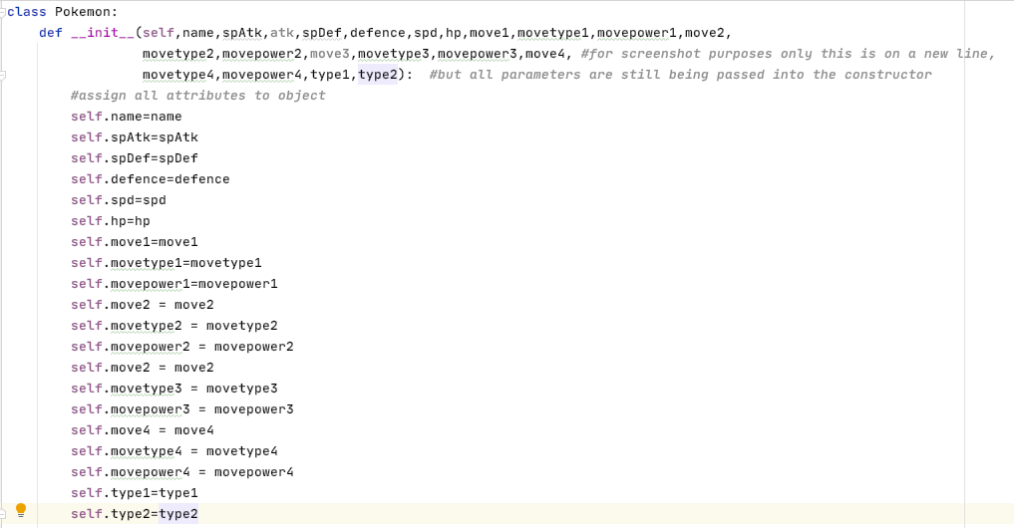

* This is me using the constructor (__init__) to assign all attributes to an object in the class Pokémon
* 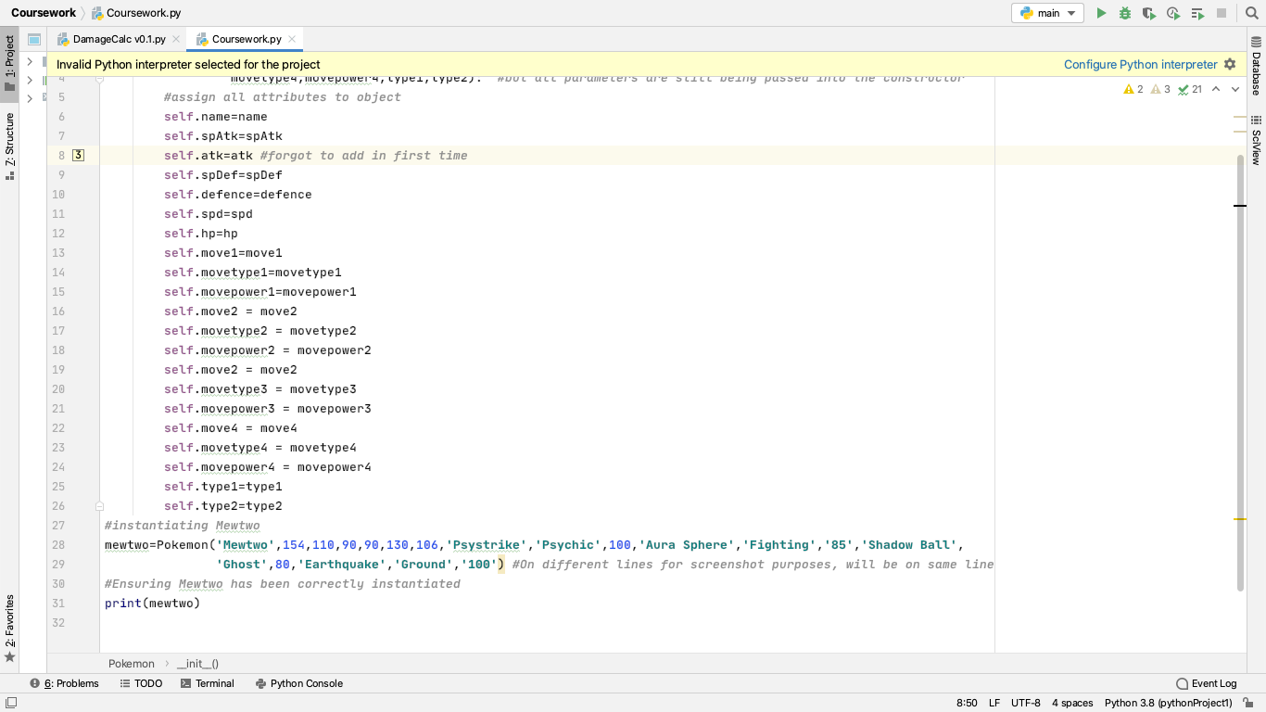I forgot to initialise the *atk* attribute, but I added it in immediately



* Here I instantiate Mewtwo and its contents to ensure it has all been instantiated correctly
* It produced the following when ran:

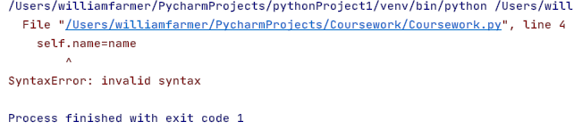

* I found out this was because when I inserted a comment explaining why the parameters were on a new line (to fit in the screenshot) I forgot to take it out
* This meant half of the parameters were comments, and the closing bracket was included in the comment, causing the program to think the whole class was being passed in as a parameter as there was no closing bracket
* After fixing this issue, it produced the following

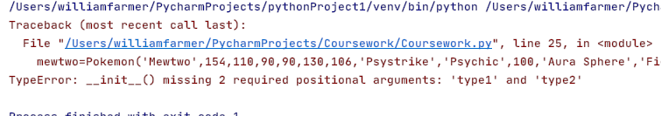

* This is because I forgot to add in type1 and type2 as parameters when instantiating Mewtwo
* The value for both of these is ‘Psychic’, and was immediately added in
* After fixing this issue and adding the following code to replace print(mewtwo)

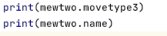

* The program produced the following:
* 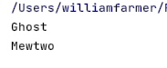
* Which was correct
* Given that it was correct, I decided to add in the instantiation of all Pokémon used in the game
* 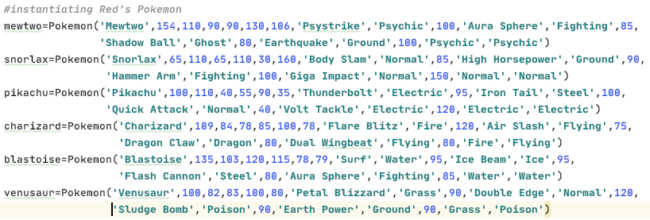I started with Trainer Red’s Pokémon
* Once again, in order for the parameters to be visible in the screenshots they have been split up into two lines, but this is entirely for visibility purposes and will be on one line each in the actual program
* I ran the program in case any errors popped up and I was presented with the following message:

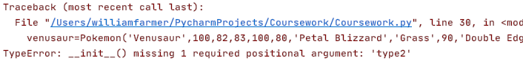

* It was easy to fix, in fact it wasn’t missing type2 but was missing hp, which I quickly put into its respected place in the parameters.
* The program ran with no errors:

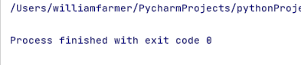

* I decided that it was time to instantiate all of Blue’s Pokémon too.
* 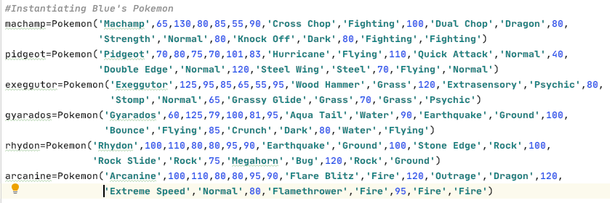The following code is once again formatted so it can fit in a screenshot:
* The code ran with no errors:

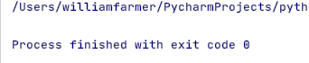

* I believe now is the time to calculate the Pokémon’s actual stats, which are calculated from their base stats
* In this prototype every Pokémon’s level will be 100
* I plan to have the calculations done in the constructor, but if that doesn’t work I’ll make a function for it
* I implemented the hp calculation first, applying level as a variable
* In my design section for this prototype, I had level as an attribute for to sub-classes redPokemon and bluePokemon, but I don’t think I’ll end up implementing these
* If I don’t, I will consequently correct the pseudocode in this section
* The current code looks like this:

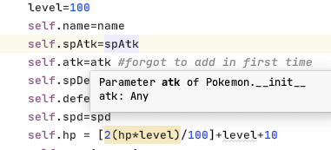

* I ran it to ensure this worked before upscaling to all the stat attributes
* The following error was displayed:
* 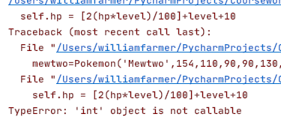
* The program thinks I am trying to call a function
* I believe this was because I kept code exactly the same as in my original notes, and so need to adjust a few things
* I changed it to the following:



* And ran the code, also adding *print(mewtwo.hp)* to ensure it calculated correctly
* It produced the following output:

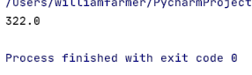

* This is exactly what it should be
* Given that this is working, I decided to add in the calculation for all stats into the constructor, which looks like the following:

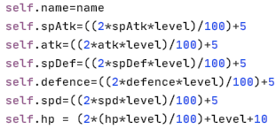

* I ran the program, printing out each of these stats for mewtwo, and the code produced the following:
* 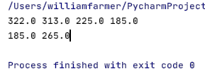
* These stats are all correct
* I decided that it was now time for testing

### Testing

I slightly adjusted my old test plan, adding an actual output and a pass/fail box, and clearing up some vagueness with expected outputs. Evidence will be below the table, clearly indicating which test it is evidencing

|  |  |  |  |  |  |  |
| --- | --- | --- | --- | --- | --- | --- |
| Test Number | Test Type | Testing Success Criteria… | Accepted Input | Expected Output | Actual Output | Pass/Fail? |
|  | Normal | 1.1.1 | No input required; process performed solely by code | Mewtwo  Snorlax  Pikachu  Charizard  Blastoise  Venusaur  Machamp  Pidgeot  Exeggutor  Gyarados  Rhydon  Arcanine | Mewtwo  Snorlax  Pikachu  Charizard  Blastoise  Venusaur  Machamp  Pidgeot  Exeggutor  Gyarados  Rhydon  Arcanine | Pass |
|  | Normal | 1.1.2.1 | No input required; process performed solely by code | 100 85 80 100  85 90 100 150  95 100 40 120  120 75 80 80  95 95 80 85  90 120 90 100  100 80 80 80  110 40 120 70  120 80 65 70  90 100 85 80  100 100 75 120  120 120 80 95 | 100 85 80 100  85 90 100 150  95 100 40 120  120 75 80 80  95 95 80 85  90 120 90 90  100 80 80 80  110 40 120 70  120 80 65 70  90 100 85 80  100 100 75 120  120 120 80 95 | Pass |
|  | Normal | 1.1.2.2 | No input required; process performed solely by code | Psychic Fighting Ghost Ground  Normal Ground Fighting Normal  Electric Steel Normal Electric  Fire Flying Dragon Flying  Water Ice Steel Fighting  Grass Normal  Poison Ground  Fighting Dragon Normal Dark  Flying Normal Normal Steel  Grass Psychic Normal Grass  Water Ground Flying Dark  Ground Rock Rock Bug  Fire Dragon Normal Fire | Psychic Fighting Ghost Ground  Normal Ground Fighting Normal  Electric Steel Normal Electric  Fire Flying Dragon Flying  Water Ice Steel Fighting  Grass Normal Poison Ground  Fighting Dragon Normal Dark  Flying Normal Normal Steel  Grass Psychic Normal Grass  Water Ground Flying Dark  Ground Rock Rock Bug  Fire Dragon Normal Fire | Pass |
|  | Normal | 1.1.3 | No input required; process performed solely by code | Psystrike Aura Sphere Shadow Ball Earthquake  Body Slam High Horsepower Hammer Arm Giga Impact  Thunderbolt Iron Tail Quick Attack Volt Tackle  Flare Blitz Air Slash Dragon Claw Dual Wingbeat  Surf Ice Beam Flash Cannon Aura Sphere  Petal Blizzard  Double Edge  Sludge Bomb Earthquake  Cross Chop Dual Chop Strength Knock Off  Hurricane Quick Attack Double Edge Steel Wing  Wood Hammer Extrasensory Stomp Grassy Glide  Earthquake Stone Edge Rock Slide Megahorn  Flare Blitz Outrage  Extreme Speed  Flamethrower | Psystrike Aura Sphere Shadow Ball Earthquake  Body Slam High Horsepower Hammer Arm Giga Impact  Thunderbolt Iron Tail Quick Attack Volt Tackle  Flare Blitz Air Slash Dragon Claw Dual Wingbeat  Surf Ice Beam Flash Cannon Aura Sphere  Petal Blizzard Double Edge Sludge Bomb Earth Power  Cross Chop Dual Chop Strength Knock Off  Hurricane Quick Attack Double Edge Steel Wing  Wood Hammer Extrasensory Stomp Grassy Glide  Aqua Tail Earthquake Bounce Crunch  Earthquake Stone Edge Rock Slide Megahorn  Flare Blitz Outrage Extreme Speed Flamethrower | Pass |
|  | normal | 1.2.2 | No input required, the following is for Pikachu. | HP: 180  Spd: 185  Atk: 225  SpAtk: 205  Def: 85  SpDef: 105 | HP: 180.0 spd: 185.0 atk: 225.0 spAtk: 205.0 Def: 115.0 spDef: 85.0 | Pass |
|  | Normal | 1.2.2 | No input required, the following is for Charizard | HP: 266  Spd: 205  Atk: 173  SpAtk: 223  Def: 161  SpDef: 175 | HP: 266.0 spd: 205.0 atk: 173.0 spAtk: 223.0 Def: 161.0 spDef: 175.0 | Pass |
|  | Normal | 1.2.2 | No input required, following is for Blastoise | HP: 268  Spd: 161  Atk: 171  SpAtk: 175  Def: 205  SpDef: 215 | HP: 268.0 spd: 161.0 atk: 211.0 spAtk: 275.0 Def: 235.0 spDef: 245.0, see evidence:  After fixing, changed to:  HP: 268.0 spd: 161.0 atk: 171.0 spAtk: 175.0 Def: 205.0 spDef: 215.0 | FAIL but then pass |
|  | Normal | 1.2.2 | No input required, following is for Venusaur | HP: 270  Spd: 165  Atk: 169  SpAtk: 205  Def: 171  SpDef: 205 | HP: 270.0 spd: 165.0 atk: 169.0 spAtk: 205.0 Def: 171.0 spDef: 205.0 | Pass |
|  | Normal | 1.2.2 | No input required, following is for Snorlax | HP: 430  Spd: 65  Atk: 225  SpAtk: 135  Def: 135  SpDef: 225 | HP: 430.0 spd: 65.0 atk: 225.0 spAtk: 135.0 Def: 135.0 spDef: 225.0 | Pass |
|  | Normal | 1.2.2 | No input required, following is for Mewtwo | HP: 322  Spd: 265  Atk: 225  SpAtk: 313  Def: 185  SpDef: 185 | HP: 322.0 spd: 265.0 atk: 225.0 spAtk: 313.0 Def: 185.0 spDef: 185.0 | Pass |
|  | Normal | 1.2.2 | No input required, following is for pidgeot | HP: 276  Spd: 207  Atk: 165  SpAtk: 145  Def: 155  SpDef: 145 | HP: 276.0 spd: 207.0 atk: 165.0 spAtk: 145.0 Def: 155.0 spDef: 145.0 | Pass |
|  | Normal | 1.2.2 | No input required, following is for Arcanine | HP: 290  Spd: 195  Atk: 225  SpAtk: 205  Def: 165  SpDef: 165 | HP: 290.0 spd: 195.0 atk: 225.0 spAtk: 205.0 Def: 165.0 spDef: 165.0 | Pass |
|  | Normal | 1.2.2 | No input required, following is for Machamp | HP: 290  Spd: 115  Atk: 265  SpAtk: 135  Def: 165  SpDef: 175 | HP: 290.0 spd: 115.0 atk: 265.0 spAtk: 135.0 Def: 165.0 spDef: 175.0 | Pass |
|  | Normal | 1.2.2 | No input required, following is for Gyarados | HP: 300  Spd: 167  Atk: 255  SpAtk: 125  Def: 163  SpDef: 205 | HP: 300.0 spd: 167.0 atk: 255.0 spAtk: 125.0 Def: 163.0 spDef: 205.0 | Pass |
|  | Normal | 1.2.2 | No input required, following is for Rhydon | HP: 320  Spd: 85  Atk: 265  SpAtk: 95  Def: 245  SpDef: 95 | HP: 290.0 spd: 195.0 atk: 225.0 spAtk: 205.0 Def: 165.0 spDef: 165.0  Identified error: changed to:  HP: 320.0 spd: 85.0 atk: 265.0 spAtk: 95.0 Def: 245.0 spDef: 95.0 | FAIL but then pass |
|  | Normal | 1.2.2 | No input required, following is for Exeggutor | HP: 300  Spd: 115  Atk: 195  SpAtk: 255  Def: 175  SpDef: 155 | HP: 300.0 spd: 115.0 atk: 195.0 spAtk: 255.0 Def: 175.0 spDef: 135.0 | Pass |

#### Evidencing Test Results

##### Test 1

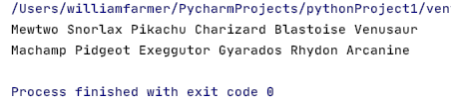

##### Test 2

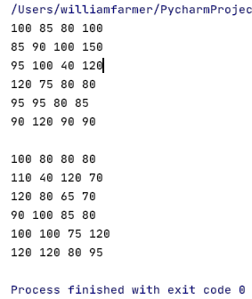

##### Test 3

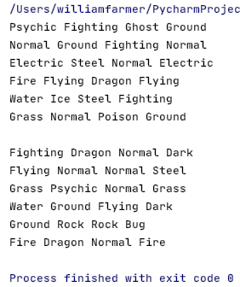

##### Test 4

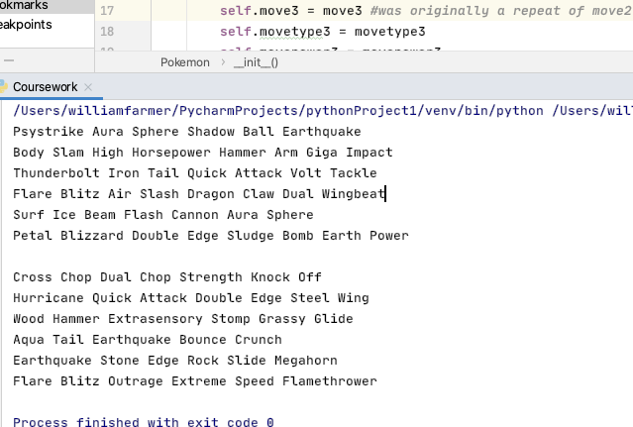

I realised that I actually hadn’t made a move3 attribute and had accidently repeated move2 twice, so I fixed it (see comment in code)

##### Test 5

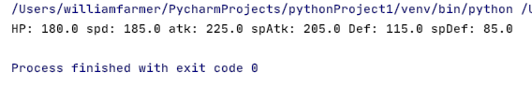

I should note that I have altered Pikachu’s stats as to not make it so weak, so it has just over double the spAtk and atk it would have in the normal Pokémon game

##### Test 6

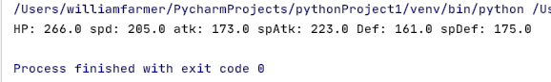

I originally had Charizard’s spDef and defence the wrong way round, but swapped it upon testing

##### Test 7

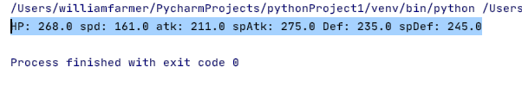

Found out I was using wrong stats, changed to:



Which output:

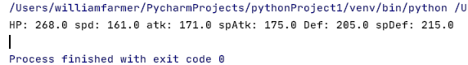

This needed to be fixed, because otherwise Blastoise would be much more powerful than it should be. This would create an unfair advantage or disadvantage, without fault of the user. Hence, remedial action was needed to be taken to restore Blastoise to its desired power level

##### Test 8

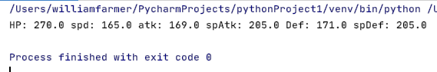

##### Test 9

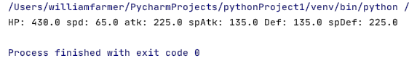

##### Test 10

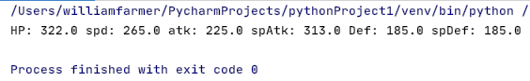

##### Test 11

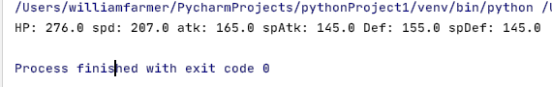

##### Test 12

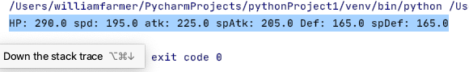

##### Test 13

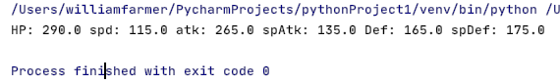

##### Test 14

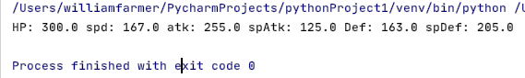

##### Test 15

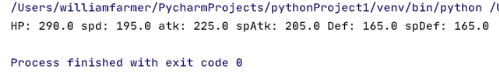

The base stats were incorrect, so I researched and found correct ones and then got the following output:

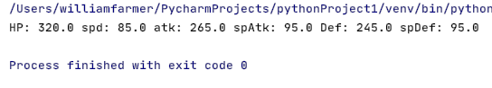

These stats were quite simply not Rhydon’s, instead they belonged to a different Pokémon. In order to keep the game authentic, remedial action needed to be taken to ensure Rhydon had Rhydon’s stats, and not a different Pokémon’s.

##### Test 16

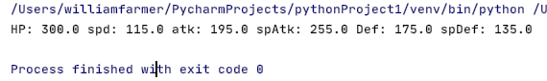

#### Corrected Pseudocode

Class Pokemon

Private name

Private spAtk

Private atk

Private spDef

Private defence

Private spd

Private hp

Private move1

Private movetype1

Private movepower1

Private move2

Private movetype2

Private movepower2

Private move3

Private movetype3

Private movepower3

Private move4

Private movetype4

Private movepower4

Private type1

Private type2

Public procedure new(getname,getspAtk,getatk,getspDef,getdef,getspd,gethp,getmove1,getmovetype1,getmovepower1,getmove2,getmovetype2,getmovepower2,getmove3,getmovetype3,getmovepower3,getmove4,getmovetype4,getmovepower4,gettype1,gettype2)

Level=int(100)

name=getName

spAtk= ((2*getspAtk*level)/100)+5

atk= ((2*getatk*level)/100)+5

spDef= ((2*spDef*level)/100)+5

defence= ((2*getdef*level)/100)+5

spd= ((2*getspd*level)/100)+5

hp= (2*(hp*level)/100)+level+10

move1=getmove1

movetype1=getmovetype1

movepower1=getmovepower1

move2=getmove2

movetype2=getmovetype2

movepower2=getmovepower2

move3=getmove3

movetype3=getmovetype3

movepower3=getmovepower3

move4=getmove4

movetype4=getmovetype4

movepower4=getmovepower4

type1=gettype1

type2=gettype2

endprocedure

endclass

#### Updating Inheritance Diagram

There is now no need for an inheritance diagram as I am no longer using the sub-classes redPokemon and bluePokemon. In later development I will instead add them to an array.

### Evaluation

#### What has been achieved?

I have correctly created the Pokemon class and instantiated each Pokémon as an onject, giving them the appropriate base stats, moves, move types and move powers, as well as the Pokémon’s types. As well as this, the program correctly calculates the Pokémon’s stats from their base stats.

#### How was it tested?

I tested as I wrote the code to ensure I wasn’t building on something that didn’t work, but then ran through my entire test plan upon completing the prototype to ensure there were no logic errors in the code. This can be evidenced in the test plan section of this prototype.

#### Does it meet the success criteria?

Yes. This prototype was designed to tackle success criterion 1 and all its sub-criteria, and, as the testing evidences, all the success criteria were met. OOP is used to store the Pokémon as objects, and store their information as attributes, as stated in the success criteria.

#### Was anything changed from the design section?

Yes. I changed from the original plan of having 2 sub-classes for Red’s Pokémon and Blue’s Pokémon as I realised there was no need to and it was just overcomplicating the code; instead I keep the main Pokémon subclass, treat *level* as a variable and add Red’s team to an array and Blue’s team to a different one, which can and will be passed into different functions.

#### Summary of the project at this stage of development

Currently if you were to run the game with no view of the source code you would assume nothing was happening, but that is just because this prototype was a beginning stage to the project, no other part of this project can exist without this prototype. Following on from this prototype there will be some playable elements from the game, this was merely just a foundation step that needed to be climbed.

## Prototype 2

This is where part of the playable game is added, with the user being able to choose their trainer and consequently their battlers.

### Evidencing Solution

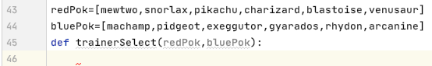

I created two arrays to store Red and Blue’s Pokémon, and then passed these arrays into the trainerSelect function. This is where the user will choose which trainer they want to battle with.

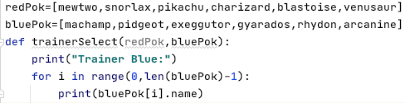

This will print out the name of Blue’s Pokémon line by line. The code produced the following output:

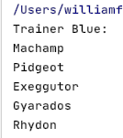

The code didn’t output arcanine. This is because my FOR loop stops one run too early. I changed the code to this:

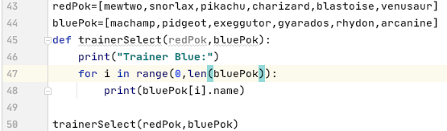

And it produced the following:

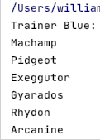

Which is exactly as desired. I then mimicked the code to print out Red’s Pokémon as so:

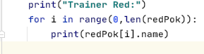

Which produced the following when ran:

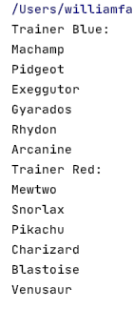

Which once again was as desired.

I then coded the inputs for allowing the user to choose a trainer and the validation for making sure they enter either red or blue, as these are the only two options:

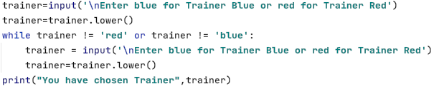

It ran to produce the following:

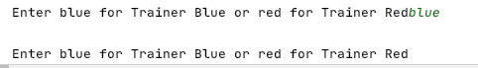

This isn’t meant to happen. I believe this is because I used an OR statement instead of an AND statement, so I switched it round and the code ran to produce the following:

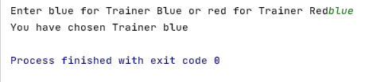

This is the expected output. I did two more tests, ensuring it worked for red and asked the user to re-enter if they didn’t enter either red or blue, as well checking that case doesn’t matter:

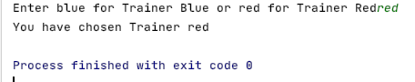

Works for red as an input

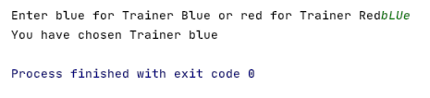

Works for different cases

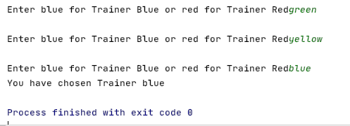

Loops until an acceptable input has been entered.

Now that I’m secure in the knowledge that this is all working; I will start to code the part of the function that checks that the user is happy with their choice of trainer.

The code looks like this:

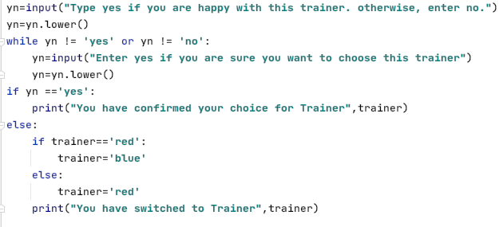

I ran it checking that it looped until a valid input was entered, and that it would swap the trainers if no was entered, and keep them to the same if yes was entered:

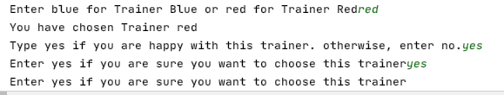

I once again needed to use AND instead of OR, so I changed it and ran the code again:

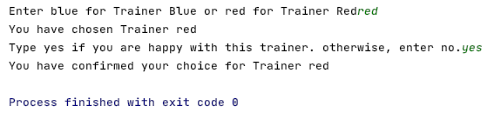

It worked as expected.

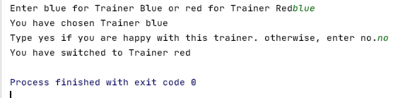

It switched trainer as desired.

I decided to change the code to this in order to make the instruction clearer:



It ran to produce the following:

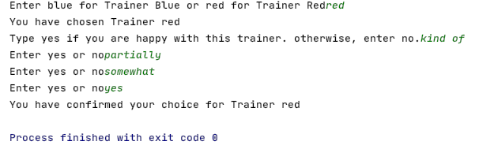

Now I’m happy that this is working for every case, I can move on to outputting all of the user’s battlers.

I changed the code to the following:

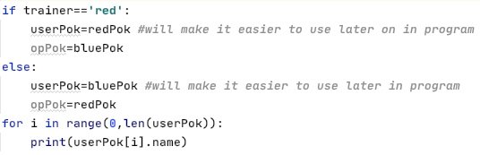

This should also print out all of the users Pokémon.

Finally, I need to return the user and opponent’ battlers, as well as the chosen trainer.

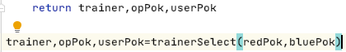

With this finished, it’s time for testing.

### Testing

I once again slightly altered some of the expected outputs, solely because I changed my mind on what I want the program to do. I have also added a few tests I now think are appropriate.

|  |  |  |  |  |  |
| --- | --- | --- | --- | --- | --- |
| Test Number | Test Type | Testing Success Criteria… | Acceptable Input | Expected Output | Pass/Fail? |
|  | Normal | 6.2 | No input required; process performed solely by code | Trainer Blue:  Arcanine  Pidgeot  Machamp  Gyarados  Rhydon  Exeggutor  Trainer Red:  Pikachu  Charizard  Blastoise  Venusaur  Snorlax  Mewtwo | PASS |
|  | Normal | 6.1 | When prompted, ‘red’ | ‘You have chosen Trainer red’  ‘Type yes if you are happy with this trainer. Otherwise, enter no.’ | PASS |
|  | Normal | 6.1 | ‘blue’ | ‘You have chosen Trainer blue’  ‘Type yes if you are happy with this trainer. Otherwise, enter no.’ | PASS |
|  | Normal | 6.1 | *(after choosing red):* ‘no’ | ‘Trainer has been switched to Trainer Blue’  ‘Machamp, Pidgeot, Exeggutor, Gyarados, Rhydon, Arcanine’ | PASS |
|  | Normal | 6.1 | *(After choosing blue):* ‘no’ | ‘Trainer has been switched to Trainer Red’  ‘Mewtwo, Snorlax, Pikachu, Charizard, Blastoise, Venusaur’ | PASS |
|  | Normal | 6.1 | *(after choosing red): “yes”* | ‘You have confirmed your choice for Trainer red’  ‘Mewtwo, Snorlax, Pikachu, Charizard, Blastoise, Venusaur’ | PASS |
|  | Normal | 6.1 | *(after choosing blue)*: ‘yes’ | ‘You have confirmed your choice for Trainer blue’  ‘Machamp, Pidgeot, Exeggutor, Gyarados, Rhydon, Arcanine’ | PASS |
|  | Erroneous | 6.1 | ‘green’ | ‘Enter blue for Trainer Blue and red for Trainer Red’ | PASS |
|  | Erroneous | 6.1 | *(after choosing red):* ‘asdf’ | Type yes if you are happy with this trainer. Otherwise enter no | PASS |
|  | Erroneous | 6.1 | *(after choosing blue):* ‘asdf’ | Enter yes if you are sure you want to choose this trainer. If you want to change, enter no. Case does not matter | PASS |
|  | Normal | 6.1 | *When prompted* ‘BlUe’ | ‘You have chosen Trainer blue’  ‘Type yes if you are happy with this trainer. Otherwise, enter no.’ | PASS |
|  | Normal | 6.1 | *When prompted* ‘rEd’ | ‘You have chosen Trainer red’  ‘Type yes if you are happy with this trainer. Otherwise, enter no’ | PASS |
|  | Normal | 6.1 | *When prompted* ‘YeS’ | ‘You have confirmed your choice for Trainer [trainer]’ | PASS |
|  | Normal | 6.1 | *When prompted* ‘nO’ | ‘You have switched to Trainer [trainer]’ | PASS |

#### Evidencing Test Results

##### Test 1



As you can see, it is the first thing printed out, as there is no user input, as specified in the test plan.

##### Test 2

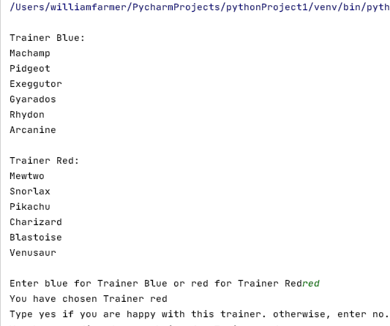

This has passed, as the output is as expected

##### Test 3

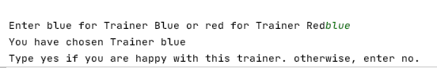

This has passed, as the output is as expected

##### Test 4

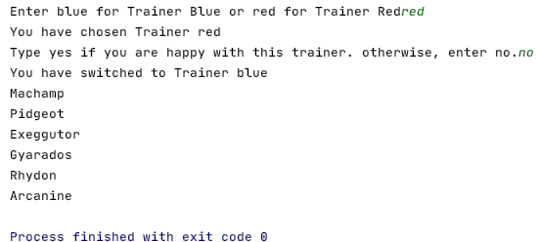

This has passed, as the output is as expected.

##### Test 5

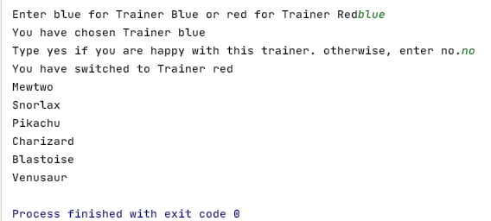

This has passed, as the output is as expected.

##### Test 6

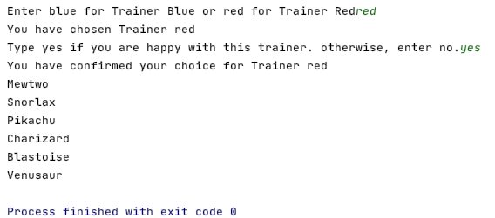

This has passed, as the output is as expected.

##### Test 7

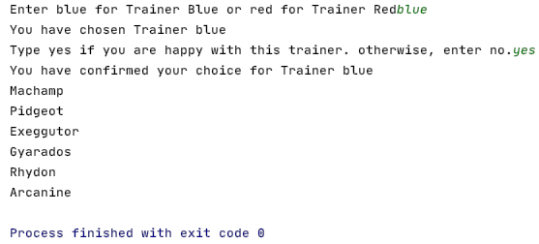

This has passed, as the output is as expected.

##### Test 8

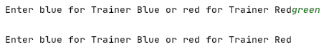

This has passed, as the output is as expected

##### Test 9

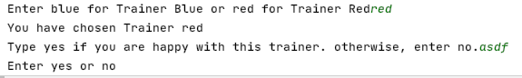

This has passed, as the output is as expected

##### Test 10

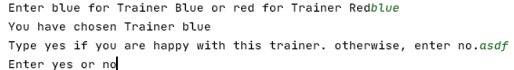This has passed, as the output is as expected.

##### Test 11

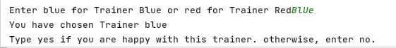

This has passed, as the output is as expected.

This means for trainer blue, the case of the input doesn’t matter

##### Test 12

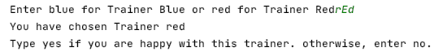

This has passed, as the output is as expected.

This means that for trainer red, the case of the input doesn’t matter.

##### Test 13

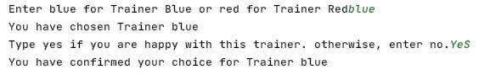

This has passed, as the output is as expected.

##### Test 14

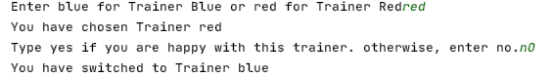

This has passed, as the output is as expected.

#### Corrected Pseudocode

As I changed my mind about the specifics of some of the outputs, the pseudocode needs to be changed. This is the corrected pseudocode:

redPok=[mewtwo,snorlax,pikachu,charizard,blastoise,venusaur]

bluePok=[machamp,pidgeot,exeggutor,gyarados,rhydon,arcanine]

trainer,opPok,userPok=Function trainerSelect(redPok,bluePok)

print(“Trainer Blue:”)

FOR x=0 to len(bluePok)-1

print(bluePok[x],name)

next x

print(“Trainer Red:”)

FOR x=0 to len(redPok)-1

print(redPok[x].name)

next x

trainer=str(input(“Enter blue for Trainer Blue and red for Trainer Red”)

trainer=trainer.lower()

WHILE trainer <> “red” or trainer <> “blue” THEN

trainer=input(“Enter blue for Trainer Blue and red for Trainer Red.”)

trainer=trainer.lower()

Endwhile

print(“You have chosen trainer”,trainer)

yn=str(input(“Type yes if you are happy with this trainer. Otherwise enter no”)

While yn.lower() <> ‘yes’ or yn.lower() <> ‘no’ THEN

yn=str(input(“Enter yes or no”)

endwhile

IF yn.lower() == ‘yes’ THEN

print(“You have confirmed your choice for Trainer”,trainer)

ELSE THEN

IF trainer==‘red’ THEN

trainer=blue

ELSE THEN

trainer=‘red’

endif

print(“You have switched to Trainer”,trainer)

endif

IF trainer ==‘red’ THEN

userPok=redPok

opPok=bluePok

ELSE THEN

userPok=bluePok

opPok=redPok

endif

FOR x = 0 to len(userPok)-1

print(userPok[x].name)

Next x

Return trainer,opPok,userPok

Endfunction

This now maps across to the python code I have coded. I was aware that I would likely find errors or inefficiencies in code, so this does not come as a surprise to me. I am not worried about changing from the design section, because as long as I document all changes then I am just improving the program, of which there are no negatives (except the requirement for extra time to be spent thinking of new solutions instead of effectively copying the pseudocode).

### The program so far

class Pokemon: *#constructor and class creation* def __init__(self,name,spAtk,atk,defence,spDef,spd,hp,move1,movetype1,movepower1,move2,movetype2,movepower2,move3,movetype3,movepower3,move4,movetype4,movepower4,type1,type2):  
 level=100  
 self.name=name  
 self.spAtk=((2*spAtk*level)/100)+5  
 self.atk=((2*atk*level)/100)+5  
 self.spDef=((2*spDef*level)/100)+5  
 self.defence=((2*defence*level)/100)+5  
 self.spd=((2*spd*level)/100)+5  
 self.hp = (2*(hp*level)/100)+level+10  
 self.move1=move1  
 self.movetype1=movetype1  
 self.movepower1=movepower1  
 self.move2 = move2  
 self.movetype2 = movetype2  
 self.movepower2 = movepower2  
 self.move3 = move3 *#was originally a repeat of move2* self.movetype3 = movetype3  
 self.movepower3 = movepower3  
 self.move4 = move4  
 self.movetype4 = movetype4  
 self.movepower4 = movepower4  
 self.type1=type1  
 self.type2=type2  
  
  
*#instantiating Red's Pokemon*mewtwo=Pokemon(**'Mewtwo'**,154,110,90,90,130,106,**'Psystrike'**,**'Psychic'**,100,**'Aura Sphere'**,**'Fighting'**,85,**'Shadow Ball'**,**'Ghost'**,80,**'Earthquake'**,**'Ground'**,100,**'Psychic'**,**'Psychic'**)  
snorlax=Pokemon(**'Snorlax'**,65,110,65,110,30,160,**'Body Slam'**,**'Normal'**,85,**'High Horsepower'**,**'Ground'**,90,**'Hammer Arm'**,**'Fighting'**,100,**'Giga Impact'**,**'Normal'**,150,**'Normal'**,**'Normal'**)  
pikachu=Pokemon(**'Pikachu'**,100,110,40,55,90,35,**'Thunderbolt'**,**'Electric'**,95,**'Iron Tail'**,**'Steel'**,100,**'Quick Attack'**,**'Normal'**,40,**'Volt Tackle'**,**'Electric'**,120,**'Electric'**,**'Electric'**)  
charizard=Pokemon(**'Charizard'**,109,84,78,85,100,78,**'Flare Blitz'**,**'Fire'**,120,**'Air Slash'**,**'Flying'**,75,**'Dragon Claw'**,**'Dragon'**,80,**'Dual Wingbeat'**,**'Flying'**,80,**'Fire'**,**'Flying'**)  
blastoise=Pokemon(**'Blastoise'**,85,83,100,105,78,79,**'Surf'**,**'Water'**,95,**'Ice Beam'**,**'Ice'**,95,**'Flash Cannon'**,**'Steel'**,80,**'Aura Sphere'**,**'Fighting'**,85,**'Water'**,**'Water'**)  
venusaur=Pokemon(**'Venusaur'**,100,82,83,100,80,80,**'Petal Blizzard'**,**'Grass'**,90,**'Double Edge'**,**'Normal'**,120,**'Sludge Bomb'**,**'Poison'**,90,**'Earth Power'**,**'Ground'**,90,**'Grass'**,**'Poison'**)  
  
*#Instantiating Blue's Pokemon*machamp=Pokemon(**'Machamp'**,65,130,80,85,55,90,**'Cross Chop'**,**'Fighting'**,100,**'Dual Chop'**,**'Dragon'**,80,**'Strength'**,**'Normal'**,80,**'Knock Off'**,**'Dark'**,80,**'Fighting'**,**'Fighting'**)  
pidgeot=Pokemon(**'Pidgeot'**,70,80,75,70,101,83,**'Hurricane'**,**'Flying'**,110,**'Quick Attack'**,**'Normal'**,40,**'Double Edge'**,**'Normal'**,120,**'Steel Wing'**,**'Steel'**,70,**'Flying'**,**'Normal'**)  
exeggutor=Pokemon(**'Exeggutor'**,125,95,85,65,55,95,**'Wood Hammer'**,**'Grass'**,120,**'Extrasensory'**,**'Psychic'**,80,**'Stomp'**,**'Normal'**,65,**'Grassy Glide'**,**'Grass'**,70,**'Grass'**,**'Psychic'**)  
gyarados=Pokemon(**'Gyarados'**,60,125,79,100,81,95,**'Aqua Tail'**,**'Water'**,90,**'Earthquake'**,**'Ground'**,100,**'Bounce'**,**'Flying'**,85,**'Crunch'**,**'Dark'**,80,**'Water'**,**'Flying'**)  
rhydon=Pokemon(**'Rhydon'**,45,130,120,45,40,105,**'Earthquake'**,**'Ground'**,100,**'Stone Edge'**,**'Rock'**,100,**'Rock Slide'**,**'Rock'**,75,**'Megahorn'**,**'Bug'**,120,**'Rock'**,**'Ground'**)  
arcanine=Pokemon(**'Arcanine'**,100,110,80,80,95,90,**'Flare Blitz'**,**'Fire'**,120,**'Outrage'**,**'Dragon'**,120,**'Extreme Speed'**,**'Normal'**,80,**'Flamethrower'**,**'Fire'**,95,**'Fire'**,**'Fire'**)  
  
redPok=[mewtwo,snorlax,pikachu,charizard,blastoise,venusaur] *#making it easier for rest of program*bluePok=[machamp,pidgeot,exeggutor,gyarados,rhydon,arcanine] *#making it easier for rest of program*def trainerSelect(redPok,bluePok): *#the user selects the trainer* print(**"**\n**Trainer Blue:"**)  
 for i in range(0,len(bluePok)): *#prints out all of blue's pokemon* print(bluePok[i].name)  
 print(**"**\n**Trainer Red:"**)  
 for i in range(0,len(redPok)): *#prints out all of red's pokemon* print(redPok[i].name)  
 trainer=input(**'**\n**Enter blue for Trainer Blue or red for Trainer Red'**)  
 trainer=trainer.lower()  
 while trainer != **'red'** and trainer != **'blue'**: *#validation loop* trainer = input(**'**\n**Enter blue for Trainer Blue or red for Trainer Red'**)  
 trainer=trainer.lower()  
 print(**"You have chosen Trainer"**,trainer) *#confirmation* yn=input(**"Type yes if you are happy with this trainer. otherwise, enter no."**) *#verification* yn=yn.lower()  
 while yn != **'yes'** and yn != **'no'**: *#validation loop* yn=input(**"Enter yes or no"**) *#Makes instruction clearer than before* yn=yn.lower()  
 if yn ==**'yes'**:  
 print(**"You have confirmed your choice for Trainer"**,trainer)  
 else:  
 if trainer==**'red'**:  
 trainer=**'blue'** *#swaps trainer* else:  
 trainer=**'red'** *#swaps trainer* print(**"You have switched to Trainer"**,trainer) *#confirmation of swap* if trainer==**'red'**:  
 userPok=redPok *#will make it easier to use later on in program* opPok=bluePok  
 else:  
 userPok=bluePok *#will make it easier to use later in program* opPok=redPok  
 for i in range(0,len(userPok)): *#prints out all of the user's battlers*  
 print(userPok[i].name)  
 return trainer,opPok,userPok  
  
trainer,opPok,userPok=trainerSelect(redPok,bluePok)

### Evaluation

#### What has been achieved?

The user can select which Pokémon they want to battle with and have the option to change Trainer if they have a change of heart. There is also suitable validation in place to ensure that any input produces an expected output; whether it be looping the program until the user enters a valid input or continuing the program when the user enters a valid.

#### How was it tested?

I tested the code as I was writing it, ensuring that all normal inputs produced expected outputs, before doing the formal testing upon completion of the new module with reference to the test plan. I evidenced all of my tests in the test plan section above.

#### Does it meet the success criteria?

Yes, this prototype was designed to meet success criterion 6 and its subsequent sub-criteria in their entirety, which it has done. In my test plan I referenced the success criteria each test was meeting and I am as a result secure in the completion of this prototype. The user is able to choose the trainer they want, the trainer’s associated Pokémon is assigned to userPok (the user’s Pokémon) and printed out to ensure they match. The associated Pokémon are printed out before the user has to make a choice so they can make an informed decision, in keeping with sub-criterion 6.2.

#### Was anything changed from the design section?

Yes, but no functionality was altered, only the wording of the outputs. In addition, the names of the Trainers’ Pokémon were printed out line-by-line rather than on the same line. This was just to make instructions clearer and the game look nicer when playing it.

#### Summary of the project at this stage of development

The game now has outputs and the asks the user for inputs. The user can choose the trainer they want to be and can change their mind if they want to. This is still just the foundations of the game, so there isn’t going to be much in terms of the playability, but it means there will be less work required once I get to coding that stage as the core components are already done.

## Prototype 3

This prototype covers success criterion 2 and all its sub-criteria. After this stage the user will be able to inflict damage upon an opponent, albeit for just one turn. This is where the actual playable part of the game starts getting developed

### Evidencing Solution

I’ve decided to make the function that calculates the damage first. Because of this, I will just be passing in Machamp as the defending Pokémon and mewtwo as the attacking one in order to help with testing while writing the code, just so I know it is functionally sound. I will also assume Mewtwo is using the move Psystrike as it has the most damage.

However, upon coding the start of this prototype, I realised that I had forgotten to instantiate the classification of moves (physical or special) and the accuracy of each move. These are required in order to create this prototype, and so I will be evidencing me changing the code made in Prototype 1.

*#instantiating Red's Pokemon*mewtwo=Pokemon(**'Mewtwo'**,154,110,90,90,130,106,**'Psystrike'**,**'Psychic'**,100,100,**'Aura Sphere'**,**'Fighting'**,85,100,**'Shadow Ball'**,**'Ghost'**,80,100,**'Earthquake'**,**'Ground'**,100,100,**'Psychic'**,**'Psychic'**)  
snorlax=Pokemon(**'Snorlax'**,65,110,65,110,30,160,**'Body Slam'**,**'Normal'**,85,100,**'High Horsepower'**,**'Ground'**,90,90,**'Hammer Arm'**,**'Fighting'**,100,85,**'Giga Impact'**,**'Normal'**,150,50,**'Normal'**,**'Normal'**)  
pikachu=Pokemon(**'Pikachu'**,100,110,40,55,90,35,**'Thunderbolt'**,**'Electric'**,95,100,**'Iron Tail'**,**'Steel'**,100,75,**'Quick Attack'**,**'Normal'**,40,100,**'Volt Tackle'**,**'Electric'**,120,87.5,**'Electric'**,**'Electric'**)  
charizard=Pokemon(**'Charizard'**,109,84,78,85,100,78,**'Flare Blitz'**,**'Fire'**,120,75,**'Air Slash'**,**'Flying'**,75,95,**'Dragon Claw'**,**'Dragon'**,80,100,**'Dual Wingbeat'**,**'Flying'**,80,90,**'Fire'**,**'Flying'**)  
blastoise=Pokemon(**'Blastoise'**,85,83,100,105,78,79,**'Surf'**,**'Water'**,95,100,**'Ice Beam'**,**'Ice'**,95,100,**'Flash Cannon'**,**'Steel'**,80,100,**'Aura Sphere'**,**'Fighting'**,85,100,**'Water'**,**'Water'**)  
venusaur=Pokemon(**'Venusaur'**,100,82,83,100,80,80,**'Petal Blizzard'**,**'Grass'**,90,100,**'Double Edge'**,**'Normal'**,120,87.5,**'Sludge Bomb'**,**'Poison'**,90,100,**'Earth Power'**,**'Ground'**,90,100,**'Grass'**,**'Poison'**)

As you can now see, each move has two numbers following it: the first being the power, the second being the accuracy. Now to do the same for Blue’s Pokémon:

*#Instantiating Blue's Pokemon*machamp=Pokemon(**'Machamp'**,65,130,80,85,55,90,**'Cross Chop'**,**'Fighting'**,100,80,**'Dual Chop'**,**'Dragon'**,80,90,**'Strength'**,**'Normal'**,80,100,**'Knock Off'**,**'Dark'**,80,100,**'Fighting'**,**'Fighting'**)  
pidgeot=Pokemon(**'Pidgeot'**,70,80,75,70,101,83,**'Hurricane'**,**'Flying'**,110,70,**'Quick Attack'**,**'Normal'**,40,100,**'Double Edge'**,**'Normal'**,120,87.5,**'Steel Wing'**,**'Steel'**,70,100,**'Flying'**,**'Normal'**)  
exeggutor=Pokemon(**'Exeggutor'**,125,95,85,65,55,95,**'Wood Hammer'**,**'Grass'**,120,80,**'Extrasensory'**,**'Psychic'**,80,100,**'Stomp'**,**'Normal'**,65,100,**'Grassy Glide'**,**'Grass'**,70,100,**'Grass'**,**'Psychic'**)  
gyarados=Pokemon(**'Gyarados'**,60,125,79,100,81,95,**'Aqua Tail'**,**'Water'**,90,90,**'Earthquake'**,**'Ground'**,100,100,**'Bounce'**,**'Flying'**,85,85,**'Crunch'**,**'Dark'**,80,100,**'Water'**,**'Flying'**)  
rhydon=Pokemon(**'Rhydon'**,45,130,120,45,40,105,**'Earthquake'**,**'Ground'**,100,100,**'Stone Edge'**,**'Rock'**,100,80,**'Rock Slide'**,**'Rock'**,75,90,**'Megahorn'**,**'Bug'**,120,85,**'Rock'**,**'Ground'**)  
arcanine=Pokemon(**'Arcanine'**,100,110,80,80,95,90,**'Flare Blitz'**,**'Fire'**,120,75,**'Outrage'**,**'Dragon'**,120,75,**'Extreme Speed'**,**'Normal'**,80,100,**'Flamethrower'**,**'Fire'**,95,100,**'Fire'**,**'Fire'**)

Now to add in whether the move is physical or special.

*#instantiating Red's Pokemon*mewtwo=Pokemon(**'Mewtwo'**,154,110,90,90,130,106,**'Psystrike'**,**'Psychic'**,100,100,**'special'**,**'Aura Sphere'**,**'Fighting'**,85,100,**'special'**,**'Shadow Ball'**,**'Ghost'**,80,100,**'special'**,**'Earthquake'**,**'Ground'**,100,100,**'physical'**,**'Psychic'**,**'Psychic'**)  
snorlax=Pokemon(**'Snorlax'**,65,110,65,110,30,160,**'Body Slam'**,**'Normal'**,85,100,**'physical'**,**'High Horsepower'**,**'Ground'**,90,90,**'physical'**,**'Hammer Arm'**,**'Fighting'**,100,85,**'physical'**,**'Giga Impact'**,**'Normal'**,150,50,**'physical'**,**'Normal'**,**'Normal'**)  
pikachu=Pokemon(**'Pikachu'**,100,110,40,55,90,35,**'Thunderbolt'**,**'Electric'**,95,100,**'special'**,**'Iron Tail'**,**'Steel'**,100,75,**'physical'**,**'Quick Attack'**,**'Normal'**,40,100,**'physical'**,**'Volt Tackle'**,**'Electric'**,120,87.5,**'physical'**,**'Electric'**,**'Electric'**)  
charizard=Pokemon(**'Charizard'**,109,84,78,85,100,78,**'Flare Blitz'**,**'Fire'**,120,75,**'physical'**,**'Air Slash'**,**'Flying'**,75,95,**'special'**,**'Dragon Claw'**,**'Dragon'**,80,100,**'physical'**,**'Dual Wingbeat'**,**'Flying'**,80,90,**'physical'**,**'Fire'**,**'Flying'**)  
blastoise=Pokemon(**'Blastoise'**,85,83,100,105,78,79,**'Surf'**,**'Water'**,95,100,**'special'**,**'Ice Beam'**,**'Ice'**,95,100,**'special'**,**'Flash Cannon'**,**'Steel'**,80,100,**'special'**,**'Aura Sphere'**,**'Fighting'**,85,100,**'special'**,**'Water'**,**'Water'**)  
venusaur=Pokemon(**'Venusaur'**,100,82,83,100,80,80,**'Petal Blizzard'**,**'Grass'**,90,100,**'physical'**,**'Double Edge'**,**'Normal'**,120,87.5,**'physical'**,**'Sludge Bomb'**,**'Poison'**,90,100,**'special'**,**'Earth Power'**,**'Ground'**,90,100,**'special'**,**'Grass'**,**'Poison'**)  
  
*#Instantiating Blue's Pokemon*machamp=Pokemon(**'Machamp'**,65,130,80,85,55,90,**'Cross Chop'**,**'Fighting'**,100,80,**'physical'**,**'Dual Chop'**,**'Dragon'**,80,90,**'physical'**,**'Strength'**,**'Normal'**,80,100,**'physical'**,**'Knock Off'**,**'Dark'**,80,100,**'physical'**,**'Fighting'**,**'Fighting'**)  
pidgeot=Pokemon(**'Pidgeot'**,70,80,75,70,101,83,**'Hurricane'**,**'Flying'**,110,70,**'special'**,**'Quick Attack'**,**'Normal'**,40,100,**'physical'**,**'Double Edge'**,**'Normal'**,120,87.5,**'physical'**,**'Steel Wing'**,**'Steel'**,70,100,**'physical'**,**'Flying'**,**'Normal'**)  
exeggutor=Pokemon(**'Exeggutor'**,125,95,85,65,55,95,**'Wood Hammer'**,**'Grass'**,120,80,**'physical'**,**'Extrasensory'**,**'Psychic'**,80,100,**'special'**,**'Stomp'**,**'Normal'**,65,100,**'physical'**,**'Grassy Glide'**,**'Grass'**,70,100,**'physical'**,**'Grass'**,**'Psychic'**)  
gyarados=Pokemon(**'Gyarados'**,60,125,79,100,81,95,**'Aqua Tail'**,**'Water'**,90,90,**'physical'**,**'Earthquake'**,**'Ground'**,100,100,**'physical'**,**'Bounce'**,**'Flying'**,85,85,**'physical'**,**'Crunch'**,**'Dark'**,80,100,**'physical'**,**'Water'**,**'Flying'**)  
rhydon=Pokemon(**'Rhydon'**,45,130,120,45,40,105,**'Earthquake'**,**'Ground'**,100,100,**'physical'**,**'Stone Edge'**,**'Rock'**,100,80,**'physical'**,**'Rock Slide'**,**'Rock'**,75,90,**'physical'**,**'Megahorn'**,**'Bug'**,120,85,**'physical'**,**'Rock'**,**'Ground'**)  
arcanine=Pokemon(**'Arcanine'**,100,110,80,80,95,90,**'Flare Blitz'**,**'Fire'**,120,75,**'physical'**,**'Outrage'**,**'Dragon'**,120,75,**'physical'**,**'Extreme Speed'**,**'Normal'**,80,100,**'physical'**,**'Flamethrower'**,**'Fire'**,95,100,**'special'**,**'Fire'**,**'Fire'**)

The constructor has been appropriately edited to accommodate these changes, which will be evidenced at the end of this prototype.

With this now completed, I can return back to what I was expected to be coding in this prototype.

def damageCalc(defender,attacker,move):  
 moveNames=[attacker.move1,attacker.move2,attacker.move3,attacker.move4]  
 moveTypes=[attacker.movetype1,attacker.movetype2,attacker.movetype3,attacker.movetype4]  
 movePowers=[attacker.movepower1,attacker.movepower2,attacker.movepower3,attacker.movepower4]  
 moveAccuracies=[attacker.moveaccuracy1,attacker.moveaccuracy2,attacker.moveaccuracy3,attacker.moveaccuracy4]  
 movePhyses=[attacker.movephys1,attacker.movephys2,attacker.movephys3,attacker.movephys4]

Here I’m making arrays to contain all of the attacker’s move types, powers, accuracies and whether each move is physical or special as well as the name of each move.

for i in range(0,4):   
 if move.lower()==moveNames[i].lower(): *#matches right attributes for the calculation* type=moveTypes[i]  
 power=movePowers[i]  
 acc=moveAccuracies[i]  
 phys=movePhyses[i]

I then added in the modifiers for the damage calculation:

if random.randint(1,8) ==8:  
 critical=1.5  
else:  
 critical=1  
randNum=(random.randint(88,100))/100  
if type == attacker.type1 or type == attacker.type2:  
 STAB=1.5  
else:  
 STAB=1

while also importing the random library at the very start of the program.

Now this is done, I need to create the effectiveCheck function.

def effectiveCheck(attacker,defender,type,power,acc,phys):  
 effective=1 *#all moves are assumed to be neutral* types=[defender.type1,defender.type2] *#for help when checking in a for loop later on* for i in range(0,2):  
 if superEffective(type,types[i])==True:  
 effective=effective*2  
 elif ineffective(type,types[i])==True:  
 effective=effective/2  
 elif affect(type,types[i])==True:  
 effective=0  
 return effective

For this function to work, I need to code the superEffective, ineffective and affect functions.

I will start with superEffective. These functions are very long and repetitive, so are being stored in separate python files. Hence, I import these functions into my main python file as so:

from superEffective import superEffective

Simply so I can understand my own code better I have named the file the same thing as the function, so I am importing the superEffective function from the python file called superEffective. I will do the same with all of these.

Here is the code for the superEffective function:

def superEffective(atkType,defType):  
 if atkType == **'Fire'**:  
 if defType == **'Grass'** or defType ==**'Ice'** or defType ==**'Bug'** or defType ==**'Steel'**:  
 return True  
 elif atkType == **'Water'**:  
 if defType == **'Ground'** or defType ==**'Fire'** or defType ==**'Rock'**:  
 return True  
 elif atkType == **'Grass'**:  
 if defType == **'Ground'** or defType ==**'Rock'** or defType ==**'Water'**:  
 return True  
 elif atkType == **'Rock'**:  
 if defType == **'Flying'** or defType ==**'Ice'** or defType ==**'Bug'** or defType ==**'Fire'**:  
 return True  
 elif atkType == **'Electric'**:  
 if defType == **'Water'** or defType ==**'Flying'**:  
 return True  
 elif atkType == **'Fighting'**:  
 if defType == **'Rock'** or defType ==**'Ice'** or defType ==**'Normal'** or defType ==**'Steel'** or defType ==**'Dark'**:  
 return True  
 elif atkType == **'Psychic'**:  
 if defType == **'Fighting'** or defType ==**'Poison'**:  
 return True  
 elif atkType == **'Ghost'**:  
 if defType == **'Psychic'** or defType ==**'Ghost'**:  
 return True  
 elif atkType == **'Dark'**:  
 if defType == **'Psychic'** or defType ==**'Ghost'**:  
 return True  
 elif atkType == **'Ground'**:  
 if defType == **'Fire'** or defType ==**'Rock'** or defType ==**'Electric'** or defType ==**'Steel'** or defType == **'Poison'**:  
 return True  
 elif atkType == **'Steel'**:  
 if defType == **'Rock'** or defType ==**'Ice'** or defType ==**'Fairy'**:  
 return True  
 elif atkType == **'Poison'**:  
 if defType == **'Grass'**:  
 return True  
 elif atkType == **'Flying'**:  
 if defType == **'Grass'** or defType ==**'Fighting'** or defType ==**'Bug'**:  
 return True  
 elif atkType == **'Bug'**:  
 if defType == **'Grass'** or defType ==**'Psychic'** or defType ==**'Dark'**:  
 return True  
 elif atkType == **'Ice'**:  
 if defType == **'Grass'** or defType == **'Ground'** or defType == **'Dragon'** or defType ==**'Flying'**:  
 return True  
 else:  
 return False

Unfortunately I couldn’t find a way to shorten this section of code, so it is very repetitive but necessary nonetheless. I tested it worked by calling it with psychic as the attacking type and fighting as the defensive, and it produced an output of ‘True’, which is as expected.

Here is the code for the ineffective function:

def ineffective(atkType,defType):  
 if atkType == **'Fire'**:  
 if defType == **'Water'** or defType == **'Rock'** or defType ==**'Fire'** or defType==**'Dragon'**:  
 return True  
 elif atkType == **'Steel'**:  
 if defType ==**'Water'** or defType ==**'Fire'** or defType ==**'Steel'** or defType ==**'Electric'**:  
 return True  
 elif atkType == **'Water'**:  
 if defType ==**'Water'** or defType ==**'Grass'** or defType ==**'Dragon'**:  
 return True  
 elif atkType ==**'Grass'**:  
 if defType == **'Fire'** or defType == **'Grass'** or defType ==**'Steel'** or defType==**'Poison'** or defType==**'Flying'** or defType ==**'Bug'** or defType ==**'Dragon'**:  
 return True  
 elif atkType == **'Normal'**:  
 if defType ==**'Rock'** or defType ==**'Steel'**:  
 return True  
 elif atkType == **'Fighting'**:  
 if defType ==**'Flying'** or defType ==**'Psychic'** or defType ==**'Poison'** or defType ==**'Bug'**:  
 return True  
 elif atkType == **'Electric'**:  
 if defType ==**'Grass'** or defType ==**'Electric'** or defType ==**'Dragon'**:  
 return True  
 elif atkType == **'Ice'**:  
 if defType ==**'Water'** or defType ==**'Fire'** or defType ==**'Steel'** or defType ==**'Ice'**:  
 return True  
 elif atkType == **'Poison'**:  
 if defType ==**'Ground'** or defType ==**'Poison'** or defType ==**'Rock'** or defType ==**'Ghost'**:  
 return True  
 elif atkType == **'Ground'**:  
 if defType ==**'Grass'** or defType ==**'Bug'**:  
 return True  
 elif atkType == **'Flying'**:  
 if defType ==**'Rock'** or defType ==**'Steel'** or defType ==**'Electric'**:  
 return True  
 elif atkType == **'Psychic'**:  
 if defType ==**'Psychic'** or defType ==**'Steel'**:  
 return True  
 elif atkType == **'Bug'**:  
 if defType ==**'Poison'** or defType ==**'Fire'** or defType ==**'Steel'** or defType ==**'Fighting'** or defType==**'Flying'** or defType==**'Ghost'**:  
 return True  
 elif atkType == **'Rock'**:  
 if defType ==**'Fighting'** or defType ==**'Ground'** or defType ==**'Steel'**:  
 return True  
 elif atkType == **'Ghost'**:  
 if defType ==**'Dark'**:  
 return True  
 elif atkType == **'Dragon'**:  
 if defType ==**'Steel'**:  
 return True  
 elif atkType == **'Dark'**:  
 if defType ==**'Fighting'** or defType ==**'Dark'**:  
 return True  
 else:  
 return False

And the code for the affect function:

def affect(atkType,defType):  
 if atkType == **'Ghost'** and defType ==**'Normal'**:  
 return True  
 elif atkType ==**'Normal'** and defType==**'Ghost'**:  
 return True  
 elif atkType ==**'Fighting'** and defType==**'Ghost'**:  
 return True  
 elif atkType==**'Poison'** and defType==**'Steel'**:  
 return True  
 elif atkType==**'Ground'** and defType==**'Flying'**:  
 return True  
 elif atkType==**'Electric'** and defType==**'Ground'**:  
 return True  
 elif atkType==**'Psychic'** and defType==**'Dark'**:  
 return True  
 else:  
 return False

Now that all of these are done, I can move onto the rest of the damageCalc function.

I’ve decided I much prefer having functions in separate files and then importing them, so I will now do the same with the damageCalc function.

I also changed my approach for Pokémon with only one type, instead having their type2 attribute hold ‘empty’ which will have a effectiveness of 1 for every move used against it, treating the Pokémon as singly-typed.

e.g. type1 and type2 for mewtwo looks like this:

**'Psychic'**,**'empty'**

I also removed the phys parameter from effectiveCheck as it wasn’t used.

I then added the following code to complete the damageCalc function:

modifier=STAB*randNum*critical*effectiveness  
if phys==**'Physical'**:  
 attack=attacker.atk  
 defensive=defender.defence  
else:  
 attack=attacker.spAtk  
 defensive=defender.spDef  
return(((((((2*attacker.level)/5)+2)*power*attack/defensive)/50)+2)*modifier)

However, when run I receive the following error:

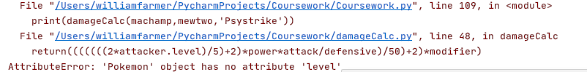

This is because in the constructor I only store level as a variable and not an attribute. I changed the code so it is now an attribute of each and every Pokémon.

When I run the following code:

print(damageCalc(arcanine,mewtwo,**'Psystrike'**))

I receive the following output:

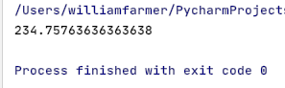

Which is one of the expected outputs. However, I need to make sure I round the output to an integer.

I changed the final return statement to



This produced an output of:

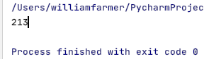

Which was one of the expected outputs, and now prints out as an integer, just as desired. I ended up putting the damageCalc function and the effectiveCheck function within the same file as they are very closely related and will help me keep track of the location of all of the modules.

Now that this has all been completed it is time to start testing:

### Testing

|  |  |  |  |  |  |
| --- | --- | --- | --- | --- | --- |
| Test number | Test type | Testing success criteria… | Accepted input | Expected output | Pass/Fail? |
|  | Normal | 2.1 | Use a special move, e.g. thunderbolt with pikachu | For the purposes of testing, the program will output “sp atk” | PASS |
|  | Normal | 2.1 | Use a physical move, e.g. body slam with snorlax | For the purposes of testing, the program will output “attack” | PASS |
|  | Normal | 2.1 | Use a physical move, e.g. body slam with snorlax | For the purposes of testing, the program will output ‘defence’ | PASS |
|  | Normal | 2.1 | Use a special move, e.g. thunderbolt with pikachu | For the purposes of testing, the program will output “sp defence” | PASS |
|  | Normal | 2.2 | Use psystrike with mewtwo against arcanine | Inflict one of the following damage in a uniform distribution:  204, 207, 210, 211, 214, 215, 216, 219, 222, 223, 226, 228, 231, 234, 235, 238, 241  depending on the random multiplier used in calculations | PASS |
|  | Normal | 2.2 | Use stone edge with rhydon against charizard | The move, unless missed the target, should cause the Charizard to always faint | PASS |
|  | Normal | 2.2 | Use petal blizzard with venusaur against arcanine | Possible damage amounts: (50, 50, 51, 51, 52, 53, 53, 54, 54, 55, 56, 56, 57, 57, 58, 59)  Depending on the random variable used in calculation | PASS |
|  | Normal | 2.1 | Use any move until you get a critical hit | Output ‘It’s a critical hit!’ if it’s a critical hit | PASS |

#### Evidencing Test Results

##### Test 1

I added in print statements solely for the purpose of testing, which print out after checking if physical or special attack and defence is meant to be used in the calculation.

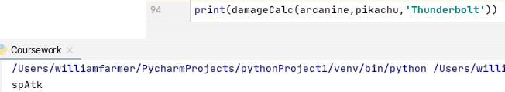  
This shows that the move was Thunderbolt, used by pikachu, of which is a special move. The program identified it was a special move, and thus used special attack, and outputted spAtk accordingly.

##### Test 2

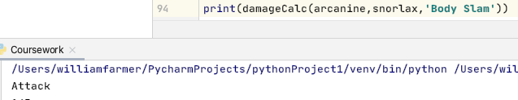

This has passed, as it was the expected output – body slam, used by snorlax, is a physical move and therefore using physical attack.

##### Test 3

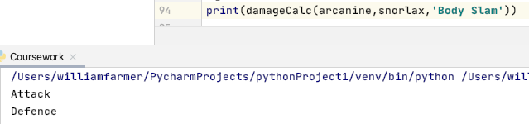

As shown, body slam, used by snorlax, is a physical move, that uses physical defence and hence defence is output.

##### Test 4

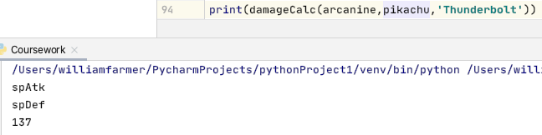

As shown, thunderbolt, used by pikachu, is a special move and hence uses special defence, which is output.

##### Test 5

This test involves multiple runs of the program in order to check that it does produce different outputs in a somewhat-uniform distribution.

The following statement is used to output the damage dealt to arcanine from mewtwo’s psystrike:



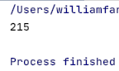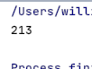I received the following outputs:

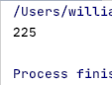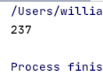

These are all expected outputs, and with 5 tests I have only received one repeat. This shows that it is varying with a somewhat uniform distribution. Therefore, this has passed

##### Test 6

I used the following statement to make rhydon use stone edge against Charizard:

print(damageCalc(charizard,rhydon,**'Stone Edge'**))

Charizard has a maximum of 266 HP. As long as in all the tests stone edge does more than this amount of damage, Charizard will be proven to always faint when hit with a stone edge.

The following damages were inflicted:

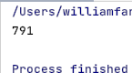

Pass

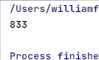

Pass

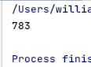

Pass

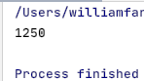

A critical hit, so ignored, as does more damage than normal.

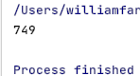

Pass

Much more damage was inflicted than the minimum 266 required to faint Charizard, so it has passed the test.

##### Test 7

The following statement is run:

print(damageCalc(arcanine,venusaur,**'Petal Blizzard'**))

to produce the following outputs:

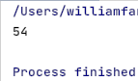

pass   
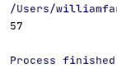 pass

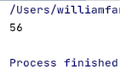

pass   
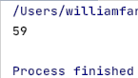 pass

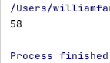

Pass

All outputs were expected, and therefore this has passed.

##### Test 8

There is no specific input for this test, I have to merely wait until I see a sharp increase in expected damage and then see if the program says it was a critical hit.

I added in the following statement:

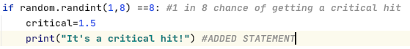

Eventually, I received the following output:

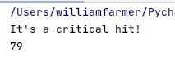

I hadn’t edited any of the code since the last test, and 79 is certainly proportionally much higher than 59, which was the highest damage output from the last test. Therefore, it has passed.

This is all the testing for this prototype complete.

#### Corrected Pseudocode

While the pseudocode does look different to my python code, the pseudocode does not actually need to be corrected, as almost all of the pseudocode in this prototype was just the logic, as I was aware the python code would be very long and repetitive.

### The program so far

#### Main File

import random  
from superEffective import superEffective  
from ineffective import ineffective  
from affect import affect  
from damageCalc import damageCalc  
class Pokemon: *#constructor and class creation* def __init__(self,name,spAtk,atk,defence,spDef,spd,hp,move1,movetype1,movepower1,moveaccuracy1,movephys1,move2,movetype2,movepower2,moveaccuracy2,movephys2,move3,movetype3,movepower3,moveaccuracy3,movephys3,move4,movetype4,movepower4,moveaccuracy4,movephys4,type1,type2,level):  
 self.level=level  
 self.name=name  
 self.spAtk=((2*spAtk*level)/100)+5  
 self.atk=((2*atk*level)/100)+5  
 self.spDef=((2*spDef*level)/100)+5  
 self.defence=((2*defence*level)/100)+5  
 self.spd=((2*spd*level)/100)+5  
 self.hp = (2*(hp*level)/100)+level+10  
 self.move1=move1  
 self.movetype1=movetype1  
 self.movepower1=movepower1  
 self.moveaccuracy1=moveaccuracy1 *#forgot to add in original prototype* self.movephys1=movephys1 *#forgot to add in original prototype* self.move2 = move2  
 self.movetype2 = movetype2  
 self.movepower2 = movepower2  
 self.moveaccuracy2 = moveaccuracy2 *#forgot to add in original prototype* self.movephys2 = movephys2 *# forgot to add in original prototype* self.move3 = move3 *#was originally a repeat of move2* self.movetype3 = movetype3  
 self.movepower3 = movepower3  
 self.moveaccuracy3 = moveaccuracy3 *#forgot to add in original prototype* self.movephys3 = movephys3 *# forgot to add in original prototype* self.move4 = move4  
 self.movetype4 = movetype4  
 self.movepower4 = movepower4  
 self.moveaccuracy4 = moveaccuracy4 *#forgot to add in original prototype* self.movephys4 = movephys4 *# forgot to add in original prototype* self.type1=type1  
 self.type2=type2  
  
  
*#instantiating Red's Pokemon*mewtwo=Pokemon(**'Mewtwo'**,154,110,90,90,130,106,**'Psystrike'**,**'Psychic'**,100,100,**'special'**,**'Aura Sphere'**,**'Fighting'**,85,100,**'special'**,**'Shadow Ball'**,**'Ghost'**,80,100,**'special'**,**'Earthquake'**,**'Ground'**,100,100,**'physical'**,**'Psychic'**,**'empty'**,100)  
snorlax=Pokemon(**'Snorlax'**,65,110,65,110,30,160,**'Body Slam'**,**'Normal'**,85,100,**'physical'**,**'High Horsepower'**,**'Ground'**,90,90,**'physical'**,**'Hammer Arm'**,**'Fighting'**,100,85,**'physical'**,**'Giga Impact'**,**'Normal'**,150,50,**'physical'**,**'Normal'**,**'empty'**,100)  
pikachu=Pokemon(**'Pikachu'**,100,110,40,55,90,35,**'Thunderbolt'**,**'Electric'**,95,100,**'special'**,**'Iron Tail'**,**'Steel'**,100,75,**'physical'**,**'Quick Attack'**,**'Normal'**,40,100,**'physical'**,**'Volt Tackle'**,**'Electric'**,120,87.5,**'physical'**,**'Electric'**,**'empty'**,100)  
charizard=Pokemon(**'Charizard'**,109,84,78,85,100,78,**'Flare Blitz'**,**'Fire'**,120,75,**'physical'**,**'Air Slash'**,**'Flying'**,75,95,**'special'**,**'Dragon Claw'**,**'Dragon'**,80,100,**'physical'**,**'Dual Wingbeat'**,**'Flying'**,80,90,**'physical'**,**'Fire'**,**'Flying'**,100)  
blastoise=Pokemon(**'Blastoise'**,85,83,100,105,78,79,**'Surf'**,**'Water'**,95,100,**'special'**,**'Ice Beam'**,**'Ice'**,95,100,**'special'**,**'Flash Cannon'**,**'Steel'**,80,100,**'special'**,**'Aura Sphere'**,**'Fighting'**,85,100,**'special'**,**'Water'**,**'Water'**,100)  
venusaur=Pokemon(**'Venusaur'**,100,82,83,100,80,80,**'Petal Blizzard'**,**'Grass'**,90,100,**'physical'**,**'Double Edge'**,**'Normal'**,120,87.5,**'physical'**,**'Sludge Bomb'**,**'Poison'**,90,100,**'special'**,**'Earth Power'**,**'Ground'**,90,100,**'special'**,**'Grass'**,**'Poison'**,100)  
  
*#Instantiating Blue's Pokemon*machamp=Pokemon(**'Machamp'**,65,130,80,85,55,90,**'Cross Chop'**,**'Fighting'**,100,80,**'physical'**,**'Dual Chop'**,**'Dragon'**,80,90,**'physical'**,**'Strength'**,**'Normal'**,80,100,**'physical'**,**'Knock Off'**,**'Dark'**,80,100,**'physical'**,**'Fighting'**,**'empty'**,100)  
pidgeot=Pokemon(**'Pidgeot'**,70,80,75,70,101,83,**'Hurricane'**,**'Flying'**,110,70,**'special'**,**'Quick Attack'**,**'Normal'**,40,100,**'physical'**,**'Double Edge'**,**'Normal'**,120,87.5,**'physical'**,**'Steel Wing'**,**'Steel'**,70,100,**'physical'**,**'Flying'**,**'Normal'**,100)  
exeggutor=Pokemon(**'Exeggutor'**,125,95,85,65,55,95,**'Wood Hammer'**,**'Grass'**,120,80,**'physical'**,**'Extrasensory'**,**'Psychic'**,80,100,**'special'**,**'Stomp'**,**'Normal'**,65,100,**'physical'**,**'Grassy Glide'**,**'Grass'**,70,100,**'physical'**,**'Grass'**,**'Psychic'**,100)  
gyarados=Pokemon(**'Gyarados'**,60,125,79,100,81,95,**'Aqua Tail'**,**'Water'**,90,90,**'physical'**,**'Earthquake'**,**'Ground'**,100,100,**'physical'**,**'Bounce'**,**'Flying'**,85,85,**'physical'**,**'Crunch'**,**'Dark'**,80,100,**'physical'**,**'Water'**,**'Flying'**,100)  
rhydon=Pokemon(**'Rhydon'**,45,130,120,45,40,105,**'Earthquake'**,**'Ground'**,100,100,**'physical'**,**'Stone Edge'**,**'Rock'**,100,80,**'physical'**,**'Rock Slide'**,**'Rock'**,75,90,**'physical'**,**'Megahorn'**,**'Bug'**,120,85,**'physical'**,**'Rock'**,**'Ground'**,100)  
arcanine=Pokemon(**'Arcanine'**,100,110,80,80,95,90,**'Flare Blitz'**,**'Fire'**,120,75,**'physical'**,**'Outrage'**,**'Dragon'**,120,75,**'physical'**,**'Extreme Speed'**,**'Normal'**,80,100,**'physical'**,**'Flamethrower'**,**'Fire'**,95,100,**'special'**,**'Fire'**,**'empty'**,100)  
  
redPok=[mewtwo,snorlax,pikachu,charizard,blastoise,venusaur] *#making it easier for rest of program*bluePok=[machamp,pidgeot,exeggutor,gyarados,rhydon,arcanine] *#making it easier for rest of program*def trainerSelect(redPok,bluePok): *#the user selects the trainer* print(**"**\n**Trainer Blue:"**)  
 for i in range(0,len(bluePok)): *#prints out all of blue's pokemon* print(bluePok[i].name)  
 print(**"**\n**Trainer Red:"**)  
 for i in range(0,len(redPok)): *#prints out all of red's pokemon* print(redPok[i].name)  
 trainer=input(**'**\n**Enter blue for Trainer Blue or red for Trainer Red'**)  
 trainer=trainer.lower()  
 while trainer != **'red'** and trainer != **'blue'**: *#validation loop* trainer = input(**'**\n**Enter blue for Trainer Blue or red for Trainer Red'**)  
 trainer=trainer.lower()  
 print(**"You have chosen Trainer"**,trainer) *#confirmation* yn=input(**"Type yes if you are happy with this trainer. otherwise, enter no."**) *#verification* yn=yn.lower()  
 while yn != **'yes'** and yn != **'no'**: *#validation loop* yn=input(**"Enter yes or no"**) *#Makes instruction clearer than before* yn=yn.lower()  
 if yn ==**'yes'**:  
 print(**"You have confirmed your choice for Trainer"**,trainer)  
 else:  
 if trainer==**'red'**:  
 trainer=**'blue'** *#swaps* else:  
 trainer=**'red'** *#swaps* print(**"You have switched to Trainer"**,trainer) *#confirmation of swap* if trainer==**'red'**:  
 userPok=redPok *#will make it easier to use later on in program* opPok=bluePok  
 else:  
 userPok=bluePok *#will make it easier to use later in program* opPok=redPok  
 for i in range(0,len(userPok)): *#prints out all of the user's battlers* print(userPok[i].name)  
 return trainer,opPok,userPok  
  
print(damageCalc(arcanine,venusaur,**'Petal Blizzard'**))

#### damageCalc.py

import random  
from superEffective import superEffective  
from ineffective import ineffective  
from affect import affect  
 *#EFFECTIVENESS CHECKER*def effectiveCheck(attacker,defender,type,power,acc):  
 effective=1 *#all moves are assumed to be neutral* types=[defender.type1,defender.type2] *#for help when checking in a for loop later on* for i in range(0,2):  
 if superEffective(type,types[i])==True:  
 effective=effective*2  
 elif ineffective(type,types[i])==True:  
 effective=effective/2  
 elif affect(type,types[i])==True:  
 effective=0  
 return effective  
  
def damageCalc(defender,attacker,move):  
 moveNames=[attacker.move1,attacker.move2,attacker.move3,attacker.move4]  
 moveTypes=[attacker.movetype1,attacker.movetype2,attacker.movetype3,attacker.movetype4]  
 movePowers=[attacker.movepower1,attacker.movepower2,attacker.movepower3,attacker.movepower4]  
 moveAccuracies=[attacker.moveaccuracy1,attacker.moveaccuracy2,attacker.moveaccuracy3,attacker.moveaccuracy4]  
 movePhyses=[attacker.movephys1,attacker.movephys2,attacker.movephys3,attacker.movephys4]  
  
 for i in range(0,4):  
 if move.lower()==moveNames[i].lower(): *#matches right attributes for the calculation* type=moveTypes[i]  
 power=movePowers[i]  
 acc=moveAccuracies[i]  
 phys=movePhyses[i]  
 if random.randint(1,8) ==8: *#1 in 8 chance of getting a critical hit* critical=1.5  
 print(**"It's a critical hit!"**) *#ADDED STATEMENT* else:  
 critical=1  
 randNum=(random.randint(88,100))/100 *#generates a random 2-decimal-place number between 0.88 and 1* if type == attacker.type1 or type == attacker.type2:  
 STAB=1.5 *#sets the same type attack bonus* else:  
 STAB=1  
 effectiveness=effectiveCheck(attacker,defender,type,power,acc) *#Checks how effective the move is* modifier=STAB*randNum*critical*effectiveness  
 if phys==**'physical'**: *#checks if move is physical* attack=attacker.atk *#uses physical attack and defence* defensive=defender.defence  
 else:  
 attack=attacker.spAtk *#otherwise uses special attack and defence* defensive=defender.spDef  
 return int(round((((((((2*attacker.level)/5)+2)*power*attack/defensive)/50)+2)*modifier),0)) *#returns the damage*

#### superEffective.py

def superEffective(atkType,defType):  
 if atkType == **'Fire'**:  
 if defType == **'Grass'** or defType ==**'Ice'** or defType ==**'Bug'** or defType ==**'Steel'**:  
 return True  
 elif atkType == **'Water'**:  
 if defType == **'Ground'** or defType ==**'Fire'** or defType ==**'Rock'**:  
 return True  
 elif atkType == **'Grass'**:  
 if defType == **'Ground'** or defType ==**'Rock'** or defType ==**'Water'**:  
 return True  
 elif atkType == **'Rock'**:  
 if defType == **'Flying'** or defType ==**'Ice'** or defType ==**'Bug'** or defType ==**'Fire'**:  
 return True  
 elif atkType == **'Electric'**:  
 if defType == **'Water'** or defType ==**'Flying'**:  
 return True  
 elif atkType == **'Fighting'**:  
 if defType == **'Rock'** or defType ==**'Ice'** or defType ==**'Normal'** or defType ==**'Steel'** or defType ==**'Dark'**:  
 return True  
 elif atkType == **'Psychic'**:  
 if defType == **'Fighting'** or defType ==**'Poison'**:  
 return True  
 elif atkType == **'Ghost'**:  
 if defType == **'Psychic'** or defType ==**'Ghost'**:  
 return True  
 elif atkType == **'Dark'**:  
 if defType == **'Psychic'** or defType ==**'Ghost'**:  
 return True  
 elif atkType == **'Ground'**:  
 if defType == **'Fire'** or defType ==**'Rock'** or defType ==**'Electric'** or defType ==**'Steel'** or defType == **'Poison'**:  
 return True  
 elif atkType == **'Steel'**:  
 if defType == **'Rock'** or defType ==**'Ice'** or defType ==**'Fairy'**:  
 return True  
 elif atkType == **'Poison'**:  
 if defType == **'Grass'**:  
 return True  
 elif atkType == **'Flying'**:  
 if defType == **'Grass'** or defType ==**'Fighting'** or defType ==**'Bug'**:  
 return True  
 elif atkType == **'Bug'**:  
 if defType == **'Grass'** or defType ==**'Psychic'** or defType ==**'Dark'**:  
 return True  
 elif atkType == **'Ice'**:  
 if defType == **'Grass'** or defType == **'Ground'** or defType == **'Dragon'** or defType ==**'Flying'**:  
 return True  
 else:  
 return False

#### ineffective.py

def ineffective(atkType,defType):  
 if atkType == **'Fire'**:  
 if defType == **'Water'** or defType == **'Rock'** or defType ==**'Fire'** or defType==**'Dragon'**:  
 return True  
 elif atkType == **'Steel'**:  
 if defType ==**'Water'** or defType ==**'Fire'** or defType ==**'Steel'** or defType ==**'Electric'**:  
 return True  
 elif atkType == **'Water'**:  
 if defType ==**'Water'** or defType ==**'Grass'** or defType ==**'Dragon'**:  
 return True  
 elif atkType ==**'Grass'**:  
 if defType == **'Fire'** or defType == **'Grass'** or defType ==**'Steel'** or defType==**'Poison'** or defType==**'Flying'** or defType ==**'Bug'** or defType ==**'Dragon'**:  
 return True  
 elif atkType == **'Normal'**:  
 if defType ==**'Rock'** or defType ==**'Steel'**:  
 return True  
 elif atkType == **'Fighting'**:  
 if defType ==**'Flying'** or defType ==**'Psychic'** or defType ==**'Poison'** or defType ==**'Bug'**:  
 return True  
 elif atkType == **'Electric'**:  
 if defType ==**'Grass'** or defType ==**'Electric'** or defType ==**'Dragon'**:  
 return True  
 elif atkType == **'Ice'**:  
 if defType ==**'Water'** or defType ==**'Fire'** or defType ==**'Steel'** or defType ==**'Ice'**:  
 return True  
 elif atkType == **'Poison'**:  
 if defType ==**'Ground'** or defType ==**'Poison'** or defType ==**'Rock'** or defType ==**'Ghost'**:  
 return True  
 elif atkType == **'Ground'**:  
 if defType ==**'Grass'** or defType ==**'Bug'**:  
 return True  
 elif atkType == **'Flying'**:  
 if defType ==**'Rock'** or defType ==**'Steel'** or defType ==**'Electric'**:  
 return True  
 elif atkType == **'Psychic'**:  
 if defType ==**'Psychic'** or defType ==**'Steel'**:  
 return True  
 elif atkType == **'Bug'**:  
 if defType ==**'Poison'** or defType ==**'Fire'** or defType ==**'Steel'** or defType ==**'Fighting'** or defType==**'Flying'** or defType==**'Ghost'**:  
 return True  
 elif atkType == **'Rock'**:  
 if defType ==**'Fighting'** or defType ==**'Ground'** or defType ==**'Steel'**:  
 return True  
 elif atkType == **'Ghost'**:  
 if defType ==**'Dark'**:  
 return True  
 elif atkType == **'Dragon'**:  
 if defType ==**'Steel'**:  
 return True  
 elif atkType == **'Dark'**:  
 if defType ==**'Fighting'** or defType ==**'Dark'**:  
 return True  
 else:  
 return False

#### affect.py

def affect(atkType,defType):  
 if atkType == **'Ghost'** and defType ==**'Normal'**:  
 return True  
 elif atkType ==**'Normal'** and defType==**'Ghost'**:  
 return True  
 elif atkType ==**'Fighting'** and defType==**'Ghost'**:  
 return True  
 elif atkType==**'Poison'** and defType==**'Steel'**:  
 return True  
 elif atkType==**'Ground'** and defType==**'Flying'**:  
 return True  
 elif atkType==**'Electric'** and defType==**'Ground'**:  
 return True  
 elif atkType==**'Psychic'** and defType==**'Dark'**:  
 return True  
 else:  
 return False

### Evaluation

#### What has been achieved?

The program now accurately calculates what damage was inflicted upon an opponent. The program has been broken up into several python files that work with each other and keep code more easily maintainable and understandable.

#### How was it tested?

I tested that the program ran without syntax errors while coding, but after finishing the prototype I conducted white-box testing to check that all the code did as it was meant to and produced the expected outputs.

#### Does it meet the success criteria?

Yes, success criterion 2 and all its subsequent sub-criteria have been met; the damage is correctly calculated, special attack and special defence are used for special moves and physical attack and physical defence are used for physical moves. The formula is used and works.

#### Was anything changed from the design section?

Somewhat, yes. I had to edit modules that were not originally supposed to be involved in this prototype as I forgot to include parts of the project earlier, but for this prototype I kept to the design section.

#### Summary of the project at this stage of development

You are able to choose which trainer you want to be and confirm that choice or change your mind. You are also able to inflict damage upon your opponent’s Pokémon. However, this can only be done once and the opponent cannot damage you back.

## Prototype 4

Prototype 4 will be covering success criterion 4, as well as its sub-criteria. This is where this project starts to turn into an actual game; the user can have a battle with an AI. The AI will choose the ‘safest’ move that can KO an opponent. By ‘safest’ I mean the highest-accuracy move or highest-priority move, to maximum the chance of a successful knockout.

### Evidencing Solution

I created a new file called AI.py, which will store every module used in this prototype.

I coded the fainted function first:

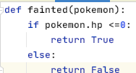

It’s very simple but quite necessary.

I then decided to code the switch function, which decides which Pokémon is the best to send out

def switch(opPok,userPok): *#passes in all AI 'mon and current user 'mon* quick=False *#to be used to check if priority move is best option* quickIdentity=[**''**,**''**] *#pokemon name, priority move name* faintMoves=[] *#list of moves that can KO user 'mon* highestDamage=0 *#in case there are no moves that KO user 'mon* highestDamageMove=**''** *#name of highest damaging move* highestDamageMon=**''** *#name of pokemon with that move*

I initialise all of these variables to be used in the decision making

I then added these statements

for i in range(0,6):  
 moves=[opPok[i].move1,opPok[i].move2,opPok[i].move3,opPok[i].move4]  
 moveAccs=[opPok[i].moveaccuracy1,opPok[i].moveaccuracy2,opPok[i].moveaccuracy3,opPok[i].moveaccuracy4]

which are used to determine which Pokémon should be sent out with regard to ‘safety’ of the move.

for x in range(0,4):  
 if damageCalc(userPok,opPok[i],moves[x]) >= userPok.hp:  
 if moves[x] ==**'Quick Attack'** or moves[x] == **'Extreme Speed'**:  
 quick=True *#signifies that there is a priority move* quickIdentity=[opPok[i],moves[x]]  
 else:  
 faintMoves.append(moves[x]) *#moves that KO* faintAccs.append(moveAccs[x])  
 elif damageCalc(userPok,opPok[i],moves[x]) > highestDamage:  
 highestDamage=damageCalc(userPok,opPok[i],moves[x])  
 highestDamageMove=moves[x] *#to be used when no KO available* highestDamageMon=opPok[i]

this was then coded to check through a Pokémon’s four moves to decide which was best/which would KO. This would run a total of 24 times as it is a nested FOR loop (four moves per Pokémon, 6 total Pokémon).

After the lists are made and appended, I need to declare which Pokémon is being sent out.

if quick == False and len(faintMoves) == 0:  
 print(**"The opponent sent out"**,highestDamageMon)  
elif quick==True:  
 print(**"The opponent sent out"**,quickIdentity[0])  
else:  
 highestAccuracyMove=**''** highestAccuracy=0  
 for i in range(0,len(faintMoves)):  
 if faintAccs[i] > highestAccuracy:  
 highestAccuracy=faintaccs[i]  
 highestAccuracyMove=faintMoves[i]

I ran this code but received a runtime error as I forgot to capitalise the ‘a’ in faintAccs.

The code was changed to this:

highestAccuracy=faintAccs[i] *#changed*

the code ran again without any runtime errors. However, there was no output as I realised I hadn’t coded one yet if there were no priority moves or ‘faint moves’. Furthermore, I had not coded a way of identifying which Pokémon could use these ‘faint moves’. I changed that by making this list:

faintAttacker=[] *#list of the pokemon who use the faintmoves*

and appending it in this statement:

faintAttacker.append(opPok[i])

which is appended at the same time as faintMoves and faintAccs

the program ran with no runtime errors. I then added these final two statements:

highestAccuracyMon=**''**

which is initialised at the same time as highestAccuracyMove and highestAccuracy, as well as

for i in range(0,len(faintMoves)):  
 if faintAccs[i] > highestAccuracy:  
 highestAccuracy=faintAccs[i] *#changed* highestAccuracyMove=faintMoves[i]  
 highestAccuracyMon=faintAttacker[i] *#just added*

I ran it again, and received no runtime errors. Finally, it is time for an output.

print(**'The opponent sent out'**,highestAccuracyMon)

ran to produce the following output:



I realised I needed to change opPok[i] to opPok[i].name every time I had used it so far.

Once I did this, the program ran to produce the following output:



It seems as though I went a bit overboard and accidently put .name at the end of things that I should not have. This was removed, and ran again:

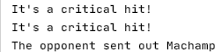

This is both a success and a failure; Machamp’s Strength is 100% accurate and should faint pikachu, but as I use the damageCalc function to check, ‘It’s a critical hit!’ is output every time it records a critical hit, even if it hasn’t been used. I will come back to this later, but for now I am going to add a print statement so I know what move the AI is thinking is best.

I ran and produced the following:

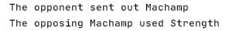

Pikachu is very fragile, so I will have Venusaur, a much bulkier Pokémon, be passed in instead. I received the following output:

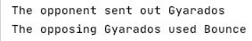

I am now adding another print statement to see what other moves were in faintMoves, to ensure that the AI is choosing the move accurate one.

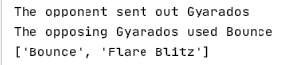

Bounce is more accurate than Flare Blitz, and so this is a good choice.

I now decided to pass Mewtwo in instead.



This is because no Pokémon can faint Mewtwo in one shot. I will print out what move it thinks pikachu should use – I assume it will be volt tackle.



This is a different output. This is because either Megahorn was a critical hit this time, or whatever move pikachu used was this time.

I ran a few more times, and received the following outputs:

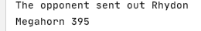

Critical hit

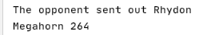

Not a critical hit

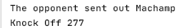

Critical hit



Not a critical hit

Therefore, it seems that megahorn is the optimum move as it does the most damage, except there are many moves that do more if they get critical hits.

I think I will keep track if it’s a critical hit or not and output it once it’s being used instead of when it decides it is going to be one.

I added the following statement when calling damageCalc from switch:

damage,crit= damageCalc(userPok,opPok[i],moves[x])

and made damageCalc return the damage, and a Boolean variable crit which would tell me if it was a critical hit or not.

I got the following output when it was run:

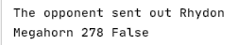

Which tells me that megahorn was used, it did 278 damage, and it wasn’t a critical hit

I ran it again, but on this occasion there was a critical hit as the move was able to faint Mewtwo:

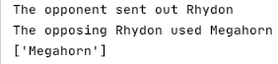

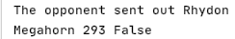  
  
  
I ran it again, and megahorn didn’t KO as it wasn’t a critical hit.  
Now that I’m comfortable that all the pathways are working, I removed the print statement I used in checking the code and moved onto the AI decision making when a Pokémon doesn’t need to be switched out.

I have now coded the following in the artificial function:

else:  
 for i in range(0,4):  
 damage=damageCalc(userPok,outPok,moves[i])[0]  
 if userPok.hp < damage and accs[i] >= faintAcc:  
 if faintMove != **'Quick Attack'** or faintMove !=**'Extreme Speed'**:  
 faintMove = moves[i]  
 faintAcc = accs[i]  
 elif highestDamage < damage and highestDamageAcc <= accs[i]:  
 highestDamage = damage  
 highestDamageMove=moves[i]  
 highestDamageAcc=accs[i]

in order to check that the priority moves are used whenever a KO is possible, I will set arcanine’s HP to 1 so that any move will KO it, and see if Pikachu uses quick attack.



That was not as desired. This is because I accidently had IF statement the wrong way round. I changed it to this:

if faintMove!=**""**:  
 print(faintMove)  
else:  
 print(highestDamageMove, highestDamage)

and ran the program. However, it produced no output. I changed the IF statement to the following in order to see if it would fix the program:

if faintMove in moves:  
 print(faintMove)  
else:  
 print(highestDamageMove, highestDamage)

this didn’t work. I wondered if arcanine’s hp was still too high, and so in the constructor I set the value of hp to 1, instead of the base hp being equal to 1.



It turns out my code was functional, I just didn’t realise that Arcanine would survive a hit from a Quick Attack at that hp. I then decided to flip the roles, to see if Arcanine’s Extreme Speed would also be prioritised.

Instead, the AI chose to use flamethrower.

When deciding the move to use, I added the following statement for testing purposes:

if faintMove != **'Quick Attack'** or faintMove !=**'Extreme Speed'**:  
 print(moves[i]) *#for testing* faintMove = moves[i]  
 faintAcc = accs[i]

and ran the code.

As expected all of arcanine’s moves are possible faintmoves

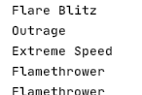

And yet it decides to use flamethrower.

print(faintMove) *#for testing*

I then changed the previous print statement to this to see if it ever assigns Extreme Speed to faintMove.

I changed the OR in the IF statement to an AND to see if that was the issue.

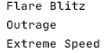

As can be seen, extreme speed is the final move assigned the faintMove. I removed the print statement used in testing and ran the code.



Perfect – I just needed to change the OR to an AND. I’ll check it again with Pikachu and Pidgeot, the other two Pokémon that have priority moves.

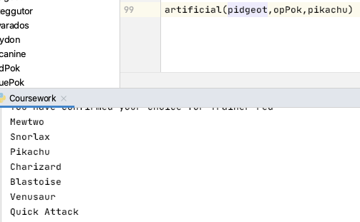

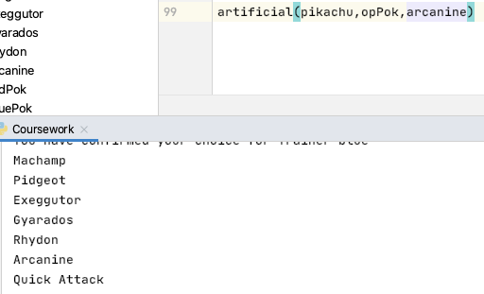

As can be seen, it works for both pikachu and Pidgeot too. I decided now was the time to check if it worked for the switch function too.

With trainer Blue being selected as the AI’s trainer, Arcanine or Pidgeot should be sent out.



And when Trainer Red is selected as the AI’s trainer, pikachu should be sent out.

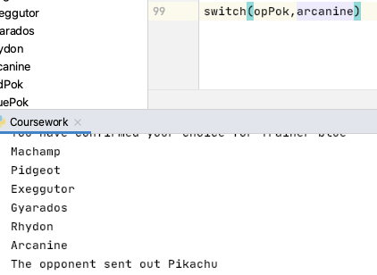

Now I’ve confirmed it chooses the correct Pokémon, it’s time to actually inflict the damage upon the user’s Pokémon.

Having added in the following statements to switch():

outMon=highestDamageMon if no move can faint opponent

outMon=quickIdentity[0] if a priority move can faint opponent

outMon=highestAccuracyMon if a non-priority move can faint opponent

and at the end of the function:  
return outMon

I then decided that the rest of the artificial function shouldn’t be in an ELSE, and instead not in an IF statement at all, as after the switch function is called the AI still needs to decide which move to use.

Now I’ve done this, I can start the code for inflicting damage upon the user’s Pokémon.

I wrote the following code:

if faintMove in moves:  
 print(faintMove)  
 userPok.hp=0  
else:  
 print(highestDamageMove, highestDamage)  
 userPok.hp=-highestDamage  
print(userPok.hp)

and ran to produce the following output:

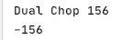

I made it so Machamp was against Mewtwo, but for some reason it assumes that Mewtwo’s HP is zero. After some re-reading of code, I realised I got the = and the – the wrong way round, so it was setting hp to the negative value of highestDamage. I swapped them back and ran again:

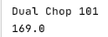

To check that the calculation is correct, I print out the hp before the calculation occurs:

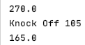

Perfect.

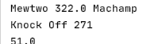

Here, the user has Mewtwo out. The game recognises that Machamp best move again Mewtwo is Knock Off, so uses it. This leaves mewtwo with 51 damage. I reverse the roles and run the program:

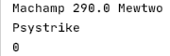

It is not necessary to print out how much damage Mewtwo does as it Psystrike is a faintMove and so has already been checked the KO Machamp.

I will now change the print statement to how they would be printed out in the finished game.

For example, with the new code the above output now looks like this:

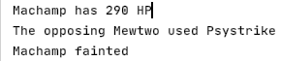

And when it doesn’t do enough damage to KO:

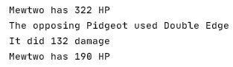

Which is also as desired.

Now I need to implement the effect of accuracy

I coded the following function:

def accuracyCheck(accuracy):  
 if randint(1,100) > accuracy:  
 return True  
 else:  
 return False

this returns True or False into a Boolean variable called miss, where the move doesn’t damage the opponent/user if miss is True.

What I noticed while running the program to check if this had worked, I noticed that the program was only using 100% accurate moves unless a faintMove was available. This is because earlier on in the program I coded this:

elif highestDamage < damage and highestDamageAcc <= accs[i]:  
 highestDamage = damage  
 highestDamageMove=moves[i]  
 highestDamageAcc=accs[i]

I removed the highestDamageAcc <= accs[i] condition as I realised I didn’t actually want this in my program.

The program now chooses the highest damage move when a faintMove isn’t available.

I am now going to check that the switch function works with the artificial function.

I am doing this by setting arcanine’s HP to 0.

I received the following error:

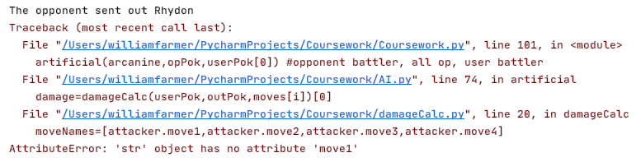

Rhydon is, in fact, the correct Pokémon to send out, but I faced an error. I believe this is because I likely returned .name of one of the objects rather than the object itself.

I changed the initial statement of return outMon

To:

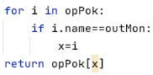

I named the variable *x* as the two variables I always use for FOR loop indices are *x* and *i.* Given that I’ve named the incrementing index *i,* I thus decided to make this one *x*. The variable will be explained in comments within the program.

And ran the code again. I then received this error:



This is because I was just meant to return x, as I forgot x wasn’t an index.

After rectifying this error I ran the code again and received the following output:

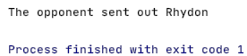

While there is no syntax or runtime error, there is a logic error. The program is meant to run through the rest of the artificial function. I implemented print statements to see where the program was stopping.

This time, I run the program and receive the output:

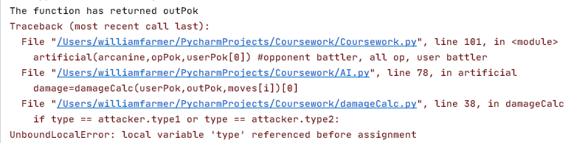

I know it’s crashing in the damageCalc function but I don’t know why as it wasn’t last time I ran the program.

I ran it again, and received no errors.

I decided to run it a further ten times to check if it was just a glitch.

On the third run, it crashed again. One the first and second it didn’t crash but didn’t make its way past the damageCalc function anyway. I added print statements to test when the game stopped.

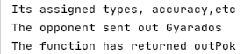

The switch function is working fine, but it the damageCalc function has only worked once.

I realised that this issue was caused as moves and accs were assigned before the switch function was called, as so:

moves=[outPok.move1,outPok.move2,outPok.move3,outPok.move4]  
accs=[outPok.moveaccuracy1,outPok.moveaccuracy2,outPok.moveaccuracy3,outPok.moveaccuracy4]  
if fainted(outPok) == True:  
 outPok = switch(opPok,userPok) *#switches out a new pokemon* print(**"The function has returned outPok"**)

and so I changed it to be:

if fainted(outPok) == True:  
 outPok = switch(opPok,userPok) *#switches out a new pokemon* print(**"The function has returned outPok"**)  
moves = [outPok.move1, outPok.move2, outPok.move3, outPok.move4]  
accs = [outPok.moveaccuracy1, outPok.moveaccuracy2, outPok.moveaccuracy3, outPok.moveaccuracy4]

I ran the program to produce the following:

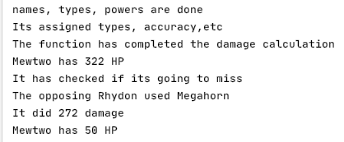

This is as expected. I went through and removed all of the testing print statements.

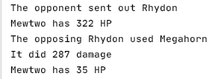

This is as expected. Mewtwo is out, and the best Pokémon to counter Mewtwo is Rhydon, and the best move Rhydon can use is Megahorn.

I now need to check that the game doesn’t send out a fainted Pokémon. This is done by a simple IF statement at the beginning of the switch function:

if not fainted(opPok[i]):

I then change how the program prints out what user is getting sent out, replacing the old statements with the following:

print(**'The Opponent sent out'**,outPok.name)

which is just underneath where the switch function is called. It produced the following output:

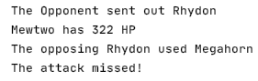

Which is expected.

Finally, I think this prototype is complete. Hence, it is time for testing.

### Testing

I replaced the justification column with a pass/fail column as they have already been justified in the design section. I changed test 4 as I did not initially anticipate Double Edge being able to OHKO pikachu.

|  |  |  |  |  |  |
| --- | --- | --- | --- | --- | --- |
| Test no. | Test Type | Testing Success Criteria… | Acceptable Input | Accepted Output | Pass/Fail |
|  | Normal | 4.1 | User sends out Arcanine vs Blastoise | Blastoise used Surf! | PASS |
|  | Normal | 4.1 | User Sends out Machamp vs Snorlax | Snorlax used Giga Impact! | PASS |
|  | Erroneous | 4.1 | User sends out Mewtwo vs Pidgeot | Pidgeot used Quick Attack! | PASS |
|  | Erroneous | 4.1 | User sends out Exeggutor vs Charizard | Pikachu used Air Slash! | PASS |
|  | Standard | 4.2 | User Snorlax causes Pokémon to faint | Trainer Blue sent out Machamp | PASS |

#### Evidencing Test results

##### Test 1

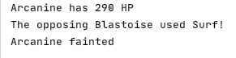

##### Test 2

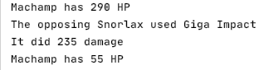

##### Test 3

This test covered a scenario I forgot to implement, so initially failed. However, I added the following code:

userMoves=[userPok.move1,userPok.move2,userPok.move3,userPok.move4]  
userDamage=[]  
for i in range(0,4):  
 damage=damageCalc(userPok,outPok,moves[i])[0]  
 userDamage.append(damageCalc(outPok,userPok,userMoves[i])[0]) *#added*

then later in the program

priority=False  
for i in range(0,len(userDamage)):  
 if userDamage[i] > outPok.hp:  
 priority=True  
if priority == True and (**'Quick Attack'** in moves or **'Extreme Speed'** in moves):  
 for x in range(0,4):  
 if moves[x] ==**'Quick Attack'** or moves[x] == **'Extreme Speed'**:  
 *highestDamageMove*=moves[x]

I ran the program again, and received the following output:

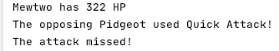

This is the correct decision, but Quick Attack should never be able to miss. This is likely because I forgot to update the accuracy variable for priority moves. Instead of searching through the code to identify where I assigned the accuracy for priority moves, I just simply removed the accuracy check for priority move damage calculation. I ran the program 10 more times to ensure it would not miss again, and that Quick Attack was still the used move.

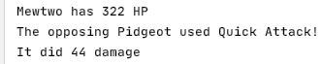

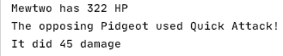

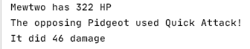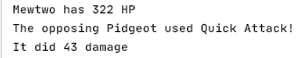

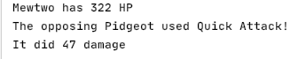

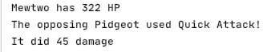



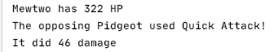

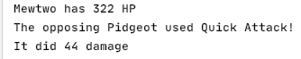

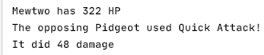

Therefore, this test passed, but only after I revisited the program and made adjustments.

##### Test 4

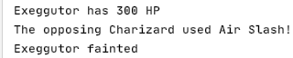

This test was implemented to see if the accuracy check worked; air slash and flare blitz would both OHKO exeguttor, but flare blitz has only 75% accuracy, whereas air slash has 95% accuracy, and therefore is the better move.

##### Test 5

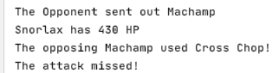

Perfect – now all these tests have been checked and passed, I can declare this prototype finished.

### The program so far

#### Main File

import random  
from AI import fainted  
from AI import switch  
from AI import artificial  
from superEffective import superEffective  
from ineffective import ineffective  
from affect import affect  
from damageCalc import damageCalc  
class Pokemon: *#constructor and class creation* def __init__(self,name,spAtk,atk,defence,spDef,spd,hp,move1,movetype1,movepower1,moveaccuracy1,movephys1,move2,movetype2,movepower2,moveaccuracy2,movephys2,move3,movetype3,movepower3,moveaccuracy3,movephys3,move4,movetype4,movepower4,moveaccuracy4,movephys4,type1,type2,level):  
 self.level=level  
 self.name=name  
 self.spAtk=((2*spAtk*level)/100)+5  
 self.atk=((2*atk*level)/100)+5  
 self.spDef=((2*spDef*level)/100)+5  
 self.defence=((2*defence*level)/100)+5  
 self.spd=((2*spd*level)/100)+5  
 self.hp = (2*(hp*level)/100)+level+10  
 self.move1=move1  
 self.movetype1=movetype1  
 self.movepower1=movepower1  
 self.moveaccuracy1=moveaccuracy1 *#forgot to add in original prototype* self.movephys1=movephys1 *#forgot to add in original prototype* self.move2 = move2  
 self.movetype2 = movetype2  
 self.movepower2 = movepower2  
 self.moveaccuracy2 = moveaccuracy2 *#forgot to add in original prototype* self.movephys2 = movephys2 *# forgot to add in original prototype* self.move3 = move3 *#was originally a repeat of move2* self.movetype3 = movetype3  
 self.movepower3 = movepower3  
 self.moveaccuracy3 = moveaccuracy3 *#forgot to add in original prototype* self.movephys3 = movephys3 *# forgot to add in original prototype* self.move4 = move4  
 self.movetype4 = movetype4  
 self.movepower4 = movepower4  
 self.moveaccuracy4 = moveaccuracy4 *#forgot to add in original prototype* self.movephys4 = movephys4 *# forgot to add in original prototype* self.type1=type1  
 self.type2=type2  
  
  
*#instantiating Red's Pokemon*mewtwo=Pokemon(**'Mewtwo'**,154,110,90,90,130,106,**'Psystrike'**,**'Psychic'**,100,100,**'special'**,**'Aura Sphere'**,**'Fighting'**,85,100,**'special'**,**'Shadow Ball'**,**'Ghost'**,80,100,**'special'**,**'Earthquake'**,**'Ground'**,100,100,**'physical'**,**'Psychic'**,**'empty'**,100)  
snorlax=Pokemon(**'Snorlax'**,65,110,65,110,30,160,**'Body Slam'**,**'Normal'**,85,100,**'physical'**,**'High Horsepower'**,**'Ground'**,90,90,**'physical'**,**'Hammer Arm'**,**'Fighting'**,100,85,**'physical'**,**'Giga Impact'**,**'Normal'**,150,50,**'physical'**,**'Normal'**,**'empty'**,100)  
pikachu=Pokemon(**'Pikachu'**,100,110,40,55,90,35,**'Thunderbolt'**,**'Electric'**,95,100,**'special'**,**'Iron Tail'**,**'Steel'**,100,75,**'physical'**,**'Quick Attack'**,**'Normal'**,40,100,**'physical'**,**'Volt Tackle'**,**'Electric'**,120,87.5,**'physical'**,**'Electric'**,**'empty'**,100)  
charizard=Pokemon(**'Charizard'**,109,84,78,85,100,78,**'Flare Blitz'**,**'Fire'**,120,75,**'physical'**,**'Air Slash'**,**'Flying'**,75,95,**'special'**,**'Dragon Claw'**,**'Dragon'**,80,100,**'physical'**,**'Dual Wingbeat'**,**'Flying'**,80,90,**'physical'**,**'Fire'**,**'Flying'**,100)  
blastoise=Pokemon(**'Blastoise'**,85,83,100,105,78,79,**'Surf'**,**'Water'**,95,100,**'special'**,**'Ice Beam'**,**'Ice'**,95,100,**'special'**,**'Flash Cannon'**,**'Steel'**,80,100,**'special'**,**'Aura Sphere'**,**'Fighting'**,85,100,**'special'**,**'Water'**,**'Water'**,100)  
venusaur=Pokemon(**'Venusaur'**,100,82,83,100,80,80,**'Petal Blizzard'**,**'Grass'**,90,100,**'physical'**,**'Double Edge'**,**'Normal'**,120,87.5,**'physical'**,**'Sludge Bomb'**,**'Poison'**,90,100,**'special'**,**'Earth Power'**,**'Ground'**,90,100,**'special'**,**'Grass'**,**'Poison'**,100)  
  
*#Instantiating Blue's Pokemon*machamp=Pokemon(**'Machamp'**,65,130,80,85,55,90,**'Cross Chop'**,**'Fighting'**,100,80,**'physical'**,**'Dual Chop'**,**'Dragon'**,80,90,**'physical'**,**'Strength'**,**'Normal'**,80,100,**'physical'**,**'Knock Off'**,**'Dark'**,80,100,**'physical'**,**'Fighting'**,**'empty'**,100)  
pidgeot=Pokemon(**'Pidgeot'**,70,80,75,70,101,83,**'Hurricane'**,**'Flying'**,110,70,**'special'**,**'Quick Attack'**,**'Normal'**,40,100,**'physical'**,**'Double Edge'**,**'Normal'**,120,87.5,**'physical'**,**'Steel Wing'**,**'Steel'**,70,100,**'physical'**,**'Flying'**,**'Normal'**,100)  
exeggutor=Pokemon(**'Exeggutor'**,125,95,85,65,55,95,**'Wood Hammer'**,**'Grass'**,120,80,**'physical'**,**'Extrasensory'**,**'Psychic'**,80,100,**'special'**,**'Stomp'**,**'Normal'**,65,100,**'physical'**,**'Grassy Glide'**,**'Grass'**,70,100,**'physical'**,**'Grass'**,**'Psychic'**,100)  
gyarados=Pokemon(**'Gyarados'**,60,125,79,100,81,95,**'Aqua Tail'**,**'Water'**,90,90,**'physical'**,**'Earthquake'**,**'Ground'**,100,100,**'physical'**,**'Bounce'**,**'Flying'**,85,85,**'physical'**,**'Crunch'**,**'Dark'**,80,100,**'physical'**,**'Water'**,**'Flying'**,100)  
rhydon=Pokemon(**'Rhydon'**,45,130,120,45,40,105,**'Earthquake'**,**'Ground'**,100,100,**'physical'**,**'Stone Edge'**,**'Rock'**,100,80,**'physical'**,**'Rock Slide'**,**'Rock'**,75,90,**'physical'**,**'Megahorn'**,**'Bug'**,120,85,**'physical'**,**'Rock'**,**'Ground'**,100)  
arcanine=Pokemon(**'Arcanine'**,100,110,80,80,95,90,**'Flare Blitz'**,**'Fire'**,120,75,**'physical'**,**'Outrage'**,**'Dragon'**,120,75,**'physical'**,**'Extreme Speed'**,**'Normal'**,80,100,**'physical'**,**'Flamethrower'**,**'Fire'**,95,100,**'special'**,**'Fire'**,**'empty'**,100)  
  
redPok=[mewtwo,snorlax,pikachu,charizard,blastoise,venusaur] *#making it easier for rest of program*bluePok=[machamp,pidgeot,exeggutor,gyarados,rhydon,arcanine] *#making it easier for rest of program*def trainerSelect(redPok,bluePok): *#the user selects the trainer* print(**"**\n**Trainer Blue:"**)  
 for i in range(0,len(bluePok)): *#prints out all of blue's pokemon* print(bluePok[i].name)  
 print(**"**\n**Trainer Red:"**)  
 for i in range(0,len(redPok)): *#prints out all of red's pokemon* print(redPok[i].name)  
 trainer=input(**'**\n**Enter blue for Trainer Blue or red for Trainer Red'**)  
 trainer=trainer.lower()  
 while trainer != **'red'** and trainer != **'blue'**: *#validation loop* trainer = input(**'**\n**Enter blue for Trainer Blue or red for Trainer Red'**)  
 trainer=trainer.lower()  
 print(**"You have chosen Trainer"**,trainer) *#confirmation* yn=input(**"Type yes if you are happy with this trainer. otherwise, enter no."**) *#verification* yn=yn.lower()  
 while yn != **'yes'** and yn != **'no'**: *#validation loop* yn=input(**"Enter yes or no"**) *#Makes instruction clearer than before* yn=yn.lower()  
 if yn ==**'yes'**:  
 print(**"You have confirmed your choice for Trainer"**,trainer)  
 else:  
 if trainer==**'red'**:  
 trainer=**'blue'** *#swaps* else:  
 trainer=**'red'** *#swaps* print(**"You have switched to Trainer"**,trainer) *#confirmation of swap* if trainer==**'red'**:  
 userPok=redPok *#will make it easier to use later on in program* opPok=bluePok  
 else:  
 userPok=bluePok *#will make it easier to use later in program* opPok=redPok  
 for i in range(0,len(userPok)): *#prints out all of the user's battlers* print(userPok[i].name)  
 return trainer,opPok,userPok  
  
  
trainer,opPok,userPok=trainerSelect(redPok,bluePok)  
artificial(opPok[0],opPok,userPok[0]) *#opponent battler, all op, user battler*

#### AI.py

from damageCalc import damageCalc  
from damageCalc import effectiveCheck  
from random import randint  
def accuracyCheck(accuracy):  
 if randint(1,100) > accuracy:  
 return True  
 else:  
 return False  
  
def fainted(pokemon):  
 if pokemon.hp <=0:  
 return True  
 else:  
 return False  
  
  
def switch(opPok,userPok): *#passes in all AI 'mon and current user 'mon* quick=False *#to be used to check if priority move is best option* quickIdentity=[**''**,**''**] *#pokemon name, priority move name* faintMoves=[] *#list of moves that can KO user 'mon* faintAccs=[] *#list of accuracies of the faintMoves* faintAttacker=[] *#list of the pokemon who use the faintmoves* highestDamage=0 *#in case there are no moves that KO user 'mon* highestDamageMove=**''** *#name of highest damaging move* highestDamageMon=**''** *#name of pokemon with that move* for i in range(0,6):  
 if not fainted(opPok[i]):  
 moves=[opPok[i].move1,opPok[i].move2,opPok[i].move3,opPok[i].move4]  
 moveAccs=[opPok[i].moveaccuracy1,opPok[i].moveaccuracy2,opPok[i].moveaccuracy3,opPok[i].moveaccuracy4]  
 for x in range(0,4):  
 damage,crit= damageCalc(userPok,opPok[i],moves[x])  
 if damage >= userPok.hp:  
 if moves[x] ==**'Quick Attack'** or moves[x] == **'Extreme Speed'**:  
 quick=True *#signifies that there is a priority move* quickIdentity=[opPok[i].name,moves[x]] *#edited* else:  
 faintMoves.append(moves[x]) *#moves that KO* faintAccs.append(moveAccs[x])  
 faintAttacker.append(opPok[i].name) *#edited* elif damage > highestDamage:  
 highestDamage=damage  
 highestDamageMove=moves[x] *#to be used when no KO available* highestDamageMon=opPok[i].name *#edited* if quick == False and len(faintMoves) == 0:  
 outMon=highestDamageMon  
 elif quick==True:  
 outMon=quickIdentity[0]  
 else:  
 highestAccuracyMove=**''** highestAccuracy=0  
 highestAccuracyMon=**''** for i in range(0,len(faintMoves)):  
 if faintAccs[i] > highestAccuracy:  
 highestAccuracy=faintAccs[i] *#changed* highestAccuracyMove=faintMoves[i]  
 highestAccuracyMon=faintAttacker[i] *#just added* outMon=highestAccuracyMon  
 for i in opPok:  
 if i.name==outMon:  
 x=i  
 return x  
  
  
def artificial(outPok,opPok,userPok):  
 faintMove=**''** faintAcc=0  
 highestDamage=0  
 highestDamageMove=**''** highestDamageAcc=0  
 userDamage=0  
 if fainted(outPok) == True:  
 outPok = switch(opPok,userPok) *#switches out a new pokemon* print(**'The Opponent sent out'**,outPok.name)  
 moves = [outPok.move1, outPok.move2, outPok.move3, outPok.move4]  
 accs = [outPok.moveaccuracy1, outPok.moveaccuracy2, outPok.moveaccuracy3, outPok.moveaccuracy4]  
 userMoves=[userPok.move1,userPok.move2,userPok.move3,userPok.move4]  
 userDamage=[]  
 for i in range(0,4):  
 damage=damageCalc(userPok,outPok,moves[i])[0]  
 if moves[i] ==**'Quick Attack'** or moves[i] == **'Extreme Speed'**:  
 priorityDamage=damage  
 userDamage.append(damageCalc(outPok,userPok,userMoves[i])[0]) *#added* if userPok.hp < damage and accs[i] >= faintAcc:  
 if faintMove != **'Quick Attack'** and faintMove !=**'Extreme Speed'**:  
 faintMove = moves[i]  
 faintAcc = accs[i]  
 elif highestDamage < damage:  
 highestDamage = damage  
 highestDamageMove=moves[i]  
 highestDamageAcc=accs[i]  
 print(userPok.name,**'has'**,int(userPok.hp),**'HP'**)  
 miss=accuracyCheck(highestDamageAcc)  
 priority=False  
 for i in range(0,len(userDamage)):  
 if userDamage[i] > outPok.hp and outPok.spd < userPok.spd:  
 priority=True  
 if priority == True and (**'Quick Attack'** in moves or **'Extreme Speed'** in moves):  
 for x in range(0,4):  
 if moves[x] ==**'Quick Attack'** or moves[x] == **'Extreme Speed'**:  
 priorityMove=moves[x]  
 print(**'The opposing'**,outPok.name,**'used '**+priorityMove+**'!'**)  
 print(**'It did'**,priorityDamage,**'damage'**)  
 elif faintMove in moves:  
 print(**'The opposing'**,outPok.name,**'used '**+faintMove+**'!'**)  
 userPok.hp=0  
 if miss:  
 print(**"The attack missed!"**)  
 else:  
 print(userPok.name,**'fainted'**)  
 else:  
 print(**'The opposing'**,outPok.name,**'used'**,highestDamageMove)  
 if miss:  
 print(**'The attack missed!'**)  
 else:  
 print(**'It did'**,highestDamage,**'damage'**)  
 userPok.hp-=highestDamage  
 print(userPok.name,**'has'**,int(userPok.hp),**'HP'**)

#### damageCalc.py

import random  
from superEffective import superEffective  
from ineffective import ineffective  
from affect import affect  
 *#EFFECTIVENESS CHECKER*def effectiveCheck(attacker,defender,type,power,acc):  
 effective=1 *#all moves are assumed to be neutral* types=[defender.type1,defender.type2] *#for help when checking in a for loop later on* for i in range(0,2):  
 if superEffective(type,types[i])==True:  
 effective=effective*2  
 elif ineffective(type,types[i])==True:  
 effective=effective/2  
 elif affect(type,types[i])==True:  
 effective=0  
 return effective  
  
def damageCalc(defender,attacker,move):  
 crit=False  
 moveNames=[attacker.move1,attacker.move2,attacker.move3,attacker.move4]  
 moveTypes=[attacker.movetype1,attacker.movetype2,attacker.movetype3,attacker.movetype4]  
 movePowers=[attacker.movepower1,attacker.movepower2,attacker.movepower3,attacker.movepower4]  
 moveAccuracies=[attacker.moveaccuracy1,attacker.moveaccuracy2,attacker.moveaccuracy3,attacker.moveaccuracy4]  
 movePhyses=[attacker.movephys1,attacker.movephys2,attacker.movephys3,attacker.movephys4]  
 for i in range(0,4):  
 if move.lower()==moveNames[i].lower(): *#matches right attributes for the calculation* type=moveTypes[i]  
 power=movePowers[i]  
 acc=moveAccuracies[i]  
 phys=movePhyses[i]  
 if random.randint(1,8) ==8: *#1 in 8 chance of getting a critical hit* critical=1.5  
 crit=True *#ADDED STATEMENT* else:  
 critical=1  
 randNum=(random.randint(88,100))/100 *#generates a random 2-decimal-place number between 0.88 and 1* if type == attacker.type1 or type == attacker.type2:  
 STAB=1.5 *#sets the same type attack bonus* else:  
 STAB=1  
 effectiveness=effectiveCheck(attacker,defender,type,power,acc) *#Checks how effective the move is* modifier=STAB*randNum*critical*effectiveness  
 if phys==**'physical'**: *#checks if move is physical* attack=attacker.atk *#uses physical attack and defence* defensive=defender.defence  
 else:  
 attack=attacker.spAtk *#otherwise uses special attack and defence* defensive=defender.spDef  
 return int(round((((((((2*attacker.level)/5)+2)*power*attack/defensive)/50)+2)*modifier),0)),crit *#returns the damage*

#### superEffective.py

def superEffective(atkType,defType):  
 if atkType == **'Fire'**:  
 if defType == **'Grass'** or defType ==**'Ice'** or defType ==**'Bug'** or defType ==**'Steel'**:  
 return True  
 elif atkType == **'Water'**:  
 if defType == **'Ground'** or defType ==**'Fire'** or defType ==**'Rock'**:  
 return True  
 elif atkType == **'Grass'**:  
 if defType == **'Ground'** or defType ==**'Rock'** or defType ==**'Water'**:  
 return True  
 elif atkType == **'Rock'**:  
 if defType == **'Flying'** or defType ==**'Ice'** or defType ==**'Bug'** or defType ==**'Fire'**:  
 return True  
 elif atkType == **'Electric'**:  
 if defType == **'Water'** or defType ==**'Flying'**:  
 return True  
 elif atkType == **'Fighting'**:  
 if defType == **'Rock'** or defType ==**'Ice'** or defType ==**'Normal'** or defType ==**'Steel'** or defType ==**'Dark'**:  
 return True  
 elif atkType == **'Psychic'**:  
 if defType == **'Fighting'** or defType ==**'Poison'**:  
 return True  
 elif atkType == **'Ghost'**:  
 if defType == **'Psychic'** or defType ==**'Ghost'**:  
 return True  
 elif atkType == **'Dark'**:  
 if defType == **'Psychic'** or defType ==**'Ghost'**:  
 return True  
 elif atkType == **'Ground'**:  
 if defType == **'Fire'** or defType ==**'Rock'** or defType ==**'Electric'** or defType ==**'Steel'** or defType == **'Poison'**:  
 return True  
 elif atkType == **'Steel'**:  
 if defType == **'Rock'** or defType ==**'Ice'** or defType ==**'Fairy'**:  
 return True  
 elif atkType == **'Poison'**:  
 if defType == **'Grass'**:  
 return True  
 elif atkType == **'Flying'**:  
 if defType == **'Grass'** or defType ==**'Fighting'** or defType ==**'Bug'**:  
 return True  
 elif atkType == **'Bug'**:  
 if defType == **'Grass'** or defType ==**'Psychic'** or defType ==**'Dark'**:  
 return True  
 elif atkType == **'Ice'**:  
 if defType == **'Grass'** or defType == **'Ground'** or defType == **'Dragon'** or defType ==**'Flying'**:  
 return True  
 else:  
 return False

#### ineffective.py

def ineffective(atkType,defType):  
 if atkType == **'Fire'**:  
 if defType == **'Water'** or defType == **'Rock'** or defType ==**'Fire'** or defType==**'Dragon'**:  
 return True  
 elif atkType == **'Steel'**:  
 if defType ==**'Water'** or defType ==**'Fire'** or defType ==**'Steel'** or defType ==**'Electric'**:  
 return True  
 elif atkType == **'Water'**:  
 if defType ==**'Water'** or defType ==**'Grass'** or defType ==**'Dragon'**:  
 return True  
 elif atkType ==**'Grass'**:  
 if defType == **'Fire'** or defType == **'Grass'** or defType ==**'Steel'** or defType==**'Poison'** or defType==**'Flying'** or defType ==**'Bug'** or defType ==**'Dragon'**:  
 return True  
 elif atkType == **'Normal'**:  
 if defType ==**'Rock'** or defType ==**'Steel'**:  
 return True  
 elif atkType == **'Fighting'**:  
 if defType ==**'Flying'** or defType ==**'Psychic'** or defType ==**'Poison'** or defType ==**'Bug'**:  
 return True  
 elif atkType == **'Electric'**:  
 if defType ==**'Grass'** or defType ==**'Electric'** or defType ==**'Dragon'**:  
 return True  
 elif atkType == **'Ice'**:  
 if defType ==**'Water'** or defType ==**'Fire'** or defType ==**'Steel'** or defType ==**'Ice'**:  
 return True  
 elif atkType == **'Poison'**:  
 if defType ==**'Ground'** or defType ==**'Poison'** or defType ==**'Rock'** or defType ==**'Ghost'**:  
 return True  
 elif atkType == **'Ground'**:  
 if defType ==**'Grass'** or defType ==**'Bug'**:  
 return True  
 elif atkType == **'Flying'**:  
 if defType ==**'Rock'** or defType ==**'Steel'** or defType ==**'Electric'**:  
 return True  
 elif atkType == **'Psychic'**:  
 if defType ==**'Psychic'** or defType ==**'Steel'**:  
 return True  
 elif atkType == **'Bug'**:  
 if defType ==**'Poison'** or defType ==**'Fire'** or defType ==**'Steel'** or defType ==**'Fighting'** or defType==**'Flying'** or defType==**'Ghost'**:  
 return True  
 elif atkType == **'Rock'**:  
 if defType ==**'Fighting'** or defType ==**'Ground'** or defType ==**'Steel'**:  
 return True  
 elif atkType == **'Ghost'**:  
 if defType ==**'Dark'**:  
 return True  
 elif atkType == **'Dragon'**:  
 if defType ==**'Steel'**:  
 return True  
 elif atkType == **'Dark'**:  
 if defType ==**'Fighting'** or defType ==**'Dark'**:  
 return True  
 else:  
 return False

#### affect.py

def affect(atkType,defType):  
 if atkType == **'Ghost'** and defType ==**'Normal'**:  
 return True  
 elif atkType ==**'Normal'** and defType==**'Ghost'**:  
 return True  
 elif atkType ==**'Fighting'** and defType==**'Ghost'**:  
 return True  
 elif atkType==**'Poison'** and defType==**'Steel'**:  
 return True  
 elif atkType==**'Ground'** and defType==**'Flying'**:  
 return True  
 elif atkType==**'Electric'** and defType==**'Ground'**:  
 return True  
 elif atkType==**'Psychic'** and defType==**'Dark'**:  
 return True  
 else:  
 return False

### Evaluation

#### What has been achieved?

There is now a fully-functioning AI, that makes decisions on what the best Pokémon to send out is, as well as what move is the best to be used – using information such as speed of the opponent, accuracies of different moves, priorities of different moves and damages of different moves.

#### How was it tested?

It was tested during coding before progressing onto next step (in order to ensure no need for massive changes at end of development), as well as formal testing at the end of development to ensure all pathways are functional.

#### Does it meet the success criteria?

Yes, the success criterion 4, as well as its sub-criteria have been met in their entirety. The success criteria states:

The AI:

Chooses the optimum move for each scenario by checking which move would do the most damage

Is still beatable

If forced to, send out the best Pokémon to counter the player’s battler

This is indeed met by the program. I cannot check whether it is beatable or not until I code the user’s sequence of the game (which is the next prototype), but as far as my estimations go at the moment, the AI is strong but not impossible, which is as desired.

#### Was anything changed from the design section?

The logic from the pseudocode and flowcharts were followed throughout coding, and while it wasn’t a straight translation from pseudocode to python, the logic was replicated and the main framework of this prototype. I did add complexity to the AI in order to make it slightly more difficult, however.

#### Summary of the project at this stage of development

In terms of playability of the game, the project is nearly complete: the user can choose a trainer and, subsequently, which Pokémon to use; the program can calculate the damage of a move and the AI can switch in a Pokémon and determine which move is the best for each scenario. All that is left is allowing the user to move, implementing the different difficulties into the game and then coding a GUI.

## Prototype 5

This prototype allows the user to choose what they want to do in battle and allows a full battle experience.

### Evidencing Solution

def user(userPok,userOutPok,opOutPok,opMove):  
 flag=-1  
 while flag ==-1:  
 choice=input(**"What do you want to do?**\n**"**)  
 while choice.lower() !=**'bag'** and choice.lower() != **'fight'** and choice.lower() !=**'pokemon'**:  
 choice=input(**"Please enter a valid input: bag, fight or pokemon**\n**"**)  
 if choice.lower() == **'fight'**:  
 possibleMoves=[[userOutPok.move1,userOutPok.move2,userOutPok.move3,userOutPok.move4],[userOutPok.moveaccuracy1,userOutPok.moveaccuracy2,userOutPok.moveaccuracy3,userOutPok.moveaccuracy4],[userOutPok.movepower1,userOutPok.movepower2,userOutPok.movepower3,userOutPok.movepower4],[userOutPok.movetype1,userOutPok.movetype2,userOutPok.movetype3,userOutPok.movetype4],[userOutPok.movephys1,userOutPok.movephys2,userOutPok.movephys3,userOutPok.movephys4]]

*The possibleMoves array stores every single bit of information to do with any available move for use later.*

*The rest of this function cannot be completed until the other function in this prototype are completed, and so they shall be done first.*

*Here is the useBag function:*

def useBag(userPok):  
 possibleItems=[**'max potion'**,**'super potion'**,**'revive'**]  
 userNames=[userPok[0].name,userPok[1].name,userPok[2].name,userPok[3].name,userPok[4].name,userPok[5].name]  
 print(**"Your available items are:"**)  
 for i in possibleItems:  
 print(i)  
 item=input(**'Which item do you want to apply?'**)  
 applyTo=input(**"What pokemon do you want to apply this item to?"**)  
 if item not in possibleItems or applyTo not in userNames:  
 flag=-1  
 for i in userPok:  
 if applyTo==i.name:  
 applyTo=i  
 if (item==possibleItems[0] or item==possibleItems[1]) and fainted(applyTo)==True and applyTo.hp >= applyTo.maxHP:  
 flag=-1  
 elif (item==possibleItems[0]) and fainted(applyTo)==False and applyTo.hp < applyTo.maxHP:  
 flag=0  
 applyTo.hp=applyTo.maxHP  
 elif item==possibleItems[1] and fainted(applyTo)==False and applyTo.hp < applyto.maxHP:  
 flag=0  
 if applyTo.hp+50 > applyTo.maxHP:  
 applyTo.hp=applyTo.maxHP  
 else:  
 applyTo.hp+=50  
 if (item==possibleItems[2]) and fainted(applyTo) == False:  
 flag=-1  
 elif item==possibleItems[2] and fainted(applyTo) == True:  
 applyTo.hp=applyTo.maxHP//2  
 flag=0  
 if flag==0:  
 print(applyTo.name, **"now has"**, applyTo.hp, **"health"**)  
 else:  
 print(**"Invalid choice"**)  
 return flag,userPok

*the validation for item and Pokémon input is in the user function in case their decision breaks the rules of the game, and so want to switch out/fight rather than use an item.*

*When ran, I encountered this error:*

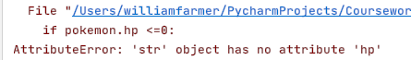

This is because applyTo wasn’t being replace by the Pokémon object, as I forgot to implement the .lower() function to remove case sensitivity. Once implemented, the code ran as the following:

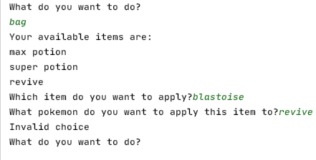

Which is just as expected.

Now I can move onto the switch function.

When I first ran the switch function, it produced the following:

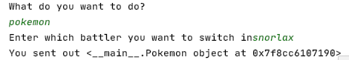

This is because I output the actual object, rather than object.name.

Upon fixing this issue, I ran the following code:

def switchUser(userOutPok,userPok):  
 unfainted=[]  
 unfaintedNames=[]  
 for i in userPok:  
 if i.hp > 0:  
 unfainted.append(i)  
 unfaintedNames.append(i.name.lower())  
 switch=input(**"Enter which battler you want to switch in"**)  
 switch=switch.lower()  
 if switch not in unfaintedNames:  
 flag=-1  
 print(**'Invalid Choice'**)  
 else:  
 flag=0  
 for i in range(0,len(unfaintedNames)):  
 if switch==unfaintedNames[i]:  
 switch=unfainted[i]  
 return flag,switch

to produce the following output:

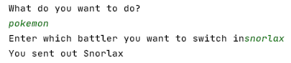

I then realised that you could waste a turn by swapping a Pokémon out for itself, e.g swapping in Mewtwo when Mewtwo is already battling, so I modified this IF statement:

if i.hp > 0:

and changed it to this:

if i.hp > 0 and i.name!=userOutPok.name: *#modified*

however, I didn’t account for the fact that it would be returning a string instead of an object, as the code wouldn’t recognise the input. So, at the end of the function, I added this:

if flag==0:  
 print(**'You sent out'**, userOutPok.name) *# declares which pokemon was swapped* return flag,switch  
else:  
 return flag,userOutPok

which ran to produce the following:

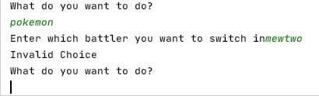

This is perfect, as mewtwo cannot be switched in to battle as it is already battling.

Next, it is onto the useMove function.

However, I realised that the useMove function was, in fact, obsolete, as the damageCalc function coded earlier performed the exact same role. Hence, I added this line of code:

userDamage,crit=damageCalc(opOutPok, userOutPok, userMove) *#calcs damage*

to be executed just before the moveOrder function.

I ran the new code and received the following output:

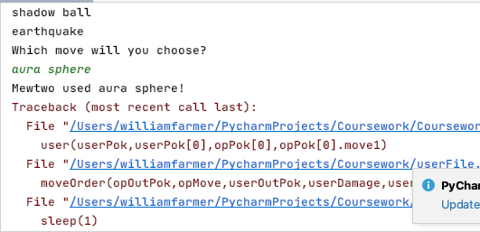

I imported the sleep function from the time library and started coding the moveOrder function. I then realised that in cases where the user chooses to use the bag or switch in a new battler instead of fighting, userDamage and userMove would be undefined. I decided to approach this issue after coding the moveOrder function so I could check to make sure the user damage calculation was working. I decided the best way for this to work was to make two smaller functions, one for inflicted damage upon the opponent, and one upon the user. This does involve rewriting some of the AI function, but ensures that there are no undefined variables.

I coded the following for the moveOrder function:

def moveOrder(opOutPok,opMove,userOutPok,userDamage,userMove):  
 priorityMoves=[**'Quick Attack'**,**'Extreme Speed'**]  
 userAccs=[userOutPok.moveaccuracy1,userOutPok.moveaccuracy2,userOutPok.moveaccuracy3,userOutPok.moveaccuracy4]  
 for i in userAccs:  
 userAcc=i  
 if ((userMove in priorityMoves) and opMove not in priorityMoves) or userOutPok.spd > opOutPok.spd:  
 opOutPok=userInflict(userOutPok,userDamage,userMove,userAcc,opOutPok)  
 if fainted(opOutPok)==False:  
 print(**"The opposing"**,opOutPok.name,**'has'**,opOutPok.hp,**'HP'**)  
 sleep(1)  
 userOutPok=opInflict(opOutPok,opMove,opAcc,userOutPok)  
 if fainted(userOutPok)==False:  
 print(userOutPok.name,**'has'**,userOutPok.hp,**'HP'**)  
 else:  
 print(**'The opposing'**,opOutPok.name,**"fainted!"**)

and the following for the userInflict function:

def userInflict(userOutPok,userDamage,userMove,userAcc,opOutPok): *#inflicts damage on opp* print(userOutPok.name, **"used "** + userMove + **'!'**)  
 sleep(1)  
 print(**'It did'**, userDamage, **'damage!'**)  
 opOutPok.hp -= userDamage  
 sleep(1)  
 return opOutPok

which ran to produce the following:

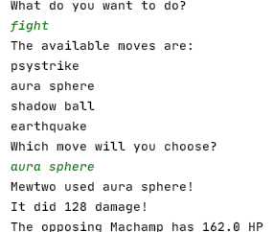

There was then a runtime error, but that was expected as I hadn’t coded the opInflict function yet which is necessary for the whole code to run. For this to work I need to have interoperability between all files in my program.

Currently, the artificial function applies damage to the user first, with no regard to speed checking or priority moves. This needs to be removed.

I changed it so it instead returned the move that was to be used and the accuracy of said move, as well as the opponent’s current battler.

if priority == True and (**'Quick Attack'** in moves or **'Extreme Speed'** in moves):  
 for x in range(0,4):  
 if moves[x] ==**'Quick Attack'** or moves[x] == **'Extreme Speed'**:  
 priorityMove=moves[x]  
 return priorityMove,100,outPok  
elif faintMove in moves:  
 return faintMove,faintAcc,outPok  
else:  
 return highestDamageMove,highestDamageAcc,outPok

I ran the code and used Psystrike to get a guaranteed OHKO, and the code ran as follows:

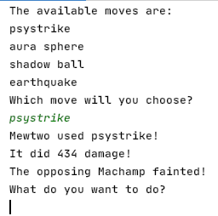

Which was as desired. I then coded the opInflict function:

def opInflict(opOutPok,opMove,opAcc,userOutPok): *#inflicts damage on user* print(opOutPok.name, **'used '** + opMove + **'!'**)  
 sleep(1)  
 print(**'It did'**, opDamage, **'damage!'**)  
 userOutPok.hp -= opDamage  
 sleep(1)  
 return userOutPok

and ran the code again:

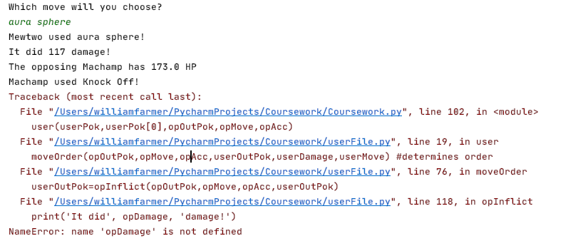

I forgot to assign a value to opDamage.

Upon fixing this issue, I remembered to add in new accuracyChecks and critical hit outputs after the old ones were deleted:

def userInflict(userOutPok,userDamage,userMove,userAcc,opOutPok,crit): *#inflicts damage on opp* print(userOutPok.name, **"used "** + userMove + **'!'**)  
 sleep(1)  
 if accuracyCheck(userAcc) == False:  
 print(**'It did'**, userDamage, **'damage!'**)  
 if crit==True:  
 print(**"It's a critical hit!"**)  
 opOutPok.hp -= userDamage  
 else:  
 print(**'The attack missed!'**)  
 sleep(1)  
 return opOutPok  
  
def opInflict(opOutPok,opMove,opAcc,userOutPok): *#inflicts damage on user* print(opOutPok.name, **'used '** + opMove + **'!'**)  
 sleep(1)  
 opDamage,opCrit=damageCalc(userOutPok,opOutPok,opMove)  
 if accuracyCheck(userAcc)==False:  
 print(**'It did'**, opDamage, **'damage!'**)  
 if opCrit==True:  
 print(**"It's a critical hit!"**)  
 userOutPok.hp -= opDamage  
 else:  
 print(**'The attack missed!'**)  
 sleep(1)  
 return userOutPok

and the code ran to produce the first full-turn of a battle in this simulator:

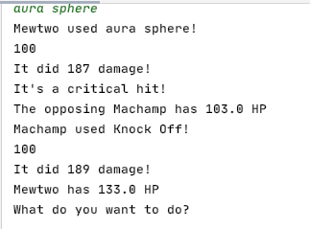

Now, I had to make it to multiple turns could be experienced. Currently there is no endgame function, so I will just make an endless while loop that I can stop with a keyboard interrupt to keep the game flowing.

However, the AI wasn’t switching out Machamp for a new Pokémon like it was supposed to.

This was because I had forgot that to keep the HPs updated for each Pokémon I needed to return it from all functions in which it was used.

I then added print statements into the main while loop:

while True:  
 opMove,opAcc,opOutPok=artificial(opPok[0],opPok,userPok[0]) *#opponent battler, all op, user battler* userPok,userOutPok,opOutPok=user(userPok,userPok[0],opOutPok,opMove,opAcc)  
 print(userOutPok.hp)

and discovered that the user function wasn’t returning, just looping itself. Upon adding ‘flag=0’ into the moveOrder function, I received the following output:

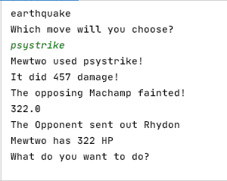

Just as desired.

However, upon battling for multiple turns multiple logic errors start to reveal themselves:

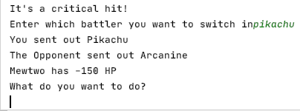

The game detects that Mewtwo has fainted and allows you to choose to switch in Pikachu, but then thinks that Mewtwo is still active in battle and with negative HP.

This is because the while loop currently always sends out opPok[0] and userPok[0].

This was edited and changed to the following:

trainer,opPok,userPok=trainerSelect(redPok,bluePok)  
  
opMove,opAcc,opOutPok=artificial(opPok[0],opPok,userPok[0]) *#opponent battler, all op, user battler*userPok,userOutPok,opOutPok=user(userPok,userPok[0],opOutPok,opMove,opAcc)  
while True:  
 opMove,opAcc,opOutPok=artificial(opOutPok,opPok,userOutPok)  
 userPok,userOutPok,opOutPok=user(userPok,userOutPok,opOutPok,opMove,opAcc)

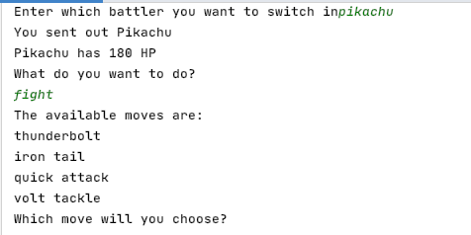

This change produced the desired outcome. Now to ensure it remains functioning I played out the full game to see if any more logic errors appeared.

Upon attempting to switch to Blastoise when the opponent sent out arcanine, the AI doesn’t use a move, giving the user a free switch-in.

I added a line after the useBag function and the switchUser function calling opInflict and ran the program.

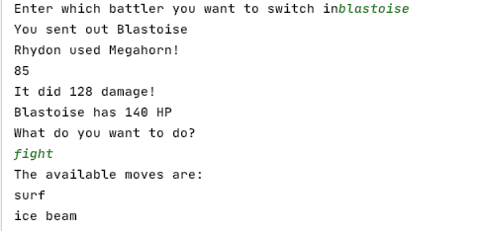

And the code worked just as desired. I decided to try play out the rest of the game to identify any more logic errors before the formal testing stage.

A few turns into the game, Snorlax and Pikachu aren’t able to use any of their moves, but are able to use the bag and to switch.

I ran the game again to see if this works early on in the game or not.

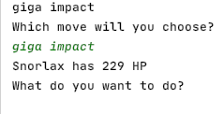

This may be an error for Pokémon who move slower than their opponent.

I realised when checking the moveOrder function that I forgot to code in an eventuality if the opponent was faster. This is obviously easy to fix, and so I coded the following:

else:  
 userOutPok=opInflict(opOutPok,opMove,opAcc,userOutPok)  
 if fainted(userOutPok)==False:  
 print(**'Your'**,userOutPok.name,**'has'**,userOutPok.hp,**'HP'**)  
 sleep(1)  
 opOutPok=userInflict(userOutPok,userDamage,userMove,userAcc,opOutPok,crit)  
 if fainted(opOutPok)==False:  
 print(opOutPok.name,**'has'**,opOutPok.hp,**'HP'**)  
 else:  
 print(**'Your'**,userOutPok.name,**'fainted!'**)

which is effectively what happens if the user is quicker, except reversed.

I ran the code to check if the aforementioned logic error was still present.

While that logic error was fixed, I encountered an error where upon entering an invalid input when the game asks you to enter a Pokémon to replace your fallen battler, the game continues (with your battler having negative health points, as seen below)

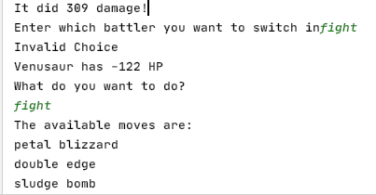

I added the following into the switchUser function to try and fix the issue:

if switch not in unfaintedNames:  
 if flag!=1:  
 flag=-1  
 print(**'Invalid Choice'**)

this means that the flag would remain at 1 and therefore would run the function again. The flag being 1 instead of -1 signifies that this swap MUST occur due to a fainted battler.

I ran it and received the following error:

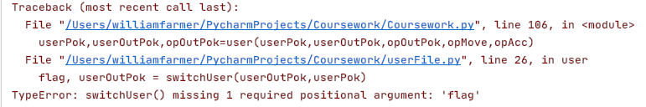  
this was fixed by adding flag as an argument to where it was called and ran again.

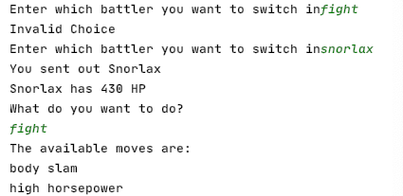

I played through an entire 6v6 battle and the only error I encountered was once the battle was completely over because the game didn’t know what to do once the AI had used all of its Pokémon up.

That’s an issue that will be addressed in the next prototype where the game can end without an abrupt error.

For now, it is time to start formally testing the prototype.

### Testing

|  |  |  |  |  |  |
| --- | --- | --- | --- | --- | --- |
| Test no. | Test Type | Testing Success Criteria… | Acceptable Input | Accepted Output | Pass/Fail? |
|  | Normal | 8.1 | Select bag on easy mode | The contents of the bag should pop up, allowing the user to select an item to apply | Pass |
|  | Erroneous | 8.1 | Select bag on medium or hard mode | The program should output “this action is not available in this mode” and not allow the user to apply an item | Unable to adequately test  At this time |
|  | Normal | 8.2 | At the beginning of the user’s turn, the user clicks ‘Pokémon’ | The program should ask the user which Pokémon they want to switch in. | Pass |
|  | Normal | 8.2 | The user should pick a non-fainted Pokémon after clicking ‘Pokémon’ at the beginning of their turn | The Pokémon the user currently has out should switch with the one that was just selected | Pass |
|  | Erroneous | 8.2 | The user should pick a fainted Pokémon after clicking ‘Pokémon’ at the beginning of their turn | The program should output “this battler has no energy left to battle” and not let that Pokémon be sent out. | Pass, after adding code  Shown in the evidencing  Section |
|  | Normal | 8.3 | The user should select ‘fight’ at the beginning of their turn | The program should output the current battler’s four moves, and await an input | Pass |
|  | Normal | 8.3 | The user should input one of the four moves and selecting ‘fight’ | The program should say which move the user used, how much damage it did, and how much HP the opponent has left, whether it was a critical hit. | Pass |
|  | Erroneous | 8.3 | After selecting ‘fight’, input a move that isn’t one of the four available moves | The program should NOT use a move, and tell the user to enter a valid move, and loop. | Pass |
|  | Normal | 8.4 | AI KOs user’s battler | The user’s available Pokémon pop up to allow the user to switch in a new Pokémon | PASS |

#### Evidencing Test Results

##### Test 1

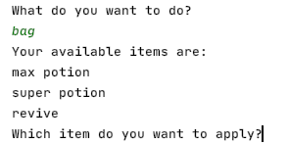

The bag is opened and its contents is outputted. Therefore, it has passed

##### Test 2

Cannot be completed until medium and hard mode have been added

##### Test 3

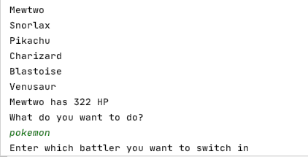

The user enters ‘Pokémon’ and is consequently given the option to switch a new battler in

##### Test 4

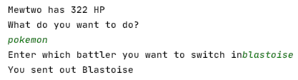

The user inputs Blastoise and hence Blastoise is sent out

##### Test 5

Code used to solve problem:

for i in userPok:  
 if i.hp > 0 and i.name!=userOutPok.name: *#modified* unfainted.append(i)  
 unfaintedNames.append(i.name.lower())  
 if i.name !=userOutPok.name: *#added to differentiate* names.append(i.name.lower()) *#added*switch=input(**"Enter which battler you want to switch in"**)  
switch=switch.lower()  
if switch not in unfaintedNames:  
 if switch in names: *#invalid vs fainted check* print(**'This battler has no energy left to battle'**)

output of code:

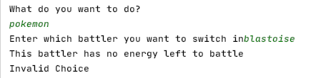

This remedial action was required, as otherwise the user would be able to fight with a Pokémon who had already been defeated. This would defeat the whole purpose of the game, as what point is there in defeating an opponent if the opponent can still fight you? Hence, the above changes were made.

##### Test 6

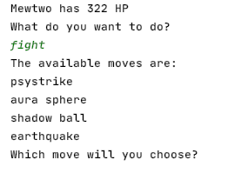

The four available moves were output as expected, therefore this passed

##### Test 7

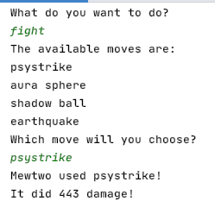

The user chose fight and one of the four moves, and hence the damage was calculated and output. This instance was not a critical hit and thus no output regarding critical hits occurred.

##### Test 8

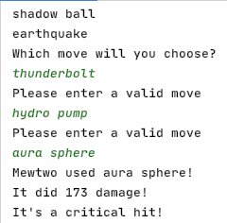

As can be seen, two invalid moves were entered and the user was told to re-enter a move. Once a valid move was entered the game continued as normal

##### Test 9

After adding the following code:

print(**'Available battlers are:'**)  
for x in unfaintedNames:  
 print(x)

I ran the code to produce the following output:

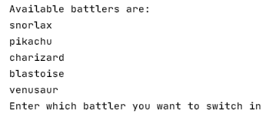

Which is as desired.

#### Additions and Debugging

I decided to make it clearer when the user’s Pokémon faints, and so added in the following lines:

if fainted(userOutPok)==False:  
 print(userOutPok.name,**'has'**,userOutPok.hp,**'HP'**)  
else:  
 print(**'Your'**,userOutPok.name,**'fainted!'**)

to ensure the user is aware that they lost a team member.

There are also times when the game outputs the HP of the user’s battler as a float rather than an integer (i.e. 300.0 rather than 300). This was changed by adding in the following:

print(**'Your'**,userOutPok.name,**'has'**,int(userOutPok.hp),**'HP'**)

Furthermore, at the beginning of the game the opponent’s battler isn’t output to the user. This means that unless the user has already played the game, they won’t know who they are initially fighting against until they choose their move.

This was solved by adding in this line:

print(**'The opponent sent out'**,opPok[0].name)

before calling user() for the first time.

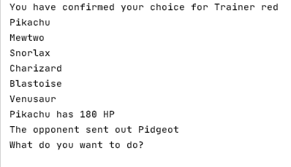

Which has worked, as can be seen in the screenshot above.

In addition, I noticed upon playing the game myself that priority moves are not working as intended.

I coded the following speed and priority checker to make it easier to understand:

def priorityCheck(userMove,opMove,priorityMoves,opSpeed,userSpeed):  
 userPriority=False  
 opPriority=False  
 if userMove in priorityMoves:  
 userPriority=True  
 if opMove in priorityMoves:  
 opPriority=True  
 if userPriority==True and opPriority==False:  
 return True  
 elif userPriority ==False and opPriority==True:  
 return False  
 elif userSpeed > opSpeed:  
 return True  
 else:  
 return False

and called it in the following IF statement:

if priorityCheck(userMove,opMove,priorityMoves,opOutPok.spd,userOutPok.spd):  
 opOutPok=userInflict(userOutPok,userDamage,userMove,userAcc,opOutPok,crit)

this worked when ran.

These were all the additions I needed to make to the program at this stage.

### The program so far

Comments are included

#### Main File

import random  
from userFile import user  
from AI import fainted  
from AI import switch  
from AI import artificial  
from superEffective import superEffective  
from ineffective import ineffective  
from affect import affect  
from damageCalc import damageCalc  
class Pokemon: *#constructor and class creation* def __init__(self,name,spAtk,atk,defence,spDef,spd,hp,move1,movetype1,movepower1,moveaccuracy1,movephys1,move2,movetype2,movepower2,moveaccuracy2,movephys2,move3,movetype3,movepower3,moveaccuracy3,movephys3,move4,movetype4,movepower4,moveaccuracy4,movephys4,type1,type2,level):  
 self.level=level  
 self.name=name  
 self.spAtk=((2*spAtk*level)/100)+5  
 self.atk=((2*atk*level)/100)+5  
 self.spDef=((2*spDef*level)/100)+5  
 self.defence=((2*defence*level)/100)+5  
 self.spd=((2*spd*level)/100)+5  
 self.hp = (2*(hp*level)/100)+level+10  
 self.maxHP=self.hp  
 self.move1=move1  
 self.movetype1=movetype1  
 self.movepower1=movepower1  
 self.moveaccuracy1=moveaccuracy1 *#forgot to add in original prototype* self.movephys1=movephys1 *#forgot to add in original prototype* self.move2 = move2  
 self.movetype2 = movetype2  
 self.movepower2 = movepower2  
 self.moveaccuracy2 = moveaccuracy2 *#forgot to add in original prototype* self.movephys2 = movephys2 *# forgot to add in original prototype* self.move3 = move3 *#was originally a repeat of move2* self.movetype3 = movetype3  
 self.movepower3 = movepower3  
 self.moveaccuracy3 = moveaccuracy3 *#forgot to add in original prototype* self.movephys3 = movephys3 *# forgot to add in original prototype* self.move4 = move4  
 self.movetype4 = movetype4  
 self.movepower4 = movepower4  
 self.moveaccuracy4 = moveaccuracy4 *#forgot to add in original prototype* self.movephys4 = movephys4 *# forgot to add in original prototype* self.type1=type1  
 self.type2=type2  
  
  
*#instantiating Red's Pokemon*mewtwo=Pokemon(**'Mewtwo'**,154,110,90,90,130,106,**'Psystrike'**,**'Psychic'**,100,100,**'special'**,**'Aura Sphere'**,**'Fighting'**,85,101,**'special'**,**'Shadow Ball'**,**'Ghost'**,80,100,**'special'**,**'Earthquake'**,**'Ground'**,100,100,**'physical'**,**'Psychic'**,**'empty'**,100)  
snorlax=Pokemon(**'Snorlax'**,65,110,65,110,30,160,**'Body Slam'**,**'Normal'**,85,100,**'physical'**,**'High Horsepower'**,**'Ground'**,90,90,**'physical'**,**'Hammer Arm'**,**'Fighting'**,100,85,**'physical'**,**'Giga Impact'**,**'Normal'**,150,50,**'physical'**,**'Normal'**,**'empty'**,100)  
pikachu=Pokemon(**'Pikachu'**,100,110,40,55,90,35,**'Thunderbolt'**,**'Electric'**,95,100,**'special'**,**'Iron Tail'**,**'Steel'**,100,75,**'physical'**,**'Quick Attack'**,**'Normal'**,40,100,**'physical'**,**'Volt Tackle'**,**'Electric'**,120,87.5,**'physical'**,**'Electric'**,**'empty'**,100)  
charizard=Pokemon(**'Charizard'**,109,84,78,85,100,78,**'Flare Blitz'**,**'Fire'**,120,75,**'physical'**,**'Air Slash'**,**'Flying'**,75,95,**'special'**,**'Dragon Claw'**,**'Dragon'**,80,100,**'physical'**,**'Dual Wingbeat'**,**'Flying'**,80,90,**'physical'**,**'Fire'**,**'Flying'**,100)  
blastoise=Pokemon(**'Blastoise'**,85,83,100,105,78,79,**'Surf'**,**'Water'**,95,100,**'special'**,**'Ice Beam'**,**'Ice'**,95,100,**'special'**,**'Flash Cannon'**,**'Steel'**,80,100,**'special'**,**'Aura Sphere'**,**'Fighting'**,85,100,**'special'**,**'Water'**,**'Water'**,100)  
venusaur=Pokemon(**'Venusaur'**,100,82,83,100,80,80,**'Petal Blizzard'**,**'Grass'**,90,100,**'physical'**,**'Double Edge'**,**'Normal'**,120,87.5,**'physical'**,**'Sludge Bomb'**,**'Poison'**,90,100,**'special'**,**'Earth Power'**,**'Ground'**,90,100,**'special'**,**'Grass'**,**'Poison'**,100)  
  
*#Instantiating Blue's Pokemon*machamp=Pokemon(**'Machamp'**,65,130,80,85,55,90,**'Cross Chop'**,**'Fighting'**,100,80,**'physical'**,**'Dual Chop'**,**'Dragon'**,80,90,**'physical'**,**'Strength'**,**'Normal'**,80,100,**'physical'**,**'Knock Off'**,**'Dark'**,80,100,**'physical'**,**'Fighting'**,**'empty'**,100)  
pidgeot=Pokemon(**'Pidgeot'**,70,80,75,70,101,83,**'Hurricane'**,**'Flying'**,110,70,**'special'**,**'Quick Attack'**,**'Normal'**,40,100,**'physical'**,**'Double Edge'**,**'Normal'**,120,87.5,**'physical'**,**'Steel Wing'**,**'Steel'**,70,100,**'physical'**,**'Flying'**,**'Normal'**,100)  
exeggutor=Pokemon(**'Exeggutor'**,125,95,85,65,55,95,**'Wood Hammer'**,**'Grass'**,120,80,**'physical'**,**'Extrasensory'**,**'Psychic'**,80,100,**'special'**,**'Stomp'**,**'Normal'**,65,100,**'physical'**,**'Grassy Glide'**,**'Grass'**,70,100,**'physical'**,**'Grass'**,**'Psychic'**,100)  
gyarados=Pokemon(**'Gyarados'**,60,125,79,100,81,95,**'Aqua Tail'**,**'Water'**,90,90,**'physical'**,**'Earthquake'**,**'Ground'**,100,100,**'physical'**,**'Bounce'**,**'Flying'**,85,85,**'physical'**,**'Crunch'**,**'Dark'**,80,100,**'physical'**,**'Water'**,**'Flying'**,100)  
rhydon=Pokemon(**'Rhydon'**,45,130,120,45,40,105,**'Earthquake'**,**'Ground'**,100,100,**'physical'**,**'Stone Edge'**,**'Rock'**,100,80,**'physical'**,**'Rock Slide'**,**'Rock'**,75,90,**'physical'**,**'Megahorn'**,**'Bug'**,120,85,**'physical'**,**'Rock'**,**'Ground'**,100)  
arcanine=Pokemon(**'Arcanine'**,100,110,80,80,95,90,**'Flare Blitz'**,**'Fire'**,120,75,**'physical'**,**'Outrage'**,**'Dragon'**,120,75,**'physical'**,**'Extreme Speed'**,**'Normal'**,80,100,**'physical'**,**'Flamethrower'**,**'Fire'**,95,100,**'special'**,**'Fire'**,**'empty'**,100)  
  
redPok=[pikachu,mewtwo,snorlax,charizard,blastoise,venusaur] *#making it easier for rest of program*bluePok=[pidgeot,machamp,exeggutor,gyarados,rhydon,arcanine] *#making it easier for rest of program*def trainerSelect(redPok,bluePok): *#the user selects the trainer* print(**"**\n**Trainer Blue:"**)  
 for i in range(0,len(bluePok)): *#prints out all of blue's pokemon* print(bluePok[i].name)  
 print(**"**\n**Trainer Red:"**)  
 for i in range(0,len(redPok)): *#prints out all of red's pokemon* print(redPok[i].name)  
 trainer=input(**'**\n**Enter blue for Trainer Blue or red for Trainer Red'**)  
 trainer=trainer.lower()  
 while trainer != **'red'** and trainer != **'blue'**: *#validation loop* trainer = input(**'**\n**Enter blue for Trainer Blue or red for Trainer Red'**)  
 trainer=trainer.lower()  
 print(**"You have chosen Trainer"**,trainer) *#confirmation* yn=input(**"Type yes if you are happy with this trainer. otherwise, enter no."**) *#verification* yn=yn.lower()  
 while yn != **'yes'** and yn != **'no'**: *#validation loop* yn=input(**"Enter yes or no"**) *#Makes instruction clearer than before* yn=yn.lower()  
 if yn ==**'yes'**:  
 print(**"You have confirmed your choice for Trainer"**,trainer)  
 else:  
 if trainer==**'red'**:  
 trainer=**'blue'** *#swaps* else:  
 trainer=**'red'** *#swaps* print(**"You have switched to Trainer"**,trainer) *#confirmation of swap* if trainer==**'red'**:  
 userPok=redPok *#will make it easier to use later on in program* opPok=bluePok  
 else:  
 userPok=bluePok *#will make it easier to use later in program* opPok=redPok  
 for i in range(0,len(userPok)): *#prints out all of the user's battlers* print(userPok[i].name)  
 return trainer,opPok,userPok  
  
  
trainer,opPok,userPok=trainerSelect(redPok,bluePok) *#allows user to choose trainer*opMove,opAcc,opOutPok=artificial(opPok[0],opPok,userPok[0]) *#gets the AI to make a decision*print(**'The opponent sent out'**,opPok[0].name) *#so the user can see who they are initially fighting*userPok,userOutPok,opOutPok=user(userPok,userPok[0],opOutPok,opMove,opAcc) *#gets user to make decision*while True: *#this will change - game has not yet got an ending* opMove,opAcc,opOutPok=artificial(opOutPok,opPok,userOutPok) *#AI makes decision first to ensure the user's   
 #decision has no influence (i.e. if the user switches battler)* userPok,userOutPok,opOutPok=user(userPok,userOutPok,opOutPok,opMove,opAcc) *#user makes decision*

#### userFile.py

from time import sleep *#used to allow users to read in time*from AI import fainted *#importing modules from other files*from damageCalc import damageCalc  
from AI import accuracyCheck  
def user(userPok,userOutPok,opOutPok,opMove,opAcc):  
 flag=-1 *#indicates an invalid input* while flag ==-1: *#will always run once* choice=input(**"What do you want to do?**\n**"**)  
 while choice.lower() !=**'bag'** and choice.lower() != **'fight'** and choice.lower() !=**'pokemon'**: *#valid options* choice=input(**"Please enter a valid input: bag, fight or pokemon**\n**"**)  
 if choice.lower() == **'fight'**: *#battle sequence* flag=0 *#shows that a valid option has been selected* possibleMoves=[[userOutPok.move1.lower(),userOutPok.move2.lower(),userOutPok.move3.lower(),userOutPok.move4.lower()],[userOutPok.moveaccuracy1,userOutPok.moveaccuracy2,userOutPok.moveaccuracy3,userOutPok.moveaccuracy4],[userOutPok.movepower1,userOutPok.movepower2,userOutPok.movepower3,userOutPok.movepower4],[userOutPok.movetype1,userOutPok.movetype2,userOutPok.movetype3,userOutPok.movetype4],[userOutPok.movephys1,userOutPok.movephys2,userOutPok.movephys3,userOutPok.movephys4]] *#names,accs,powers,types,phys* print(**'The available moves are:'**)  
 for i in possibleMoves[0]:  
 print(i) *#informs the user of the available moves* userMove=input(**'Which move will you choose?**\n**'**)  
 while userMove.lower() not in possibleMoves[0]: *#repeats until a valid move has been selected* userMove=input(**'Please enter a valid move**\n**'**)  
 userDamage,crit=damageCalc(opOutPok, userOutPok, userMove) *#calcs damage* opOutPok,userOutPok=moveOrder(opOutPok,opMove,opAcc,userOutPok,userDamage,userMove,crit) *#determines order* elif choice.lower() == **'bag'**:  
 flag,userPok = useBag(userPok) *#returns info about pokemon and flag to see if valid* userOutPok = opInflict(opOutPok, opMove, opAcc, userOutPok) *#opponent inflicts damage* else:  
 flag, userOutPok = switchUser(userOutPok,userPok,flag) *#allows user to switch pokemon* userOutPok=opInflict(opOutPok,opMove,opAcc,userOutPok) *#opponent inflicts damage* if fainted(userOutPok) == True:  
 flag=1 *#special key for this scenario* while flag==1: *#repeats until user enters valid pokemon* flag,userOutPok=switchUser(userOutPok,userPok,flag) *#user MUST switch as battler is fainted* return userPok,userOutPok,opOutPok *#returns the current battler*def useBag(userPok): *#BAG FUNCTION* possibleItems=[**'max potion'**,**'super potion'**,**'revive'**] *#available items* userNames=[userPok[0].name,userPok[1].name,userPok[2].name,userPok[3].name,userPok[4].name,userPok[5].name]  
 print(**"Your available items are:"**)  
 for i in possibleItems: *#outputs the 3 items they can use* print(i)  
 item=input(**'Which item do you want to apply?'**)  
 applyTo=input(**"What pokemon do you want to apply this item to?"**)  
 if item not in possibleItems or applyTo not in userNames:  
 flag=-1  
 for i in userPok:  
 if applyTo==i.name.lower(): *#the following is for checking if items can be validly applied* applyTo=i  
 if (item==possibleItems[0] or item==possibleItems[1]) and fainted(applyTo)==True and applyTo.hp >= applyTo.maxHP:  
 flag=-1  
 elif (item==possibleItems[0]) and fainted(applyTo)==False and applyTo.hp < applyTo.maxHP:  
 flag=0  
 applyTo.hp=applyTo.maxHP  
 elif item==possibleItems[1] and fainted(applyTo)==False and applyTo.hp < applyto.maxHP:  
 flag=0  
 if applyTo.hp+50 > applyTo.maxHP:  
 applyTo.hp=applyTo.maxHP  
 else:  
 applyTo.hp+=50  
 if (item==possibleItems[2]) and fainted(applyTo) == False:  
 flag=-1  
 elif item==possibleItems[2] and fainted(applyTo) == True:  
 applyTo.hp=applyTo.maxHP//2  
 flag=0  
 if flag==0:  
 print(applyTo.name, **"now has"**, applyTo.hp, **"health"**)  
 else:  
 print(**"Invalid choice"**) *#validation in other function* return flag,userPok *#in case user wanted to use an item they couldn't*def moveOrder(opOutPok,opMove,opAcc,userOutPok,userDamage,userMove,crit):  
 priorityMoves=[**'quick attack'**,**'extreme speed'**] *#for priority checking* userAccs=[userOutPok.moveaccuracy1,userOutPok.moveaccuracy2,userOutPok.moveaccuracy3,userOutPok.moveaccuracy4]  
 for i in userAccs:  
 userAcc=i  
 if priorityCheck(userMove,opMove,priorityMoves,opOutPok.spd,userOutPok.spd): *#checks which battler goes first* opOutPok=userInflict(userOutPok,userDamage,userMove,userAcc,opOutPok,crit)  
 if fainted(opOutPok)==False: *#see if the user can choose a move* print(**"The opposing"**,opOutPok.name,**'has'**,int(opOutPok.hp),**'HP'**)  
 sleep(1)  
 userOutPok=opInflict(opOutPok,opMove,opAcc,userOutPok) *#opponent inflicts damage* if fainted(userOutPok)==False:  
 print(userOutPok.name,**'has'**,int(userOutPok.hp),**'HP'**) *#outputs HP* else:  
 print(**'Your'**,userOutPok.name,**'fainted!'**) *#tells the user their battler has fainted* else:  
 print(**'The opposing'**,opOutPok.name,**"fainted!"**) *#tells the user their opponent has fainted* else:  
 userOutPok=opInflict(opOutPok,opMove,opAcc,userOutPok) *#effectively the same as above but inverted* if fainted(userOutPok)==False:  
 print(**'Your'**,userOutPok.name,**'has'**,int(userOutPok.hp),**'HP'**)  
 sleep(1)  
 opOutPok=userInflict(userOutPok,userDamage,userMove,userAcc,opOutPok,crit)  
 if fainted(opOutPok)==False:  
 print(opOutPok.name,**'has'**,int(opOutPok.hp),**'HP'**)  
 else:  
 print(**'The opposing'**,opOutPok.name,**'fainted!'**)  
 else:  
 print(**'Your'**,userOutPok.name,**'fainted!'**)  
 return opOutPok,userOutPok  
  
def switchUser(userOutPok,userPok,flag):  
 unfainted=[]  
 unfaintedNames=[]  
 names=[] *#to differentiate* for i in userPok:  
 if i.hp > 0 and i.name!=userOutPok.name: *#modified* unfainted.append(i)  
 unfaintedNames.append(i.name.lower())  
 if i.name !=userOutPok.name: *#added to differentiate* names.append(i.name.lower()) *#added* print(**'Available battlers are:'**)  
 for x in unfaintedNames: *#so the user doesn't have to remember their pokemon* print(x)  
 switch=input(**"Enter which battler you want to switch in"**)  
 switch=switch.lower()  
 if switch not in unfaintedNames:  
 if switch in names: *#invalid vs fainted check* print(**'This battler has no energy left to battle'**)  
 if flag!=1: *#so doesn't change when fainted* flag=-1  
 print(**'Invalid Choice'**)  
 else:  
 flag=0 *#valid selection* for i in range(0,len(unfaintedNames)):  
 if switch==unfaintedNames[i]:  
 switch=unfainted[i]  
 if flag==0:  
 print(**'You sent out'**, switch.name) *# declares which pokemon was swapped* return flag,switch  
 else:  
 return flag,userOutPok *#in case of invalidity*def userInflict(userOutPok,userDamage,userMove,userAcc,opOutPok,crit): *#inflicts damage on opp* print(userOutPok.name, **"used "** + userMove + **'!'**) *#displays user's move* sleep(1)  
 if accuracyCheck(userAcc) == False: *#if attack hits target* print(**'It did'**, userDamage, **'damage!'**)  
 if crit==True: *#so the user can see if the attack was critical hit or not* print(**"It's a critical hit!"**) *#this explains why they may see abnormally high damage output* opOutPok.hp -= userDamage *#deduction of HP* else:  
 print(**'The attack missed!'**)  
 sleep(1)  
 return opOutPok  
  
def opInflict(opOutPok,opMove,opAcc,userOutPok): *#inflicts damage on user* print(opOutPok.name, **'used '** + opMove + **'!'**) *#effectively the same as above but inverted* sleep(1)  
 opDamage,opCrit=damageCalc(userOutPok,opOutPok,opMove)  
 if accuracyCheck(opAcc)==False:  
 print(**'It did'**, opDamage, **'damage!'**)  
 if opCrit==True:  
 print(**"It's a critical hit!"**)  
 userOutPok.hp -= opDamage  
 else:  
 print(**'The attack missed!'**)  
 sleep(1)  
 return userOutPok  
  
def priorityCheck(userMove,opMove,priorityMoves,opSpeed,userSpeed): *#speed determiner* userPriority=False  
 opPriority=False  
 if userMove in priorityMoves:  
 userPriority=True  
 if opMove in priorityMoves:  
 opPriority=True  
 if userPriority==True and opPriority==False:  
 return True  
 elif userPriority ==False and opPriority==True:  
 return False  
 elif userSpeed > opSpeed:  
 return True  
 else:  
 return False

#### AI.py

from damageCalc import damageCalc  
from damageCalc import effectiveCheck  
from random import randint  
def accuracyCheck(accuracy):  
 if randint(1,100) > accuracy:  
 return True  
 else:  
 return False  
  
def fainted(pokemon):  
 if pokemon.hp <=0:  
 return True  
 else:  
 return False  
  
  
def switch(opPok,userPok): *#passes in all AI 'mon and current user 'mon* quick=False *#to be used to check if priority move is best option* quickIdentity=[**''**,**''**] *#pokemon name, priority move name* faintMoves=[] *#list of moves that can KO user 'mon* faintAccs=[] *#list of accuracies of the faintMoves* faintAttacker=[] *#list of the pokemon who use the faintmoves* highestDamage=0 *#in case there are no moves that KO user 'mon* highestDamageMove=**''** *#name of highest damaging move* highestDamageMon=**''** *#name of pokemon with that move* for i in range(0,6):  
 if not fainted(opPok[i]):  
 moves=[opPok[i].move1,opPok[i].move2,opPok[i].move3,opPok[i].move4]  
 moveAccs=[opPok[i].moveaccuracy1,opPok[i].moveaccuracy2,opPok[i].moveaccuracy3,opPok[i].moveaccuracy4]  
 for x in range(0,4):  
 damage,crit= damageCalc(userPok,opPok[i],moves[x])  
 if damage >= userPok.hp:  
 if moves[x] ==**'Quick Attack'** or moves[x] == **'Extreme Speed'**:  
 quick=True *#signifies that there is a priority move* quickIdentity=[opPok[i].name,moves[x]] *#edited* else:  
 faintMoves.append(moves[x]) *#moves that KO* faintAccs.append(moveAccs[x])  
 faintAttacker.append(opPok[i].name) *#edited* elif damage > highestDamage:  
 highestDamage=damage  
 highestDamageMove=moves[x] *#to be used when no KO available* highestDamageMon=opPok[i].name *#edited* if quick == False and len(faintMoves) == 0:  
 outMon=highestDamageMon  
 elif quick==True:  
 outMon=quickIdentity[0]  
 else:  
 highestAccuracyMove=**''** highestAccuracy=0  
 highestAccuracyMon=**''** for i in range(0,len(faintMoves)):  
 if faintAccs[i] > highestAccuracy:  
 highestAccuracy=faintAccs[i] *#changed* highestAccuracyMove=faintMoves[i]  
 highestAccuracyMon=faintAttacker[i] *#just added* outMon=highestAccuracyMon  
 for i in opPok:  
 if i.name==outMon:  
 x=i  
 return x  
  
  
def artificial(outPok,opPok,userPok):  
 faintMove=**''** faintAcc=0  
 highestDamage=0  
 highestDamageMove=**''** highestDamageAcc=0  
 userDamage=0  
 if fainted(outPok) == True:  
 outPok = switch(opPok,userPok) *#switches out a new pokemon* print(**'The Opponent sent out'**,outPok.name)  
 moves = [outPok.move1, outPok.move2, outPok.move3, outPok.move4]  
 accs = [outPok.moveaccuracy1, outPok.moveaccuracy2, outPok.moveaccuracy3, outPok.moveaccuracy4]  
 userMoves=[userPok.move1,userPok.move2,userPok.move3,userPok.move4]  
 userDamage=[]  
 for i in range(0,4):  
 damage=damageCalc(userPok,outPok,moves[i])[0]  
 if moves[i] ==**'Quick Attack'** or moves[i] == **'Extreme Speed'**:  
 priorityDamage=damage  
 userDamage.append(damageCalc(outPok,userPok,userMoves[i])[0]) *#added* if userPok.hp < damage and accs[i] >= faintAcc:  
 if faintMove != **'Quick Attack'** and faintMove !=**'Extreme Speed'**:  
 faintMove = moves[i]  
 faintAcc = accs[i]  
 elif highestDamage < damage:  
 highestDamage = damage  
 highestDamageMove=moves[i]  
 highestDamageAcc=accs[i]  
 print(userPok.name,**'has'**,int(userPok.hp),**'HP'**)  
 miss=accuracyCheck(highestDamageAcc)  
 priority=False  
 for i in range(0,len(userDamage)):  
 if userDamage[i] > outPok.hp and outPok.spd < userPok.spd:  
 priority=True  
 if priority == True and (**'Quick Attack'** in moves or **'Extreme Speed'** in moves):  
 for x in range(0,4):  
 if moves[x] ==**'Quick Attack'** or moves[x] == **'Extreme Speed'**:  
 priorityMove=moves[x]  
 return priorityMove,100,outPok  
 elif faintMove in moves:  
 return faintMove,faintAcc,outPok  
 else:  
 return highestDamageMove,highestDamageAcc,outPok

#### damageCalc.py

import random  
from superEffective import superEffective  
from ineffective import ineffective  
from affect import affect  
 *#EFFECTIVENESS CHECKER*def effectiveCheck(attacker,defender,type,power,acc):  
 effective=1 *#all moves are assumed to be neutral* types=[defender.type1,defender.type2] *#for help when checking in a for loop later on* for i in range(0,2):  
 if superEffective(type,types[i])==True:  
 effective=effective*2  
 elif ineffective(type,types[i])==True:  
 effective=effective/2  
 elif affect(type,types[i])==True:  
 effective=0  
 return effective  
  
def damageCalc(defender,attacker,move):  
 crit=False  
 moveNames=[attacker.move1,attacker.move2,attacker.move3,attacker.move4]  
 moveTypes=[attacker.movetype1,attacker.movetype2,attacker.movetype3,attacker.movetype4]  
 movePowers=[attacker.movepower1,attacker.movepower2,attacker.movepower3,attacker.movepower4]  
 moveAccuracies=[attacker.moveaccuracy1,attacker.moveaccuracy2,attacker.moveaccuracy3,attacker.moveaccuracy4]  
 movePhyses=[attacker.movephys1,attacker.movephys2,attacker.movephys3,attacker.movephys4]  
 for i in range(0,4):  
 if move.lower()==moveNames[i].lower(): *#matches right attributes for the calculation* type=moveTypes[i]  
 power=movePowers[i]  
 acc=moveAccuracies[i]  
 phys=movePhyses[i]  
 if random.randint(1,8) ==8: *#1 in 8 chance of getting a critical hit* critical=1.5  
 crit=True *#ADDED STATEMENT* else:  
 critical=1  
 randNum=(random.randint(88,100))/100 *#generates a random 2-decimal-place number between 0.88 and 1* if type == attacker.type1 or type == attacker.type2:  
 STAB=1.5 *#sets the same type attack bonus* else:  
 STAB=1  
 effectiveness=effectiveCheck(attacker,defender,type,power,acc) *#Checks how effective the move is* modifier=STAB*randNum*critical*effectiveness  
 if phys==**'physical'**: *#checks if move is physical* attack=attacker.atk *#uses physical attack and defence* defensive=defender.defence  
 else:  
 attack=attacker.spAtk *#otherwise uses special attack and defence* defensive=defender.spDef  
 return int(round((((((((2*attacker.level)/5)+2)*power*attack/defensive)/50)+2)*modifier),0)),crit *#returns the damage*

#### Other Files

superEffective.py, ineffective.py and affect.py are all identical when previously shown.

### Evaluation

#### What has been achieved?

The user can choose to use a move against their opponent, use a healing item from the bag and switch out to a different battler.

In addition, the game is a fully-operational text-based game. The AI makes a decision, the user then makes their decision and the game checks who goes first. This then repeats, with damage being inflicted (or healed) until one team has no more available battlers. The game has suitable validation in place so no unexpected inputs are accepted.

#### How was it tested?

The game was informally tested during development to ensure I didn’t get ahead of myself – each time I coded a large section of the game I ran the code to ensure it could progress, and then I coded the section that would chronologically follow. After I deemed the prototype complete, I performed formal testing using the test plan I had already made in the design section.

#### Does it meet the success criteria?

Yes, Success Criterion 8 and its subsequent sub-criteria have been mostly met, with the only unmet criteria being ones involving difficulty settings. The user can select the bag (no difficulties have been coded as of this prototype) and switch Pokémon. The user can also inflict damage upon the opponent using moves they select.

#### Was anything changed from the design section?

The logic of the design section was preserved, but I modularised further sections of code to help make it more maintainable and understandable, as this prototype contained a lot of new code that performed very different tasks (for example, the priorityCheck function was much more easily understandable in a new function than within the moveOrder function).

Other than that, however, this prototyped mirrored the design section.

#### Summary of the project at this stage of development

So far, the user is able to select which trainer (and subsequently which Pokémon) they want to use; the AI can make competitive decisions; the game performs accurate damage calculations; the user can make decisions and the game loops as intended to allow the user to play a full round-based game (with each round being one pass of a while loop). All that is needed to finish the game is a GUI, an ending and the addition of difficulty settings.

## Prototype 6

This prototype will completely cover Success Criterion 7, allowing the game to end error-free, with a suitable message displayed if the user wins or loses. This will be implemented by checking if all of user’s team has fainted, or if all the opponent’s has. If neither have fully fainted teams, the game continued as normal. Otherwise, a function is called and the while loop keeping the game running ends.

### Evidencing solution

Before I implement a condition that ends the while loop keeping the game running, I need to code the endCheck and gameEnd functions first. These functions will together produce an output at the end of the game, and check if the while loop should keep running or not.

Importing the fainted() function was the first thing I added to the new file as the game ends when all Pokémon on one team has fainted, so the fainted() function is used to check this.

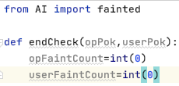

* The fainted function is imported
* opPok and userPok are passed into endCheck and these will be used to check the HP of each Pokémon
* opFaintCount and userFaintCount will store how many of the user’s and AI’s battlers have fainted

Adding the FOR loop was the next section of the function that needed to be added:

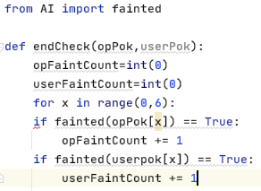

* This runs through each item in opPok and userPok and checks if they have fainted or not
* If they have fainted, the counter should increase by one
* I then realised that the IF statements were indented incorrectly as I pasted them in from my pseudocode. This was fixed.

The code ran to produce the following:

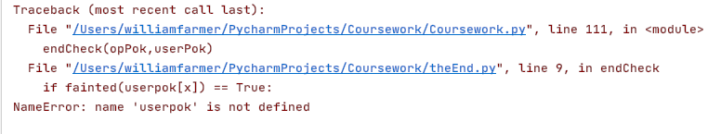

* This was because I forgot to capitalise the ‘p’ in userPok. This was corrected.

The code was run again:

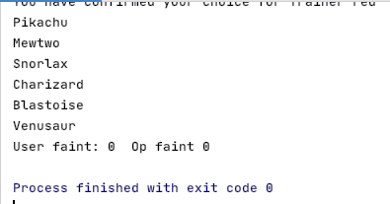

* This is as desired
* At this stage in the game, the user had no fainted Pokémon and neither did the opponent
* Hence, I moved onwards and coded the following:

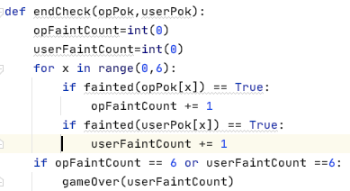

* This checks that one team no longer has any available battlers and hence calls the gameOver function.
* Therefore, the gameOver function needs to be coded.

def gameOver(userFaintCount):  
 if userFaintCount == 6:  
 print(**"Unlucky!"**)  
 sleep(0.5)  
 print(**"This time the opponent has beaten you"**)  
 print(**"But come bck again and show them what you're really made of!"**)

* This is what the program does if the user loses
* Hence why it checks if the user has 6 fainted battlers
* Only userFaintCount is passed in as *either* one of the AI *or* the user can have all their battlers fainted at once
* Therefore, and IF…ELSE is all that required rather than IF…ELIF…ELSE

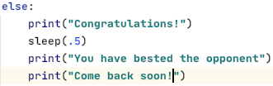

* This is what is output when the user wins
* This can only be tested if the one team loses
  + So I moved onto the changing the WHILE loop condition

while True: *#this will change - game has not yet got an ending*

* This was only implemented as no ending was coded onto the game
  + Was always designed to be changed

I then realised that I actually needed endCheck to return opFaintCount and userFaintCount so it could be used as a condition in the while loop

return opFaintCount,userFaintCount

* And thus the while loop was changed to:

while userFaintCount < 6 and opFaintCount < 6:

* I also added this into the while loop:

opFaintCount,userFaintCount=endCheck(opPok,userPok)

* I then added this after the while loop:

gameOver(userFaintCount)

* So that it will be called after one team has had their Pokémon fainted
* I ran the code, and received the following output:

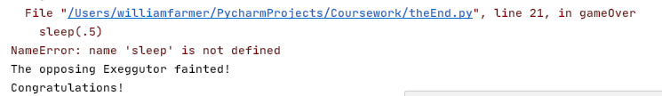

* This is a slight success
  + The game recognises the user won and displays part of the message
  + But I forgot to import the time library and so a runtime error occurred
* I imported time from the library module and ran again:

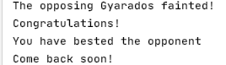

* As can be seen, the game finishes and the program identifies that the user has won
* Therefore, the winning message was output
* I will now test this if the user loses:

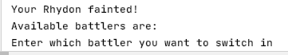

* Here, the game is not identifying that the user has lost
* I decide to print out opFaintCount and userFaintCount after each pass of the while loop to determine whether the counting is incorrect or if the condition is wrong
* I concluded that the condition was right, it was just the way that I wrote the user function
  + The game realises the user has a fainted Pokémon and asks the user to enter their new one before the turn ends, meaning that they will be asked to input even if theres no one left
* I fixed this error by passing opPok() into the user() function
  + Then, I changed the compulsory switch-in code to this:

if fainted(userOutPok) == True:  
 if endCheck(opPok,userPok)[1] != 6: *#check if any left* flag=1 *#special key for this scenario* while flag==1: *#repeats until user enters valid pokemon* flag,userOutPok=switchUser(userOutPok,userPok,flag) *#user MUST switch as battler is fainted*return userPok,userOutPok,opOutPok *#returns the current battler*

I ran the code and it produced the following output:

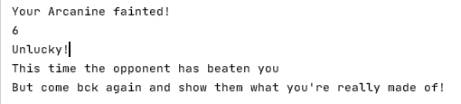

Perfect! The output for how many Pokémon were fainted was then removed as the testing was not necessary anymore.

Both of these tests were conducted when Trainer Blue lost, so I need to make sure that if Trainer Red loses the same outputs occur.

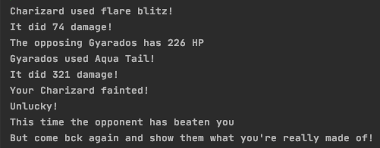

This is as desired, save for the spelling mistake which was corrected. To be absolutely certain that this prototype is complete, I want the user to use Trainer Blue to defeat Trainer Red just in case.

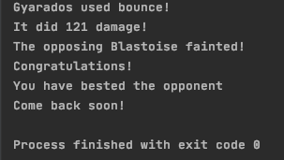

Finally I can declare this prototype ready for terminal testing.

### Testing

|  |  |  |  |  |  |
| --- | --- | --- | --- | --- | --- |
| Test no. | Test Type | Testing Success Criteria… | Acceptable Input | Accepted Output | PASS/FAIL? |
|  | Standard | 7.1 | User faints all AI’s Pokémon | Congratulations! You have bested the opponent. Come back soon! | Pass |
|  | Standard | 7.2 | User loses to AI | Unlucky! This time, the opponent has beaten you, but come back and show them what you’re really made of! | Pass |
|  | Standard | 7 | One side loses | “Game Over” // *this is then followed by the appropriate message from one of the above tests* | Pass |

#### Evidencing Test Results

The test plan was very small, but so was the prototype in general; simply just a needed step to be taken.

##### Test 1

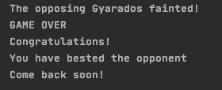

As can be seen, the game finishes when the user knocks out all of the opposing battlers and the message is the same as in the test plan

##### Test 2



As can be seen, the game finishes when all the user’s Pokémon have fainted, with the message being the same as in the test plan.

##### Test 3

See above two screenshots.

### The program so far

#### Main File

import random  
from userFile import user  
from AI import fainted  
from AI import switch  
from AI import artificial  
from superEffective import superEffective  
from ineffective import ineffective  
from affect import affect  
from damageCalc import damageCalc  
from theEnd import endCheck  
from theEnd import gameOver  
class Pokemon: #constructor and class creation  
 def __init__(self,name,spAtk,atk,defence,spDef,spd,hp,move1,movetype1,movepower1,moveaccuracy1,movephys1,move2,movetype2,movepower2,moveaccuracy2,movephys2,move3,movetype3,movepower3,moveaccuracy3,movephys3,move4,movetype4,movepower4,moveaccuracy4,movephys4,type1,type2,level):  
 self.level=level  
 self.name=name  
 self.spAtk=((2*spAtk*level)/100)+5  
 self.atk=((2*atk*level)/100)+5  
 self.spDef=((2*spDef*level)/100)+5  
 self.defence=((2*defence*level)/100)+5  
 self.spd=((2*spd*level)/100)+5  
 self.hp = (2*(hp*level)/100)+level+10  
 self.maxHP=self.hp  
 self.move1=move1  
 self.movetype1=movetype1  
 self.movepower1=movepower1  
 self.moveaccuracy1=moveaccuracy1 #forgot to add in original prototype  
 self.movephys1=movephys1 #forgot to add in original prototype  
 self.move2 = move2  
 self.movetype2 = movetype2  
 self.movepower2 = movepower2  
 self.moveaccuracy2 = moveaccuracy2 #forgot to add in original prototype  
 self.movephys2 = movephys2 # forgot to add in original prototype  
 self.move3 = move3 #was originally a repeat of move2  
 self.movetype3 = movetype3  
 self.movepower3 = movepower3  
 self.moveaccuracy3 = moveaccuracy3 #forgot to add in original prototype  
 self.movephys3 = movephys3 # forgot to add in original prototype  
 self.move4 = move4  
 self.movetype4 = movetype4  
 self.movepower4 = movepower4  
 self.moveaccuracy4 = moveaccuracy4 #forgot to add in original prototype  
 self.movephys4 = movephys4 # forgot to add in original prototype  
 self.type1=type1  
 self.type2=type2  
  
  
#instantiating Red's Pokemon  
mewtwo=Pokemon('Mewtwo',154,110,90,90,130,106,'Psystrike','Psychic',100,100,'special','Aura Sphere','Fighting',85,101,'special','Shadow Ball','Ghost',80,100,'special','Earthquake','Ground',100,100,'physical','Psychic','empty',100)  
snorlax=Pokemon('Snorlax',65,110,65,110,30,160,'Body Slam','Normal',85,100,'physical','High Horsepower','Ground',90,90,'physical','Hammer Arm','Fighting',100,85,'physical','Giga Impact','Normal',150,50,'physical','Normal','empty',100)  
pikachu=Pokemon('Pikachu',100,110,40,55,90,35,'Thunderbolt','Electric',95,100,'special','Iron Tail','Steel',100,75,'physical','Quick Attack','Normal',40,100,'physical','Volt Tackle','Electric',120,87.5,'physical','Electric','empty',100)  
charizard=Pokemon('Charizard',109,84,78,85,100,78,'Flare Blitz','Fire',120,75,'physical','Air Slash','Flying',75,95,'special','Dragon Claw','Dragon',80,100,'physical','Dual Wingbeat','Flying',80,90,'physical','Fire','Flying',100)  
blastoise=Pokemon('Blastoise',85,83,100,105,78,79,'Surf','Water',95,100,'special','Ice Beam','Ice',95,100,'special','Flash Cannon','Steel',80,100,'special','Aura Sphere','Fighting',85,100,'special','Water','Water',100)  
venusaur=Pokemon('Venusaur',100,82,83,100,80,80,'Petal Blizzard','Grass',90,100,'physical','Double Edge','Normal',120,87.5,'physical','Sludge Bomb','Poison',90,100,'special','Earth Power','Ground',90,100,'special','Grass','Poison',100)  
  
#Instantiating Blue's Pokemon  
machamp=Pokemon('Machamp',65,130,80,85,55,90,'Cross Chop','Fighting',100,80,'physical','Dual Chop','Dragon',80,90,'physical','Strength','Normal',80,100,'physical','Knock Off','Dark',80,100,'physical','Fighting','empty',100)  
pidgeot=Pokemon('Pidgeot',70,80,75,70,101,83,'Hurricane','Flying',110,70,'special','Quick Attack','Normal',40,100,'physical','Double Edge','Normal',120,87.5,'physical','Steel Wing','Steel',70,100,'physical','Flying','Normal',100)  
exeggutor=Pokemon('Exeggutor',125,95,85,65,55,95,'Wood Hammer','Grass',120,80,'physical','Extrasensory','Psychic',80,100,'special','Stomp','Normal',65,100,'physical','Grassy Glide','Grass',70,100,'physical','Grass','Psychic',100)  
gyarados=Pokemon('Gyarados',60,125,79,100,81,95,'Aqua Tail','Water',90,90,'physical','Earthquake','Ground',100,100,'physical','Bounce','Flying',85,85,'physical','Crunch','Dark',80,100,'physical','Water','Flying',100)  
rhydon=Pokemon('Rhydon',45,130,120,45,40,105,'Earthquake','Ground',100,100,'physical','Stone Edge','Rock',100,80,'physical','Rock Slide','Rock',75,90,'physical','Megahorn','Bug',120,85,'physical','Rock','Ground',100)  
arcanine=Pokemon('Arcanine',100,110,80,80,95,90,'Flare Blitz','Fire',120,75,'physical','Outrage','Dragon',120,75,'physical','Extreme Speed','Normal',80,100,'physical','Flamethrower','Fire',95,100,'special','Fire','empty',100)  
  
redPok=[pikachu,mewtwo,snorlax,charizard,blastoise,venusaur] #making it easier for rest of program  
bluePok=[pidgeot,machamp,exeggutor,gyarados,rhydon,arcanine] #making it easier for rest of program  
def trainerSelect(redPok,bluePok): #the user selects the trainer  
 print("\nTrainer Blue:")  
 for i in range(0,len(bluePok)): #prints out all of blue's pokemon  
 print(bluePok[i].name)  
 print("\nTrainer Red:")  
 for i in range(0,len(redPok)): #prints out all of red's pokemon  
 print(redPok[i].name)  
 trainer=input('\nEnter blue for Trainer Blue or red for Trainer Red')  
 trainer=trainer.lower()  
 while trainer != 'red' and trainer != 'blue': #validation loop  
 trainer = input('\nEnter blue for Trainer Blue or red for Trainer Red')  
 trainer=trainer.lower()  
 print("You have chosen Trainer",trainer) #confirmation  
 yn=input("Type yes if you are happy with this trainer. otherwise, enter no.") #verification  
 yn=yn.lower()  
 while yn != 'yes' and yn != 'no': #validation loop  
 yn=input("Enter yes or no") #Makes instruction clearer than before  
 yn=yn.lower()  
 if yn =='yes':  
 print("You have confirmed your choice for Trainer",trainer)  
 else:  
 if trainer=='red':  
 trainer='blue' #swaps  
 else:  
 trainer='red' #swaps  
 print("You have switched to Trainer",trainer) #confirmation of swap  
 if trainer=='red':  
 userPok=redPok #will make it easier to use later on in program  
 opPok=bluePok  
 else:  
 userPok=bluePok #will make it easier to use later in program  
 opPok=redPok  
 for i in range(0,len(userPok)): #prints out all of the user's battlers  
 print(userPok[i].name)  
 return trainer,opPok,userPok  
  
  
trainer,opPok,userPok=trainerSelect(redPok,bluePok) #allows user to choose trainer  
opFaintCount,userFaintCount=0,0  
opMove,opAcc,opOutPok=artificial(opPok[0],opPok,userPok[0]) #gets the AI to make a decision  
print('The opponent sent out',opPok[0].name) #so the user can see who they are initially fighting  
userPok,userOutPok,opOutPok=user(userPok,userPok[0],opOutPok,opMove,opAcc,opPok) #gets user to make decision  
while userFaintCount < 6 and opFaintCount < 6:  
 opMove,opAcc,opOutPok=artificial(opOutPok,opPok,userOutPok) #AI makes decision first to ensure the user's  
 #decision has no influence (i.e. if the user switches battler)  
 userPok,userOutPok,opOutPok=user(userPok,userOutPok,opOutPok,opMove,opAcc,opPok) #user makes decision  
 opFaintCount,userFaintCount=endCheck(opPok,userPok)  
  
gameOver(userFaintCount)

#### userFile.py

from time import sleep #used to allow users to read in time  
from AI import fainted #importing modules from other files  
from damageCalc import damageCalc  
from AI import accuracyCheck  
from theEnd import endCheck  
def user(userPok,userOutPok,opOutPok,opMove,opAcc,opPok):  
 flag=-1 #indicates an invalid input  
 while flag ==-1: #will always run once  
 choice=input("What do you want to do?\n")  
 while choice.lower() !='bag' and choice.lower() != 'fight' and choice.lower() !='pokemon': #valid options  
 choice=input("Please enter a valid input: bag, fight or pokemon\n")  
 if choice.lower() == 'fight': #battle sequence  
 flag=0 #shows that a valid option has been selected  
 possibleMoves=[[userOutPok.move1.lower(),userOutPok.move2.lower(),userOutPok.move3.lower(),userOutPok.move4.lower()],[userOutPok.moveaccuracy1,userOutPok.moveaccuracy2,userOutPok.moveaccuracy3,userOutPok.moveaccuracy4],[userOutPok.movepower1,userOutPok.movepower2,userOutPok.movepower3,userOutPok.movepower4],[userOutPok.movetype1,userOutPok.movetype2,userOutPok.movetype3,userOutPok.movetype4],[userOutPok.movephys1,userOutPok.movephys2,userOutPok.movephys3,userOutPok.movephys4]] #names,accs,powers,types,phys  
 print('The available moves are:')  
 for i in possibleMoves[0]:  
 print(i) #informs the user of the available moves  
 userMove=input('Which move will you choose?\n')  
 while userMove.lower() not in possibleMoves[0]: #repeats until a valid move has been selected  
 userMove=input('Please enter a valid move\n')  
 userDamage,crit,moveAcc=damageCalc(opOutPok, userOutPok, userMove) #calcs damage  
 opOutPok,userOutPok=moveOrder(opOutPok,opMove,opAcc,userOutPok,userDamage,userMove,crit,moveAcc) #determines order  
 elif choice.lower() == 'bag':  
 flag,userPok = useBag(userPok) #returns info about pokemon and flag to see if valid  
 userOutPok = opInflict(opOutPok, opMove, opAcc, userOutPok) #opponent inflicts damage  
 else:  
 flag, userOutPok = switchUser(userOutPok,userPok,flag) #allows user to switch pokemon  
 userOutPok=opInflict(opOutPok,opMove,opAcc,userOutPok) #opponent inflicts damage  
  
  
 if fainted(userOutPok) == True:  
 if endCheck(opPok,userPok)[1] != 6: #check if any left  
 flag=1 #special key for this scenario  
 while flag==1: #repeats until user enters valid pokemon  
 flag,userOutPok=switchUser(userOutPok,userPok,flag) #user MUST switch as battler is fainted  
 return userPok,userOutPok,opOutPok #returns the current battler  
  
def useBag(userPok): #BAG FUNCTION  
 possibleItems=['max potion','super potion','revive'] #available items  
 userNames=[userPok[0].name,userPok[1].name,userPok[2].name,userPok[3].name,userPok[4].name,userPok[5].name]  
 print("Your available items are:")  
 for i in possibleItems: #outputs the 3 items they can use  
 print(i)  
 item=input('Which item do you want to apply?')  
 applyTo=input("What pokemon do you want to apply this item to?")  
 if item not in possibleItems or applyTo not in userNames:  
 flag=-1  
 for i in userPok:  
 if applyTo==i.name.lower(): #the following is for checking if items can be validly applied  
 applyTo=i  
 if (item==possibleItems[0] or item==possibleItems[1]) and fainted(applyTo)==True and applyTo.hp >= applyTo.maxHP:  
 flag=-1  
 elif (item==possibleItems[0]) and fainted(applyTo)==False and applyTo.hp < applyTo.maxHP:  
 flag=0  
 applyTo.hp=applyTo.maxHP  
 elif item==possibleItems[1] and fainted(applyTo)==False and applyTo.hp < applyTo.maxHP:  
 flag=0  
 if applyTo.hp+50 > applyTo.maxHP:  
 applyTo.hp=applyTo.maxHP  
 else:  
 applyTo.hp+=50  
 if (item==possibleItems[2]) and fainted(applyTo) == False:  
 flag=-1  
 elif item==possibleItems[2] and fainted(applyTo) == True:  
 applyTo.hp=applyTo.maxHP//2  
 flag=0  
 if flag==0:  
 print(applyTo.name, "now has", applyTo.hp, "health")  
 else:  
 print("Invalid choice") #validation in other function  
 return flag,userPok #in case user wanted to use an item they couldn't  
  
  
def moveOrder(opOutPok,opMove,opAcc,userOutPok,userDamage,userMove,crit,userAcc):  
 priorityMoves=['quick attack','extreme speed'] #for priority checking  
  
 if priorityCheck(userMove,opMove,priorityMoves,opOutPok.spd,userOutPok.spd): #checks which battler goes first  
 opOutPok=userInflict(userOutPok,userDamage,userMove,userAcc,opOutPok,crit)  
 if fainted(opOutPok)==False: #see if the user can choose a move  
 print("The opposing",opOutPok.name,'has',int(opOutPok.hp),'HP')  
 sleep(1)  
 userOutPok=opInflict(opOutPok,opMove,opAcc,userOutPok) #opponent inflicts damage  
 if fainted(userOutPok)==False:  
 print(userOutPok.name,'has',int(userOutPok.hp),'HP') #outputs HP  
 else:  
 print('Your',userOutPok.name,'fainted!') #tells the user their battler has fainted  
 else:  
 print('The opposing',opOutPok.name,"fainted!") #tells the user their opponent has fainted  
 else:  
 userOutPok=opInflict(opOutPok,opMove,opAcc,userOutPok) #effectively the same as above but inverted  
 if fainted(userOutPok)==False:  
 print('Your',userOutPok.name,'has',int(userOutPok.hp),'HP')  
 sleep(1)  
 opOutPok=userInflict(userOutPok,userDamage,userMove,userAcc,opOutPok,crit)  
 if fainted(opOutPok)==False:  
 print(opOutPok.name,'has',int(opOutPok.hp),'HP')  
 else:  
 print('The opposing',opOutPok.name,'fainted!')  
 else:  
 print('Your',userOutPok.name,'fainted!')  
 return opOutPok,userOutPok  
  
def switchUser(userOutPok,userPok,flag):  
 unfainted=[]  
 unfaintedNames=[]  
 names=[] #to differentiate  
 for i in userPok:  
 if i.hp > 0 and i.name!=userOutPok.name: #modified  
 unfainted.append(i)  
 unfaintedNames.append(i.name.lower())  
 if i.name !=userOutPok.name: #added to differentiate  
 names.append(i.name.lower()) #added  
 print('Available battlers are:')  
 for x in unfaintedNames: #so the user doesn't have to remember their pokemon  
 print(x)  
 switch=input("Enter which battler you want to switch in")  
 switch=switch.lower()  
 if switch not in unfaintedNames:  
 if switch in names: #invalid vs fainted check  
 print('This battler has no energy left to battle')  
 if flag!=1: #so doesn't change when fainted  
 flag=-1  
 print('Invalid Choice')  
 else:  
 flag=0 #valid selection  
 for i in range(0,len(unfaintedNames)):  
 if switch==unfaintedNames[i]:  
 switch=unfainted[i]  
 if flag==0:  
 print('You sent out', switch.name) # declares which pokemon was swapped  
 return flag,switch  
 else:  
 return flag,userOutPok #in case of invalidity  
  
  
def userInflict(userOutPok,userDamage,userMove,userAcc,opOutPok,crit): #inflicts damage on opp  
 print(userOutPok.name, "used " + userMove + '!') #displays user's move  
 sleep(1)  
 if accuracyCheck(userAcc) == False: #if attack hits target  
 print('It did', userDamage, 'damage!')  
 if crit==True: #so the user can see if the attack was critical hit or not  
 print("It's a critical hit!") #this explains why they may see abnormally high damage output  
 opOutPok.hp -= userDamage #deduction of HP  
 else:  
 print('The attack missed!')  
 sleep(1)  
 return opOutPok  
  
def opInflict(opOutPok,opMove,opAcc,userOutPok): #inflicts damage on user  
 print(opOutPok.name, 'used ' + opMove + '!') #effectively the same as above but inverted  
 sleep(1)  
 opDamage,opCrit,opAcc=damageCalc(userOutPok,opOutPok,opMove)  
 if accuracyCheck(opAcc)==False:  
 print('It did', opDamage, 'damage!')  
 if opCrit==True:  
 print("It's a critical hit!")  
 userOutPok.hp -= opDamage  
 else:  
 print('The attack missed!')  
 sleep(1)  
 return userOutPok  
  
def priorityCheck(userMove,opMove,priorityMoves,opSpeed,userSpeed): #speed determiner  
 userPriority=False  
 opPriority=False  
 if userMove.lower() in priorityMoves:  
 userPriority=True  
 if opMove.lower() in priorityMoves:  
 opPriority=True  
 if userPriority==True and opPriority==False:  
 return True  
 elif userPriority ==False and opPriority==True:  
 return False  
 elif userSpeed > opSpeed:  
 return True  
 else:  
 return False

#### AI.py

from damageCalc import damageCalc  
from damageCalc import effectiveCheck  
from random import randint  
def accuracyCheck(accuracy):  
 if randint(1,100) > accuracy:  
 return True  
 else:  
 return False  
  
def fainted(pokemon):  
 if pokemon.hp <=0:  
 return True  
 else:  
 return False  
  
  
def switch(opPok,userPok): #passes in all AI 'mon and current user 'mon  
 quick=False #to be used to check if priority move is best option  
 quickIdentity=['',''] #pokemon name, priority move name  
 faintMoves=[] #list of moves that can KO user 'mon  
 faintAccs=[] #list of accuracies of the faintMoves  
 faintAttacker=[] #list of the pokemon who use the faintmoves  
 highestDamage=0 #in case there are no moves that KO user 'mon  
 highestDamageMove='' #name of highest damaging move  
 highestDamageMon='' #name of pokemon with that move  
 for i in range(0,6):  
 if not fainted(opPok[i]):  
 moves=[opPok[i].move1,opPok[i].move2,opPok[i].move3,opPok[i].move4]  
 moveAccs=[opPok[i].moveaccuracy1,opPok[i].moveaccuracy2,opPok[i].moveaccuracy3,opPok[i].moveaccuracy4]  
 for x in range(0,4):  
 damage,crit,accuracy= damageCalc(userPok,opPok[i],moves[x])  
 if damage >= userPok.hp:  
 if moves[x] =='Quick Attack' or moves[x] == 'Extreme Speed':  
 quick=True #signifies that there is a priority move  
 quickIdentity=[opPok[i].name,moves[x]] #edited  
 else:  
 faintMoves.append(moves[x]) #moves that KO  
 faintAccs.append(moveAccs[x])  
 faintAttacker.append(opPok[i].name) #edited  
 elif damage > highestDamage:  
 highestDamage=damage  
 highestDamageMove=moves[x] #to be used when no KO available  
 highestDamageMon=opPok[i].name #edited  
 if quick == False and len(faintMoves) == 0:  
 outMon=highestDamageMon  
 elif quick==True:  
 outMon=quickIdentity[0]  
 else:  
 highestAccuracyMove=''  
 highestAccuracy=0  
 highestAccuracyMon=''  
 for i in range(0,len(faintMoves)):  
 if faintAccs[i] > highestAccuracy:  
 highestAccuracy=faintAccs[i] #changed  
 highestAccuracyMove=faintMoves[i]  
 highestAccuracyMon=faintAttacker[i] #just added  
 outMon=highestAccuracyMon  
 for i in opPok:  
 if i.name==outMon:  
 x=i  
 return x  
  
  
def artificial(outPok,opPok,userPok):  
 faintMove=''  
 faintAcc=0  
 highestDamage=0  
 highestDamageMove=''  
 highestDamageAcc=0  
 userDamage=0  
 if fainted(outPok) == True:  
 outPok = switch(opPok,userPok) #switches out a new pokemon  
 print('The Opponent sent out',outPok.name)  
 moves = [outPok.move1, outPok.move2, outPok.move3, outPok.move4]  
 accs = [outPok.moveaccuracy1, outPok.moveaccuracy2, outPok.moveaccuracy3, outPok.moveaccuracy4]  
 userMoves=[userPok.move1,userPok.move2,userPok.move3,userPok.move4]  
 userDamage=[]  
 for i in range(0,4):  
 damage=damageCalc(userPok,outPok,moves[i])[0]  
 if moves[i] =='Quick Attack' or moves[i] == 'Extreme Speed':  
 priorityDamage=damage  
 userDamage.append(damageCalc(outPok,userPok,userMoves[i])[0]) #added  
 if userPok.hp < damage and accs[i] >= faintAcc:  
 if faintMove != 'Quick Attack' and faintMove !='Extreme Speed':  
 faintMove = moves[i]  
 faintAcc = accs[i]  
 elif highestDamage < damage:  
 highestDamage = damage  
 highestDamageMove=moves[i]  
 highestDamageAcc=accs[i]  
 print(userPok.name,'has',int(userPok.hp),'HP')  
 miss=accuracyCheck(highestDamageAcc)  
 priority=False  
 for i in range(0,len(userDamage)):  
 if userDamage[i] > outPok.hp and outPok.spd < userPok.spd:  
 priority=True  
 if priority == True and ('Quick Attack' in moves or 'Extreme Speed' in moves):  
 for x in range(0,4):  
 if moves[x] =='Quick Attack' or moves[x] == 'Extreme Speed':  
 priorityMove=moves[x]  
 return priorityMove,100,outPok  
 elif faintMove in moves:  
 return faintMove,faintAcc,outPok  
 else:  
 return highestDamageMove,highestDamageAcc,outPok

#### theEnd.py

from AI import fainted  
from time import sleep  
  
def endCheck(opPok,userPok):  
 opFaintCount=int(0) #sets the number of fainted battlers  
 userFaintCount=int(0) #to 0 for both teams  
 for x in range(0,6):  
 if fainted(opPok[x]) == True:  
 opFaintCount += 1 #calculates number of fainted  
 if fainted(userPok[x]) == True:  
 userFaintCount += 1  
 return opFaintCount,userFaintCount #returns the value to   
 #be the condition of the while loop  
 #that stops the game  
  
def gameOver(userFaintCount):  
 print('GAME OVER') #only called if game is over  
 sleep(1)  
 if userFaintCount == 6: #if user loses  
 print("Unlucky!")  
 sleep(0.5)  
 print("This time the opponent has beaten you")  
 sleep(0.25)  
 print("But come back again and show them what you're really made of!")  
 else: #can only be called if one team or other loses  
 print("Congratulations!") #so if not user, must be opponent  
 sleep(.5)  
 print("You have bested the opponent")  
 sleep(0.25)  
 print("Come back soon!")

#### Other Files

All other files are the same as when they were last evidenced

### Evaluation

#### What has been achieved?

The game now ends when one team has no available battlers left, displaying an appropriate message to finish the game. In addition, the game is fully playable as a text-based game. They can select a move, or an item in the bag, or a Pokémon to switch to. The program then allows this to happen. Furthermore, the AI makes an intelligent decision based on accuracies, damage possibilities (to inflict and be inflicted upon them) and the speed stat. All that is left to add are the difficulty settings (if I have time to implement them) and the graphics, which I will be doing first as they are more important to the game, and I want to ensure they are implemented before the deadline.

#### How was it tested?

I performed multiple tests throughout its development and evidenced these using screenshots showing the code working. When I thought I had tested all the pathways, I then turned to my formal test plan that I had pre-made in the design section and performed terminal testing, which it passed.

#### Does it meet the success criteria?

Yes, success criterion 7 has been completely met. The game finishes produces a ‘GAME OVER’ message and then produced a suitable message depending on whether the user won or lost.

#### Was anything changed from the design section?

No – in fact, my pseudocode is effectively exactly the same as my python code (with the exception of replacing THEN with a colon and the removal of ENDIFs, etc).

#### Summary of the project at this stage of development

The game allows the user to choose their battler, and hence their team. They can then play as many turns as they want until either the opponent has no Pokémon left, or the user has none left. When this happens, the game ends and outputs an appropriate message taking into account whether the user won or not. The AI makes intelligent decisions, measuring possible damage outputs and speeds of various Pokémon to determine which is the best move.

## Prototype 8

This prototype completely covers Success Criterion 3 and its subsequent sub-criteria. This was initially meant to be the final addition to my game, but I need to ensure that the graphics are in place before the deadline. However, the implementation of the difficulty settings is just an extension of the game.

This prototype will have many stages as there is a lot to cover. I will be splitting this up into sub-prototypes, which will correspond to the following:

|  |  |  |
| --- | --- | --- |
| Sub-prototype ID | Success criterion being covered | Explanation |
| 8.1 | 3.1 | To import sprites and ensure they map across to the correct object, allowing the user to select their team |
| 8.2 | 3.3 | To ensure there is a scene of which the battle can take place |
| 8.3 | 3.2, 3.4, 3.6, 3.10 | To allow that the user can play the game; being able to see their moves, their HP, their opponents HP, the damage the move(s) inflict and level of Pokémon. |
| 8.4 | 3.5, 3.7-3.9 | So the user can see working animations for the game to make the user feel more engaged in the game. |

This will be done using the pygame library.

After some consideration, I decided that the coding for these graphics will have to be spread out over coursework.py, userFile.py, AI.py. I will make it clear that I’ve stopped coding in one file and changed to another and will also note which file I’ve changed to.

Given that I am using a lot of constants in this prototype, I will be globalising almost all of them. These constants will contain colours, screen dimensions and the refresh rate of the program. I will not be globalising *any* variables at all as many functions will edit them and thus globalising variables would result in many inconsistencies and errors.

### Prototype 8.1

This prototype maps to success criterion 3.1, where I import the sprites and assign them to the correct objects, and hence ensure they are aptly displayed. I will conduct my usual test plan at the end of this sub-prototype, but obviously only tests that apply.

##### Evidencing solution

The pygame library was imported into the main file, which will be where I am initially coding.

The sprites [18]will be attributes of each object, and hence they must be added to the instantiation part of the file.

Firstly, however, I need to choose which sprites I’m going to use. Each Pokémon will have two sprites: one if they are on the opponent’s team, another for if they’re on the user’s team.

###### Importing Sprites

Mewtwo’s sprites:

 

This sprite is for the AI This is for the user

Both of these are 96x96, and thus all other sprites will fit these dimensions too.

Snorlax’s sprites:

 

This is for the user This is for AI

Pikachu’s sprites:

 

This is for AI This is for user

Charizard’s Sprites:

 

This is for AI This is for user

Blastoise Sprites:

 

This is for AI This is for User

Venusaur Sprites:

 

This is for AI This is for User

Machamp’s Sprites:

 

This is for AI This is for User

Pidgeot’s Sprites:

 

This is for AI This is for User

Exeggutor’s Sprites:

 

This is for AI This is for User

Gyarados’s Sprites:

 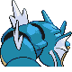

This is for AI This is for user

Rhydon’s Sprites:

 

This is for AI This is for User

Arcanine’s Sprites:

 

This is for AI This is for User

Red’s Sprites:

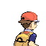 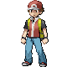

This is for user This is for the intro menu

Blue’s Sprites:

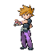 

This is for the intro menu this is for user

All of these images have been saved as .png files, in the same folder as all of the python files I am using to run this game. Before I add these sprites as attributes, I must first create a pygame window. Blue and Red’s sprites will not be attributes of objects

###### Creating the pygame window

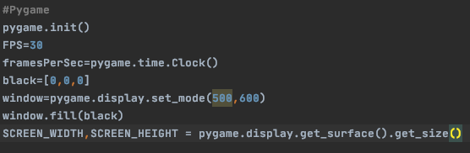

I firstly had to initialise pygame, before then setting up the dimensions of the window. 500x600 is not permanent; it is merely just so I can gauge the size of the window so I can adjust the size accordingly. I set the colour black as a variable of the same name to stop me from having to enter the RBY values of it every time I wanted to use it. FPS was set to 30 – again, not final. The screen will be completely black to begin with, and the constants SCREEN_WIDTH and SCREEN_HEIGHT are also used so in case I decide to change the width and height of the window.

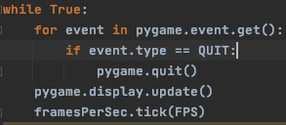

Firstly I should clarify that this was just to ensure that everything I coded would work: the pygame window was generated (see below), no syntax errors were received and the game quit when I pressed the QUIT button in the corner of the window.

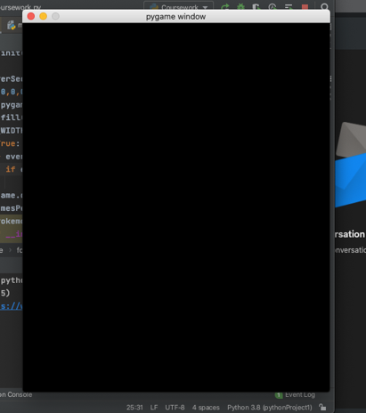

This is said window. The screen is 500x600 (which I have decided is too small) and is completely black to begin with.

I ultimately decided that 1200x800 was the perfect size for my game.

Finally, I add in a caption saying: “Battle Simulator”. The initial screen looks like this:

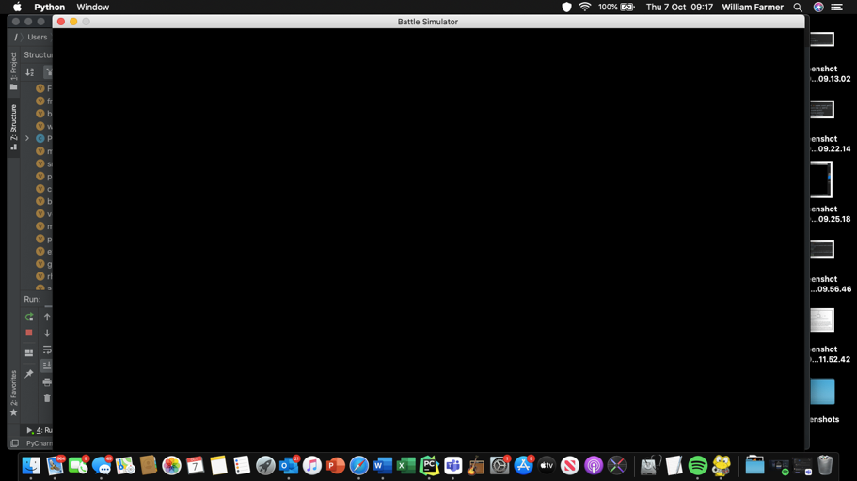

This is 1200x800 with ‘Battle Simulator’ as the caption.

###### Creating the Menu

Now that the window has been created, it’s time for the menu to be made. This will display Trainer Red and Trainer Blue, alongside all of their Pokémon. The user will then click either Red or Blue, and the battle should then be able to commence.

Before I fully committed to my idea of having the images as attributes, I wanted to check it would work as intended. I added all of the user sprites to the objects as attributes and added the following to the Pokémon class:

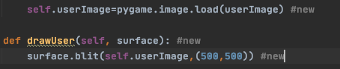

The coordinates are, once again, not permanent and just here for testing purposes. I then added the following (for testing only):

while True:  
 mewtwo.drawUser(window)  
 for event in pygame.event.get():  
 if event.type == QUIT:  
 pygame.quit()  
 pygame.display.update()  
 framesPerSec.tick(30)

and ran the program, hoping to see Mewtwo’s user sprite be displayed. This was what was output:

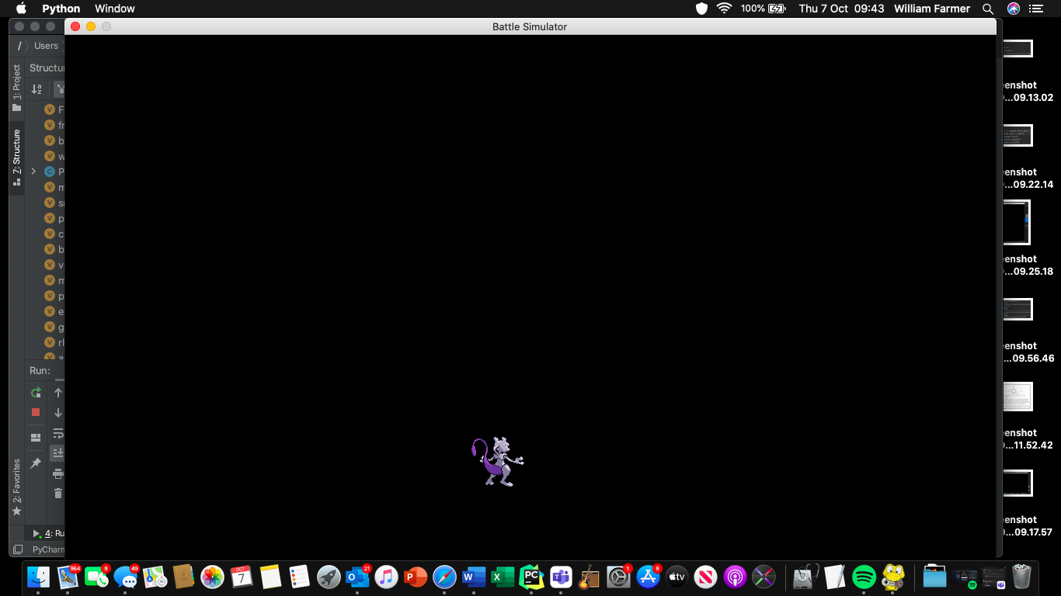

This is exactly what I’d hoped for. This gave me enough confidence to add all of the AI sprites into the game.

def drawOp(self,surface): #Draws Opponent Sprite  
 surface.blit(self.userImage,(750,500))

was added, alongside adding all of the image names as attributes to all of the objects in the Pokémon class. Then I added this to ensure it worked as intended:

arcanine.drawOp(window)

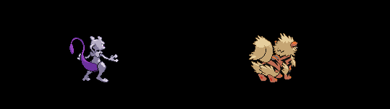

This was not intended: the Mewtwo is fine, but Arcanine is displaying the wrong image. However, as you can see above, this is because it was drawing userImage rather than opImage. I changed this and ran again:

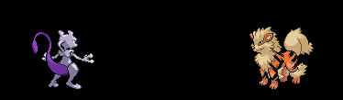

Perfect! Now to make this more maintainable I will pass the co-ordinates into the methods, like so:

mewtwo.drawUser(window,500,500)  
arcanine.drawOp(window,750,500)

with the method altered to reflect this change:

def drawUser(self, surface,x,y): #Draws User Sprite  
 surface.blit(self.userImage,(x,y))  
def drawOp(self,surface,x,y): #Draws Opponent Sprite  
 surface.blit(self.opImage,(x,y))

the following screen was output:

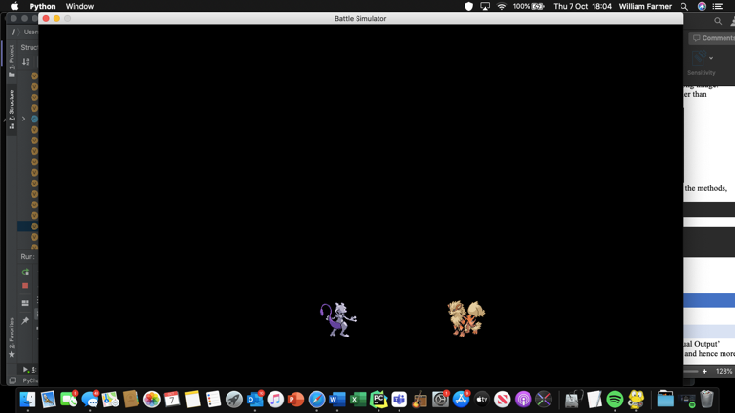

Which is as desired. Now that I know this works, I remove the statements calling the drawUser and drawOp methods and create the Trainer class.

class Trainer:  
 def __init__(self,userImage,opImage):  
 self.userImage=pygame.image.load(userImage)  
 self.opImage=pygame.image.load(opImage)

and instantiate red and blue as trainers:

red=Trainer('userRed.png','introRed.png')

blue=Trainer('userBlue.png','introBlue.png')

I then add methods that display the image for when selected by the user, and the image displayed at the beginning of the game.

def drawUser(self, surface, x, y):  
 surface.blit(self.userImage,(x,y))  
def drawIntro(self, surface, x, y):  
 surface.blit(self.introImage,(x,y))

I then add the following statements to call these methods, and hence to display Red and Blue in the desired locations:

red.drawIntro(window,500,500)  
blue.drawIntro(window,750,500)

which run to produce the following output:

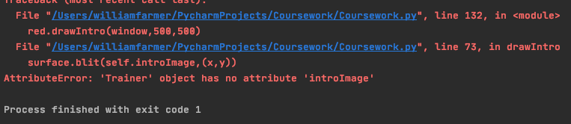

This was because I accidently added opImage as an attribute rather than introImage:

self.opImage=pygame.image.load(introImage)

this was changed to the following:

self.introImage=pygame.image.load(introImage)

and ran again to see if the error had been resolved.

The program produced:

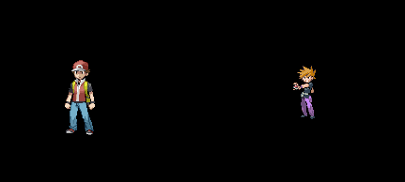

Which is intended, but Red should not be bigger than Blue. To solve this issue I used an online png resizer, and named the new image resizedIntroBlue.png.

However, as you can see below, there is a reduction is quality as a result of the size increase. I tried to see if making Red smaller was the better option, which resulted in the following:

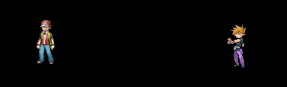

I concluded that this was better; quality was preserved and they are both the same height. Now to display both of their teams either side them. I tested initially by displaying Red and his full team:

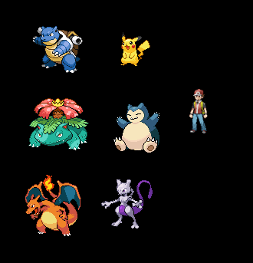

And after seeing it worked I did the same for Blue and his team:

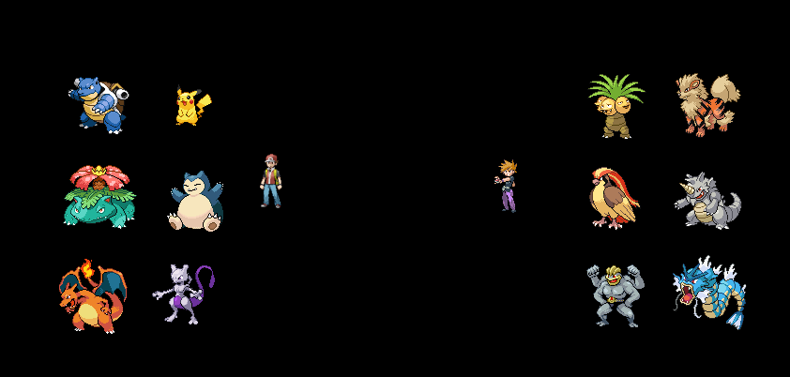

###### Allowing the user to choose their team

Now I need to incorporate the clicking feature to my game. To do this, I needed to create rectangles that are created behind the sprites so I can then use the collidepoint method. I do this as so:

class Trainer:  
 def __init__(self,userImage,introImage,x,y):  
 self.userImage=pygame.image.load(userImage)  
 self.introImage=pygame.image.load(introImage)  
 self.rect = pygame.draw.rect(window, (black),(x,y,64,64))  
 def drawUser(self, surface, x,y):  
 surface.blit(self.userImage,(x,y))  
 def drawIntro(self, surface, x,y):  
 surface.blit(self.introImage, (x,y))

where x and y are the coordinates of the sprite, and 64,64 are the dimensions of the sprites. Black signifies the colour black, which is the colour of the rectangle.

I then started the changeover between text and graphics by restructuring the trainerSelect function:

def trainerSelect(redPok,bluePok,red,blue): #the user selects the trainer  
 clicked=False  
 while not clicked:  
 for event in pygame.event.get():  
 if event.type == MOUSEBUTTONDOWN:  
 pos=pygame.mouse.get_pos()  
 if blue.rect.collidepoint(pos):  
 trainer='blue'  
 clicked=True  
 if red.rect.collidepoint(pos):  
 trainer='red'  
 clicked=True  
  
 print("You have chosen Trainer",trainer) #confirmation

the print statement at the end was just to check that it was working as intended. I ran the program, and received the following outputs:

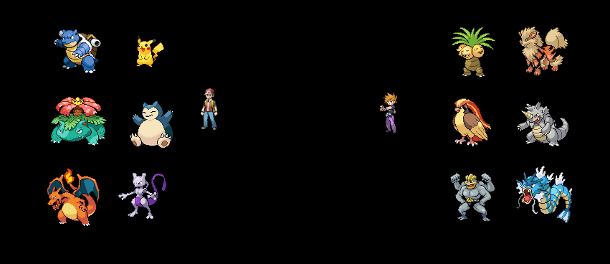

The initial screen was output, with no *visible* rectangle, but when I clicked Red:

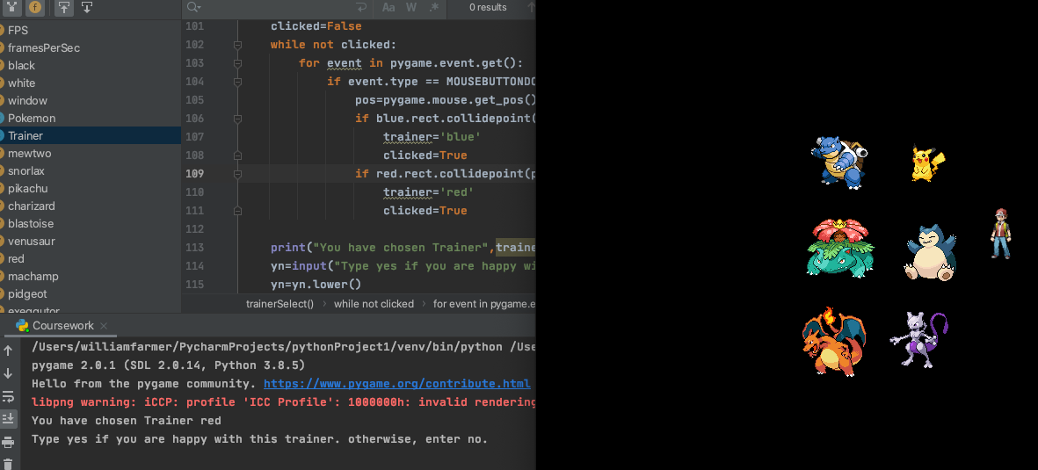

You can see that the game output that Trainer red was selected, which was the expected output as I clicked on trainer Red. I then performed the test again, but selecting Blue instead to ensure it doesn’t always output Red being selected

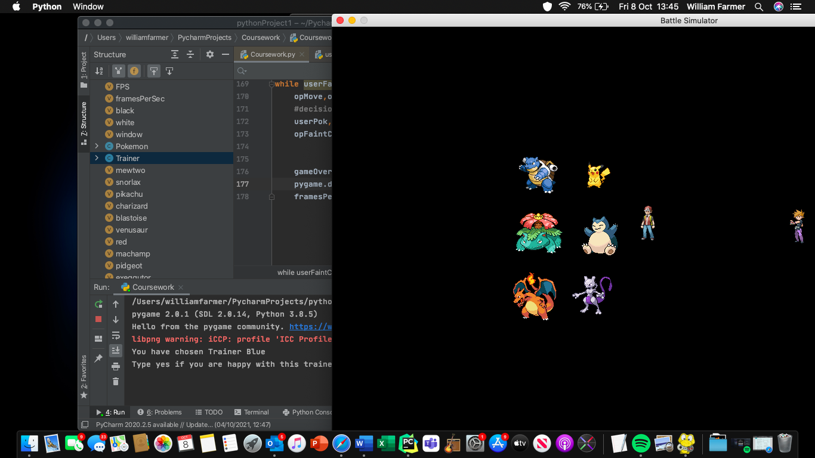

As can be seen above, this passed the test.

I now want the selected battler to move to the centre surrounded by his team, with the unselected trainer to disappear.

To do this I need to add move methods to the classes. Firstly, I make use of the super().__init__() in the constructor, which allows me to do change the trainer class to this:

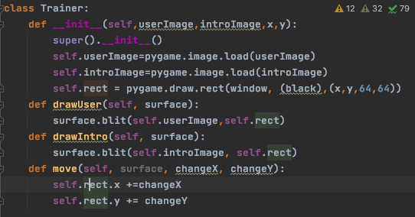

This removed the need for me to pass x and y into any of the drawing methods, and meant that I only had to pass in changeX and changeY for the move method. However, when I ran the following code (in conjunction with the above code)…

blue.move(window,-10,-10)

there was no change. I then added the following to see if it would work:

pygame.display.update()  
framesPerSec.tick(FPS)

and once again nothing happened, so I added a line drawing Blue:

blue.drawIntro(window)

and received the following output:

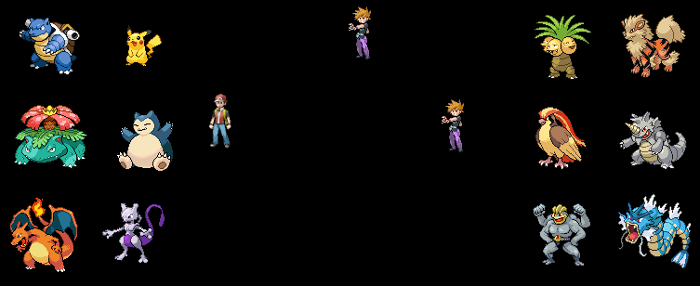

The image was duplicated, with the original staying in the same location it was, and the other being moved.

After looking at some of my previous games using pygame, I decided that I should make a background class and hence a background object that gets updated to see if this fixes my issue.

I start of defining the class Background, before adding the following into the constructor:

class Background:  
 def __init__(self):  
 self.backgroundImage=pygame.image.load('blackscreen.jpg')  
 self.backgroundRect=self.backgroundImage.get_rect()  
  
 self.backgroundX1 = 0  
 self.backgroundX2 = 0  
  
 self.backgroundY1 = 0  
 self.backgroundY2 = -self.backgroundRect.height

X1, X2, Y1 and Y2 all refer to a corner of the rectangle. The hope is that displaying a black rectangle will hide the unwanted sprites, so I can then re-draw the desired sprites in their new locations.

I then added a render method and made an object called background:

def render(self):  
 window.blit(self.backgroundImage, (self.backgroundX1, self.backgroundY1))  
 window.blit(self.backgroundImage, (self.backgroundX2, self.backgroundY2))  
background=Background()

I then added the following statements into trainerSelect():

blue.move(window,100,-100)  
pygame.display.update()  
framesPerSec.tick(FPS)  
background.render() #hide the unwanted  
blue.drawIntro(window)  
return trainer,opPok,userPok

and ran the code to produce the following output:

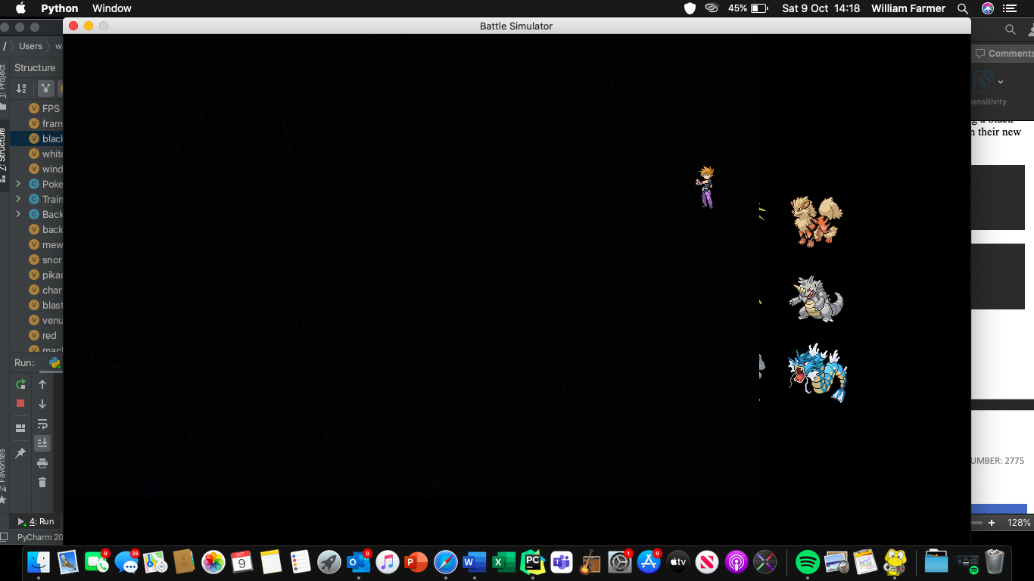

This is a partial success; the black rectangle does indeed cover up the unwanted sprites, but it isn’t big enough to cover them all up. I therefore used an online image resizer and renamed the new file ‘resizedblackscreen.jpg’. I replaced the old image with the new and hence received the following output:

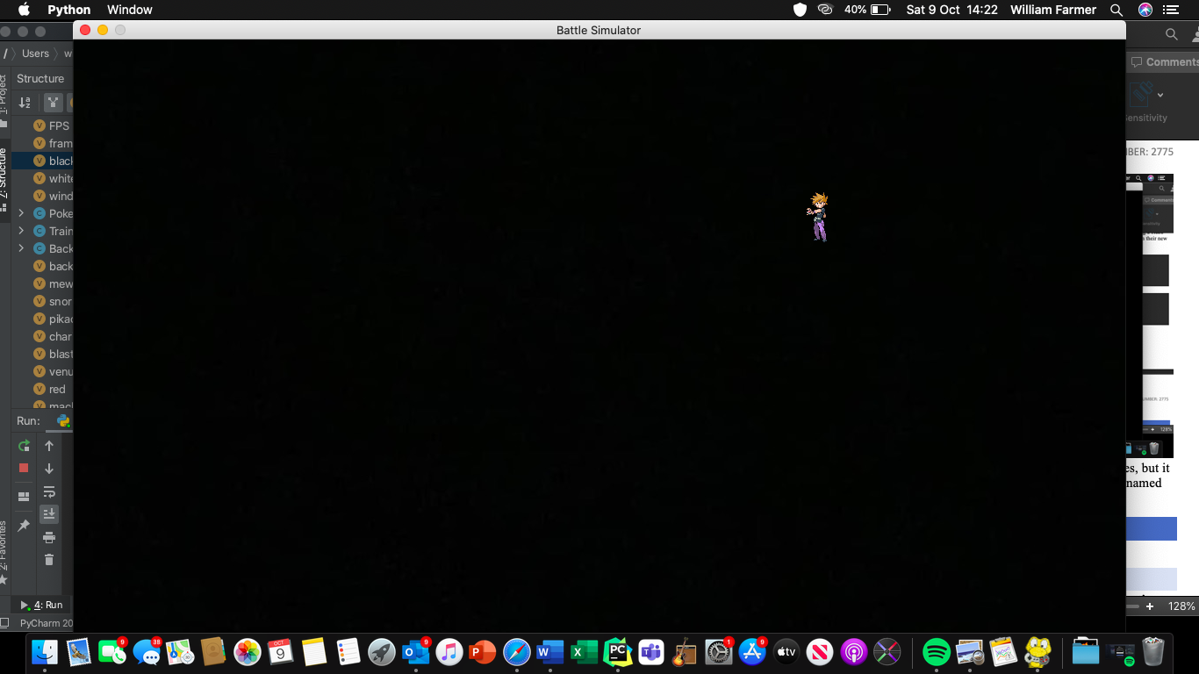

Blue’s sprite had been ‘moved’, and all the others had ‘disappeared’.

Now I want to ensure that the trainer that’s pressed is the one that’s displayed alongside their team. Hence, I removed the current bit of code that moved Red and Blue as I didn’t need that for the game to function (I just needed it to make sure I could do it) and added the following:

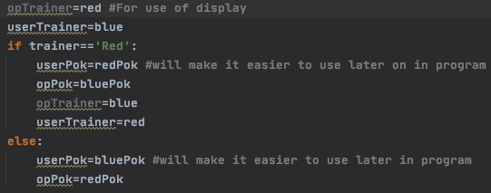

Here I set the variable UserTrainer to store the object of the Trainer the user chose. This will make it much easier to display the trainers in battle.

I then added the following to ensure the selected Trainer was drawn alongside their team:



This code was run, and when Red was clicked the following occurred:

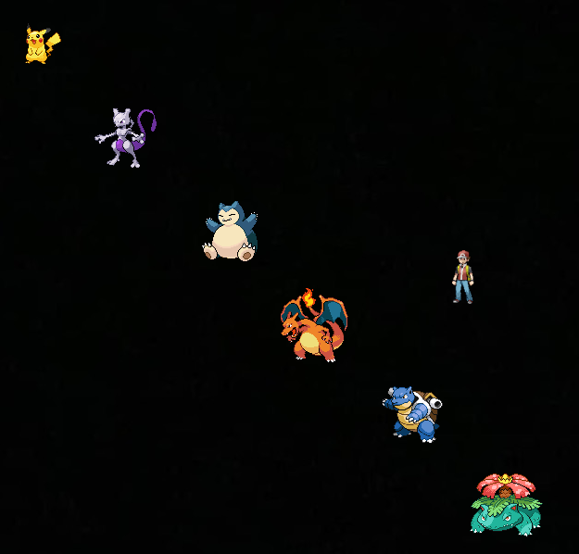

And likewise when Blue was clicked the following occurred:

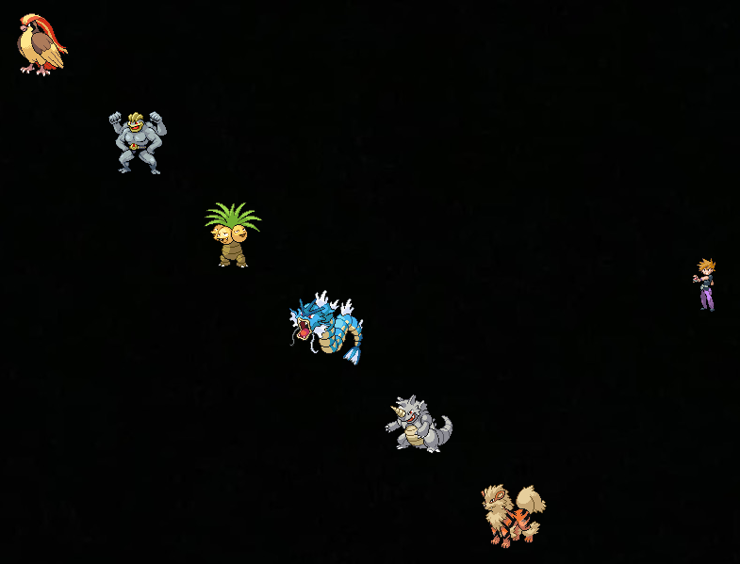

This was great, but it made me change my mind about how I wanted to ‘move’ the Trainer sprites. Instead of changing their position by *a* pixels along the x axis and *b* pixels along the y axis, I decided to wanted to move them to a set position. Hence, I altered the move method.

I then added statement redrawing the chosen trainer to the centre of the screen. The altered move method looks like so:

def move(self,surface,x,y):  
 self.rect=self.introImage.get_rect(center = (x,y))

and the code that displays the trainer:



Proof that it works for both Red and Blue:

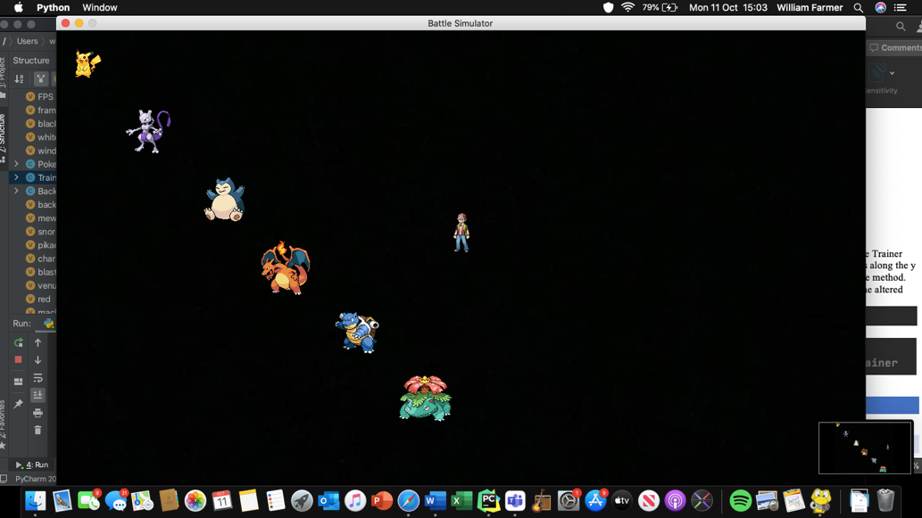

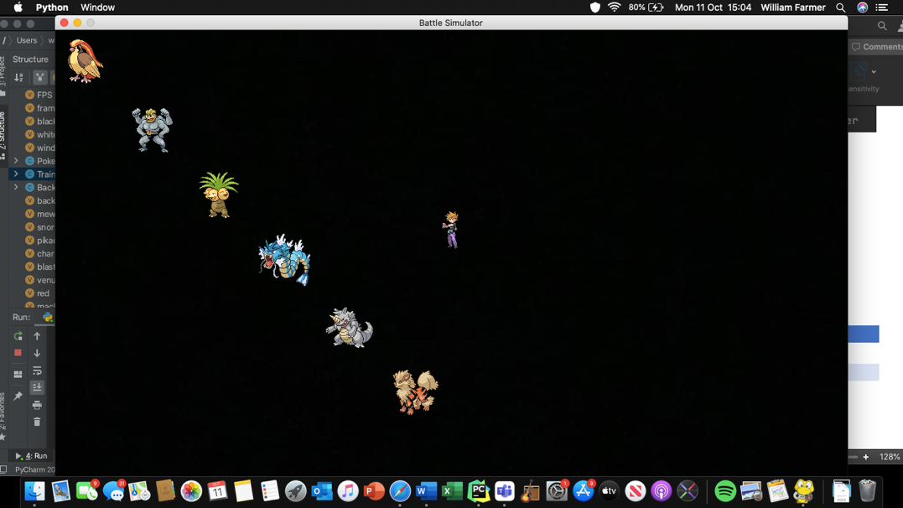

With this done I had a very few final changes left to make. Given that I now had a Trainer object which was split into userTrainer and opTrainer, I decided it would be best to give them a name attribute and return them from the trainerSelect function.

The changes are as follows:

userTrainer,opTrainer,opPok,userPok=trainerSelect(redPok,bluePok,red,blue) #allows user to choose trainer

and

self.name=name

Satisfied, I declare this sub-prototype complete.

### Prototype 8.2

This prototype maps across to Success Criterion 3.3, meaning that I create a background for the battle to take place on. This will be the same *background* object that I use to hide the sprites in prototype 8.1. I will also display the Pokémon and trainers in correct positions in the background.

#### Evidencing Solution

##### Choosing Background

After some consideration, I decided that instead of attempting to create my own background, I would use the battle scene from Pokémon Black 2 and Pokémon White 2[19]. I saved it as battlescene.png.

The image looks like so:

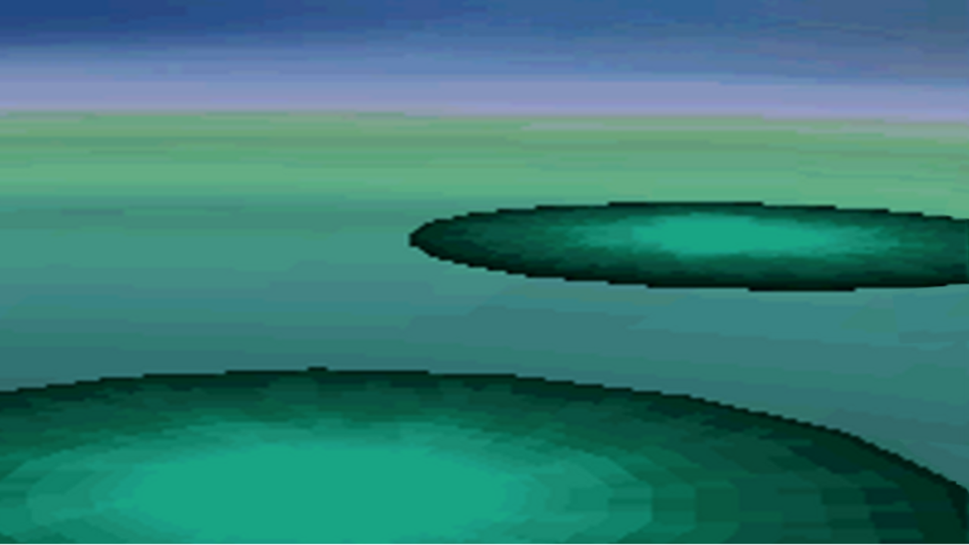

And when displayed in the pygame window it looks like this:

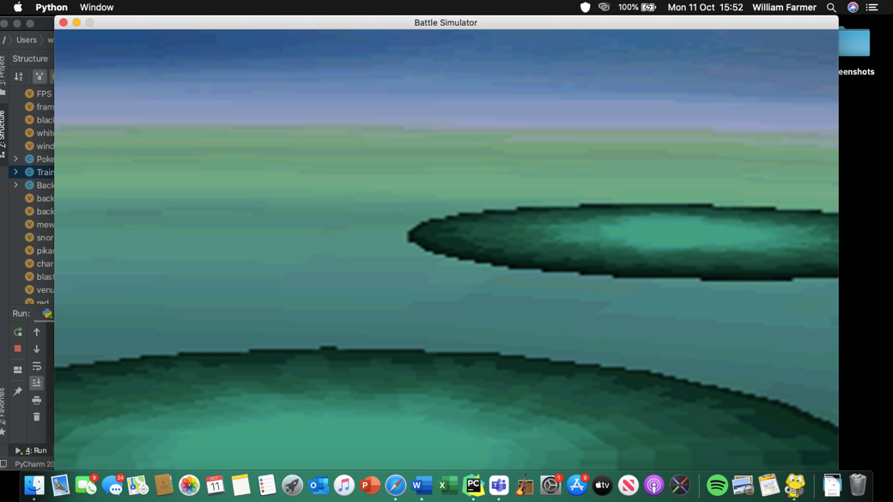

##### Displaying Trainer and Pokemon

Now I just need to be able to display the Trainers and the Pokémon in the right place.

As you would have seen from the previous sub-prototype, the Trainers and Pokémon have user and opponent/intro sprites, so I need to make sure they are displayed not only in the right place, but with the right sprite. This meant that for a while I just spent some time doing trial and error with the co-ordinates until the opponent sprite was output in the correct location.

I eventually settled on (900,250), which looks like this:

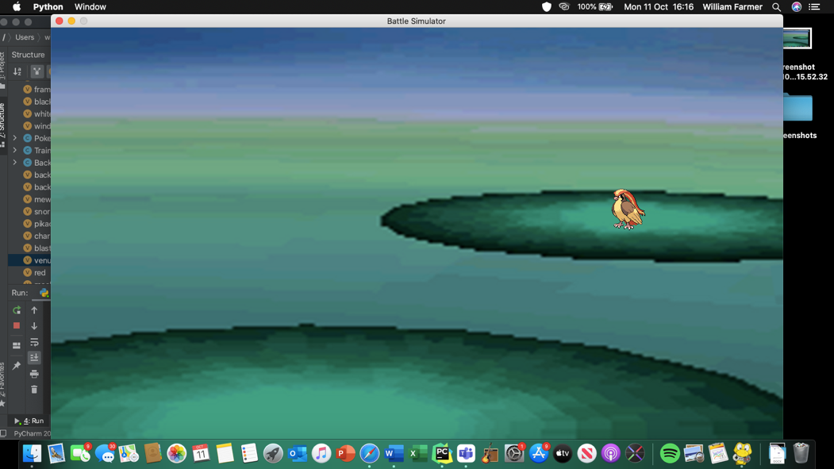

And (900,300) for the Trainer sprite, which looks like this for Red:

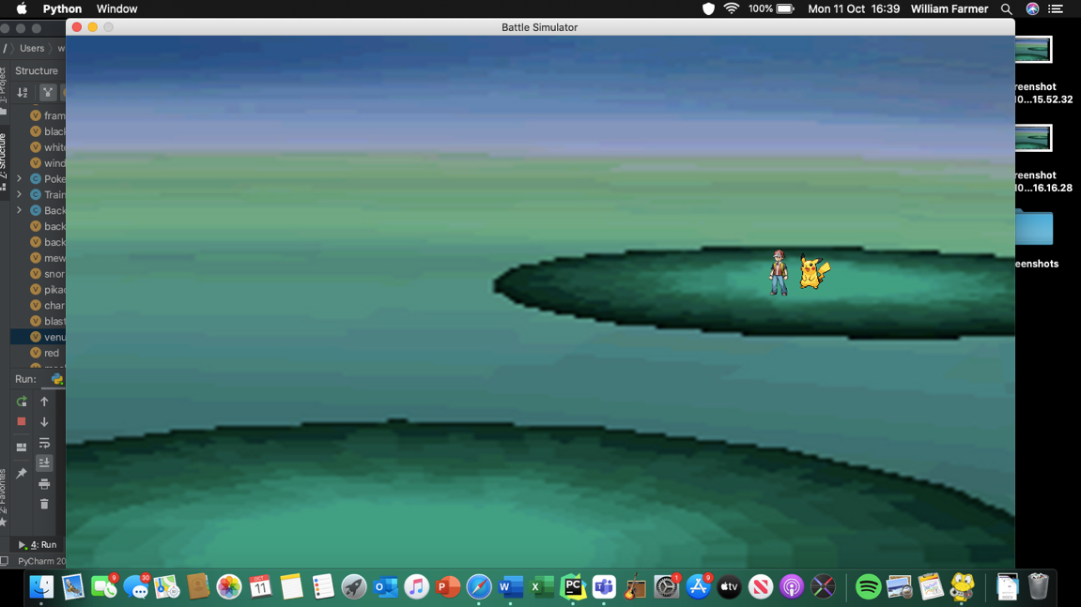

And this for Blue:

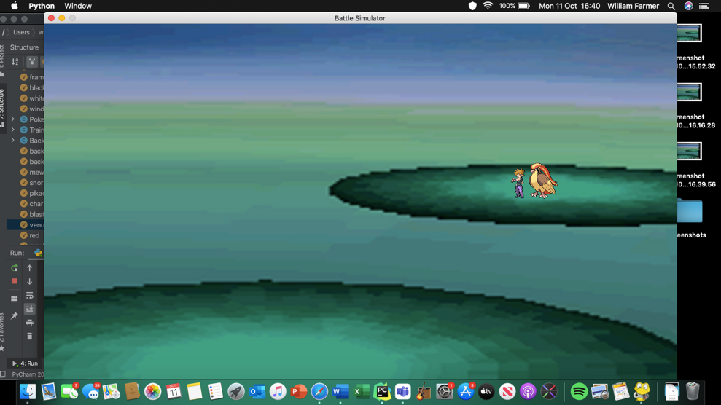

The Opponent Trainer will only be output there at the beginning of the game, or when an opposing Pokémon has fainted.

I once again had to do trial and error for the location of the user. During me trying to replicate the code, I accidently made a syntax error, using .draw() as a method for the trainer, when it should be .drawUser(). This was corrected.

However, I was met with a very peculiar logic error:

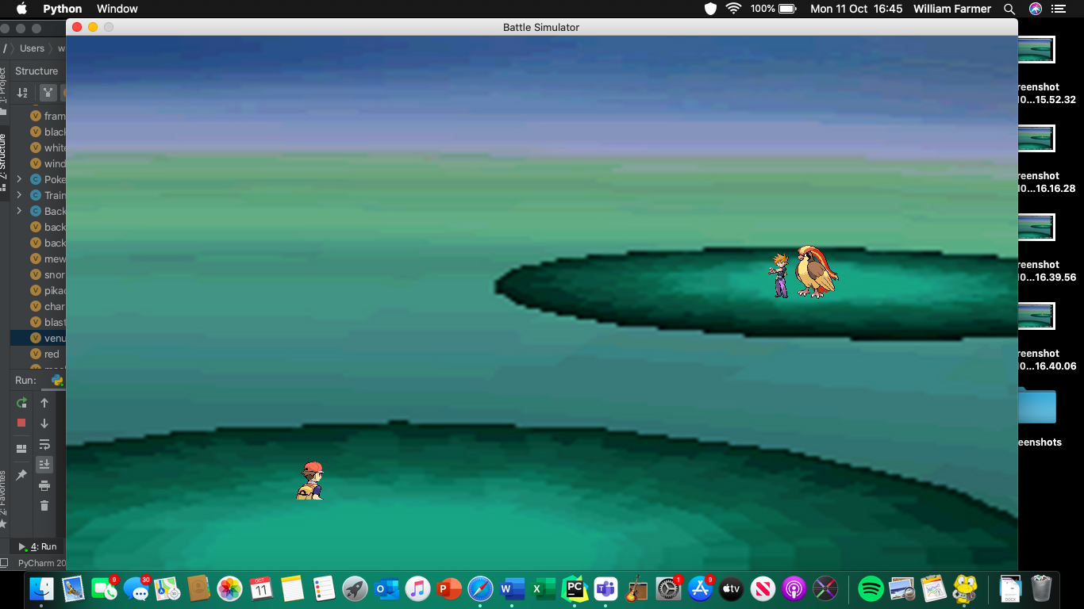

As you can see, the bottom half of the User’s trainer is seemingly cut off. However, this only applies for Red’s sprite:

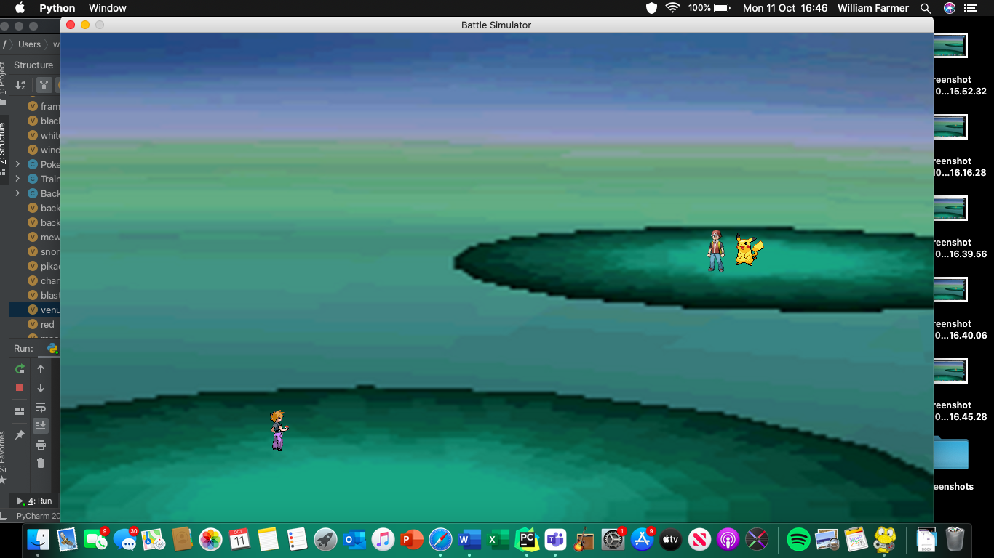

After I checked the sizes of each image, I realised that Red’s User sprite was larger than his Intro sprite, meaning that I forgot to change it when I changed the size of the Intro sprite. This meant that the invisible rectangle is too small, and so I instead changed it so the rectangle matched the size of the User sprite instead, as it would only minimally affect the area of clicking and wouldn’t result in a loss of resolution. However, Red’s bottom half was still cut off. I tried outputting him higher on the screen to see if that would make a difference:

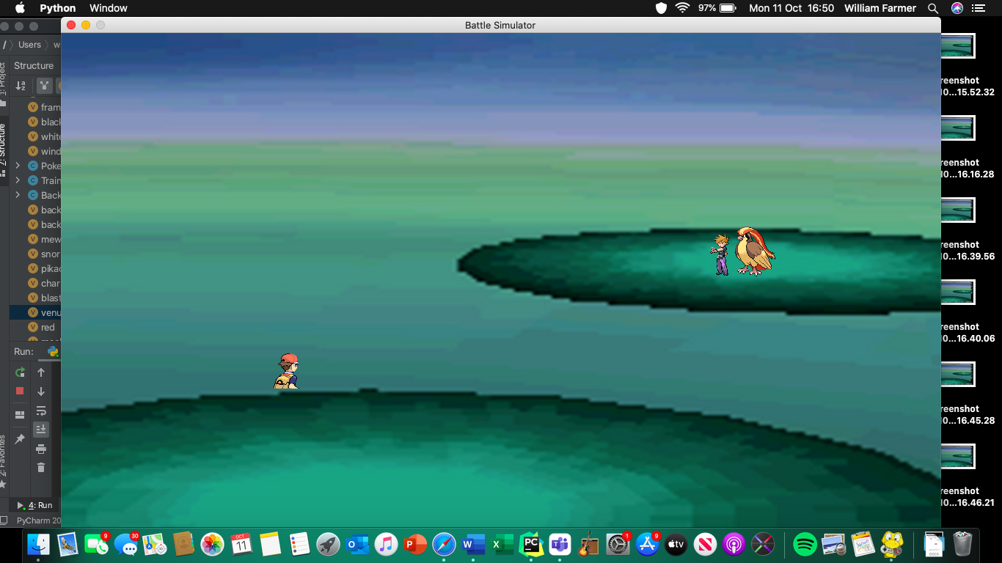

But it didn’t. I therefore decided it was in fact likely to do with the actual image itself. Upon inspection, I discovered that it was in fact the sprite that was the issue:

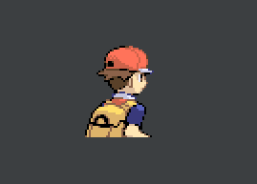

This was not actually an error; I realised after a few minutes of searching for a new sprite to use that this was in fact a sprite from Pokémon Fire Red and Leaf Green, and this worked well because of the narrative box. This does mean that at the current stage of development that this is going to look quite weird, but, once I implement the narrative box, it will eventually look normal. This led me to set the User’s co-ordinates to (500,500), which looks like this:

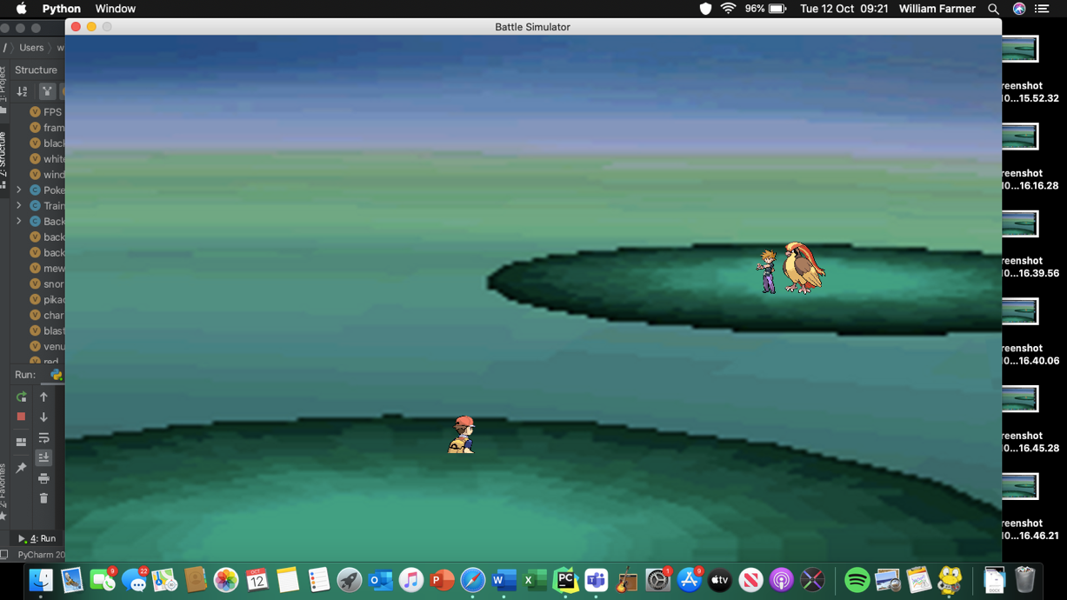

Again, this looks out of place currently, but won’t in the next prototype when add I the narrative box. Now to the User’s battler:

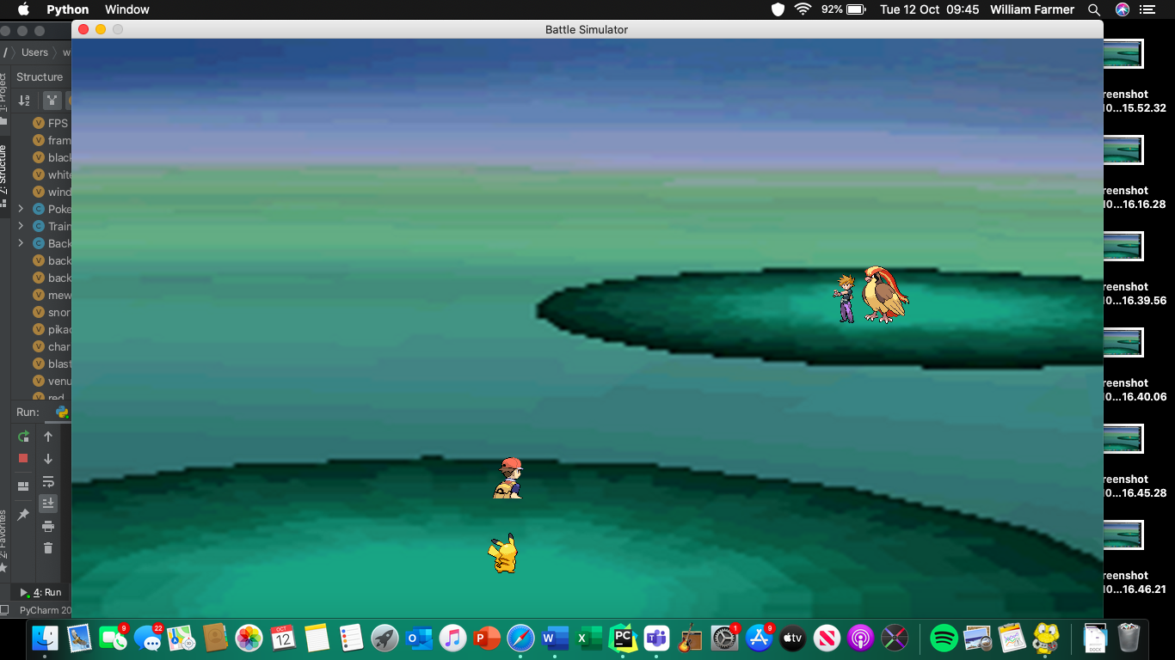

I decided on the co-ordinates (450,550). The narrative box will cover up the Pokémon now and again, but only to announce moves and new Pokémon entering the battle.

I am now going to do a few checks to ensure that every Pokémon is displayed in the correct place.

For Mewtwo and Machamp:

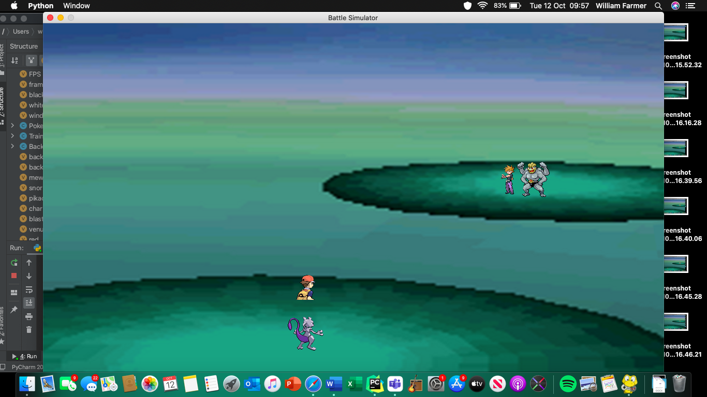

For Snorlax and Exeggutor

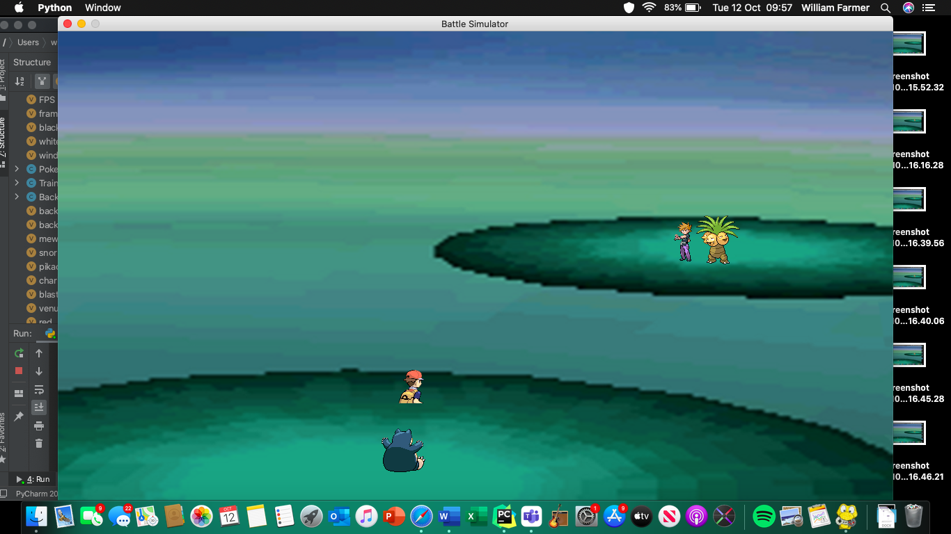

For Charizard and Gyarados:

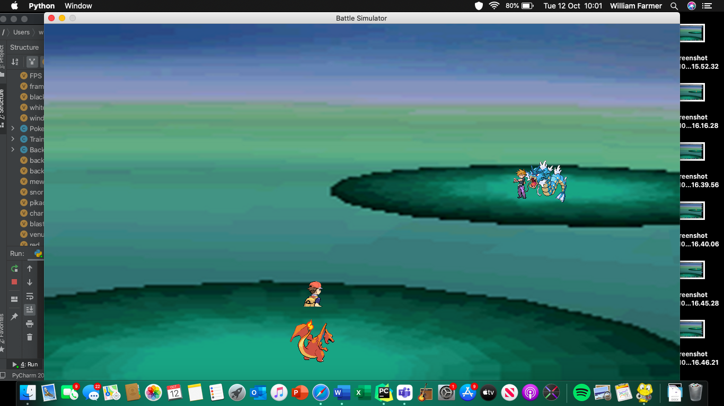

For Blastoise and Rhydon:

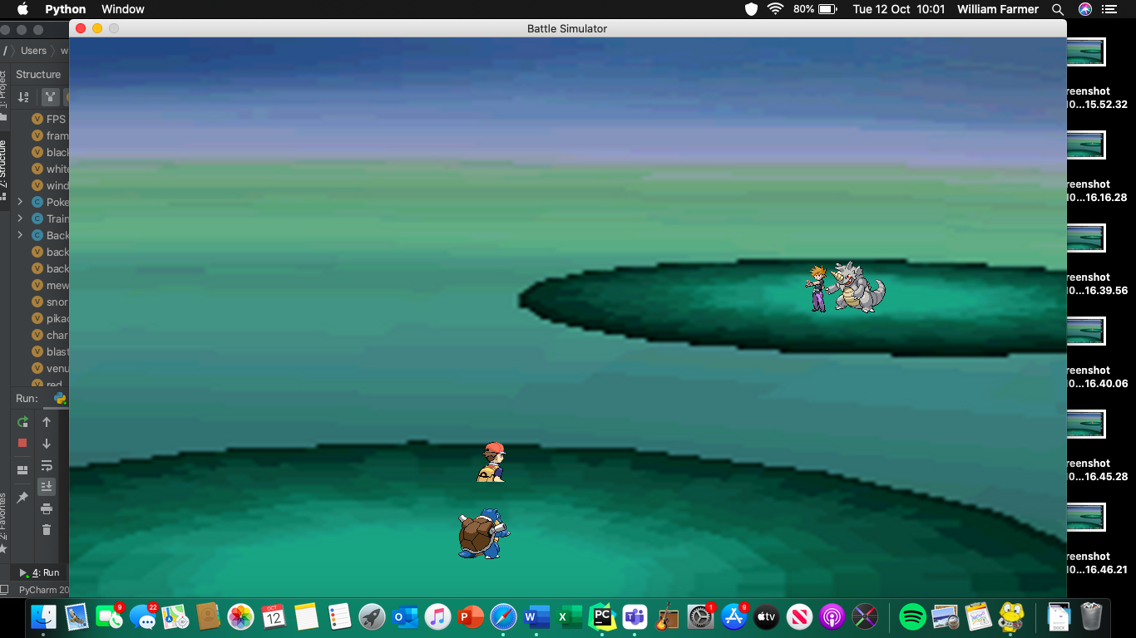

For Venusaur and Arcanine:

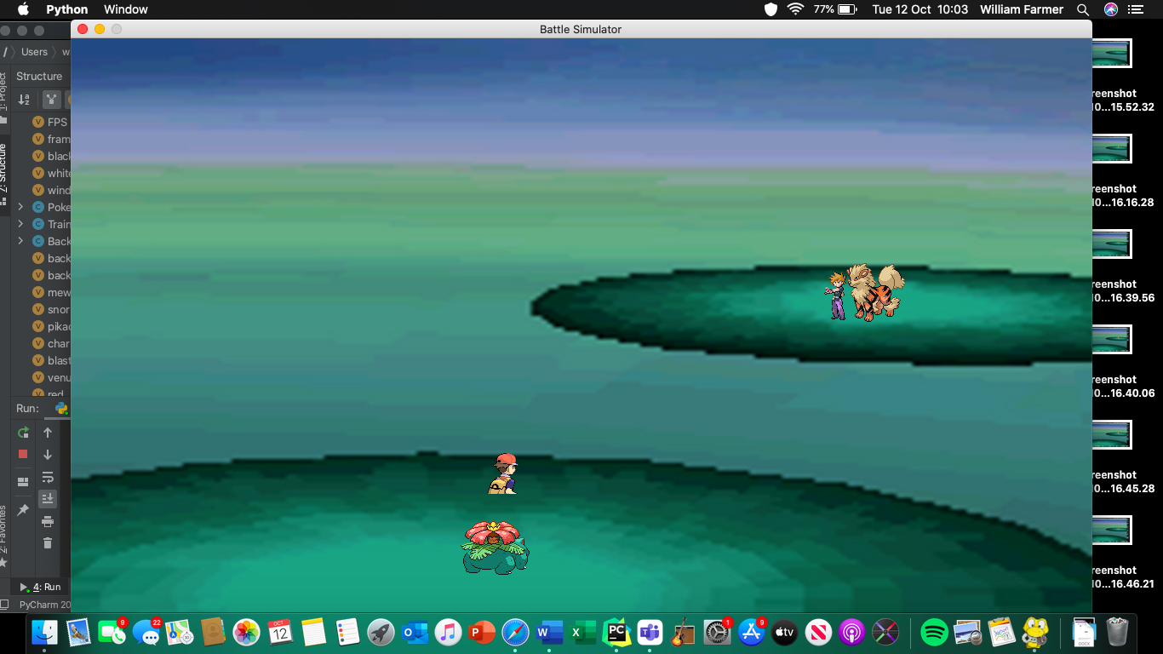

I’m not going to check each one for user and for opponent as I’m currently satisfied just checking each one is displayed correctly with Red as User and Blue as Opponent. In the formal test plan at the end of the prototype, however, I will test it more destructively.

Hence, I declare this sub-prototype completed.

### Prototype 8.3

This sub-prototype covers success criterion 3.2, which means that this there will be a working narrative box, HP bar and level display. I am unsure whether to add the sexes of each Pokémon at this stage as in this game it will have no effect on the battle, and thus seems just an unnecessary addition to the game. The main priority of this prototype is to get a working narrative box, which involves having text appear on the screen. Throughout this sub-prototype I will make clear what file I am adding to, as there will be many different files involved. The development of the narrative box involves having a working graphical battle system, which is what I’ll initially work on in this sub-prototype.

#### Creating buttons

I therefore start in userFile.py.

I need buttons for Fight, Bag and Pokémon, and so I will make a button class.

I define the button class as so:

class Button:  
 def __init__(self,image,x,y):  
 self.image = pygame.image.load(image)  
 self.rect = image.get_rect(center = (x,y))

and then add the method to move and draw the button(s).

def move(self,window,x,y):  
 self.rect=self.image.get_rect(center=(x,y))  
def draw(self,window):  
 window.blit(self.image,self.rect)

this will allow me to display the buttons at the beginning of each turn, allowing the user to choose their option. For fight:



I then coded the following:

fight = Button('fightbutton.png', 1130,500)  
fight.draw(window)  
pygame.display.update()  
framesPerSec.tick(30)

Within the user() function in userFile.py (after doing some trial-and-error with the placement of the button) and it looked like this:

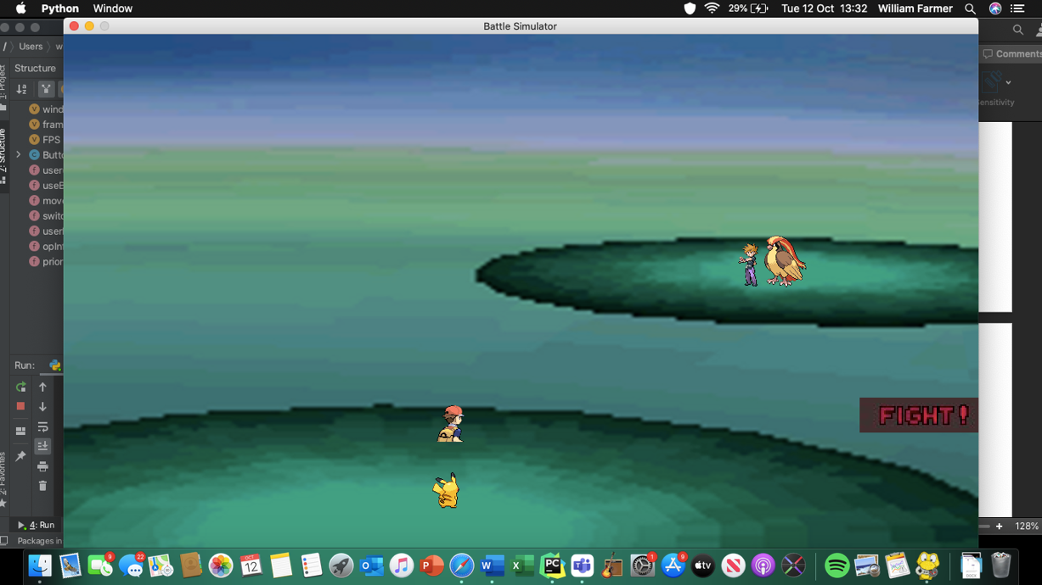

So now I need an image for bag and an image for Pokémon:

 and 

These have been taken from the Pokémon games ‘Pokémon: Black and White’. I may change this if it looks too out of place, but I currently want BAG to be the least important button and so for this reason I am making the conscious decision to have it smallest, with Pokémon as the second smallest. This will hopefully create an emphasis on the FIGHT button.

I create the objects as so:

pkmn = Button('pkmn.png',1160,535)

bag= Button('bagIMG.png',1170,561)

The screen now looks like this:

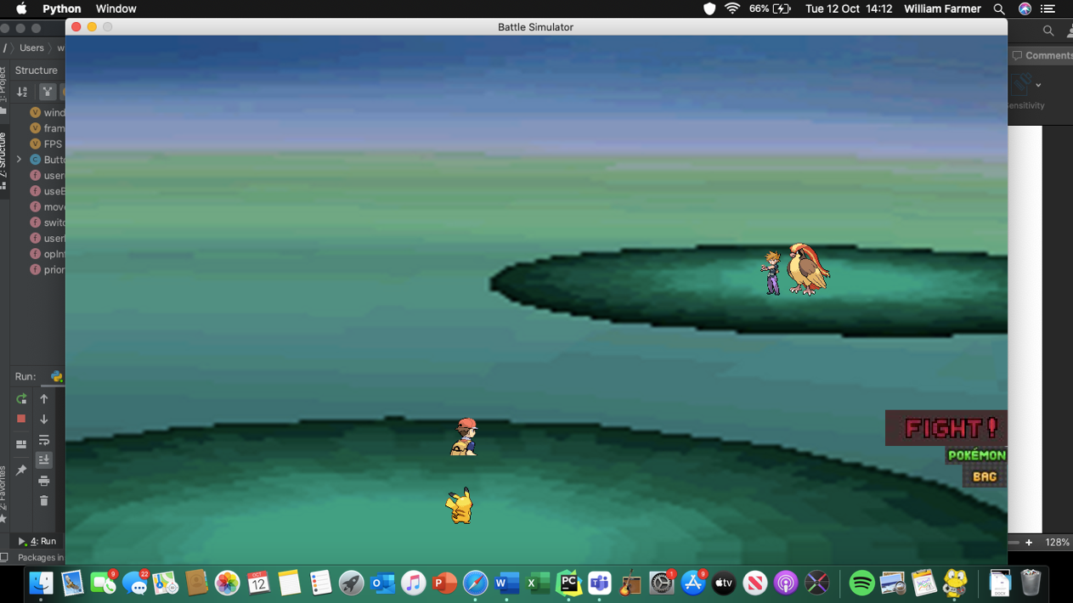

I am satisfied with how it looks; I was worried about the size different but I do like how there is a clear emphasis on FIGHT and Pokémon and Bag don’t look weird, which I was worried about.

#### Integrating graphics to battling

Firstly, I will sort out move selection and damage, and then move onto selecting new Pokémon and items from the bag. I amended the fight/bag/switch section to the following:

choice='switch'

while flag ==-1: #will always run once  
 clicked=False  
 while not clicked:  
 for event in pygame.event.get():  
 if event.type == QUIT:  
 pygame.quit()  
 if event.type == MOUSEBUTTONDOWN:  
 pos=pygame.mouse.get_pos()  
 if fight.rect.collidepoint(pos):  
 choice = 'fight'  
 clicked=True  
 if bag.rect.collidepoint(pos):  
 choice = 'bag'  
 clicked=True

this allows the user to exit the game entirely, click FIGHT if they want to fight, BAG if they want to use bag, and click Pokémon if they want to switch – though I have temporarily hashed out the switching function. To test if this worked I ran the code and kept a print statement in the code telling me which one I’ve pressed –

##### Getting Fight and Bag buttons working

When FIGHT pressed:

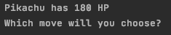

When BAG pressed:

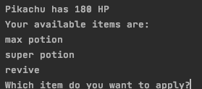

So the click detection works. The reason I have temporarily removed the switching function is because, with the addition of graphics, I now need to have an animation for the new Pokémon entering, which I have decided to complete in a later sub-prototype.

I removed the validation I had at this stage for move selection, as in the text-based game there were room for invalid inputs; in the new click-based version, you can simply click a valid input and the game progresses, or you don’t and nothing happens until you do.

##### Choosing moves

From here I have to now create buttons for each move that appear after FIGHT is selected. I was initially going to reuse the Button class, but then I realised that the buttons that map across to moves need to display text, and are drawn as a rectangle, not an image. This is so the user can see what move they are selecting. The new class will be called GameChoice because the user uses this class to make their choices throughout the game and will feature black rectangles with white outlines (to help differentiate one rectangle from the other) with text on, displaying the name of the move, item, or Pokémon.

My first attempt at this class was this:

class GameChoice:  
 def __init__(self, height, width, centre):  
 self.rect = pygame.draw.rect(window,white,pygame.Rect(centre[0],centre[1],height,width),2)  
 def draw(self,window, centre):  
 window.blit(self.rect(center = centre))

I then realised that the .draw() method was redundant (as the object is drawn upon instantiation), and so removed it. Still, when ran, the code produced the following output:



There was no black filling, just a white background. After looking at stack overflow and Reddit, I discovered that for this to happen I would need two rectangles, one acting as the border, one acting as the button. Hence, I changed the GameChoice constructor to:

class GameChoice:  
 def __init__(self, height, width, centre,border,colour):  
 if border == 2:  
 self.rect = pygame.draw.rect(window,colour,pygame.Rect(centre[0],centre[1],height,width),border)  
 else:  
 self.rect = pygame.draw.rect(window,colour,pygame.Rect(centre[0],centre[1],height,width))

and instantiated the objects:

move1buttonborder = GameChoice(172,40,(1044,450),2,white)  
move1button = GameChoice(171,40,(1044,450),1,black)

however, I made the border slightly too small; only the bottom border is displayed:



While this would be sufficient for the user to differentiate the rectangles, I want the whole rectangle to be surrounded by white. Hence the instantiation was changed to:

move1buttonborder = GameChoice(172,40,(1044,450),2,white)  
move1button = GameChoice(170,38,(1044,450),1,black)

but this had the same issue, so I decided to revert the instantiation code to as it is above, and simply swap the order they were instantiated, so the border is displayed on top of the button. This created the following output:



Perfect!

Now to add text. I don’t currently know how to add text to a rectangle, and so I used Stack [20]Overflow to help me learn. The new GameChoice class looked like this:

class GameChoice:  
 def __init__(self, height, width, centre,border,colour):  
 self.font = pygame.font.SysFont('Arial',20)  
 if border == 2:  
 self.rect = pygame.draw.rect(window,colour,pygame.Rect(centre[0],centre[1],height,width),border)  
 else:  
 self.rect = pygame.draw.rect(window,colour,pygame.Rect(centre[0],centre[1],height,width))  
 def addText(self,window,move):  
 window.blit(self.font.render(move,True,white),self.rect)

and ran to produce the following output:

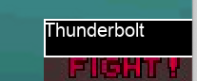

This is great! My next step is to output three more rectangles underneath this one, which contain the three other moves and also cover up the FIGHT, BAG and Pokémon buttons.

The code looks like this:

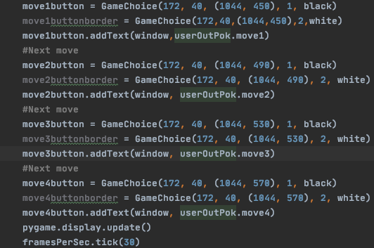

The comments were inserted just to help break the code up a little bit, but it still feels very unnecessary. If I have time, I will go back to this section and use a FOR loop instead to help with maintainability.

This code produced the following output:

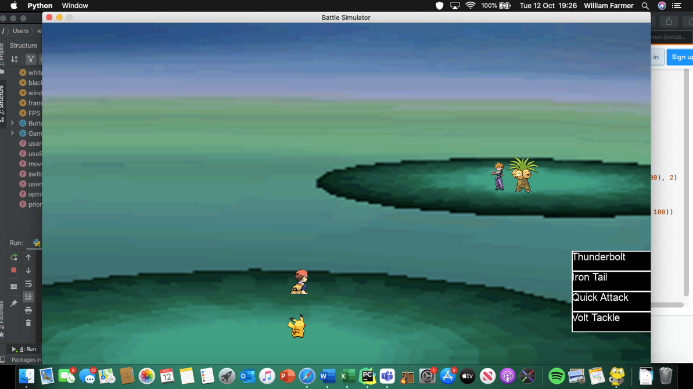

The moves are all correctly output and the bottoms are easy to differentiate between. However, the white text does blend into the white background, especially with Iron Tail. For this reason, I decided to make the text black, and also use a more fitting font. The new display looks like this:

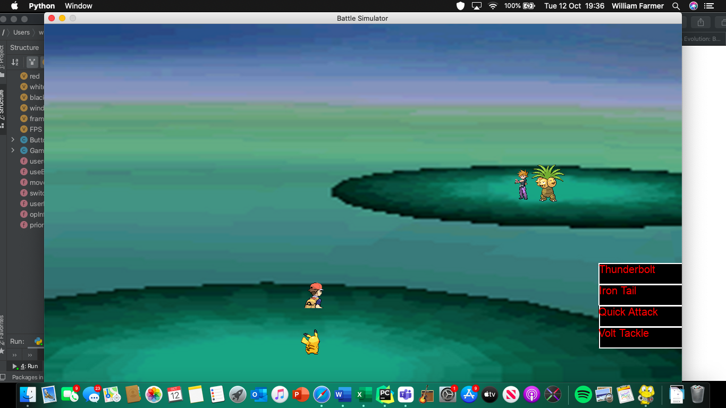

The Red stands out much more from the white border, and the Calibri font seems much more fitting than Arial.

I then coded in the ability to click your desired move:

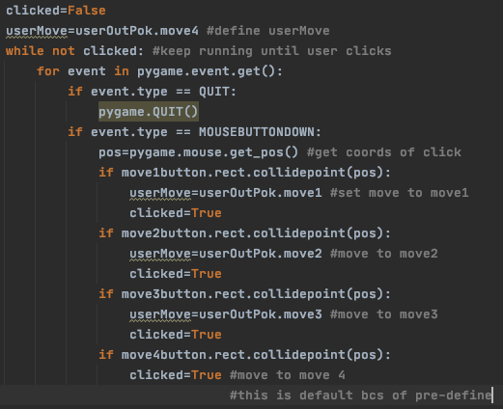

I defined userMove before the IF statement so that if move4button was pressed then I wouldn’t have to assign move4 to userMove as it was already done. I used userMove as the variable name as it is quite simply the user’s move, and it is what I called it in prototype 5 when the game was still text-based. This means that it still works with the damageCalc function, which has no *visible* output.

The HP bar and narrative box have not yet been programmed, so to check that the clicking worked as intended I ran the game once with Pidgeot as my Pokémon using Double Edge (as Pidgeot is faster than pikachu) and once with pikachu using Quick Attack using the old moveOrder, opInflict and userInflict functions.

When I used Pidgeot and chose Double Edge, the following occurred:

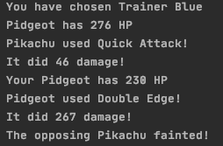

And when I used quick attack with pikachu:

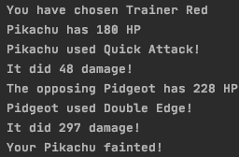

Good – this means all the inputs are correctly registering.

Still in userFile.py, I now need to move onto the functions within moveOrder. priorityCheck is able to remain untouched, as is fainted, but userInflict and OpInflict need to be altered.

For this, the narrative box and HP bar needs to be displayed. For this, I need to create the narrative box.

##### Creating the narrative box

I contemplated making a new class for the narrative box, but then deemed this unnecessary as everything I need from the narrative box can be done using the GameChoice class, as all I need is a rectangle to be drawn, with the ability to have text drawn on top; both of these I can do with GameChoice.

After some more trial and error with the placement of this box, I coded the following for the narrative box:



This led me to swap around the location of the User’s Pokémon sprite and the User’s Trainer Sprite, because I realised that the narrative box would then cover up the Pokémon all the time and would, in Red’s case, reveal his lack of lower body. The code ran as so:

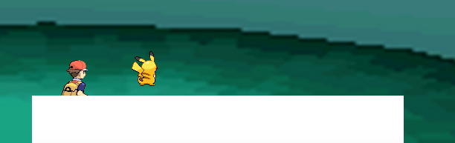

I thought this white box was too garish, and so tried having a black border around it to see if it reduced the effect of this:

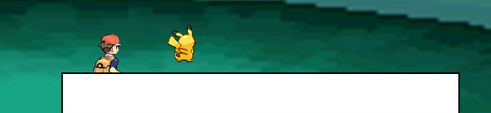

And I believed this achieved this goal. Whilst running the program I decided that the narrative box should also be displayed at the same time as the battle scene is made, and so moved its instantiation into the place where the aforementioned features are displayed, back in user().

##### Battling the opponent

Now I move to the OpInflict and userInflict functions. I want the narrative box to say what move was used, how much damage it did and who used it; in essence, what was output in the text-based game, minus the remaining HP of the Pokémon, as the soon-to-be-made HP bar will cover that. I will first edit OpInflict, as Pidgeot is faster than Pikachu.

I wrote the following code adding text to the narrative box:

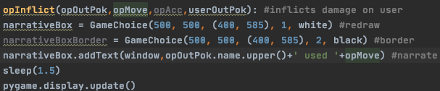

The Pokémon’s name is to be displayed in capital letters because this is how it’s done in the original Pokémon game. If I find the time I will try and create my own font that will mimic the games’ font, but for now I just use Calibri.

The code ran to produce the following output:

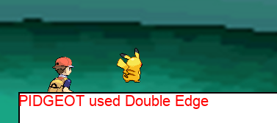

Perfect! Now, I want it to output the damage inflicted.

To achieve this, I coded the following:

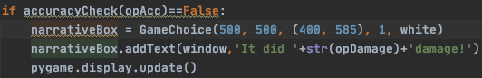

This re-draws narrativeBox, and then adds a phrase telling the user how much damage was inflicted. I’ve put a sleep(1.5) statement in just before the IF statement, so the user has time to read what move was chosen, and then sees how much damage was done. I made opDamage a string so that it would concatenate the phrase together, rather than crash after trying to add two strings to an integer.I ran the code, and it produced the following:

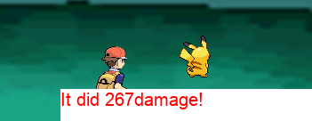

The output was a success, but the format in which it was output was not. There should be a space between the damage and the word ‘damage’, and the border should be regenerated. I changed the above code to the following:

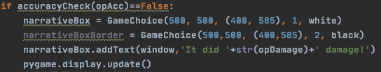

And ran the code again:

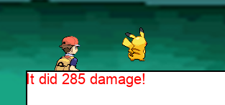

This has resolved all of the flaws I just mentioned. Now I want it to output whether it was a critical hit or not, so the user can see if that’s a regular amount of damage or more than they should normally account for. This is so they can make more informed judgements throughout their playtime. I coded the following:

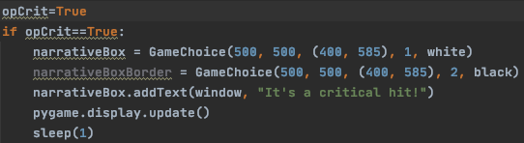

opCrit is set to True just for the purposes of testing. Next, I will set it to false to ensure it doesn’t always output “It’s a critical hit”. The code above was run:

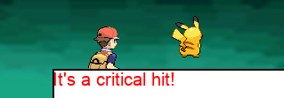

And when I changed it to set opCrit to False:

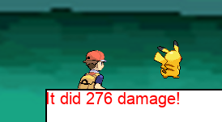

This is a success, because nothing else is output after the damage output *unless* it’s a critical hit, which this wasn’t. Next is creating an output in case the opponent’s attack misses. This is very similar code to all of the other outputs the narrative box produces, with the only change being the actual text that is to be displayed.

I coded the following:

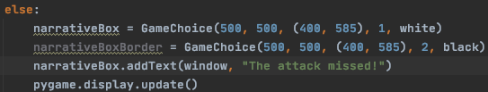

And ran the program until an attack missed:

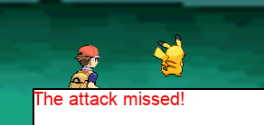

This happened on the first attempt, so I made sure to re-run the program to ensure that it didn’t always produce this output.

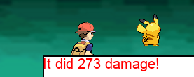

And on the next attempt the move connected, dealing 273 damage. This confirmed that the attack did actually miss on the first run and doesn’t just output that every time.

This should be a very similar process for the userInflict function; opInflict and userInflict perform the exact same tasks, just to different objects. Hence, I copy and pasted opInflict into userInflict and changed the ‘opponent version’ of variables to the ‘user version’ of them (e.g. opDamage 🡺 userDamage, opOutPok 🡺 userOutPok, etc)

When I ran the new code, and used Quick Attack with pikachu (so it would go first), the following was output:

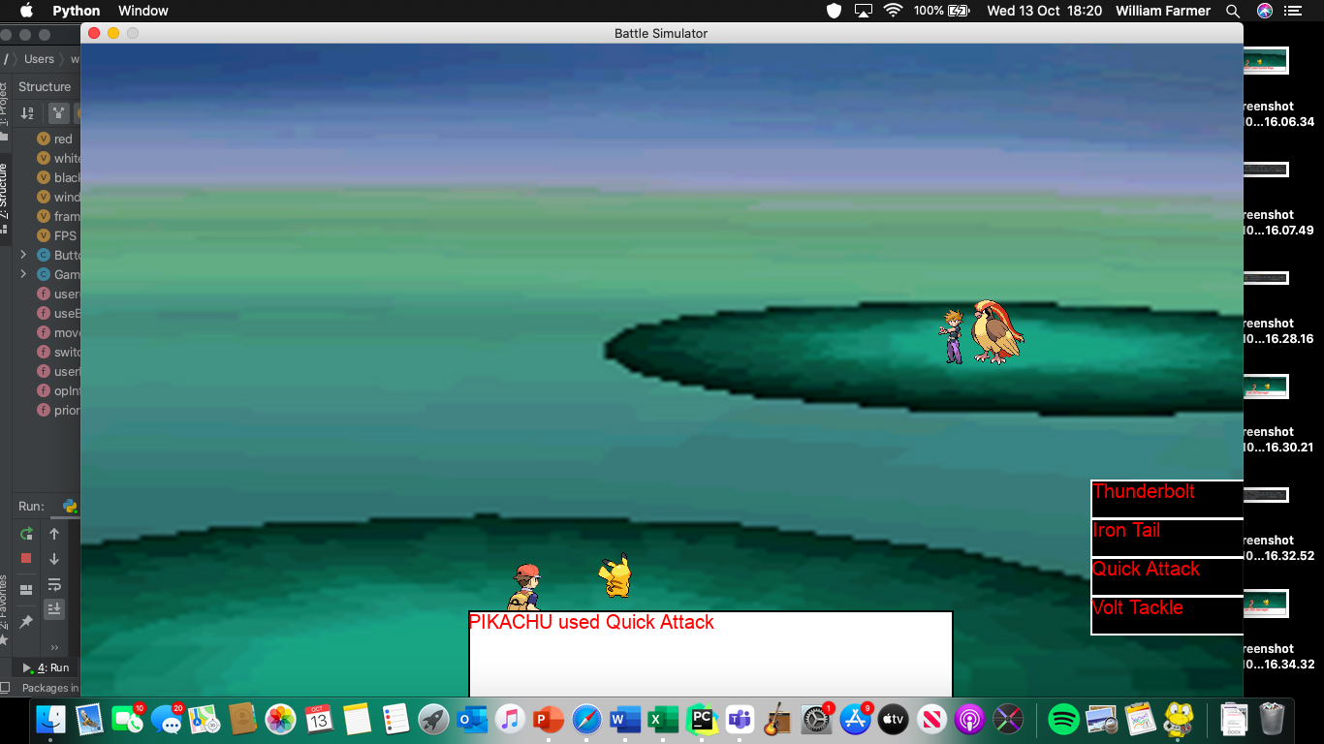

Then:

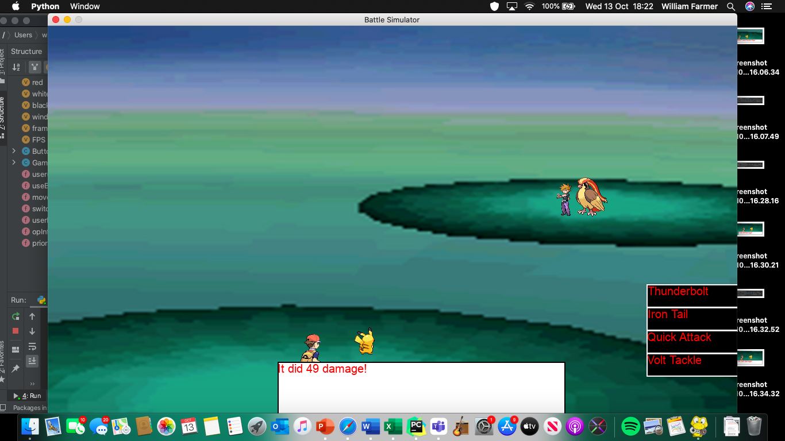

Which is consistent with the possible damage calculations. Then Pidgeot used its move:

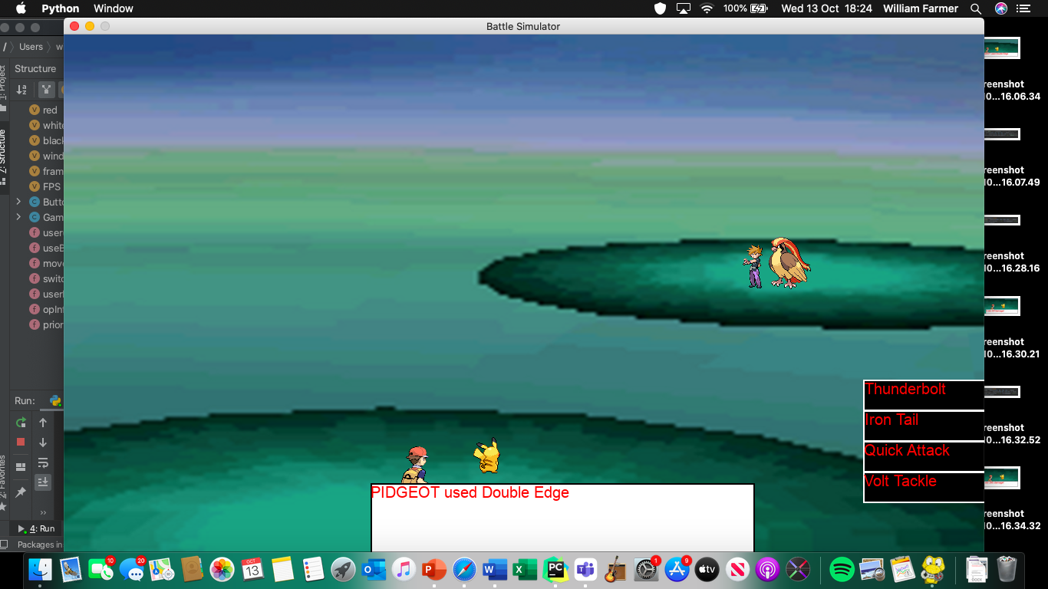

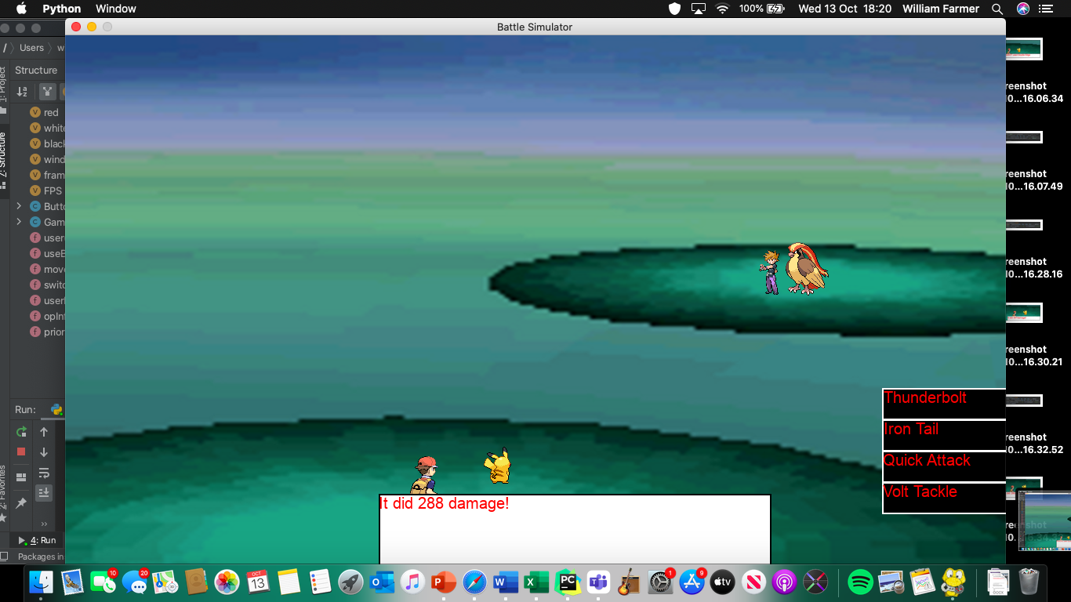

Great! This means that - in terms of *fighting* - one full turn is able to be completed.

Before I start coding in the BAG, I want to the change the name of the class GameChoice to Box, as I feel this is a much more appropriate name, especially considering it covers the narrative box.

##### Choosing the bag

For choosing the bag, I want a similar thing to occur to when you choose FIGHT; 4 boxes appear with different items being available. I will use the 3 I had in the text-based version (revive, super potion, max potion) as well a new item: the hyper potion. This does more health than the super potion, but less than the max potion, giving the recipient 120 more HP.

This will be coded in the useBag function. Once the items have been displayed, and one has been clicked, all of the available Pokémon will be displayed. To reduce the need for validation, I will only output the valid Pokémon; for example, only fainted Pokémon will appear after the user clicks ‘Revive’, and only Pokémon who have less than their maxHP will be displayed, provided they haven’t fainted. This will make sure that the user **cannot** enter an invalid input so the program runs without error. Now, onto coding.

I kept the possibleItems list, as it makes it easier to change, add and remove items from the bag. The only change I made was capitalising initials and adding the hyper potion.

I then removed the userNames list as that is no longer required, as the user is no longer directly inputting the name of the Pokémon they want to apply the item to. This means I will also remove the IF applyTo in userNames statement, because the only input possibilities are valid ones, because I will make sure each Pokémon fits the required HP boundary (see above for more details).

Instead of this:

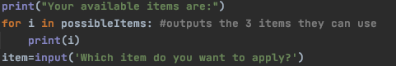

I will have the narrative box output ‘Which item do you want to apply?’, with all of the items appearing on the right hand side. I coded the following:

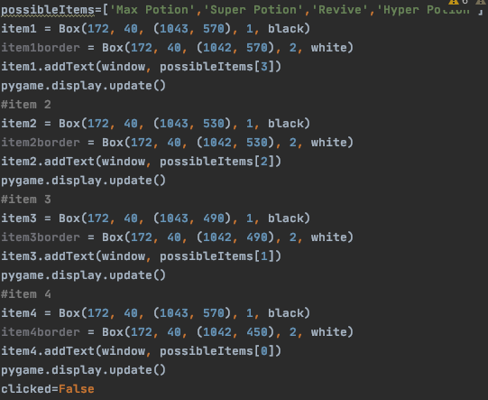

This draws every item in the place of where the moves would be displayed if FIGHT was selected instead. The Boxes are the exact same size, in the exact same places. This is because they have been pre-tested in these locations, and I know for a fact they will be displayed how I want them to be. For the click-detection I added in clicked=False, which will turn True when one of the items are clicked. When this happens the WHILE loop will break and the item will be applied so the user can progress with the game. The code for the click detection looks like this:

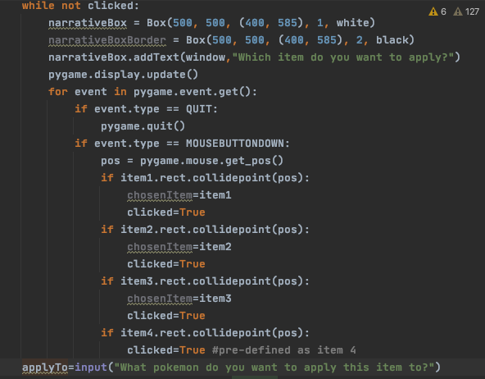

Which is very similar to all of the other mouse-clicking detection parts of my program. Like I did with the move selection, I pre-defined chosenItem as item4 so I didn’t have to define it again in the IF statement. The code ran to produce the following output:

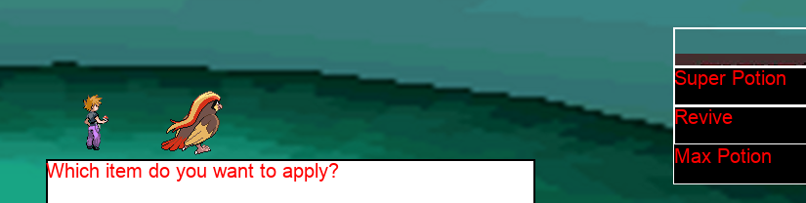

This is obviously not intended. This is because I only changed the location of the border of item4, and not the actual Box, so it is hidden behind one of the other buttons. I fixed this, and ran again:

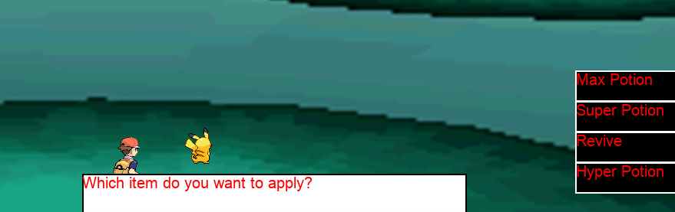

And when I clicked ‘Max Potion’, I received the following output (text-based just for testing purposes):

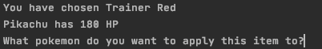

Now, I then realised that in this scenario not a single Pokémon would be allowed to have an item applied to them, as they all have maximum HP. This would mean that the user would be presented with an empty screen after selecting this. Hence, I added the following validation into the user function:

if bag.rect.collidepoint(pos):  
 if userPok[0].hp == userPok[0].maxHP and userPok[1].hp == userPok[1].maxHP and userPok[2].hp == userPok[2].maxHP and userPok[3].hp == userPok[3].maxHP and userPok[4].hp == userPok[4].maxHP and userPok[5].hp == userPok[5].maxHP:  
 narrativeBox = Box(500, 500, (400, 585), 1, white)  
 narrativeBoxBorder = Box(500, 500, (400, 585), 2, black)  
 narrativeBox.addText(window,' No items can be applied')

This means that when bag is pressed, it checks if all the Pokémon have full health. If they do, they obviously can’t have an item applied to them, and so the narrative box outputs “No items can be applied” and the WHILE NOT clicked loop continues until a valid option has been pressed. When I run the code and click bag before making a move, the following output is received:

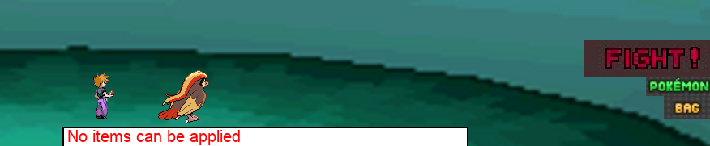

When I then try to fight:

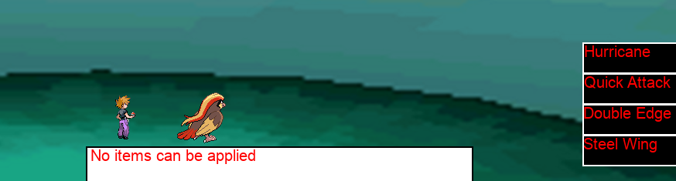

The game continues. Then when I try and choose a move:

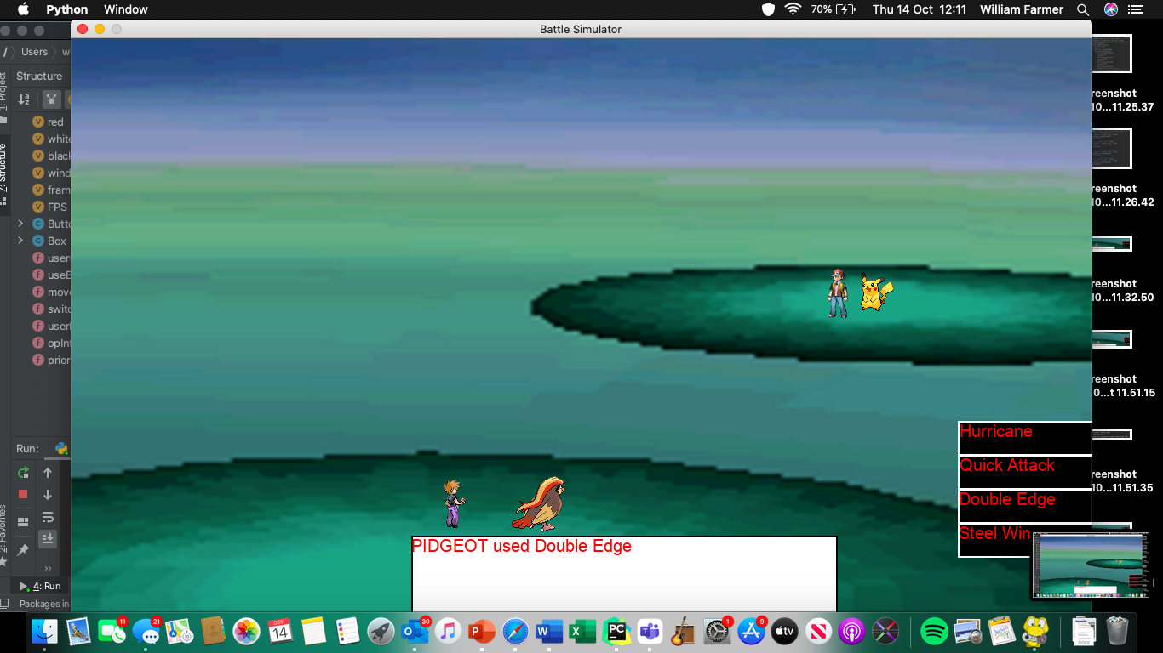

The game still progresses. I’m going to update the narrative box to say “What move will you choose” when the user clicks the fight button.

I coded this as so:

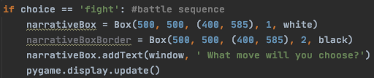

And ran the code to check it worked:

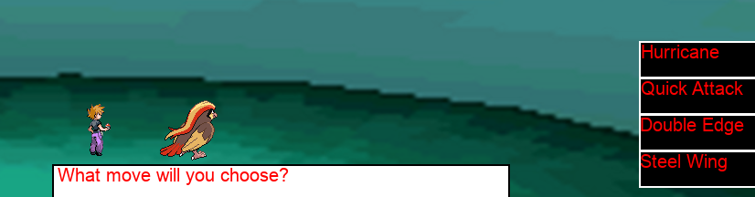

And it did! Now I want to add the validation that prevents the user from selecting revive when no Pokémon are fainted and selecting a potion when all Pokémon are either fainted or at max health.

Hence, I coded two functions to assist with checking for item validity. The following is for potions:

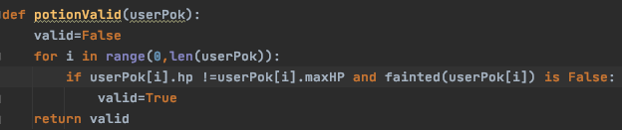

This was then used in the following IF statement:

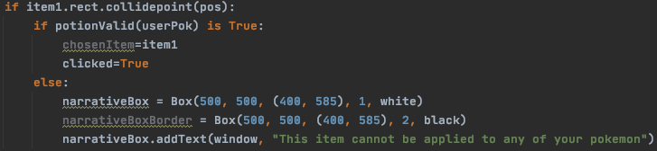

And duplicated for the rest, except for item2 which isn’t a potion. I then set all other team members to 0 health and ran the code to see if the message would pop up. However, I instead received the following runtime error:



This was just down to how I tried to set the HPs to zero. When I corrected this, I ran the code and selected Max Potion. The following output was provided:

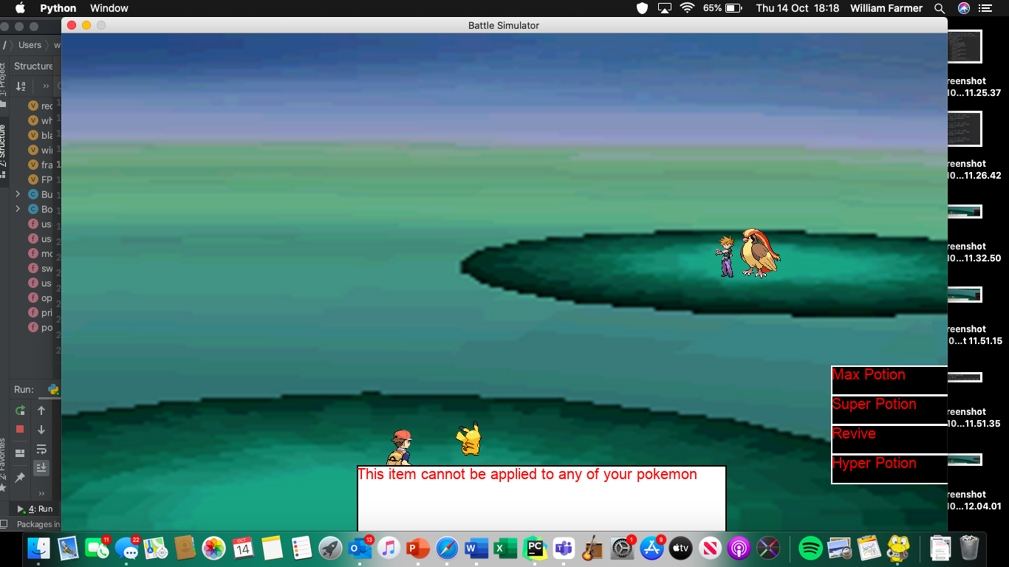

This originally only happened very quickly, so I added a sleep(1) statement in to allow the user more time to read the narrative box. I checked all four options to ensure it allowed Revive but nothing else. This was a success and confirmed my belief that the sleep statement was a good decision, as I was able to comfortably read the output, before it reverted back to asking the user to select their desired item. I then coded the reviveValid function:

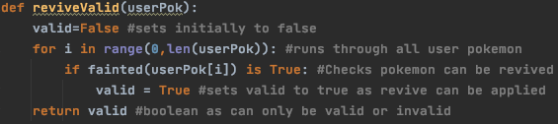

Which is used in the following IF statement:

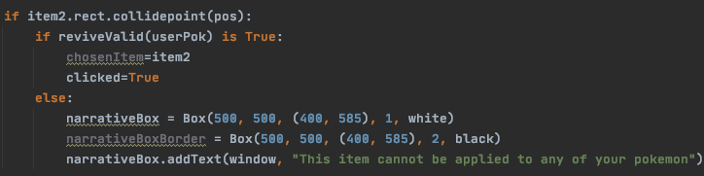

Which only sets clicked to True and chosenItem to the revive if a Pokémon can be revived. When code is run and Revive is clicked (when no Pokémon can be revived), I received the following output:

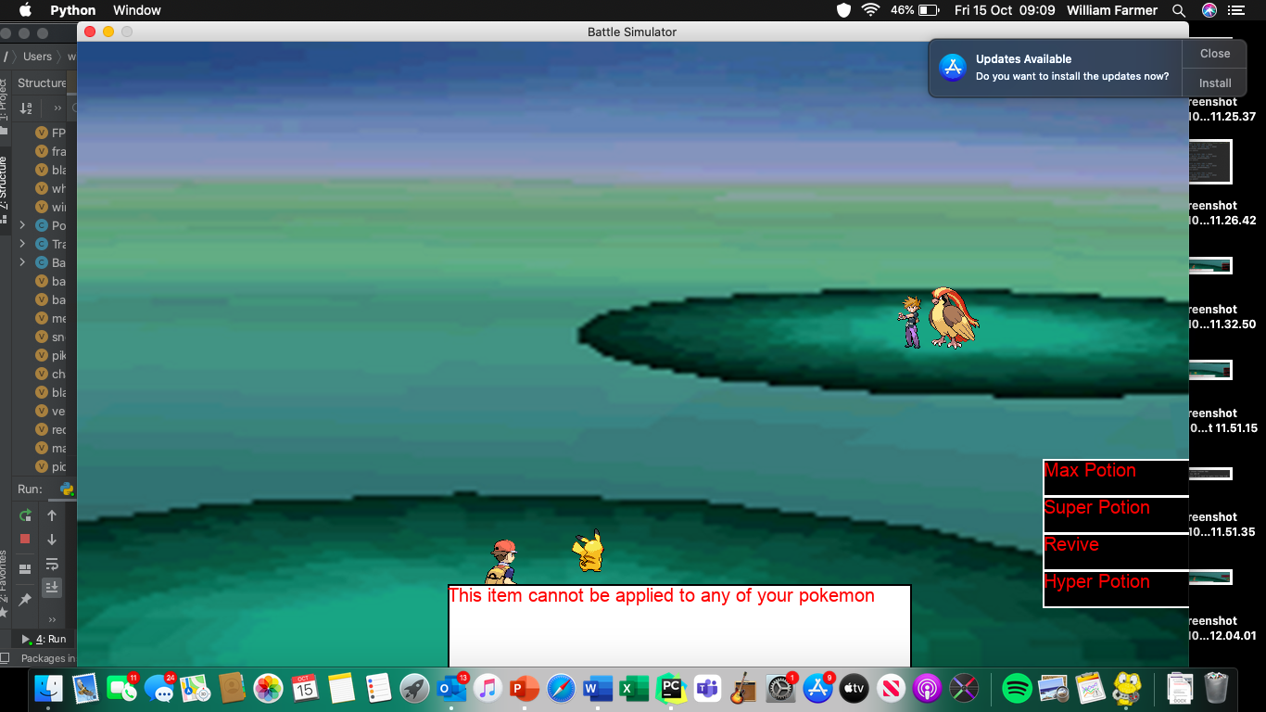

Which means that the code has worked. There is now suitable validation in place to prevent the user from entering an invalid input for which *item* is applied, now I need it for which Pokémon it can be applied to.

This is prompted in the following:

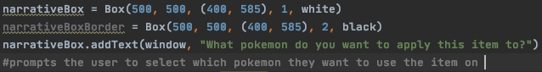

Which runs to produce:

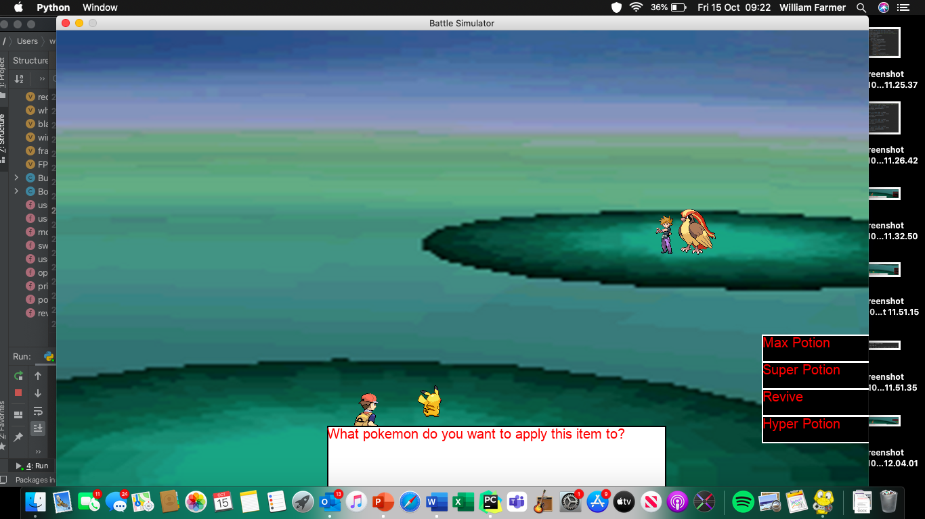

This means the narrative box is being output correctly, so I can now output the Pokémon that can legally have the selected item applied to them. This will mean that I have to re-draw the background, narrative box, Pokémon and trainers, so that the items are guaranteed to be hidden. If I simply output the possible Pokémon on top of the boxes, there could be instances where there are not enough valid Pokémon to cover up the item boxes. Hence, I need to redraw the scene. Unfortunately, when trying to import the class Background from the main file, the program immediately crashes due to a circular import. To get around this I just copy-paste the class into userFile. To refresh the background, I code the following and run it:

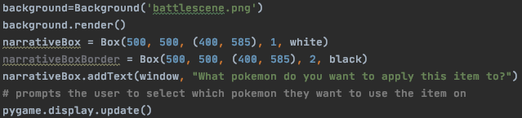

Which results in the following output:

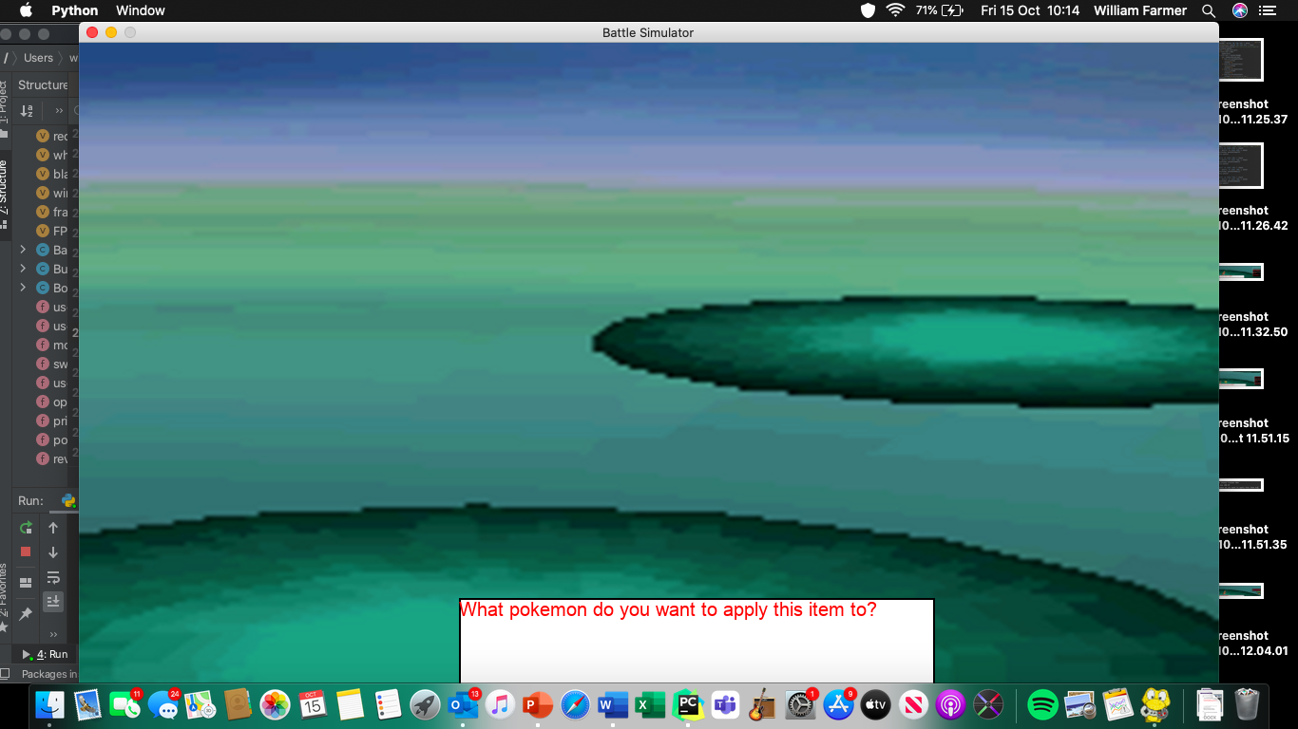

This shows me that the window was successfully emptied, and the background and narrative box correctly displayed. Now I add back in the Trainer and Pokémon sprites. To do this, I have to pass userTrainer and opTrainer into user(), then again into userBag(). Similarly, from user() I then have to pass userOutPok and opOutPok into useBag(). Once this is done, I code the following:

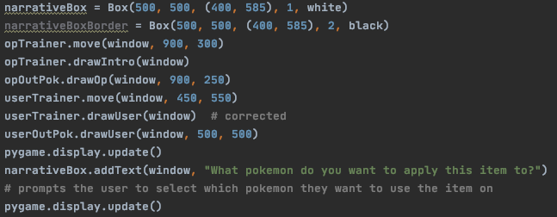

This redraws the whole scene with the exception of the possible items, as desired. Now I can create boxes to display the names of the Pokémon that can have the selected item applied to them with fear of one of item Boxes still being visible. I ran the code, and it produced the following output:

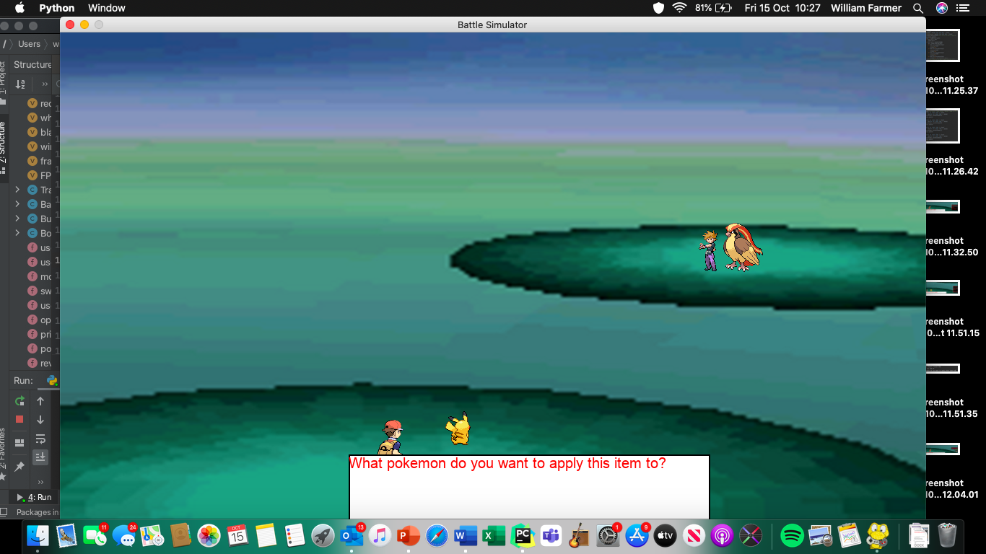

This shows that the background, Trainer, Pokémon and narrative box have all been re-drawn. Now I need to alter the following code for graphics:

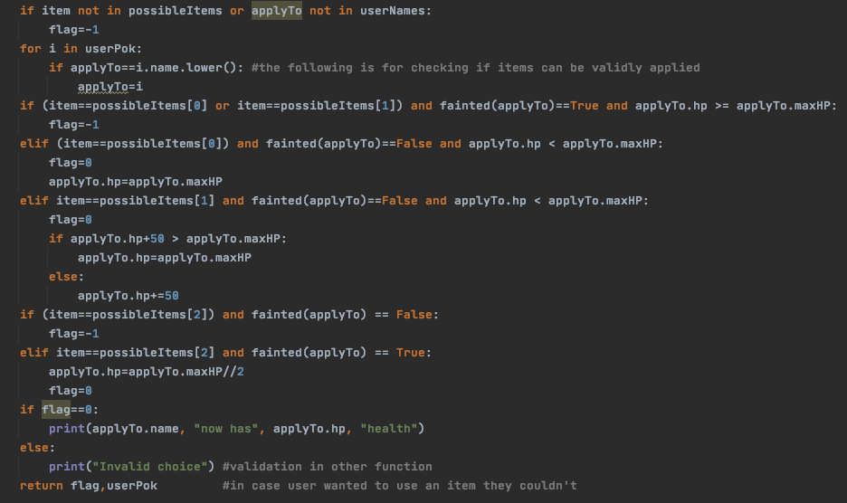

I will keep the actual application code the same, but the validity checking will no longer be necessary. This is because, alongside the validation I’ve already implemented, I’m now going to display only the Pokémon that can have the desired item applied to them, so the user can’t select a valid item but invalid recipient. I code the following to check for validity:

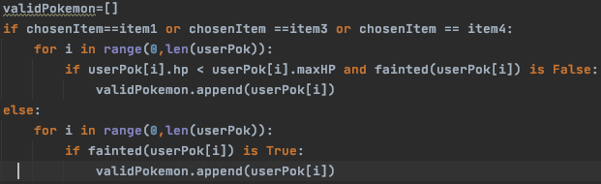

The IF statement is for potions, the ELSE is for revives. I can do an IF..Else rather than IF..ELIF because to get to this section the user has to have chosen one or the other. The list validPokemon stores the objects of all the Pokémon that can have the desired item applied to them. Now I need to create the boxes for them. This will be done using a FOR loop given that the number of valid Pokémon can vary. The code for that is below:

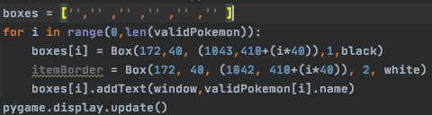

Here I made a list of 6 empty items. This is done so I can later keep track of which item was clicked. The FOR loops then runs as many times as there are valid Pokémon, assigning each valid Pokémon’s Box to an item in the list. The list is 6 items long as that is the maximum number of valid Pokémon. The validation I did earlier in this function ensures that there is at least one valid Pokémon, so the game will never crash. I set each Pokémon to 1 below their max HP and press Max Potion, and it produces the following output:

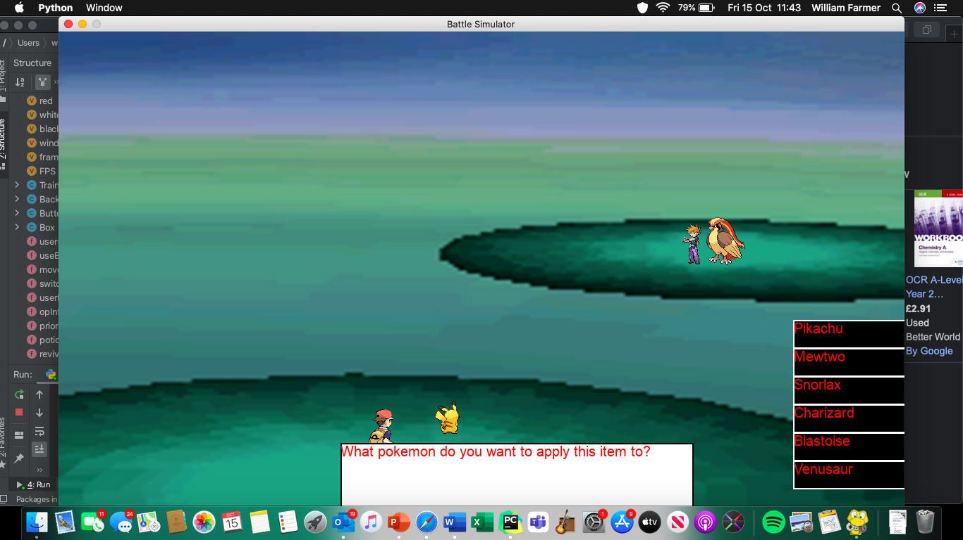

Ensuring that it works for this scenario. I then changed it so only pikachu could have an item applied to it:

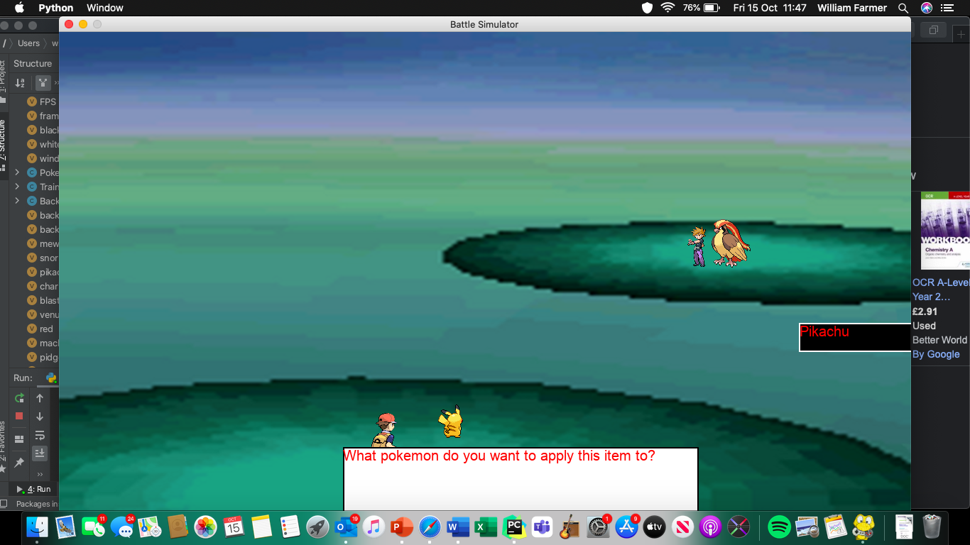

And it only displayed pikachu as being a valid Pokémon. This means that the code for validity works! Now I need to code the actual application process of the item.

This section can only be tested once the whole thing has been coded. Firstly I created two more lists to help me check which Boxes had been displayed and then which object corresponded to each Box:

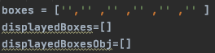

Which then caused me to alter the FOR loop as well:

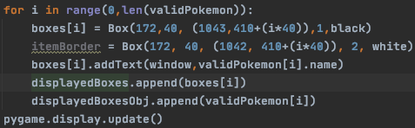

This updates the displayedBoxes list and displayedBoxesObj list, thus keeping track of which Boxes have been displayed and which objects have been associated with the Boxes that have been displayed.

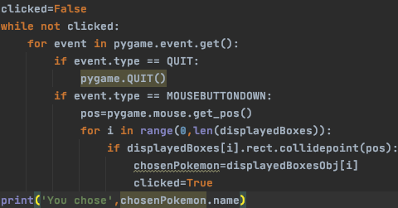

This is the click detection loop. The position of the mouse is stored in the variable pos, which is only stored once a mouse click is detected. If the position of this click collides with a Box, the object associated with this is stored in chosenPokemon as it’s the Pokémon the user has selected to apply the item to. The loop then breaks because clicked is set to True and the selected name will be output in a print statement for testing purposes.

I ran this code twice and selected Charizard, then Pikachu, receiving the following outputs for both:

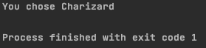

and

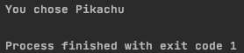

Assured that this was working, I then changed it so the narrative box would output this information instead. I wrote the following code to output this:



And it ran to produce the following output:



This runtime error only occurred after I selected the Pokémon I wanted to apply the item to. This is because chosenItem is set as the clicked Box, not item itself. I then added the following to each Box creation:

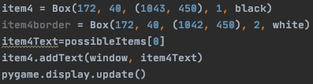

I then changed the click detection system to the following:

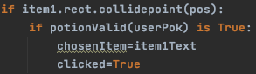

Which means I can keep the output the same. When I run the code this time, I’m met with the following output:

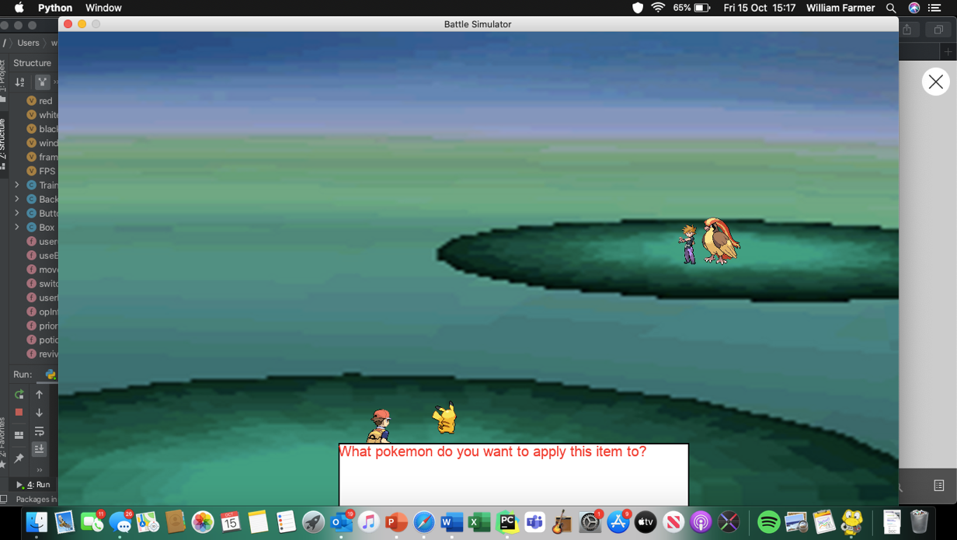

This is because I forgot to change my validation. Once I changed it to:



I ran it again, and received the output:

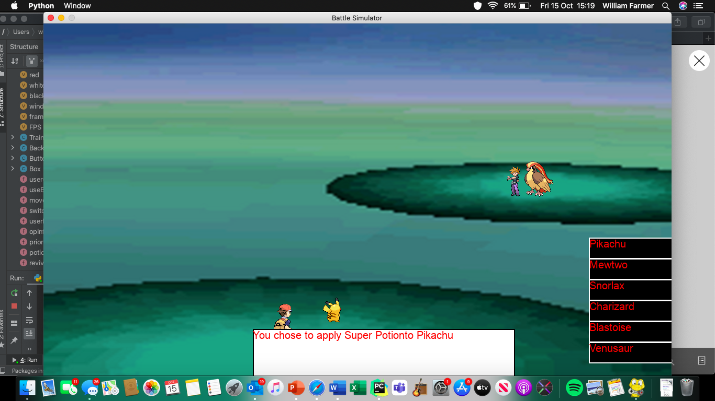

This is a success! I made sure to add a space between the item and ‘to’. Now I have to apply the effect of the item.

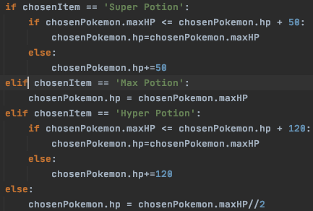

This is identical to the code in the text-based version, which has been pre-tested and thus pre-proven to work. Hence, I moved onto outputting the new HP of the Pokémon that had the item applied to them:

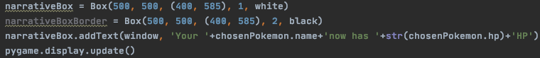

chosenPokemon.hp was output as a string because otherwise the program tries to add the values together rather than concatenate them. The following output was produced:

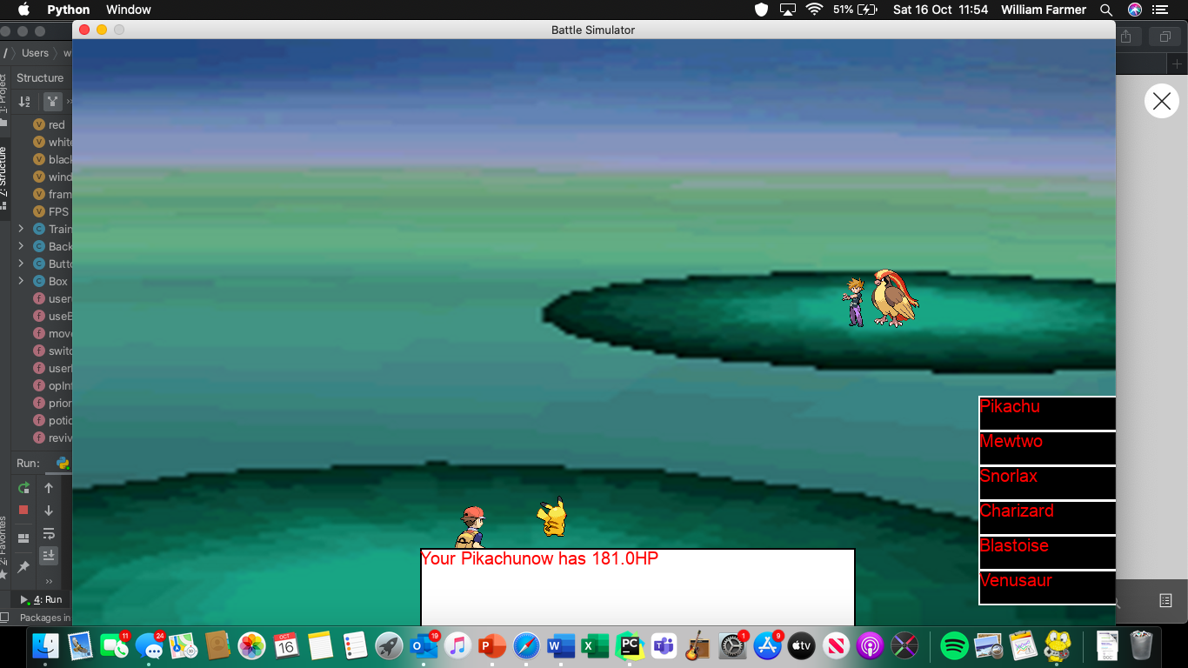

Two flaws here: there is no space between the health value and the ‘HP’, the name of the Pokémon and the ‘now’ and the health value is output as a real number, not an integer. Therefore, I changed the code to the following:

narrativeBox.addText(window, 'Your '+chosenPokemon.name+' now has '+str(int(chosenPokemon.hp))+' HP')

and ran the program again:

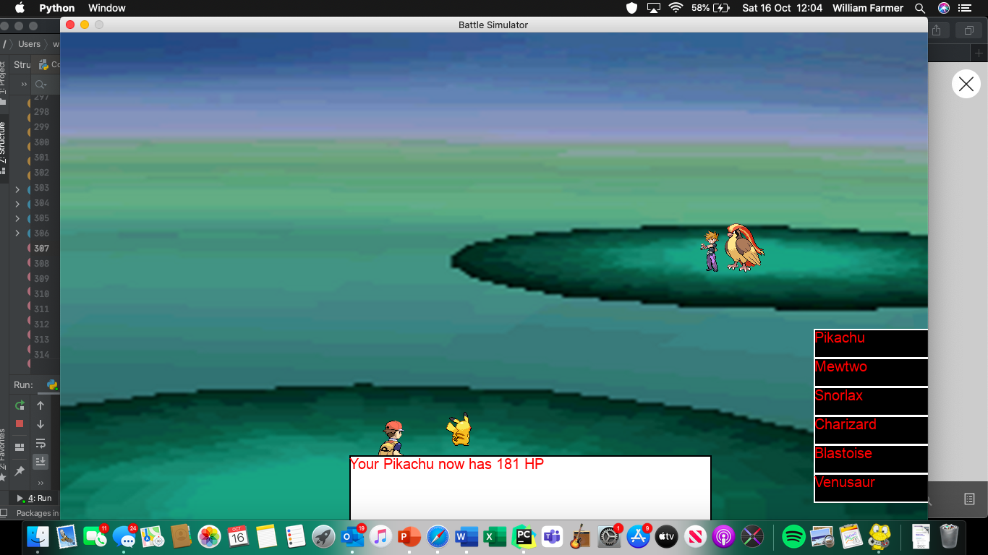

Great! Now the final thing I have to do is integrate graphics into the switch() function. Before I do this, I remove every mention of the flag variable. This was meant to identify any invalid inputs to the text-based game, but the new graphical game has no need for such a variable, as the only invalid inputs are the ones I’ve already addressed earlier in this section, or the ones I will address while coding the switch function. None of these require the flag variable I’m currently using and so it has been removed.

##### Switching battlers

Before I start the validation for the switch function, I want to make sure the function itself works. This will mean that I can better test if the validation works afterwards, as there will be working outputs in place. This pre-coded section of code from the text-based version will remain the same, except I will remove the .lower() wherever its mentioned:

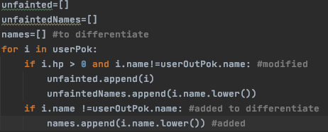

I changed the following:

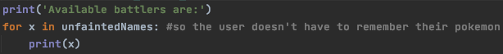

So that instead of the ‘Available battlers are:’ statement and the valid Pokémon being printed out, they are output in the form of Boxes (for the Pokémon) and via the narrative box for the initial print statement. Firstly, I completely reset the screen exactly how I did in the useBag() function, so I just copy the code into this one. I then start replacing the above screenshot of code with the new code, which looks like this:

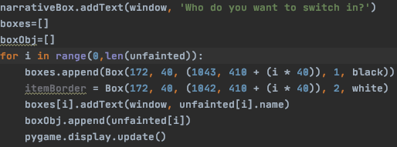

This is obviously very similar to the code used in useBag(), with the *boxes* list in this function replacing the one of the same name in useBag(), and boxObj replacing displayedBoxesObj in useBag(). There is no displayedBoxes list in this function as all boxes are displayed. When I ran the code and clicked the Pokémon button nothing. This was because I forgot I hadn’t coded in a click-detection system for the Pokémon button, only the FIGHT and BAG buttons. I implemented this:

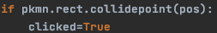

Without needing to set a new value to the *choice* variable as it contained ‘switch’ by default. When I ran the code this time, I received the following output:

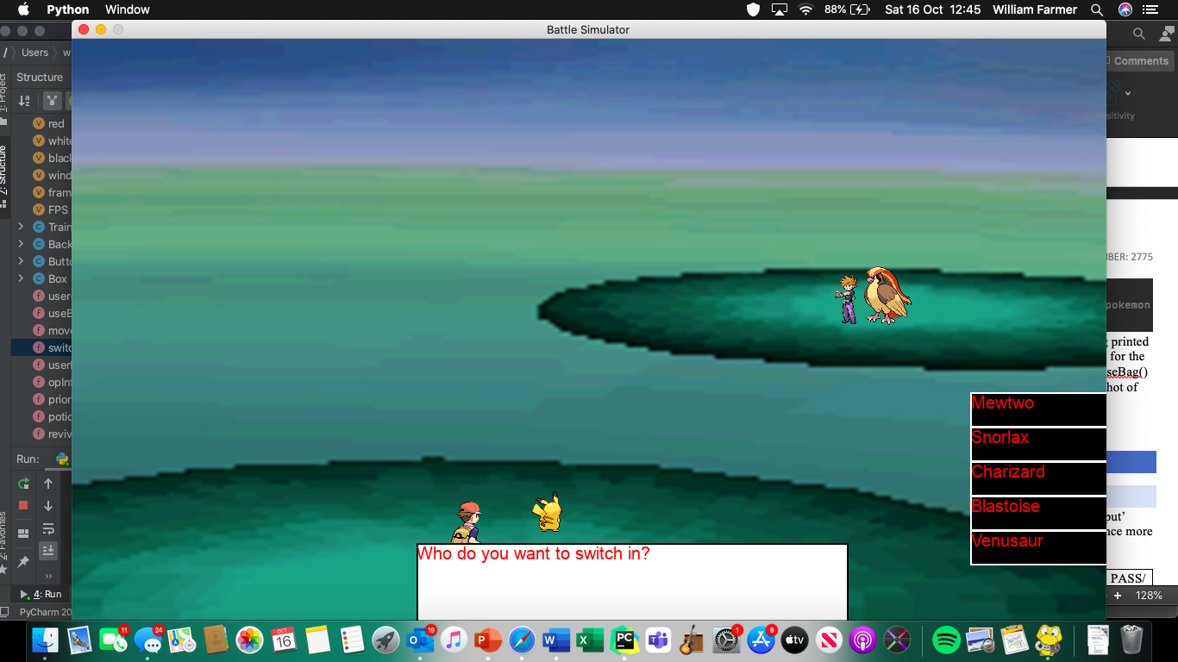

Which now leads me onto the click detection system. It’s important to note that pikachu wasn’t one of the Pokémon that appears as valid – this is because it is already in battle, and therefore cannot be switched in. It is, once again, going to be very similar to the system used in useBag(). I added in the following detection system:

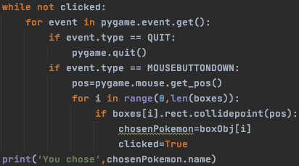

And had the program print out which Pokémon was selected for testing purposes. I ran the above code, clicked Blastoise as my desired switch-in and received the following output:

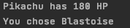

Now I knew it was working I changed the print statement so that the narrative box performed the output instead.

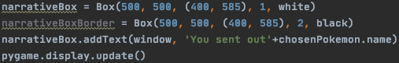

This was the code I used to display this message, resulting in the following output:

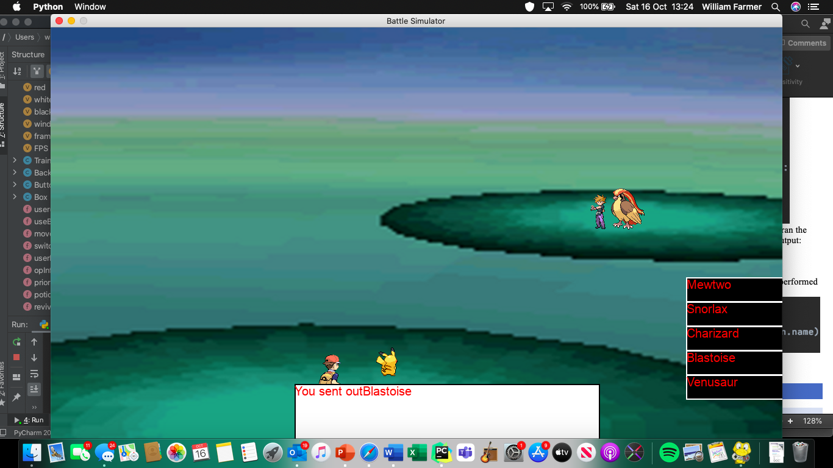

I forgot to include the space (again!) but fixed it immediately. I now need to replace the old Pokémon with the new one. I’m going to try and do this without resetting the whole screen, as the narrative box takes a while to draw itself from scratch. Instead, I’m going to have the new Pokémon drawn on top of the pre-existing one. I try this for Blastoise, and it works:

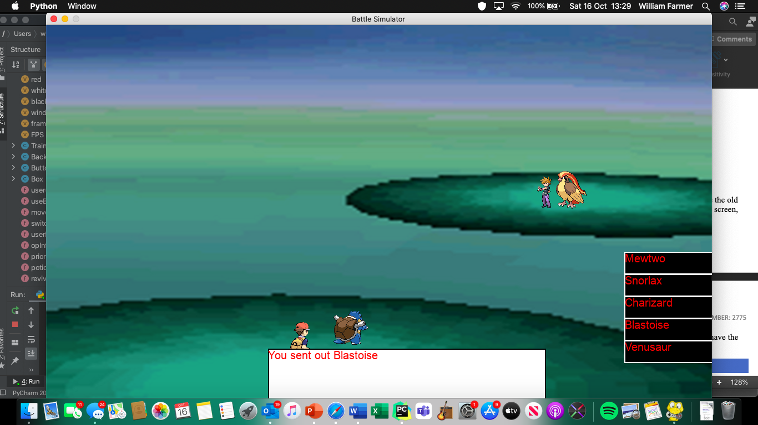

But I then realised this could be because Blastoise is bigger than pikachu. Hence, I try again but I switch Snorlax out for pikachu, as snorlax is the largest Pokémon.

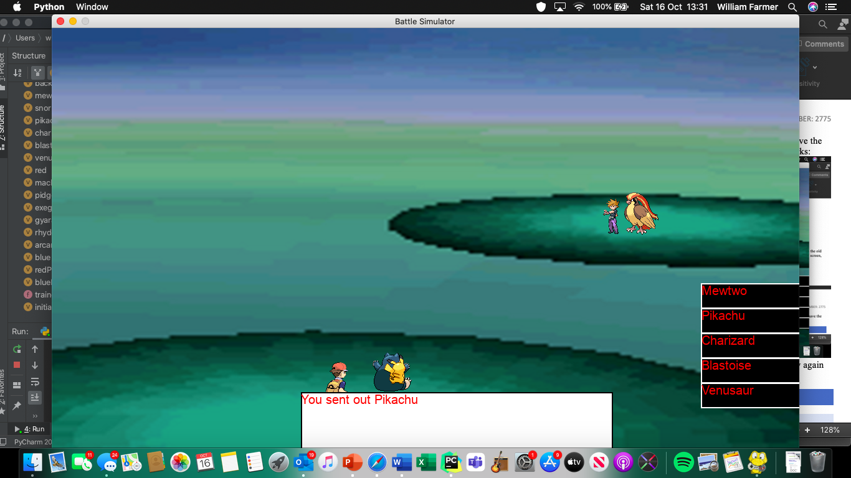

As expected, it didn’t work. This means that I just reset the screen instead. I swap back pikachu and snorlax, in the game code, then run the game. In this test, I have snorlax switch in for Pikachu:

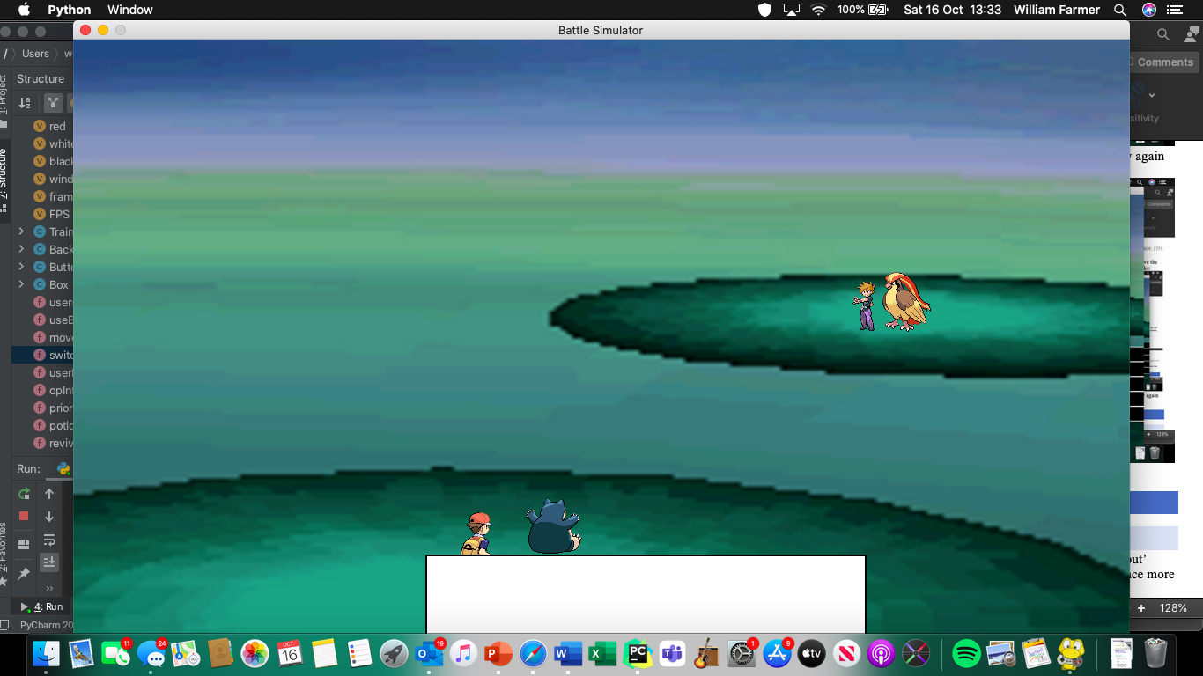

I want it to still say “You sent out Snorlax” and so add it in during the reset. The game now produces the following output:

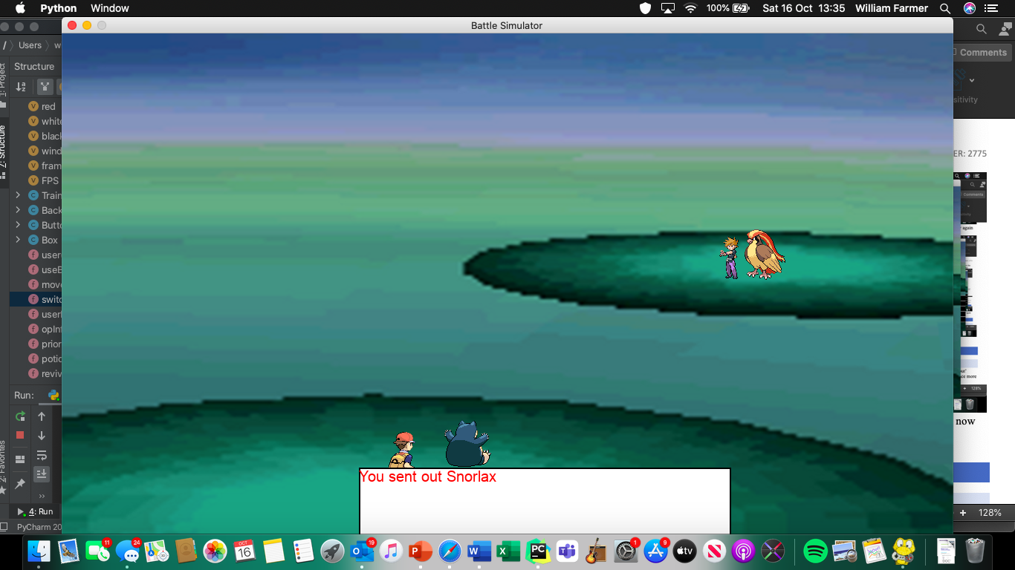

Which is as desired. I return the user’s new battle (userOutPok) and run the program again to ensure that while the Pokémon switch, the opponent still attacks. This time I switched out pikachu for mewtwo, and I received the following outputs:

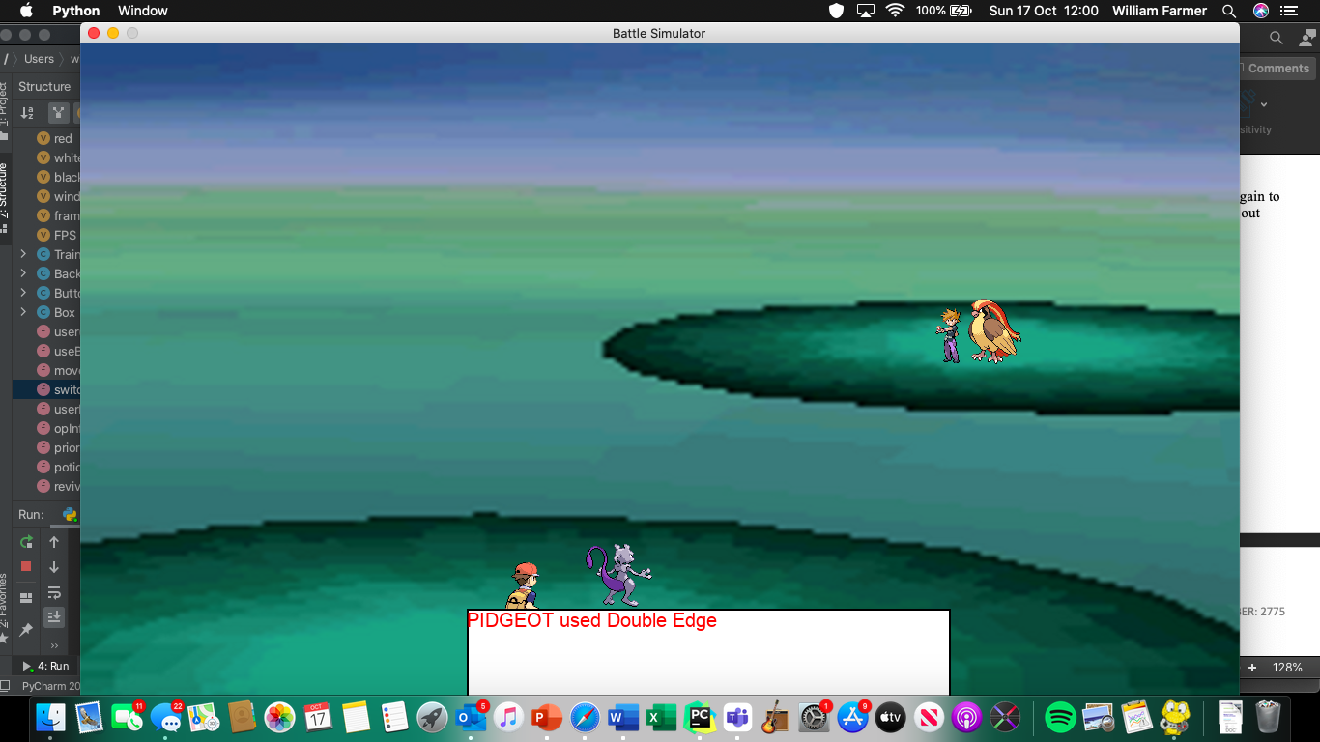

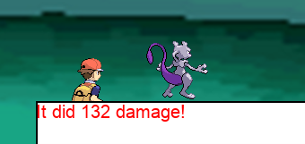

This is just as desired. Now I need to implement the validation. To do this, I code the following validation function:

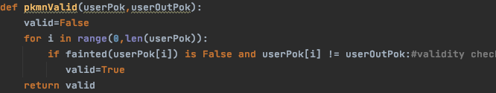

This checks that there is a non-fainted team member who already isn’t in battle when the user clicks the Pokémon button. If such a Pokémon exists, then a switch is deemed to be valid, and hence the Boolean variable is set to True. It is used in the IF statement below:

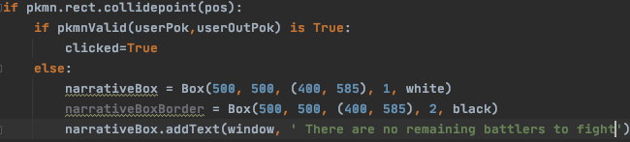

This first checks whether the Pokémon button has been clicked. If it has been, and a valid switch is available, the game progresses. Otherwise, the above message is output to the narrative box. I ran the code when a Pokémon could be validly switched to, and received the following output:

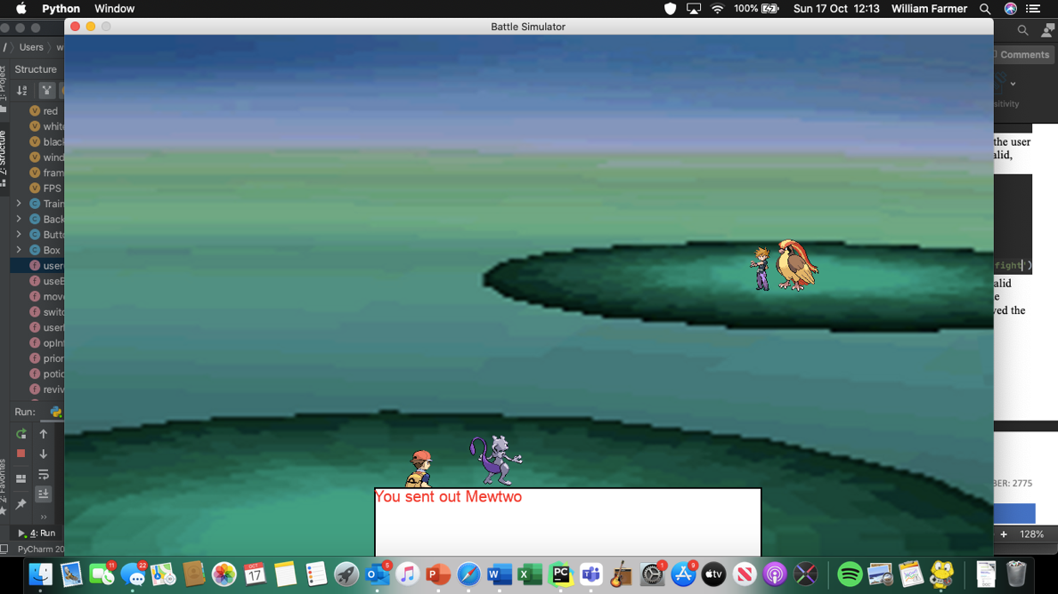

Which is as expected. I then made all of the user’s Pokémon fainted except for Pikachu and ran the code again.

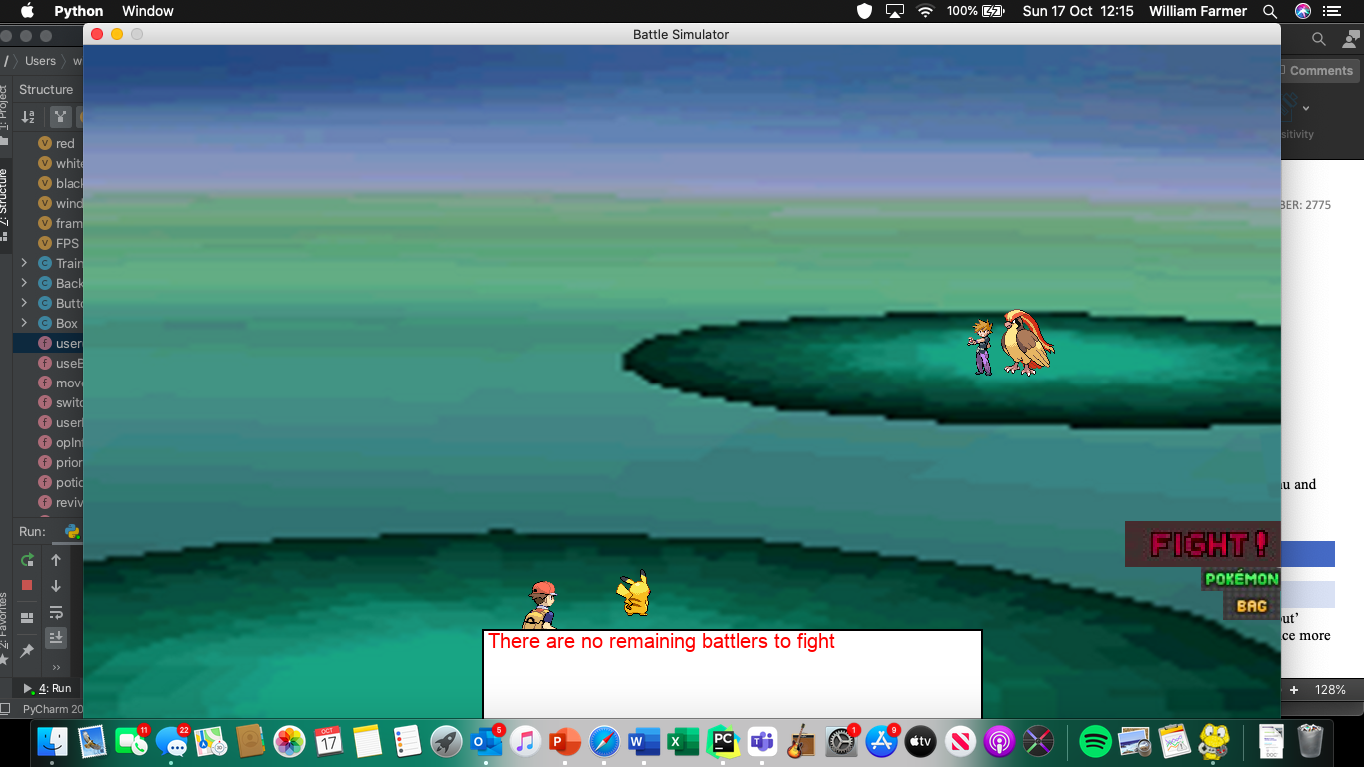

Great! I decide to change the message to ‘You have no more battlers left’ and so I replace the one shown above. Now I need to implement the system that forces the user to send in a new Pokémon when their current battler has fainted. I try and run using the old system, changing only the use of the flag variable. However, I encounter the following error:



This is because the switchUser function has new arguments, which I forgot to add in here. I update this, resulting in the following code:

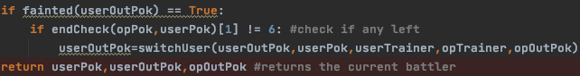

When I ran this code and used thunderbolt with pikachu, the AI’s Pidgeot used Double Edge, which caused my pikachu to faint. This was confirmed in the below text-based output I implemented for testing:

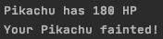

And the below screenshot of the pygame window asking which Pokémon I was going to switch in:

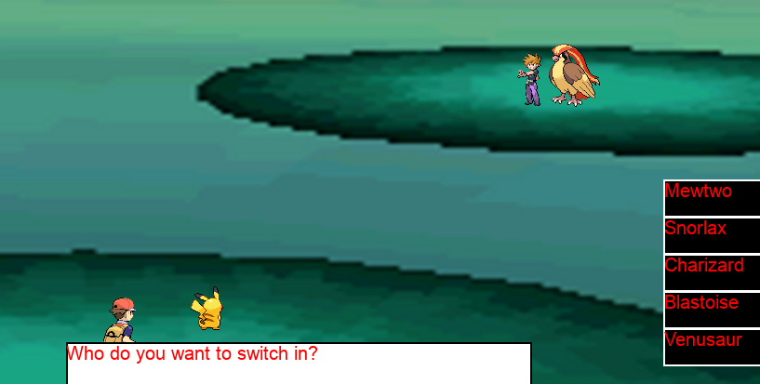

I then decided to add in an output in the narrative box saying that my Pokémon had fainted, but not one for how much HP they have left. This is because once I’ve finished with integrating graphics into switching a Pokémon out, I’m then going to implement the HP bar.

I coded the following in the opInflict function:

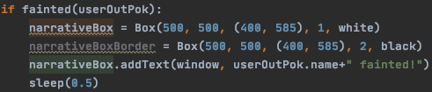

And when Pidgeot’s Double Edge caused Pikachu to faint:

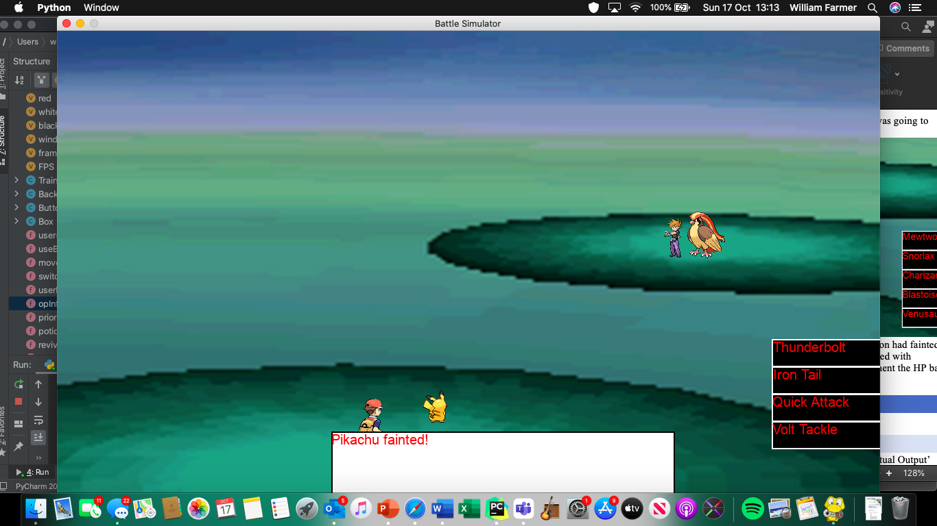

Just as desired. Now, onto the health bar.

##### Creating the health boxes

My idea for the health bar is for it to be contained in an outlined Box (on the bottom left for the user and top right for opponent) which also stores its level and name. I may add in each Pokémon’s sex later but right now that’s just an unnecessary cosmetic addition.

The Box it’ll all be contained with be grey coloured with a black border, with the HP bar being green. If I have enough time, I will have different coloured bars depending on the amount of health the Pokémon has. After I implement this, the game should be fully playable, with the exception of me having to add in the ending messages. At this stage it is unfortunately looking unlikely for the addition of animations, but I will talk about this more in the evaluation section if this is indeed the case.

I create the colour grey using rgb(132,132,132), and code the following for the opponent’s health box and border:

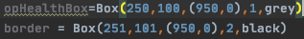

And run the code to produce the following:

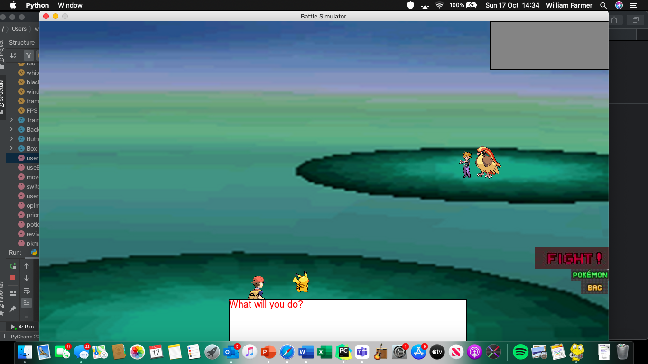

I then duplicate this and change the coordinates to create the user’s health box:

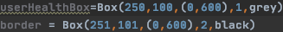

And run the code:

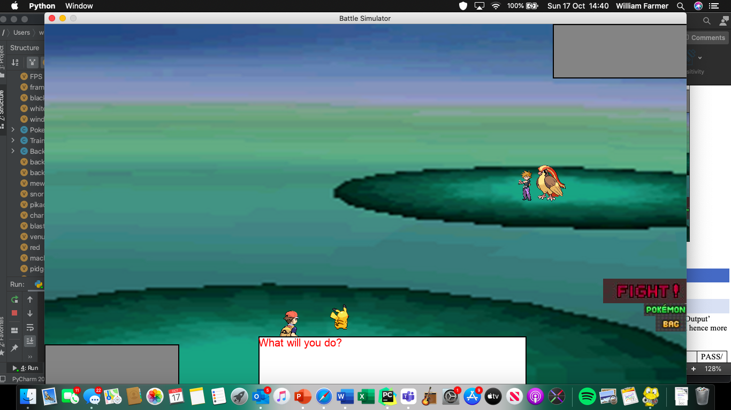

Great! Now I need to display the Pokémon’s name and level.

For this I code the following:



And



Which run to produce the following output:

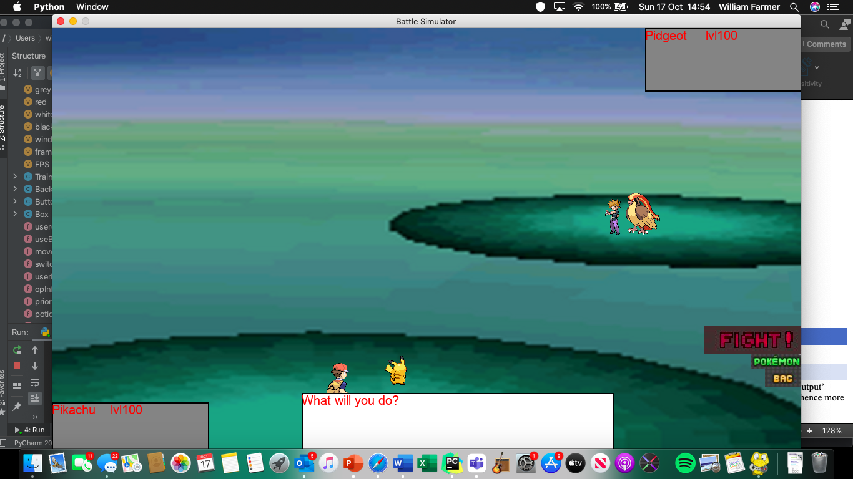

I then alter the outputs so that it adds the current HP of the Pokémon. This is done by just adding:



To the end of the pre-existing output statement. The new screen looks like this:

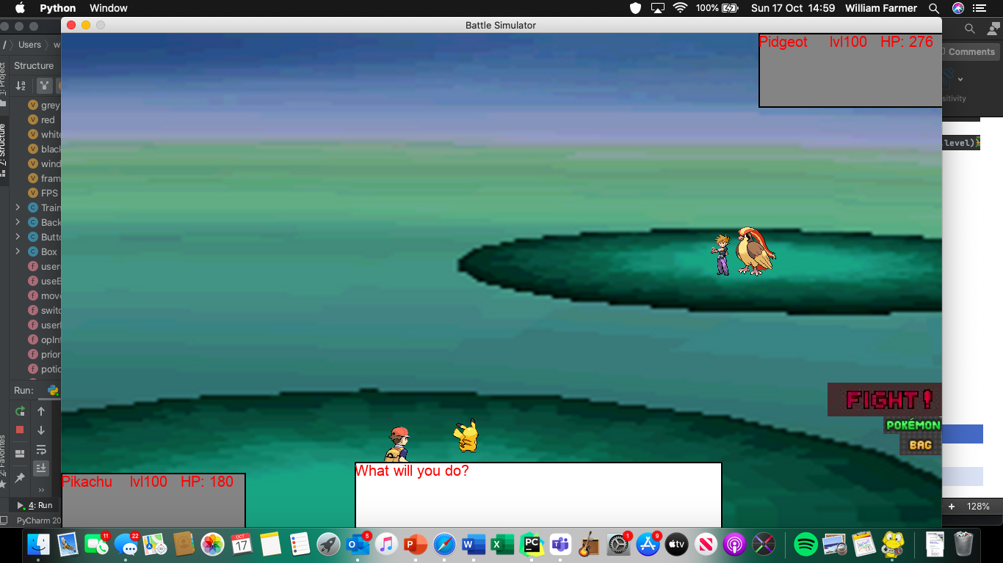

Which is great! Now onto the coding of the actual health bar.

##### Creating the Health Bar

I initially coded the following for the health bar:



But this resulted in the following:

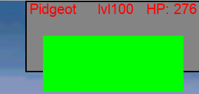

Which is obviously much too large for a health bar, and it goes outside of the health box. I hence made it less tall:

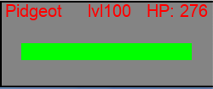

By setting the height to 20 instead of 80. This looks much more appropriate. I then adding a border around it so the user can see what proportion of the health remains:

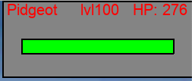

And I thought this looked amazing, so I copied it over to the user’s box, resulting in the following screen:

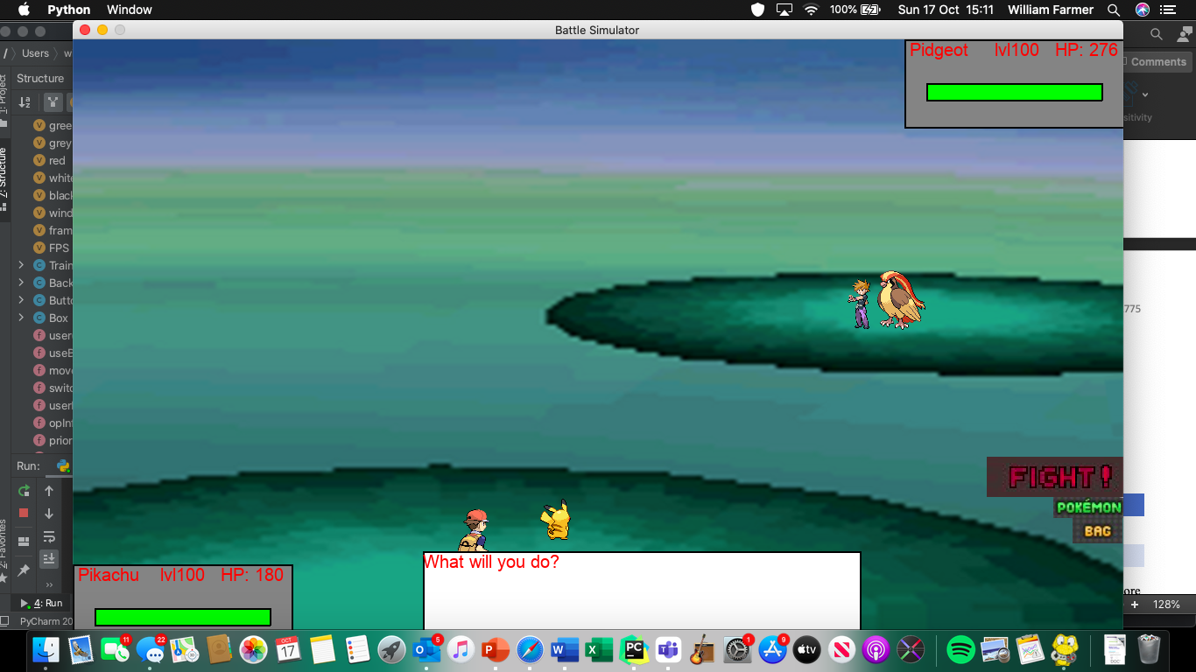

Now that I was content with the dimensions, I introduced two variables, called opHealthPerCent and userHealthPerCent. These two variables store the percentage health the current battlers have, coded like so:



This value is then multiplied to the starting width of the health bar (200) so the user can see how much health their, or their opponent’s, Pokémon has left. I deducted half of pikachu’s HP and then ran the code:

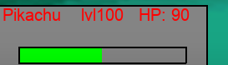

Which clearly shows that pikachu has lost half of it’s HP. The box also states a numerical value of the HP in the top right.

I coded the following in the userInflict function:

if opOutPok.hp < 0:  
 opOutPok.hp = 0  
opHealthPerCent = opOutPok.hp / opOutPok.maxHP  
opHealthBox = Box(250, 100, (950, 0), 1, grey)  
border = Box(251, 101, (950, 0), 2, black)  
opHealthBox.addText(window," " + opOutPok.name + " lvl" + str(opOutPok.level) + " HP: " + str(int(opOutPok.hp)))  
opHealthBar = Box(200 * opHealthPerCent, 20, (975, 50), 1, green)  
border = Box(201, 20, (975, 50), 2, black)  
pygame.display.update()

which redraws the Box with the new health bar and numerical HP value. I considered making it decrease incrementally but then decided to draw how long it takes to draw the Boxes that it would take too long. I ran the code above, selected Quick Attack with Pikachu, and received the following output:

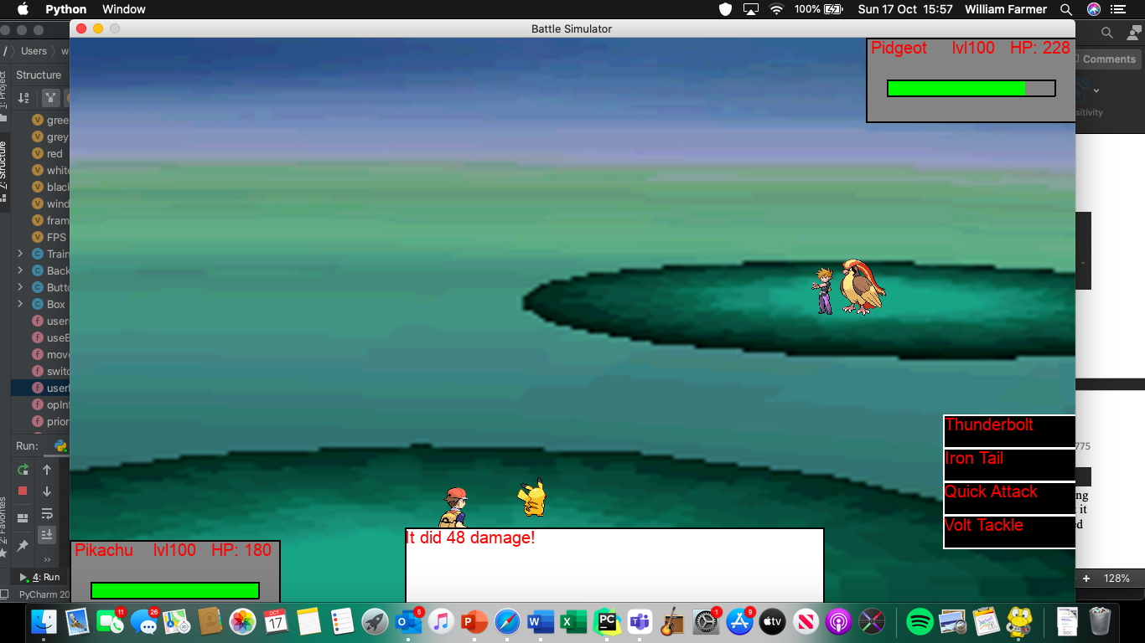

As you can see, the health bar has decreased in length, and the HP has decreased from 48 (Pidgeot’s max HP is 276). I then replicated this code for the opInflict function.

Now the integration of graphics is fully completed for the main section of the game. Next to complete is ensure the game still works when it’s multi-round instead of just one.

##### Looping the rounds

I simply de-hashed the main loop and adding an exit condition if the user wanted to stop playing the game:

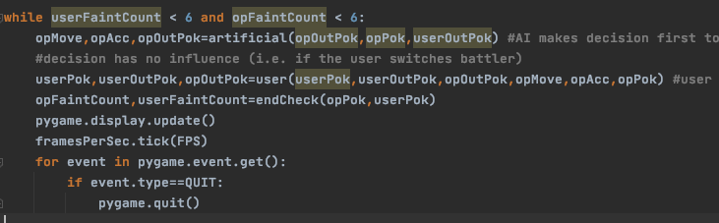

The game ran for one full turn, but I then received the following error:



This is because I forgot to update the arguments when the function user is called in the main loop. I ran the code again after correcting this error. This time, the code worked fine for two rounds, but when I knocked-out Pidgeot with mewtwo, it remained there next turn. In addition, Mewtwo’s moves were showing behind the FIGHT, BAG and Pokémon Buttons. This led me to believe that I need to reset the background at the end of every loop. This just means I copy-and-paste the code I used to do this in userFile into the main loop of the main file. I then have to also duplicate the Box class so the narrative box may be drawn.

I ran the code, and after knocking out Pidgeot I was met with the following:

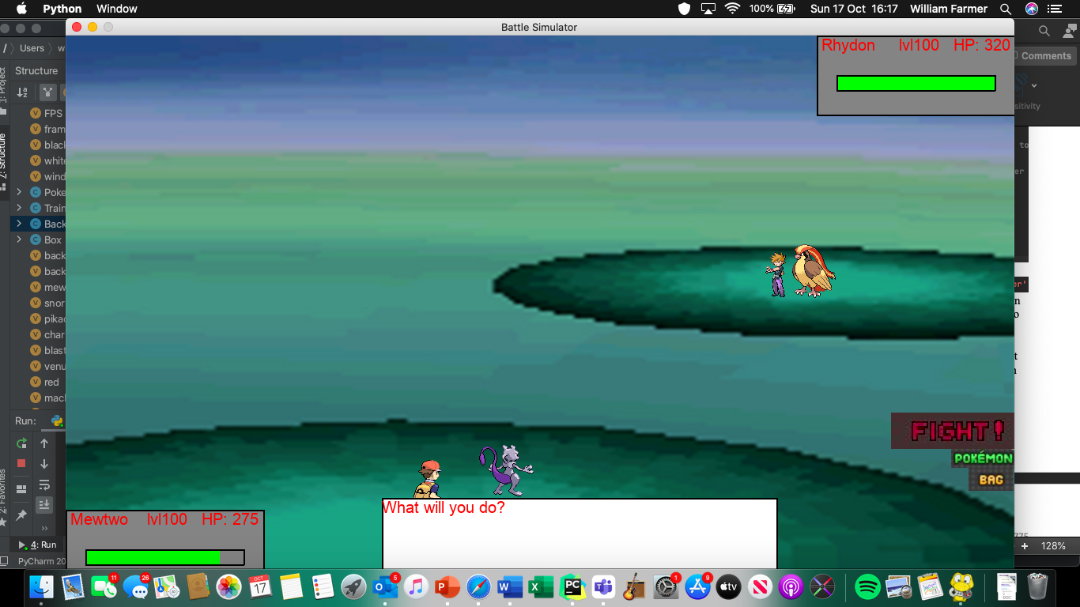

Everything has been reset, except Pidgeot’s sprite remains. The program is definitely updating opOutPok, as the health Box clearly shows the name being Rhydon and the numerical HP value is 320, Rhydon’s maxHP.

After some time to think, I realised that the difference between when the user chooses their new battler and when the AI does it is that the AI does it at the beginning of a turn, whereas the user does it at the end. Hence, I removed the statements for drawing the opponent’s Pokémon from the main loop and put it in the switch function in AI.py

After adding the following to the artificial function:

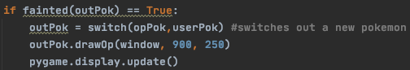

And removing the statement that draws the opponent’s Pokémon, I finally got the following output after causing Pidgeot to faint:

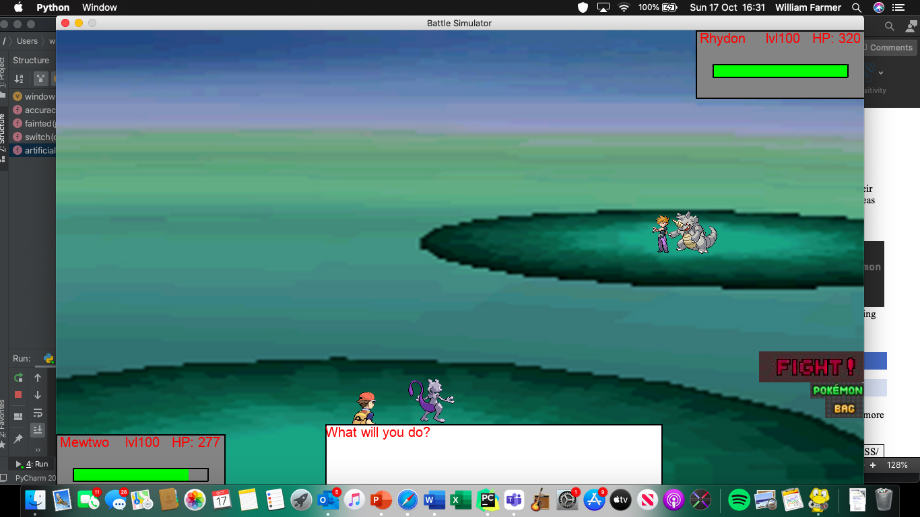

Just as desired. I then played out the rest of the game to ensure no other errors appeared. I did, however, manage to find a new error:

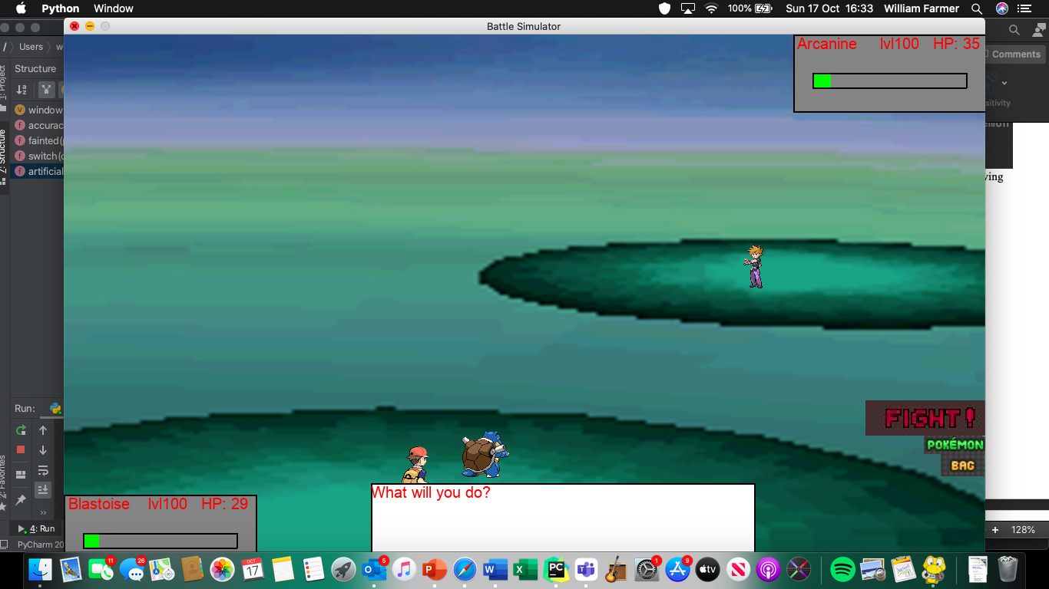

This is because the game only draws in the opponent’s sprite if they have just been sent out, rather than the beginning of *every* turn. Hence, I de-indented the statement and ran the code again to check for more errors.

The only error I encountered was that some Pokémon with larger names ended up having their numerical HP values displayed outside the narrative box. This meant that, for the opponent’s Pokémon, it sometimes ended up being displayed off the screen. To solve this I simply reduced the spaces between the Pokémon name and level. Now all I have to do is turn the gameOver function from text-based to graphical. Hence, all coding from here onwards will be in the theEnd.py file.

#### Ending the game

We now move over the theEnd.py file, where a message is output which states whether the user has won or lost the game. The endCheck function remains the same, so the only additions are to the gameOver function. Firstly, I pass in the background object as the background needs to change from the battle scene, because a battle is no longer occurring. I then code in the following in the gameOver function:

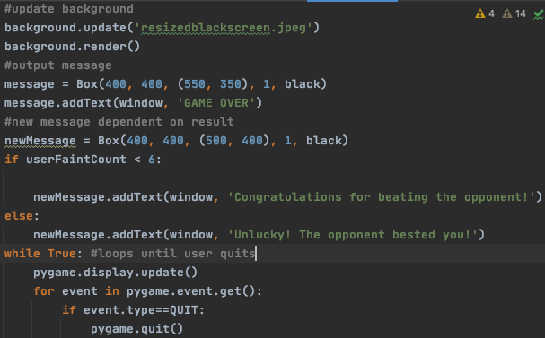

This displays an appropriate message depending on the result of the battle, and then loops until the user chooses to quit the game. I ran this code twice: once when I won and once when I lost.

When I won:

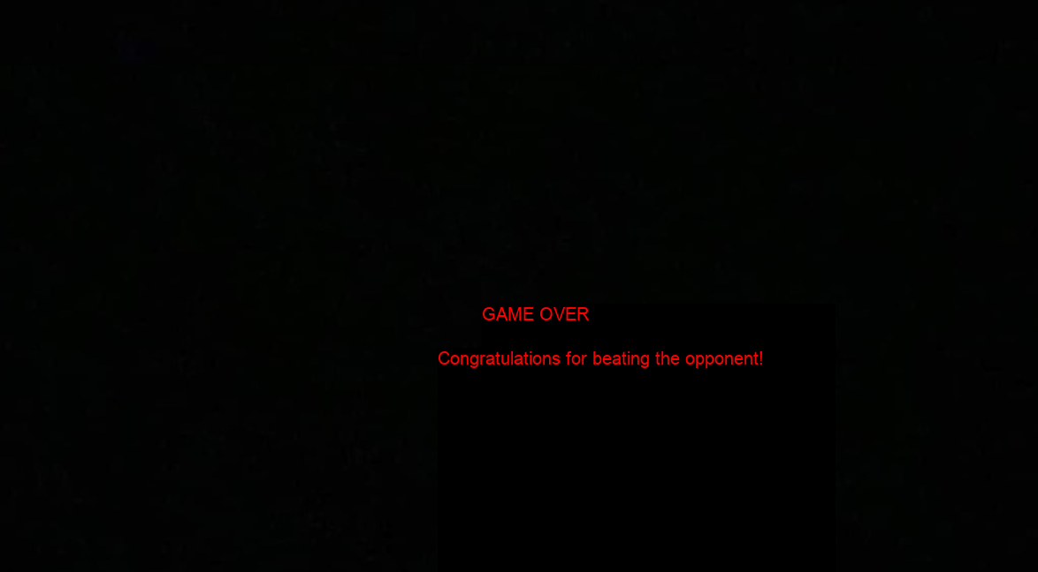

This as desired, but the lower message should be more central. Hence, I moved it to the left and ran again, but this time losing:



Which was much better, and it was the desired message. With this done, this is the whole prototype complete. I wished to include animations for moves and for switching Pokémon, but alas I did not have enough time. This will be touched upon in the evaluation section.

### Testing

In this, anything highlighted in green is a pass, in orange is a technical fail and will explained more in the evidencing section, and a red is a fail. Here is the test plan I created in the design section:

|  |  |  |  |  |  |  |  |  |  |
| --- | --- | --- | --- | --- | --- | --- | --- | --- | --- |
| Test no. | Test Type | Testing Success Criteria… | Acceptable Input | Accepted Output | Pass/Fail |  |  |  |  |
|  | Normal | 3.1 | Running the program | All Pokémon should be displayed alongside their associated trainer | Pass |  |  |  |  |
|  | Normal | 3.2 | Selecting trainer, which consequently starts the battle sequence | HP bars in top right and bottom left corners, narrative box at the bottom, Pokémon level in the HP box and sex of Pokémon alongside | Fail – see evidencing  Test result section |  |  |  |  |
|  | Normal | 3.3 | Selecting trainer, which consequently starts the battle sequence | The background | Pass |  |  |  |  |
|  | Normal | 3.4 | Selecting trainer and clicking ‘FIGHT’ | The Pokémon’s moves | Pass |  |  |  |  |
|  | Normal | 3.5 | Any move | A small explosion on the opposing Pokémon | Fail – see evidencing  Section |  |  |  |  |
|  | Erroneous | 3.5 | Choosing an item from the bag in easy mode | No animation | Fail – see evidencing  Section |  |  |  |  |
|  | Erroneous | 3.5 | Switching out a Pokémon | No animation, Pokémon out is replaced | Pass |  |  |  |  |
|  | Normal | 3.6 | Any move that affects the target | The HP bar visibly decreases for the afflicted Pokémon | Pass |  |  |  |  |
|  | Normal | 3.6 | Select either bag, switch Pokémon or a move that doesn’t cause opponent to faint so that it uses a move. | HP bar of user’s Pokémon decreases | Pass |  |  |  |  |
|  | Normal | 3.7 | A move that causes opponent Pokémon to faint | Pokémon falls over, showing it has fainted  HP bar goes empty | Fail – see evidencing  Section |  |  |  |  |
|  | Normal | 3.7 | Allows AI to faint user Pokémon | Pokémon falls over, showing it has fainted  HP bar goes empty | Fail – see evidencing  Section |  |  |  |  |
|  | Normal | 3.8 | Chooses to send out a Pokémon | Pokémon appears small, grows in size | Fail – see evidencing  Section |  |  |  |  |
|  | Normal | 3.9 | Chooses to switch a Pokémon out | Pokémon shrinks, before disappearing. | Fail – see evidencing  Section |  |  |  |  |
|  | Normal | 3.10 | Use psystrike against Arcanine | ‘Mewtwo used psystrike’  ‘It did *x* damage’ | Pass |  |  |  |  |
|  | Normal | 3.10 | Use giga impact until it misses | ‘The attack missed…” | Pass |  |  |  |  |
|  | Normal | 3.10 | Use any move that has an effect on the opponent | The HP bar should decrease, and the numerical value of the HP should as well | Pass |  |  |  |  |

#### Evidencing Test Results

##### Test 1

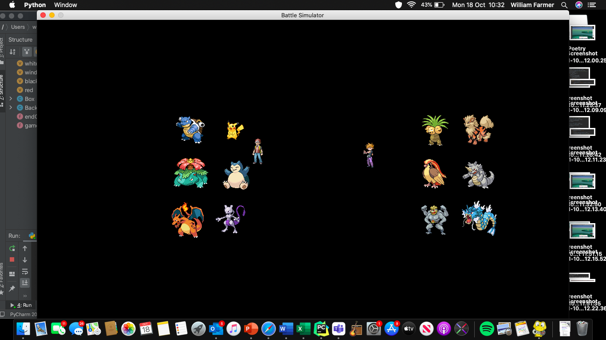

As you can see, the two trainers are displayed alongside their associated Pokémon. It is very clear which Pokémon belong to which trainer.

##### Test 2

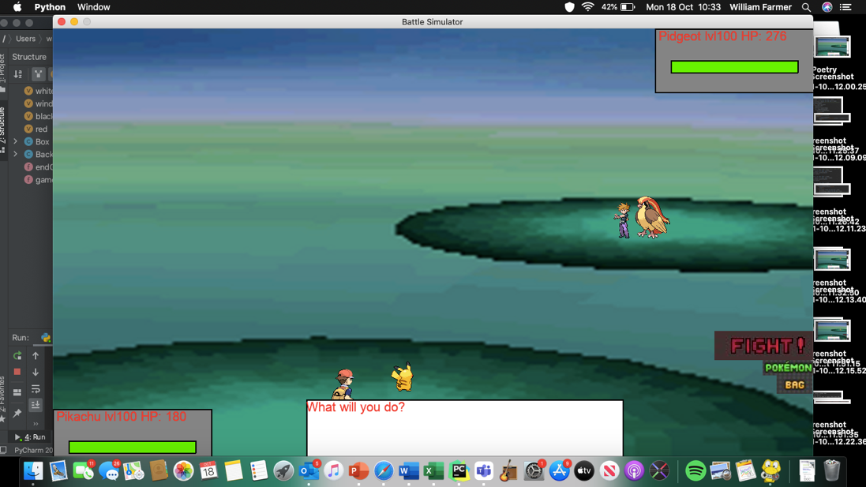

This has technically failed, because the sex of the Pokémon is not output. However, I decided during the coding of this program that, given that I was rushed for time, I would leave this out. This is because the sex of the Pokémon is just a cosmetic addition that has absolutely not factor on the game at all. Hence, it has technically failed but is not an error.

##### Test 3



As you can see, the new background has been displayed. Hence, it has passed.

##### Test 4

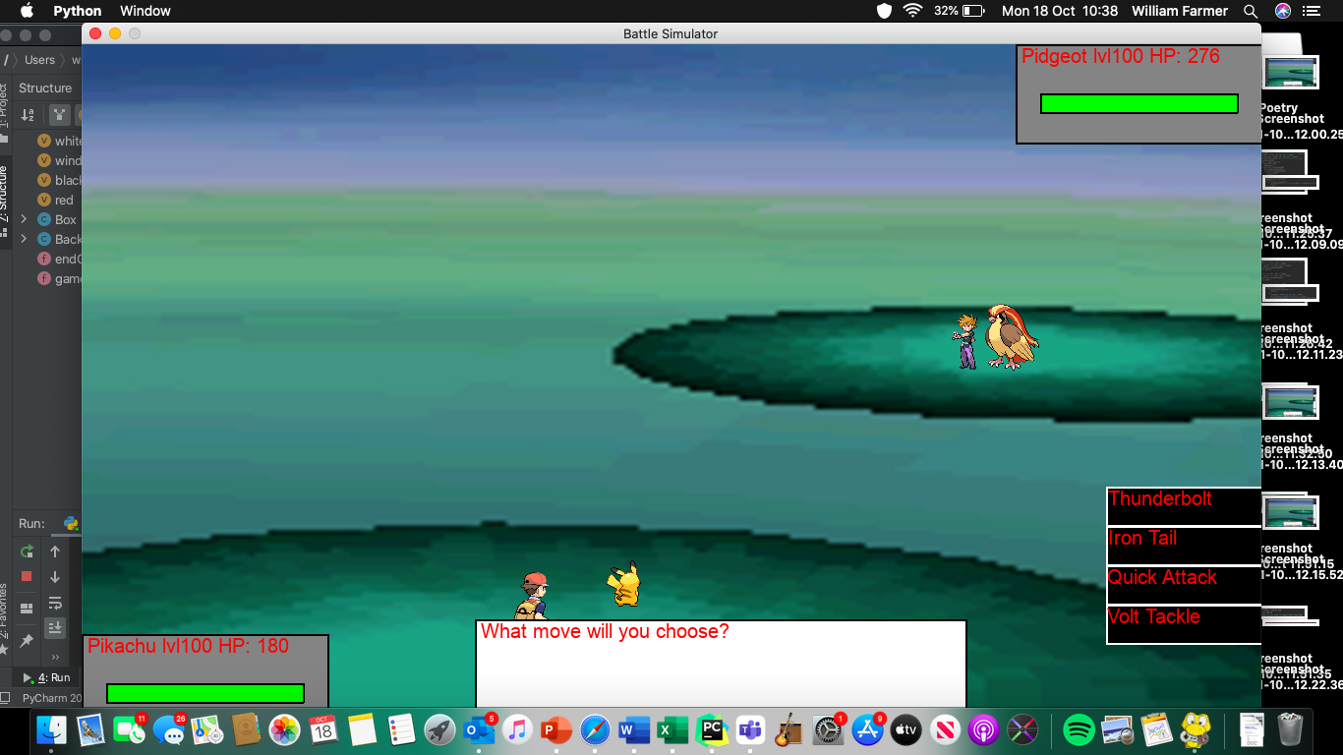

As you can see, this has passed, because the Pokémon’s moves are displayed on the right after clicking the FIGHT button, which is consequently no longer visible.

##### Test 5

I decided that this was an unnecessary cosmetic addition, and therefore I prioritised the completion of the essential aspects of this game over the completion of visual effects. Hence, this has failed, but is not an error.

##### Test 6

One aspect of this test passed while another failed. There is no animation for applying an item, which will be shown below, but there is no easy difficulty for me to test this on, as I did not have time to implement Prototype 7, where the difficulty settings were to be added. Therefore, this has failed, but is not an error.

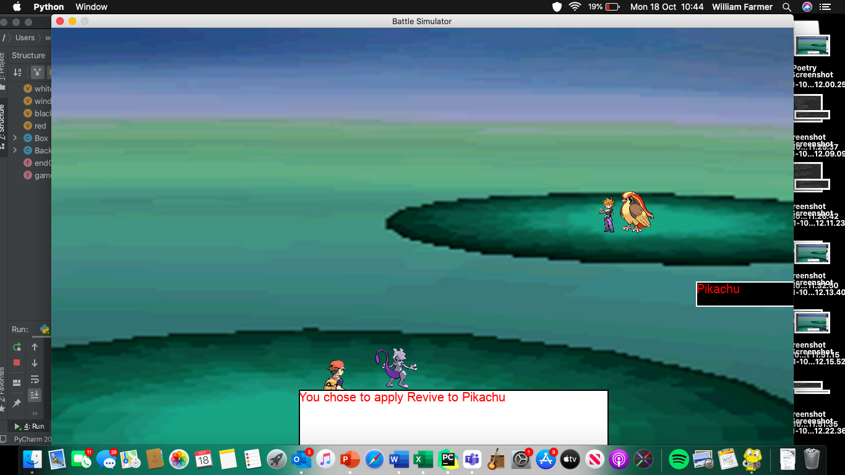

This shows the only output that occurs when applying an item.

##### Test 7

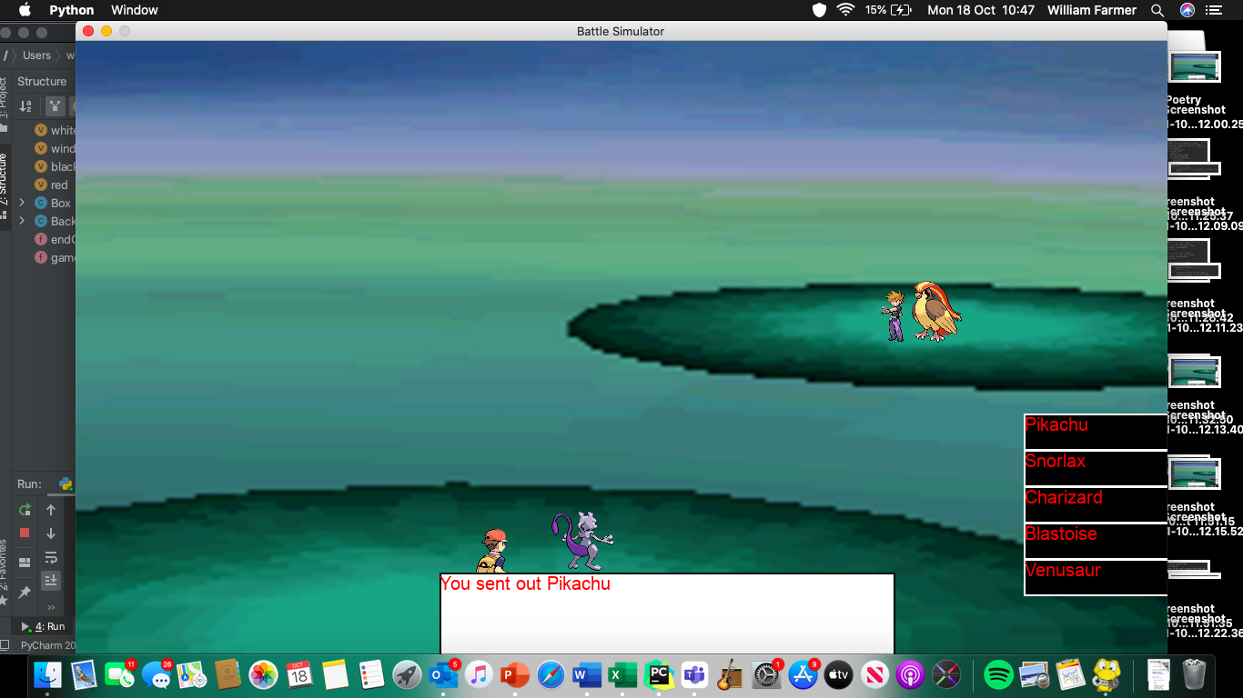

This shows the game registering the selection of Pikachu.

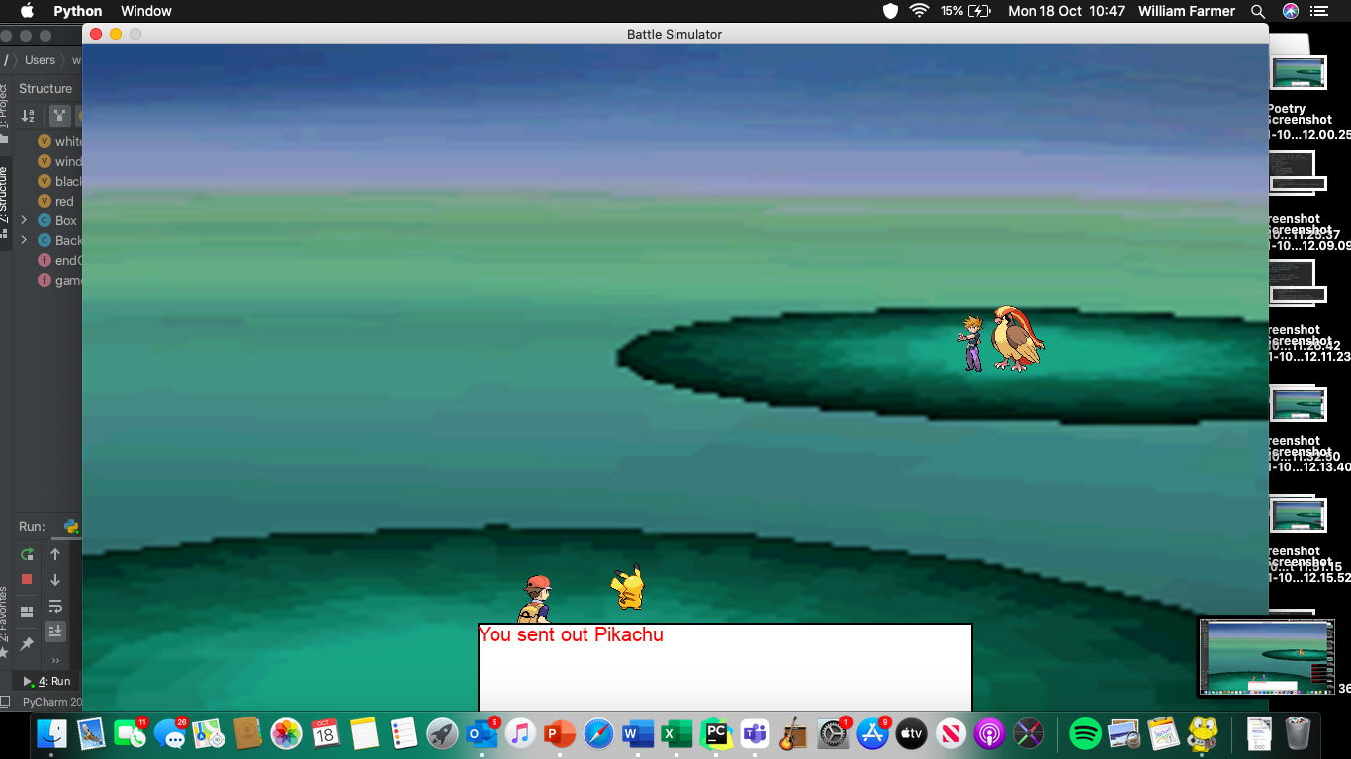

And this shows Pikachu is sent out. As you can see in the bottom right, there is my laptop telling me that it has registered the first screenshot I took to evidence this test, proving that they were taken directly after each other and therefore that there was no animation between. Hence, this has passed.

##### Test 8

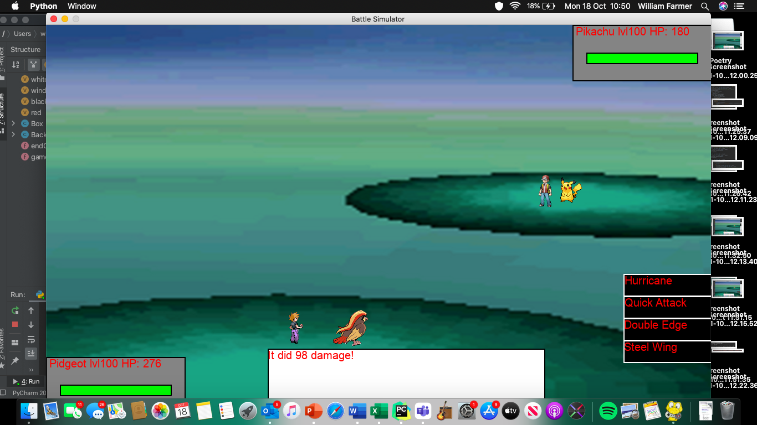

This shows the game outputting the damage Pidgeot’s move has inflicted upon pikachu.

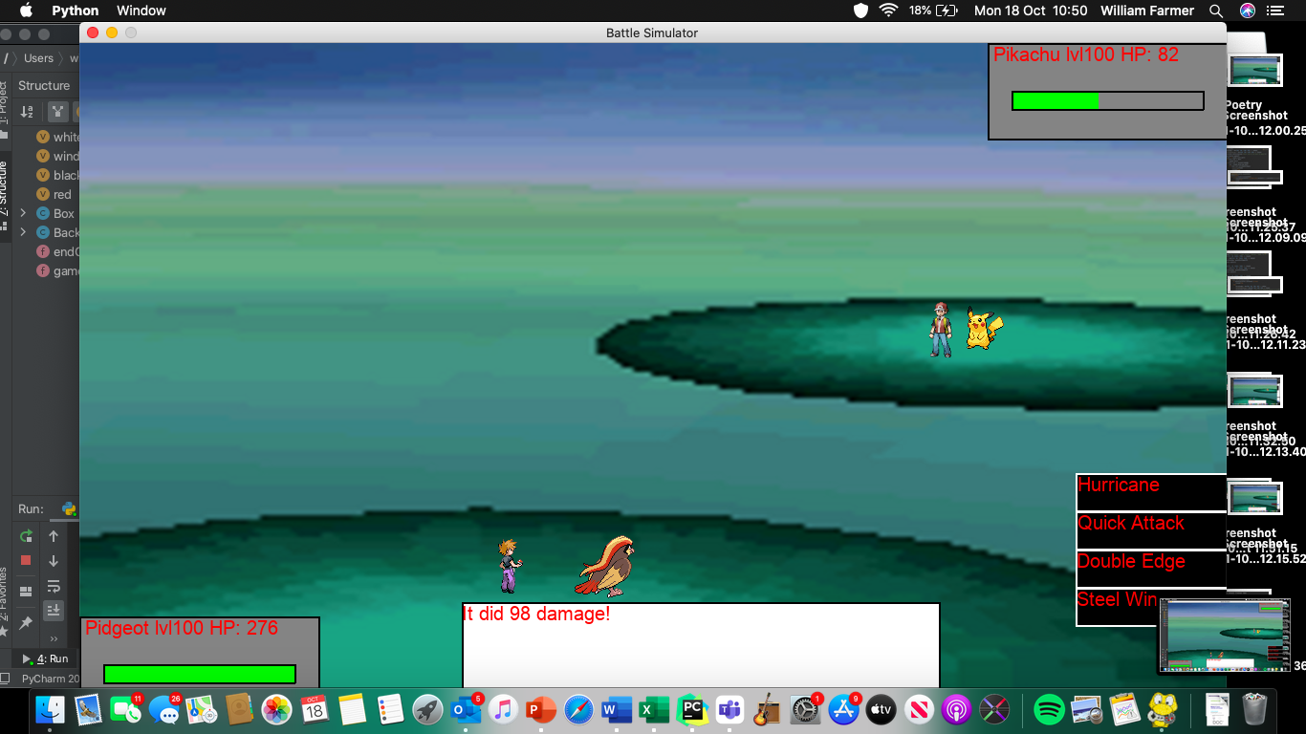

This shows the damage having been inflicted; the HP bar is just below half (as 82 is just left than half of 180 (Pikachu’s maximum health – see previous screenshot)) and the correct amount of HP is numerically displayed. In the bottom right, you can once again see the previous screenshot, showing they did in fact occur right after each other. Therefore, this test has passed.

##### Test 9

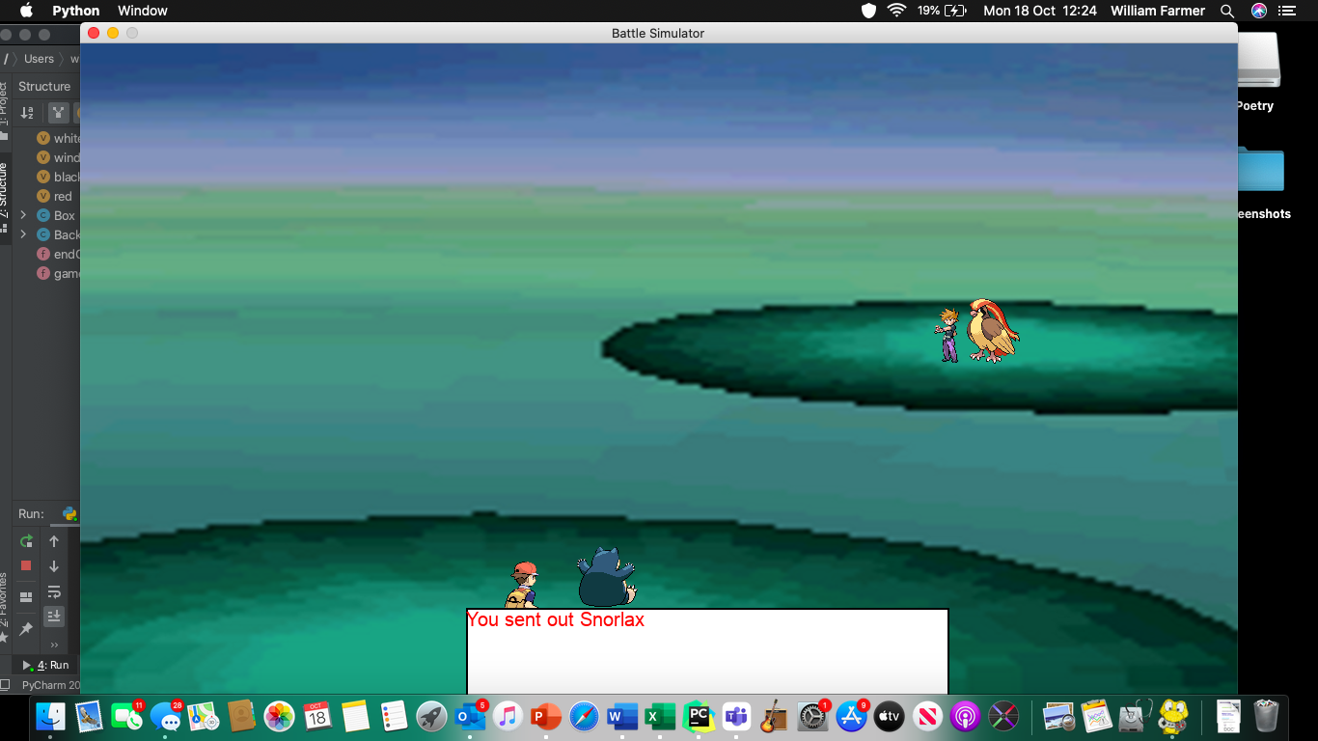

Snorlax is sent out.

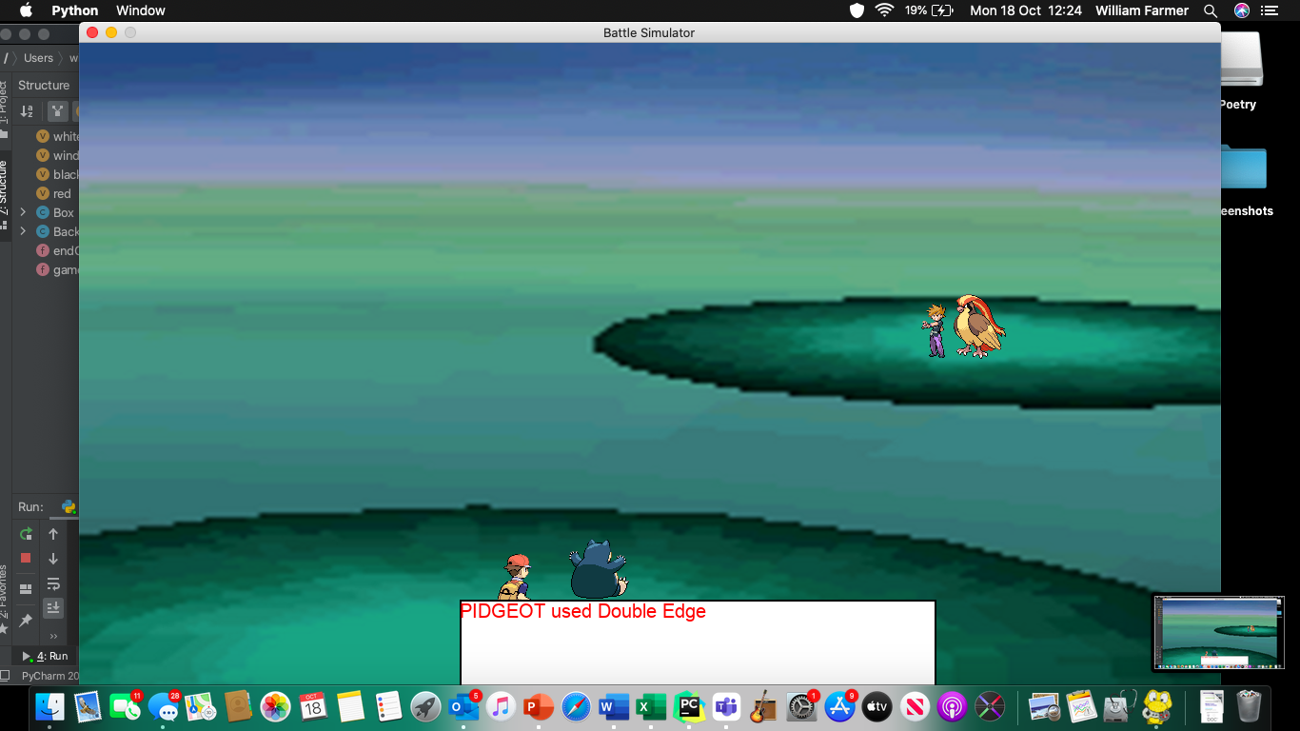

Pidgeot uses Double edge, directly after previous screenshot (see screenshot in bottom right)

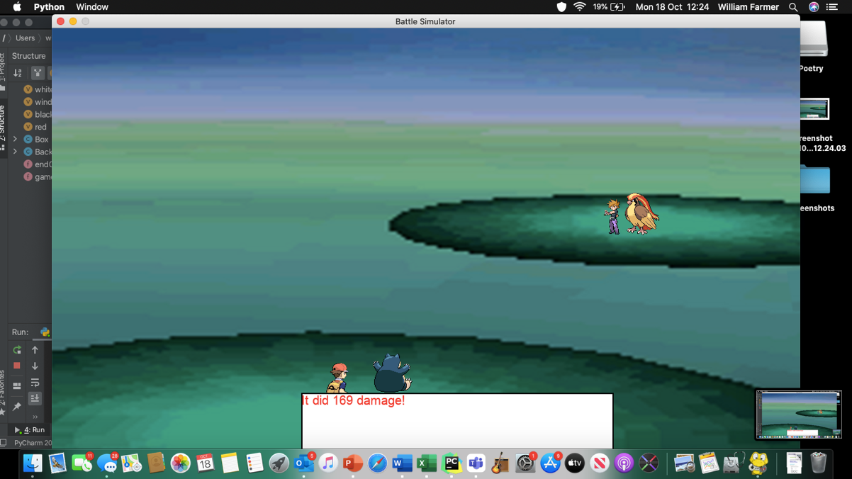

The damage is inflicted upon Snorlax

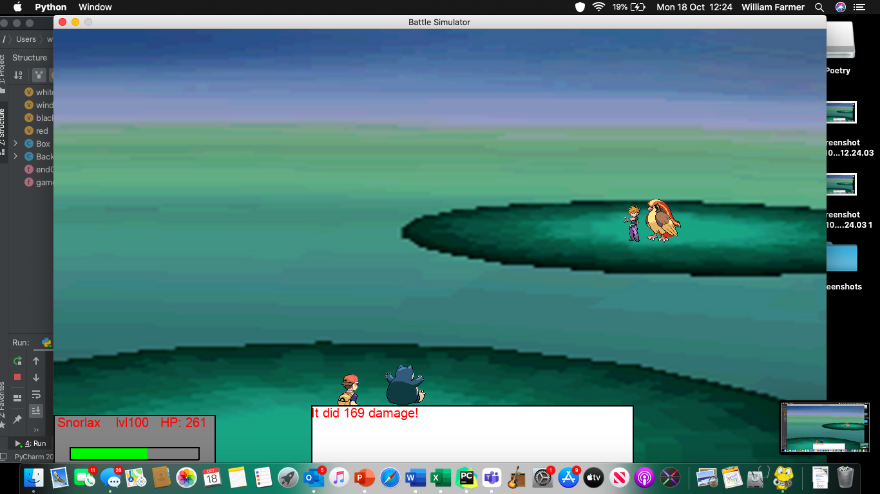

Snorlax’s HP decreases by 169.

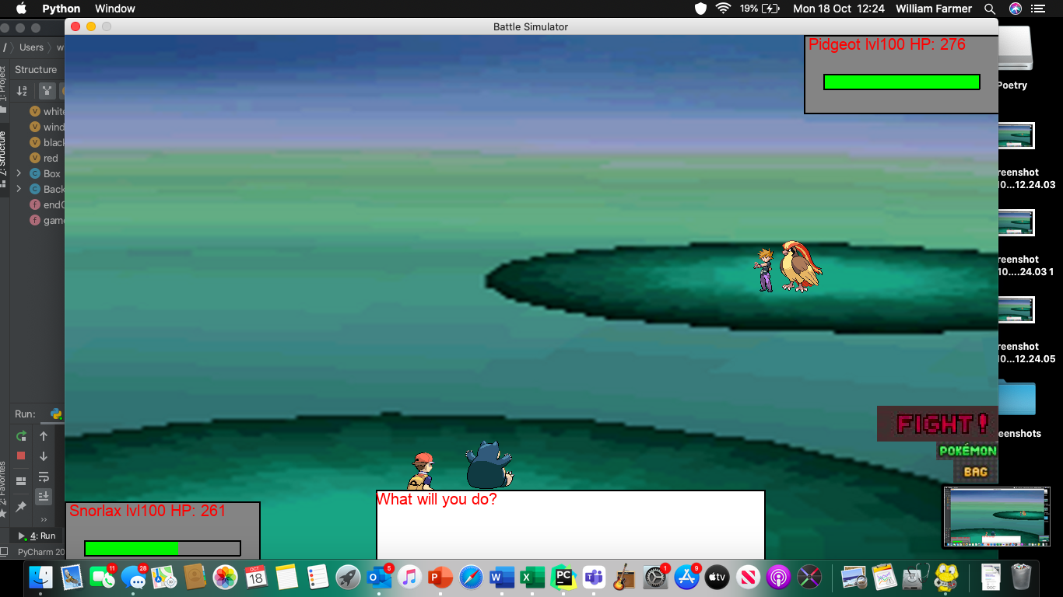

Pidgeot is undamaged as the user switched Pokémon. Therefore, the opponent remained un-fainted and thus could attack the user’s Pokémon. This passed, as the opponent could successfully damage the opponent, with a visible decrease the numerical HP value and health bar.

##### Test 10

There is no animation for fainting for the opponent as I decided once again that it was purely a cosmetic addition that I didn’t have time to add as there were much more important additions I needed to make that affected the actual functionality of the game. Hence, it failed, but is not an error.

##### Test 11

There is no animation for fainting for the user as I decided once again that it was purely a cosmetic addition that I didn’t have time to add as there were much more important additions I needed to make that affected the actual functionality of the game. Hence, it failed, but is not an error.

##### Test 12

There is no animation for sending a Pokémon out as I decided once again that it was purely a cosmetic addition that I didn’t have time to add as there were much more important additions I needed to make that affected the actual functionality of the game. Hence, it failed, but is not an error.

##### Test 13

There is no animation for withdrawing a Pokémon as I decided once again that it was purely a cosmetic addition that I didn’t have time to add as there were much more important additions I needed to make that affected the actual functionality of the game. Hence, it failed, but is not an error.

##### Test 14

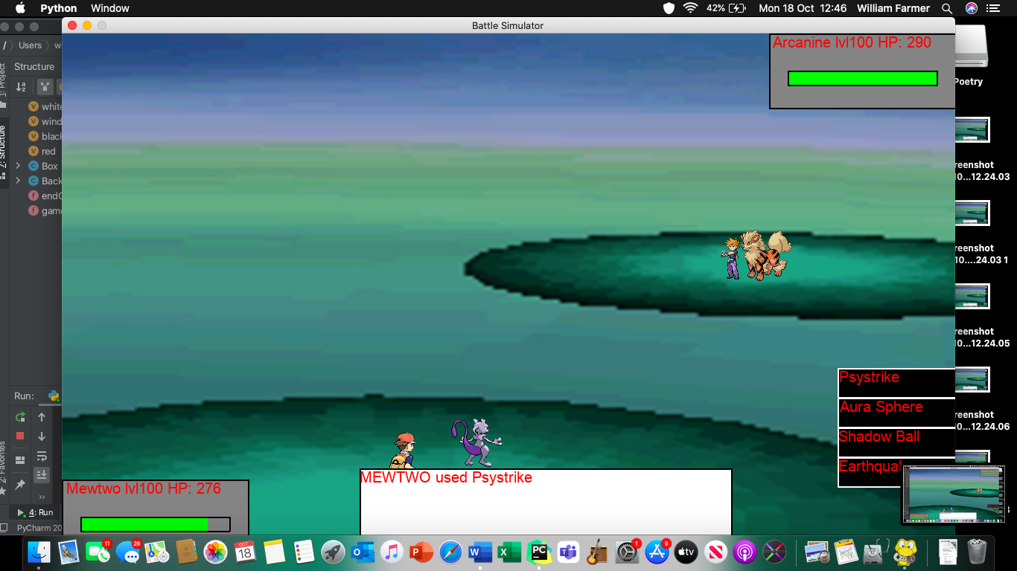

Here Mewtwo uses Psystrike, as the input required. The game then output a confirmation of this.

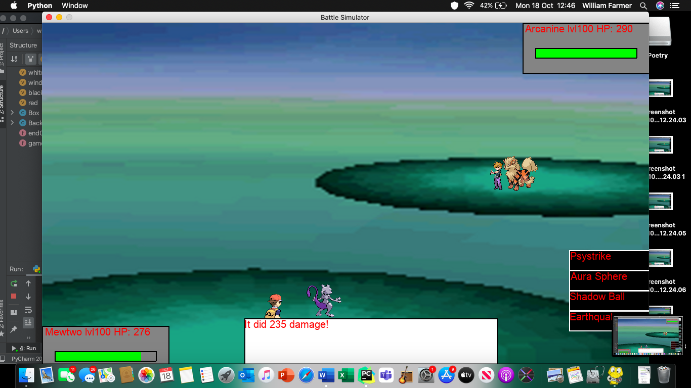

This meets the expected output, and therefore passed.

##### Test 15

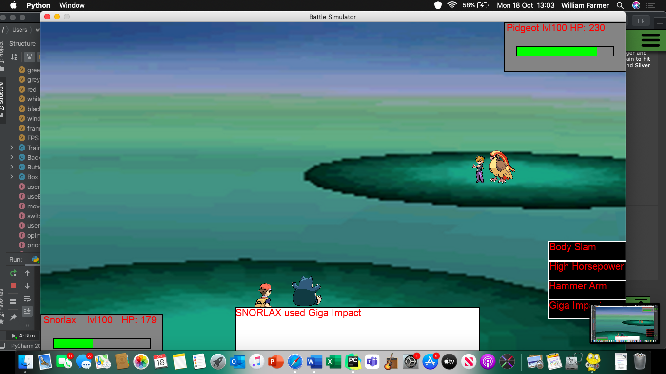

This is Snorlax using Giga Impact

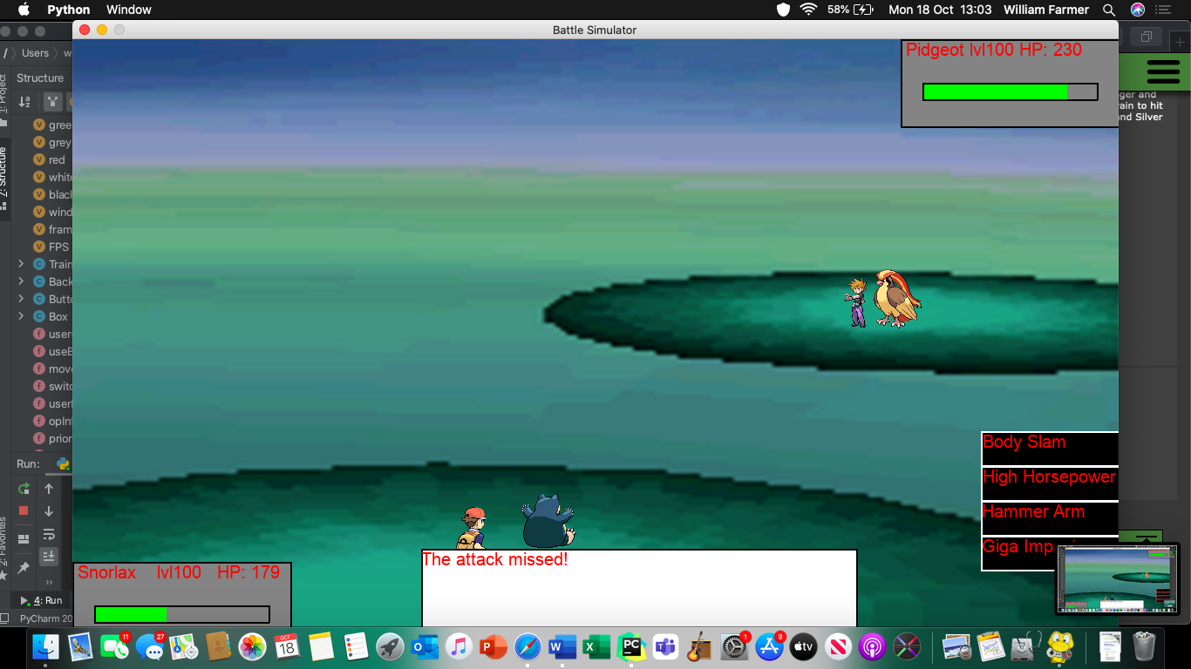

And this is the attack missed, dealing no damage. Therefore this has passed the test.

##### Test 16

See tests 8 and 9

### The Program

I will definitely make more additions to this project in the future, but with present time constraints I am unable to add anything else to my project at this stage (unless anything fails in my black box tests). With this said, here is my ‘final’ code:

#### Main File

import random #importing external modules used in program  
import pygame  
from time import sleep  
from pygame.locals import *  
#Importing modules coded in other files:  
from userFile import user  
from AI import fainted  
from AI import switch  
from AI import artificial  
from superEffective import superEffective  
from ineffective import ineffective  
from affect import affect  
from damageCalc import damageCalc  
from theEnd import endCheck  
from theEnd import gameOver  
#globalised constants  
global FPS  
global framesPerSec  
global black  
global white  
global window  
global SCREEN_WIDTH  
global SCREEN_HEIGHT  
global red  
#PYGAME - ignore for now  
pygame.init()  
red=[255,0,0] #creates Red  
FPS=30 #sets FPS  
framesPerSec=pygame.time.Clock()  
black=[0,0,0] #creates black  
white=[255,255,255] #creates white  
window=pygame.display.set_mode((1200,800)) #create a 1200x800 window  
pygame.display.set_caption('Battle Simulator') #titles the window  
window.fill(black) #fills window with black  
SCREEN_WIDTH,SCREEN_HEIGHT = pygame.display.get_surface().get_size()  
#^^sets screen width and height  
#END OF PYGAME  
class Pokemon: #constructor and class creation  
 def __init__(self,name,spAtk,atk,defence,spDef,spd,hp,move1,movetype1,movepower1,moveaccuracy1,movephys1,move2,movetype2,movepower2,moveaccuracy2,movephys2,move3,movetype3,movepower3,moveaccuracy3,movephys3,move4,movetype4,movepower4,moveaccuracy4,movephys4,type1,type2,level,userImage,opImage):  
 self.level=level  
 self.name=name  
 self.spAtk=((2*spAtk*level)/100)+5  
 self.atk=((2*atk*level)/100)+5  
 self.spDef=((2*spDef*level)/100)+5  
 self.defence=((2*defence*level)/100)+5  
 self.spd=((2*spd*level)/100)+5  
 self.hp = (2*(hp*level)/100)+level+10  
 self.maxHP=self.hp  
 self.move1=move1  
 self.movetype1=movetype1  
 self.movepower1=movepower1  
 self.moveaccuracy1=moveaccuracy1 #forgot to add in original prototype  
 self.movephys1=movephys1 #forgot to add in original prototype  
 self.move2 = move2  
 self.movetype2 = movetype2  
 self.movepower2 = movepower2  
 self.moveaccuracy2 = moveaccuracy2 #forgot to add in original prototype  
 self.movephys2 = movephys2 # forgot to add in original prototype  
 self.move3 = move3 #was originally a repeat of move2  
 self.movetype3 = movetype3  
 self.movepower3 = movepower3  
 self.moveaccuracy3 = moveaccuracy3 #forgot to add in original prototype  
 self.movephys3 = movephys3 # forgot to add in original prototype  
 self.move4 = move4  
 self.movetype4 = movetype4  
 self.movepower4 = movepower4  
 self.moveaccuracy4 = moveaccuracy4 #forgot to add in original prototype  
 self.movephys4 = movephys4 # forgot to add in original prototype  
 self.type1=type1  
 self.type2=type2  
 self.userImage=pygame.image.load(userImage) #User image  
 self.opImage=pygame.image.load(opImage) #User image  
  
 def drawUser(self, surface,x,y): #Draws User Sprite  
 surface.blit(self.userImage,(x,y))  
 def drawOp(self,surface,x,y): #Draws Opponent Sprite  
 surface.blit(self.opImage,(x,y))  
  
class Trainer: #creates the trainer  
 def __init__(self,userImage,introImage,x,y,name):  
 self.name=name #sets their name  
 super().__init__()  
 self.userImage=pygame.image.load(userImage) #loads their user sprite  
 self.introImage=pygame.image.load(introImage) #loads their intro sprite  
 self.rect = self.userImage.get_rect(center = (x,y)) #creates a rectangle  
 #around them so they can be clicked  
 def drawUser(self, surface): #draws user sprite  
 surface.blit(self.userImage,self.rect)  
 def drawIntro(self, surface): #draws opponent/intro sprite  
 surface.blit(self.introImage, self.rect)  
 def move(self,surface,x,y): #moves them  
 self.rect=self.introImage.get_rect(center = (x,y))  
  
class Background: #creates a background  
 def __init__(self,backgroundImage):  
 super().__init__()  
 self.backgroundImage=pygame.image.load(backgroundImage)  
 #^^ sets background to passed in image  
 self.backgroundRect=self.backgroundImage.get_rect()  
 #^^ creates a rectangle around it for co-ordinates  
 self.backgroundX1 = 0 #sets X co-ordinates  
 self.backgroundX2 = 0  
  
 self.backgroundY1 = 0 #sets Y co-ordinates  
 self.backgroundY2 = -self.backgroundRect.height  
 def render(self): #Renders in the background  
 window.blit(self.backgroundImage, (self.backgroundX1, self.backgroundY1))  
 window.blit(self.backgroundImage, (self.backgroundX2, self.backgroundY2))  
 def update(self,backgroundImage): #Updates the background image  
 self.backgroundImage = pygame.image.load(backgroundImage)  
 self.backgroundRect = self.backgroundImage.get_rect()  
class Box: #Creates the class for boxes  
 def __init__(self, height, width, centre,border,colour):  
 self.font = pygame.font.SysFont('Calibri',20) #Sets font size and type  
 if border == 2: #if a border to a box  
 self.rect = pygame.draw.rect(window,colour,pygame.Rect(centre[0],centre[1],height,width),border)  
 else: #if an actual box  
 self.rect = pygame.draw.rect(window,colour,pygame.Rect(centre[0],centre[1],height,width))  
 def addText(self,window,text): #adds text to the box  
 window.blit(self.font.render(text,True,red),self.rect)  
backgroundImage='resizedblackscreen.jpeg' #sets background image  
background=Background(backgroundImage) #instantiates background object  
#instantiating Red's Pokemon  
mewtwo=Pokemon('Mewtwo',154,110,90,90,130,106,'Psystrike','Psychic',100,100,'special','Aura Sphere','Fighting',85,101,'special','Shadow Ball','Ghost',80,100,'special','Earthquake','Ground',100,100,'physical','Psychic','empty',100,'userMewtwo.png','AIMewtwo.png')  
snorlax=Pokemon('Snorlax',65,110,65,110,30,160,'Body Slam','Normal',85,100,'physical','High Horsepower','Ground',90,90,'physical','Hammer Arm','Fighting',100,85,'physical','Giga Impact','Normal',150,50,'physical','Normal','empty',100,'userSnorlax.png','AISnorlax.png')  
pikachu=Pokemon('Pikachu',100,110,40,55,90,35,'Thunderbolt','Electric',95,100,'special','Iron Tail','Steel',100,75,'physical','Quick Attack','Normal',40,100,'physical','Volt Tackle','Electric',120,87.5,'physical','Electric','empty',100,'userPikachu.png','AIPikachu.png')  
charizard=Pokemon('Charizard',109,84,78,85,100,78,'Flare Blitz','Fire',120,75,'physical','Air Slash','Flying',75,95,'special','Dragon Claw','Dragon',80,100,'physical','Dual Wingbeat','Flying',80,90,'physical','Fire','Flying',100,'userCharizard.png','AICharizard.png')  
blastoise=Pokemon('Blastoise',85,83,100,105,78,79,'Surf','Water',95,100,'special','Ice Beam','Ice',95,100,'special','Flash Cannon','Steel',80,100,'special','Aura Sphere','Fighting',85,100,'special','Water','empty',100,'userBlastoise.png','AIBlastoise.png')  
venusaur=Pokemon('Venusaur',100,82,83,100,80,80,'Petal Blizzard','Grass',90,100,'physical','Double Edge','Normal',120,87.5,'physical','Sludge Bomb','Poison',90,100,'special','Earth Power','Ground',90,100,'special','Grass','Poison',100,'userVenusaur.png','AIVenusaur.png')  
redX,redY = 500,300  
blueX,blueY = 750,300  
red=Trainer('userRed.png','resizedIntroRed.png',redX,redY,'Red') #Instantiating Red  
#Instantiating Blue's Pokemon  
machamp=Pokemon('Machamp',65,130,80,85,55,90,'Cross Chop','Fighting',100,80,'physical','Dual Chop','Dragon',80,90,'physical','Strength','Normal',80,100,'physical','Knock Off','Dark',80,100,'physical','Fighting','empty',100,'userMachamp.png','AIMachamp.png')  
pidgeot=Pokemon('Pidgeot',70,80,75,70,101,83,'Hurricane','Flying',110,70,'special','Quick Attack','Normal',40,100,'physical','Double Edge','Normal',120,87.5,'physical','Steel Wing','Steel',70,100,'physical','Flying','Normal',100,'userPidgeot.png','AIPidgeot.png')  
exeggutor=Pokemon('Exeggutor',125,95,85,65,55,95,'Wood Hammer','Grass',120,80,'physical','Extrasensory','Psychic',80,100,'special','Stomp','Normal',65,100,'physical','Grassy Glide','Grass',70,100,'physical','Grass','Psychic',100,'userExeggutor.png','AIExeggutor.png')  
gyarados=Pokemon('Gyarados',60,125,79,100,81,95,'Aqua Tail','Water',90,90,'physical','Earthquake','Ground',100,100,'physical','Bounce','Flying',85,85,'physical','Crunch','Dark',80,100,'physical','Water','Flying',100,'userGyarados.png','AIGyarados.png')  
rhydon=Pokemon('Rhydon',45,130,120,45,40,105,'Earthquake','Ground',100,100,'physical','Stone Edge','Rock',100,80,'physical','Rock Slide','Rock',75,90,'physical','Megahorn','Bug',120,85,'physical','Rock','Ground',100,'userRhydon.png','AIRhydon.png')  
arcanine=Pokemon('Arcanine',100,110,80,80,95,90,'Flare Blitz','Fire',120,75,'physical','Outrage','Dragon',120,75,'physical','Extreme Speed','Normal',80,100,'physical','Flamethrower','Fire',95,100,'special','Fire','empty',100,'userArcanine.png','AIArcanine.png')  
  
blue=Trainer('userBlue.png','IntroBlue.png',blueX,blueY,'Blue')  
redPok=[pikachu,mewtwo,snorlax,charizard,blastoise,venusaur] #making it easier for rest of program  
bluePok=[pidgeot,machamp,exeggutor,gyarados,rhydon,arcanine] #making it easier for rest of program  
  
def trainerSelect(redPok,bluePok,red,blue): #the user selects the trainer  
 clicked=False  
 while not clicked: #loops until a trainer is clicked  
 for event in pygame.event.get():  
 if event.type == QUIT:  
 pygame.quit() #Quits game if exit button pressed  
 if event.type == MOUSEBUTTONDOWN: #if mouse click registered  
 pos=pygame.mouse.get_pos() #get position of mouse click  
 if blue.rect.collidepoint(pos): #if it collides with blue  
 trainer='Blue'  
 clicked=True  
 if red.rect.collidepoint(pos): #if it collides with red  
 trainer='Red'  
 clicked=True  
  
 print("You have chosen Trainer",trainer) #confirmation  
 opTrainer=red #For use of display  
 userTrainer=blue  
 if trainer=='Red':  
 userPok=redPok #will make it easier to use later on in program  
 opPok=bluePok  
 opTrainer=blue  
 userTrainer=red  
 else:  
 userPok=bluePok #will make it easier to use later in program  
 opPok=redPok #No need to assign opTrainer or userTrainer as pre-defined  
  
 pygame.display.update() #updates display  
 framesPerSec.tick(FPS)  
 background.render() #hide the unwanted  
 userTrainer.move(window, 600, 300) #moves users trainer to desired location  
 userTrainer.drawIntro(window) #Draws the user's trainer  
 for i in range(0,len(userPok)):  
 userPok[i].drawOp(window,100*i, 100*i) #Displays team diagonally  
 pygame.display.update() #updates display  
 framesPerSec.tick(30)  
 return userTrainer,opTrainer, opPok,userPok  
#Display trainers  
  
red.drawIntro(window) #Draws the trainers  
blue.drawIntro(window)  
#Display Red's team  
mewtwo.drawOp(window, 400, 400)  
snorlax.drawOp(window, 400, 300)  
pikachu.drawOp(window, 400, 200)  
charizard.drawOp(window, 300, 400)  
venusaur.drawOp(window, 300, 300)  
blastoise.drawOp(window, 300, 200)  
#Display Blue's team  
machamp.drawOp(window, 850, 400)  
pidgeot.drawOp(window, 850, 300)  
exeggutor.drawOp(window, 850, 200)  
gyarados.drawOp(window, 950, 400)  
rhydon.drawOp(window, 950, 300)  
arcanine.drawOp(window, 950, 200)  
initiallyRunning=True  
while initiallyRunning: #Runs until all necessary variables to proper loop have  
 #been created  
 for event in pygame.event.get():  
 if event.type == QUIT:  
 pygame.quit()  
 pygame.display.update()  
 framesPerSec.tick(30)  
  
 userTrainer,opTrainer,opPok,userPok=trainerSelect(redPok,bluePok,red,blue) #allows user to choose trainer  
 sleep(2)  
 opFaintCount,userFaintCount=0,0 #No pokemon have fainted yet  
 opMove,opAcc,opOutPok=artificial(opPok[0],opPok,userPok[0]) #gets the AI to make a decision  
 background.update('battlescene.png') #new background image  
 background.render() #renders new background image  
 opTrainer.move(window, 900,300) #moves to new location  
 opTrainer.drawIntro(window) #displays  
 opPok[0].drawOp(window, 900,250)  
 userTrainer.move(window, 450, 550)  
 userTrainer.drawUser(window) #corrected  
 userPok[0].drawUser(window, 500,500)  
 pygame.display.update()  
 framesPerSec.tick(30)  
 userPok,userOutPok,opOutPok=user(userPok,userPok[0],opOutPok,opMove,opAcc,opPok,userTrainer,opTrainer) #gets user to make decision  
 initiallyRunning=False #ends loop  
  
  
  
while userFaintCount < 6 and opFaintCount < 6:  
 # RESET BACKGROUND  
 background = Background('battlescene.png')  
 background.render()  
 narrativeBox = Box(500, 500, (400, 585), 1, white)  
 narrativeBoxBorder = Box(500, 500, (400, 585), 2, black)  
 opTrainer.move(window, 900, 300)  
 opTrainer.drawIntro(window)  
 #opOutPok.drawOp(window, 900, 250)  
 userTrainer.move(window, 450, 550)  
 userTrainer.drawUser(window) # corrected  
 userOutPok.drawUser(window, 500, 500)  
 pygame.display.update()  
 opMove,opAcc,opOutPok=artificial(opOutPok,opPok,userOutPok) #AI makes decision first to ensure the user's  
 #decision has no influence (i.e. if the user switches battler)  
 userPok,userOutPok,opOutPok=user(userPok,userOutPok,opOutPok,opMove,opAcc,opPok,userTrainer,opTrainer) #user makes decision  
 opFaintCount,userFaintCount=endCheck(opPok,userPok) #check how many battlers  
 #have fainted  
 pygame.display.update()  
 framesPerSec.tick(FPS)  
 for event in pygame.event.get():  
 if event.type==QUIT:  
 pygame.quit()  
  
  
gameOver(userFaintCount,background) #Ends the game

#### userFile.py

from time import sleep #used to allow users to read in time  
from AI import fainted #importing modules from other files  
from damageCalc import damageCalc  
from AI import accuracyCheck  
from theEnd import endCheck  
import pygame #globalised constants  
global window  
global black  
global white  
global red  
global grey  
global green  
#sets colours  
green = [0,255,0]  
grey = [132,132,132]  
red = [255,0,0]  
white = [255,255,255]  
black = [0,0,0]  
from pygame.locals import *  
window=pygame.display.set_mode((1200,800))  
framesPerSec=pygame.time.Clock()  
FPS=30  
  
class Trainer: #Copied from main file  
 def __init__(self,userImage,introImage,x,y,name):  
 self.name=name  
 super().__init__()  
 self.userImage=pygame.image.load(userImage)  
 self.introImage=pygame.image.load(introImage)  
 self.rect = self.userImage.get_rect(center = (x,y))  
 def drawUser(self, surface):  
 surface.blit(self.userImage,self.rect)  
 def drawIntro(self, surface):  
 surface.blit(self.introImage, self.rect)  
 def move(self,surface,x,y):  
 self.rect=self.introImage.get_rect(center = (x,y))  
class Background: #copied from main file  
 def __init__(self,backgroundImage):  
 super().__init__()  
 self.backgroundImage=pygame.image.load(backgroundImage)  
 self.backgroundRect=self.backgroundImage.get_rect()  
  
 self.backgroundX1 = 0  
 self.backgroundX2 = 0  
  
 self.backgroundY1 = 0  
 self.backgroundY2 = -self.backgroundRect.height  
 def render(self):  
 window.blit(self.backgroundImage, (self.backgroundX1, self.backgroundY1))  
 window.blit(self.backgroundImage, (self.backgroundX2, self.backgroundY2))  
 def update(self,backgroundImage):  
 self.backgroundImage = pygame.image.load(backgroundImage)  
 self.backgroundRect = self.backgroundImage.get_rect()  
class Button: #Same as box but takes on an image instead of a colour  
 def __init__(self,image,x,y):  
 self.image = pygame.image.load(image)  
 self.rect = self.image.get_rect(center = (x,y))  
 def move(self,window,x,y): #moves Button  
 self.rect=self.image.get_rect(center=(x,y))  
 def draw(self,window): #displays Button  
 window.blit(self.image,self.rect)  
class Box:  
 def __init__(self, height, width, centre,border,colour):  
 self.font = pygame.font.SysFont('Calibri',20)  
 if border == 2:  
 self.rect = pygame.draw.rect(window,colour,pygame.Rect(centre[0],centre[1],height,width),border)  
 else:  
 self.rect = pygame.draw.rect(window,colour,pygame.Rect(centre[0],centre[1],height,width))  
 def addText(self,window,text):  
 window.blit(self.font.render(text,True,red),self.rect)  
def user(userPok,userOutPok,opOutPok,opMove,opAcc,opPok,userTrainer,opTrainer):  
 #OPPONENT HEALTH  
 opHealthPerCent = opOutPok.hp/opOutPok.maxHP #for width of health bar  
 opHealthBox=Box(250,100,(950,0),1,grey) #Creates opponent box  
 border = Box(251,101,(950,0),2,black) #creates the border  
 opHealthBox.addText(window," "+opOutPok.name+" lvl"+str(opOutPok.level)+" HP: "+str(int(opOutPok.hp)))  
 #^^Adds name, level and HP to health box  
 opHealthBar = Box(200*opHealthPerCent,20,(975,50),1,green) #creates health bar  
 border=Box(201,20,(975,50),2,black) #creates border around health bar  
 #so the user can see % of health  
 #USER HEALTH - adapted from above  
 userHealthPerCent = userOutPok.hp / userOutPok.maxHP #for width of health bar  
 userHealthBox=Box(250,100,(0,600),1,grey)  
 border = Box(251,101,(0,600),2,black)  
 userHealthBox.addText(window," "+userOutPok.name + " lvl" + str(userOutPok.level)+" HP: "+str(int(userOutPok.hp)))  
 userHealthBar = Box(200*userHealthPerCent, 20, (25, 650), 1, green)  
 border = Box(201, 20, (25, 650), 2, black)  
 #MAKING BUTTONS  
 fight = Button('fightbutton.png', 1130,500) #Creates fight button  
 fight.draw(window) #Displays fight button  
 pygame.display.update() #updates display  
 pkmn = Button('pkmn.png',1160,535) #Creates pokemon button  
 pkmn.draw(window) #displays it  
 pygame.display.update() #updates display  
 bag= Button('bagIMG.png',1170,561) #Creates bag button  
 bag.draw(window) #displays it  
 pygame.display.update() #updates display  
 narrativeBox = Box(500, 500, (400, 585), 1, white) #creates narrative box  
 narrativeBoxBorder = Box(500, 500, (400, 585), 2, black) #creates border  
 #around it  
 narrativeBox.addText(window,"What will you do?") #adds text to narrative box  
 pygame.display.update() #updates display  
 framesPerSec.tick(30)  
 choice='switch' #pre-defines choice to 'switch'  
 clicked=False #Boolean as either clicked or not clicked  
 while not clicked: #loops until a button has been clicked  
 for event in pygame.event.get():  
 if event.type == QUIT:  
 pygame.quit()  
 if event.type == MOUSEBUTTONDOWN: #if mouse clicked detected  
 pos=pygame.mouse.get_pos() #Gets position of mouse  
 if fight.rect.collidepoint(pos): #if fight button clicked  
 choice = 'fight' #Sets choice to fight for later  
 clicked=True #breaks out of loop  
 #No ELSE statement as game waits until input received  
 if bag.rect.collidepoint(pos):  
 if userPok[0].hp == userPok[0].maxHP and userPok[1].hp == userPok[1].maxHP and userPok[2].hp == userPok[2].maxHP and userPok[3].hp == userPok[3].maxHP and userPok[4].hp == userPok[4].maxHP and userPok[5].hp == userPok[5].maxHP:  
 #^^If item cannot be validly applied  
 narrativeBox = Box(500, 500, (400, 585), 1, white)  
 narrativeBoxBorder = Box(500, 500, (400, 585), 2, black)  
 narrativeBox.addText(window,' No items can be applied')  
 else:  
 #Sets choice to bag and clicked to true to break out of loop  
 choice = 'bag'  
 clicked=True  
 if pkmn.rect.collidepoint(pos): #if pokemon button clicked  
 if pkmnValid(userPok,userOutPok) is True: #if valid  
 clicked=True #break out of loop  
 else:  
 narrativeBox = Box(500, 500, (400, 585), 1, white)  
 narrativeBoxBorder = Box(500, 500, (400, 585), 2, black)  
 narrativeBox.addText(window, ' You have no more battlers left')  
 #^^Output that no more battlers are remaining to switch to  
 pygame.display.update()  
 if choice == 'fight': #battle sequence  
 narrativeBox = Box(500, 500, (400, 585), 1, white)  
 narrativeBoxBorder = Box(500, 500, (400, 585), 2, black)  
 narrativeBox.addText(window, ' What move will you choose?')  
 #^Outputs to narrative box  
 pygame.display.update()  
 #Creation of a button for each move  
 move1button = Box(172, 40, (1044, 450), 1, black)  
 move1buttonborder = Box(172,40,(1042,450),2,white)  
 move1button.addText(window,userOutPok.move1)  
 #Next move  
 move2button = Box(172, 40, (1044, 490), 1, black)  
 move2buttonborder = Box(172, 40, (1042, 490), 2, white)  
 move2button.addText(window, userOutPok.move2)  
 pygame.display.update()  
 #Next move  
 move3button = Box(172, 40, (1043, 530), 1, black)  
 move3buttonborder = Box(172, 40, (1042, 530), 2, white)  
 move3button.addText(window, userOutPok.move3)  
 pygame.display.update()  
 #Next move  
 move4button = Box(172, 40, (1043, 570), 1, black)  
 move4buttonborder = Box(172, 40, (1042, 570), 2, white)  
 move4button.addText(window, userOutPok.move4)  
 pygame.display.update()  
 framesPerSec.tick(30)  
 clicked=False  
 userMove=userOutPok.move4 #define userMove  
 while not clicked: #keep running until user clicks  
 for event in pygame.event.get():  
 if event.type == QUIT:  
 pygame.QUIT()  
 if event.type == MOUSEBUTTONDOWN: #When click detected  
 pos=pygame.mouse.get_pos() #get coords of click  
 if move1button.rect.collidepoint(pos):  
 userMove=userOutPok.move1 #set move to move1  
 clicked=True  
 if move2button.rect.collidepoint(pos):  
 userMove=userOutPok.move2 #move to move2  
 clicked=True  
 if move3button.rect.collidepoint(pos):  
 userMove=userOutPok.move3 #move to move3  
 clicked=True  
 if move4button.rect.collidepoint(pos):  
 clicked=True #move to move 4  
 #this is default bcs of pre-define  
 userDamage,crit,moveAcc=damageCalc(opOutPok, userOutPok, userMove) #calcs damage  
 opOutPok,userOutPok=moveOrder(opOutPok,opMove,opAcc,userOutPok,userDamage,userMove,crit,moveAcc)  
 #^Determines order  
 elif choice == 'bag': #If bag clicked  
 userPok = useBag(userPok,userTrainer,opTrainer,opOutPok,userOutPok) #returns info about pokemon  
 userOutPok = opInflict(opOutPok, opMove, opAcc, userOutPok) #opponent inflicts damage  
 else: #If pokemon button clicked  
 userOutPok = switchUser(userOutPok,userPok,userTrainer,opTrainer,opOutPok) #allows user to switch pokemon  
 userOutPok=opInflict(opOutPok,opMove,opAcc,userOutPok) #opponent inflicts damage  
  
  
 if fainted(userOutPok) == True: #if current battler fainted  
 if endCheck(opPok,userPok)[1] != 6: #check if any left  
 userOutPok=switchUser(userOutPok,userPok,userTrainer,opTrainer,opOutPok)  
 #user MUST switch as battler is fainted  
 return userPok,userOutPok,opOutPok #returns the current battler  
  
def useBag(userPok, userTrainer,opTrainer,opOutPok,userOutPok): #BAG FUNCTION  
 possibleItems=['Max Potion','Super Potion','Revive','Hyper Potion'] #available items  
 #Creation of item 1 Box  
 item1 = Box(172, 40, (1043, 570), 1, black)  
 item1border = Box(172, 40, (1042, 570), 2, white)  
 item1Text=possibleItems[3]  
 item1.addText(window, item1Text)  
  
 pygame.display.update()  
 #Creation of item 2 Box  
 item2 = Box(172, 40, (1043, 530), 1, black)  
 item2border = Box(172, 40, (1042, 530), 2, white)  
 item2Text=possibleItems[2]  
 item2.addText(window, item2Text)  
 pygame.display.update()  
 #Creation of item 3 Box  
 item3 = Box(172, 40, (1043, 490), 1, black)  
 item3border = Box(172, 40, (1042, 490), 2, white)  
 item3Text=possibleItems[1]  
 item3.addText(window, item3Text)  
 pygame.display.update()  
 #Creation of item 4 Box  
 item4 = Box(172, 40, (1043, 450), 1, black)  
 item4border = Box(172, 40, (1042, 450), 2, white)  
 item4Text=possibleItems[0]  
 item4.addText(window, item4Text)  
 pygame.display.update()  
 clicked=False  
 chosenItem=item4Text  
 while not clicked: #Until a Box is clicked  
 narrativeBox = Box(500, 500, (400, 585), 1, white)  
 narrativeBoxBorder = Box(500, 500, (400, 585), 2, black)  
 narrativeBox.addText(window,"Which item do you want to apply?")  
 pygame.display.update() #update display  
 for event in pygame.event.get():  
 if event.type == QUIT: #close window if exit button clicked  
 pygame.quit()  
 if event.type == MOUSEBUTTONDOWN: #detects mouse click  
 pos = pygame.mouse.get_pos() #gets coords of click  
 if item1.rect.collidepoint(pos): #if item1 is clicked  
 if potionValid(userPok) is True: #if can be validly applied  
 chosenItem=item1Text  
 clicked=True  
 else: #displays message saying this is invalid  
 narrativeBox = Box(500, 500, (400, 585), 1, white)  
 narrativeBoxBorder = Box(500, 500, (400, 585), 2, black)  
 narrativeBox.addText(window, "This item cannot be applied to any of your pokemon")  
  
 if item2.rect.collidepoint(pos):  
 if reviveValid(userPok) is True:  
 chosenItem=item2Text  
 clicked=True  
 else:  
 narrativeBox = Box(500, 500, (400, 585), 1, white)  
 narrativeBoxBorder = Box(500, 500, (400, 585), 2, black)  
 narrativeBox.addText(window, "This item cannot be applied to any of your pokemon")  
  
 if item3.rect.collidepoint(pos):  
 if potionValid(userPok) is True:  
 chosenItem=item3Text  
 clicked=True  
 else:  
 narrativeBox = Box(500, 500, (400, 585), 1, white)  
 narrativeBoxBorder = Box(500, 500, (400, 585), 2, black)  
 narrativeBox.addText(window, "This item cannot be applied to any of your pokemon")  
  
 if item4.rect.collidepoint(pos):  
 if potionValid(userPok) is True:  
 clicked=True #pre-defined as item 4  
 else:  
 narrativeBox = Box(500, 500, (400, 585), 1, white)  
 narrativeBoxBorder = Box(500, 500, (400, 585), 2, black)  
 narrativeBox.addText(window, "This item cannot be applied to any of your pokemon")  
  
 pygame.display.update()  
 sleep(1) #slight pause  
 #RESET BACKGROUND  
 background=Background('battlescene.png')  
 background.render()  
 narrativeBox = Box(500, 500, (400, 585), 1, white)  
 narrativeBoxBorder = Box(500, 500, (400, 585), 2, black)  
 opTrainer.move(window, 900, 300)  
 opTrainer.drawIntro(window)  
 opOutPok.drawOp(window, 900, 250)  
 userTrainer.move(window, 450, 550)  
 userTrainer.drawUser(window) # corrected  
 userOutPok.drawUser(window, 500, 500)  
 pygame.display.update()  
  
 narrativeBox.addText(window, "What pokemon do you want to apply this item to?")  
 # prompts the user to select which pokemon they want to use the item on  
 pygame.display.update()  
 validPokemon=[]  
 if chosenItem==item1Text or chosenItem ==item3Text or chosenItem == item4Text:  
 #^^if potion  
 for i in range(0,len(userPok)): #all pokemon  
 if userPok[i].hp < userPok[i].maxHP and fainted(userPok[i]) is False:  
 validPokemon.append(userPok[i]) #adds to list if valid  
 else: #if revive  
 for i in range(0,len(userPok)):  
 if fainted(userPok[i]) is True: #if fainted (and therefore valid)  
 validPokemon.append(userPok[i])  
 boxes = ['','' ,'' ,'' ,'' ,'' ] #empty list of set length be changed in loop  
 displayedBoxes=[] #stores which boxes are stored  
 displayedBoxesObj=[] #stores the object that each box maps to  
 for i in range(0,len(validPokemon)): #displays a box for each valid pokemon  
 boxes[i] = Box(172,40, (1043,410+(i*40)),1,black)  
 itemBorder = Box(172, 40, (1042, 410+(i*40)), 2, white)  
 boxes[i].addText(window,validPokemon[i].name) #adds name of battler to box  
 displayedBoxes.append(boxes[i]) #adds displayed box to the list  
 displayedBoxesObj.append(validPokemon[i]) #adds object that maps to  
 #displayed box  
 pygame.display.update()  
 clicked=False  
 while not clicked: #loops until clicked  
 for event in pygame.event.get():  
 if event.type == QUIT:  
 pygame.quit() #quits if exit button pressed  
 if event.type == MOUSEBUTTONDOWN: #if mouse clicked  
 pos=pygame.mouse.get_pos() #gets coords of mouse click  
 for i in range(0,len(displayedBoxes)): #if box clicked  
 if displayedBoxes[i].rect.collidepoint(pos):  
 chosenPokemon=displayedBoxesObj[i] #set chosen to clicked  
 clicked=True #breaks  
 narrativeBox = Box(500, 500, (400, 585), 1, white)  
 narrativeBoxBorder = Box(500, 500, (400, 585), 2, black)  
 narrativeBox.addText(window, 'You chose to apply '+chosenItem+' to '+chosenPokemon.name)  
 #^^Outputs which item was chosen and which pokemon it was applied to  
 pygame.display.update() #updates display  
 if chosenItem == 'Super Potion': #applies effect of super potion  
 if chosenPokemon.maxHP <= chosenPokemon.hp + 50:  
 chosenPokemon.hp=chosenPokemon.maxHP  
 else:  
 chosenPokemon.hp+=50  
 elif chosenItem == 'Max Potion': #applies effect of max potion  
 chosenPokemon.hp = chosenPokemon.maxHP  
 elif chosenItem == 'Hyper Potion': #applies effect of hyper potion  
 if chosenPokemon.maxHP <= chosenPokemon.hp + 120:  
 chosenPokemon.hp=chosenPokemon.maxHP  
 else:  
 chosenPokemon.hp+=120  
 else:  
 chosenPokemon.hp = chosenPokemon.maxHP//2 #sets fainted pokemon HP to half  
 sleep(1.5) #brief pause  
 narrativeBox = Box(500, 500, (400, 585), 1, white)  
 narrativeBoxBorder = Box(500, 500, (400, 585), 2, black)  
 narrativeBox.addText(window, 'Your '+chosenPokemon.name+' now has '+str(int(chosenPokemon.hp))+' HP')  
 #^^Outputs new HP of pokemon who had item applied to them  
 pygame.display.update()  
 return userPok #returns updated attributes of user's battlers  
  
  
def moveOrder(opOutPok,opMove,opAcc,userOutPok,userDamage,userMove,crit,userAcc):  
 priorityMoves=['quick attack','extreme speed'] #for priority checking  
  
 pygame.display.update()  
 if priorityCheck(userMove,opMove,priorityMoves,opOutPok.spd,userOutPok.spd):  
 #^^checks which battler goes first  
 opOutPok=userInflict(userOutPok,userDamage,userMove,userAcc,opOutPok,crit)  
 #^^Inflicts damage upon opponent  
 if fainted(opOutPok)==False: #see if the user can choose a move  
 sleep(1)  
 userOutPok=opInflict(opOutPok,opMove,opAcc,userOutPok)  
 #^^opponent inflicts damage  
 else:  
 userOutPok=opInflict(opOutPok,opMove,opAcc,userOutPok) #effectively the same as above but inverted  
 if fainted(userOutPok)==False: #If not fainted, use a move  
 sleep(1)  
 opOutPok=userInflict(userOutPok,userDamage,userMove,userAcc,opOutPok,crit)  
  
 return opOutPok,userOutPok #returns updated attributes for current battlers  
  
def switchUser(userOutPok,userPok,userTrainer,opTrainer,opOutPok):  
 # RESET BACKGROUND  
 background = Background('battlescene.png')  
 background.render()  
 narrativeBox = Box(500, 500, (400, 585), 1, white)  
 narrativeBoxBorder = Box(500, 500, (400, 585), 2, black)  
 opTrainer.move(window, 900, 300)  
 opTrainer.drawIntro(window)  
 opOutPok.drawOp(window, 900, 250)  
 userTrainer.move(window, 450, 550)  
 userTrainer.drawUser(window) # corrected  
 userOutPok.drawUser(window, 500, 500)  
 pygame.display.update()  
  
 unfainted=[]  
 unfaintedNames=[]  
 names=[] #to differentiate  
 for i in userPok:  
 if i.hp > 0 and i.name!=userOutPok.name: #modified  
 unfainted.append(i)  
 unfaintedNames.append(i.name)  
 if i.name !=userOutPok.name: #added to differentiate  
 names.append(i.name) #added  
 narrativeBox.addText(window, 'Who do you want to switch in?')  
 boxes=[] #Keeps track of which pokemon's name have been displayed  
 boxObj=[] #stores pokemon that each box maps to  
 for i in range(0,len(unfainted)):  
 boxes.append(Box(172, 40, (1043, 410 + (i * 40)), 1, black))  
 #Creates a box for each pokemon that can be switched to  
 itemBorder = Box(172, 40, (1042, 410 + (i * 40)), 2, white)  
 #^Creates border for each box  
 boxes[i].addText(window, unfainted[i].name)  
 #^Adds pokemon's name to each box  
 boxObj.append(unfainted[i]) #assigns battler that is mapped to box  
 pygame.display.update()  
 chosenPokemon='' #Creates a variable to store pokemon that is to be switched to  
 clicked=False  
 while not clicked:  
 for event in pygame.event.get():  
 if event.type == QUIT:  
 pygame.quit()  
 if event.type == MOUSEBUTTONDOWN: #If click detected  
 pos=pygame.mouse.get_pos() #gets position of click  
 for i in range(0,len(boxes)): #if box clicked  
 if boxes[i].rect.collidepoint(pos):  
 chosenPokemon=boxObj[i] #assign pokemon of box to chosen  
 clicked=True  
 narrativeBox = Box(500, 500, (400, 585), 1, white)  
 narrativeBoxBorder = Box(500, 500, (400, 585), 2, black)  
 narrativeBox.addText(window, 'You sent out '+chosenPokemon.name)  
 #^^Outputs which pokemon has been sent out  
 pygame.display.update()  
 sleep(0.5) #slight pause  
 userOutPok=chosenPokemon #updates userOutPok  
 # RESET BACKGROUND  
 background = Background('battlescene.png')  
 background.render()  
 narrativeBox = Box(500, 500, (400, 585), 1, white)  
 narrativeBoxBorder = Box(500, 500, (400, 585), 2, black)  
 narrativeBox.addText(window,"You sent out "+userOutPok.name)  
 opTrainer.move(window, 900, 300)  
 opTrainer.drawIntro(window)  
 opOutPok.drawOp(window, 900, 250)  
 userTrainer.move(window, 450, 550)  
 userTrainer.drawUser(window) # corrected  
 userOutPok.drawUser(window, 500, 500)  
 pygame.display.update()  
 sleep(1)  
 return userOutPok #returns new battler  
  
  
def userInflict(userOutPok,userDamage,userMove,userAcc,opOutPok,crit): #inflicts damage on opp  
 narrativeBox = Box(500, 500, (400, 585), 1, white) # redraw  
 narrativeBoxBorder = Box(500, 500, (400, 585), 2, black) # border  
 narrativeBox.addText(window, userOutPok.name.upper() + ' used ' + userMove)  
 #^^narrate  
 pygame.display.update()  
 sleep(1.5) #slight pause  
 if accuracyCheck(userAcc) == False: #if attack hits target  
 narrativeBox = Box(500, 500, (400, 585), 1, white)  
 narrativeBoxBorder = Box(500, 500, (400, 585), 2, black)  
 narrativeBox.addText(window, 'It did ' + str(userDamage) + ' damage!')  
 pygame.display.update() #Outputs damage  
 sleep(1) #slight pause  
 if crit == True: #if a critical hit, output message saying so  
 narrativeBox = Box(500, 500, (400, 585), 1, white)  
 narrativeBoxBorder = Box(500, 500, (400, 585), 2, black)  
 narrativeBox.addText(window, "It's a critical hit!")  
 pygame.display.update()  
 opOutPok.hp -= userDamage #subtracts inflicted damage from health  
 if opOutPok.hp < 0:  
 opOutPok.hp = 0 #sets HP to zero if less than zero for output of HP box  
 opHealthPerCent = opOutPok.hp / opOutPok.maxHP  
 opHealthBox = Box(250, 100, (950, 0), 1, grey)  
 border = Box(251, 101, (950, 0), 2, black)  
 opHealthBox.addText(window," " + opOutPok.name + " lvl" + str(opOutPok.level) + " HP: " + str(int(opOutPok.hp)))  
 opHealthBar = Box(200 * opHealthPerCent, 20, (975, 50), 1, green)  
 border = Box(201, 20, (975, 50), 2, black)  
 pygame.display.update()  
 else:  
 narrativeBox = Box(500, 500, (400, 585), 1, white)  
 narrativeBoxBorder = Box(500, 500, (400, 585), 2, black)  
 narrativeBox.addText(window, "The attack missed!")  
 pygame.display.update()  
 sleep(1)  
 return opOutPok #returns updated attributes of current opponent battler  
  
def opInflict(opOutPok,opMove,opAcc,userOutPok): #inflicts damage on user  
 narrativeBox = Box(500, 500, (400, 585), 1, white) #redraw  
 narrativeBoxBorder = Box(500, 500, (400, 585), 2, black) #border  
 narrativeBox.addText(window,opOutPok.name.upper()+' used '+opMove) #narrate  
 pygame.display.update()  
 sleep(1.5)  
  
 opDamage,opCrit,opAcc=damageCalc(userOutPok,opOutPok,opMove) #gets op's damage  
 if accuracyCheck(opAcc)==False: #if hits target  
 narrativeBox = Box(500, 500, (400, 585), 1, white)  
 narrativeBoxBorder = Box(500,500, (400,585), 2, black)  
 narrativeBox.addText(window,'It did '+str(opDamage)+' damage!')  
 #^^Output damage  
 pygame.display.update()  
 sleep(1)  
 if opCrit==True: #if critical hit  
 narrativeBox = Box(500, 500, (400, 585), 1, white)  
 narrativeBoxBorder = Box(500, 500, (400, 585), 2, black)  
 narrativeBox.addText(window, "It's a critical hit!")  
 #^^Inform user why there was an abnormally high amount of damage  
 pygame.display.update()  
 userOutPok.hp -= opDamage#subtract damage from HP  
 if userOutPok.hp < 0: #set HP to 0 for output purposes  
 userOutPok.hp = 0 #if its less than 0  
 if opOutPok.hp < 0:  
 opOutPok.hp = 0  
 userHealthPerCent = userOutPok.hp / userOutPok.maxHP #for display in HP bar  
 userHealthBox = Box(250, 100, (0, 600), 1, grey)  
 border = Box(251, 101, (0, 600), 2, black)  
 #output level, name and HP of pokemon  
 userHealthBox.addText(window, " " + userOutPok.name + " lvl" + str(userOutPok.level) + " HP: " + str(int(userOutPok.hp)))  
 userHealthBar = Box(200 * userHealthPerCent, 20, (25, 650), 1, green)  
 border = Box(201, 20, (25, 650), 2, black) #HP border  
 pygame.display.update()  
 sleep(1)  
 if fainted(userOutPok): #if user battler fainted, tell user  
 narrativeBox = Box(500, 500, (400, 585), 1, white)  
 narrativeBoxBorder = Box(500, 500, (400, 585), 2, black)  
 narrativeBox.addText(window, userOutPok.name+" fainted!")  
 sleep(0.5)  
 else:  
 narrativeBox = Box(500, 500, (400, 585), 1, white)  
 narrativeBoxBorder = Box(500, 500, (400, 585), 2, black)  
 narrativeBox.addText(window, "The attack missed!") #so the user knows why they  
 #did no damage  
 pygame.display.update()  
 sleep(1)  
 return userOutPok #returns new attributes of user battler  
  
def priorityCheck(userMove,opMove,priorityMoves,opSpeed,userSpeed):  
 #^^speed determiner  
 userPriority=False  
 opPriority=False  
 if userMove.lower() in priorityMoves:  
 userPriority=True #user goes first  
 if opMove.lower() in priorityMoves:  
 opPriority=True #opponent goes first  
 if userPriority==True and opPriority==False:  
 return True #user goes first  
 elif userPriority ==False and opPriority==True:  
 return False #opponent goes first  
 elif userSpeed > opSpeed: #if both have priority, neither have  
 return True #user faster so goes first  
 else:  
 return False #opponent faster so goes first  
  
  
def potionValid(userPok):  
 valid=False #initially set to False  
 for i in range(0,len(userPok)): #runs through all user pokemon  
 if userPok[i].hp < userPok[i].maxHP and fainted(userPok[i]) is False: #checks potion can be applied  
 valid=True #sets valid to True as potion can be applied  
 return valid #boolean as can only be valid or invalid  
  
def reviveValid(userPok):  
 valid=False # initially set to False  
 for i in range(0,len(userPok)): #runs through all user pokemon  
 if fainted(userPok[i]) is True: #Checks pokemon can be revived  
 valid = True #sets valid to true as revive can be applied  
 return valid #boolean as can only be valid or invalid  
  
def pkmnValid(userPok,userOutPok):  
 valid=False #default false  
 for i in range(0,len(userPok)):  
 if fainted(userPok[i]) is False and userPok[i] != userOutPok:#validity check  
 valid=True #if valid, set boolean to true so can be swapped  
 return valid

#### AI.py

from damageCalc import damageCalc  
from damageCalc import effectiveCheck  
from random import randint  
import pygame  
from pygame.locals import *  
global window  
window=pygame.display.set_mode((1200,800))  
def accuracyCheck(accuracy):  
 if randint(1,100) > accuracy:  
 return True  
 else:  
 return False  
  
def fainted(pokemon):  
 if pokemon.hp <=0:  
 return True  
 else:  
 return False  
  
  
def switch(opPok,userPok): #passes in all AI 'mon and current user 'mon  
 quick=False #to be used to check if priority move is best option  
 quickIdentity=['',''] #pokemon name, priority move name  
 faintMoves=[] #list of moves that can KO user 'mon  
 faintAccs=[] #list of accuracies of the faintMoves  
 faintAttacker=[] #list of the pokemon who use the faintmoves  
 highestDamage=0 #in case there are no moves that KO user 'mon  
 highestDamageMove='' #name of highest damaging move  
 highestDamageMon='' #name of pokemon with that move  
 for i in range(0,6):  
 if not fainted(opPok[i]):  
 moves=[opPok[i].move1,opPok[i].move2,opPok[i].move3,opPok[i].move4]  
 moveAccs=[opPok[i].moveaccuracy1,opPok[i].moveaccuracy2,opPok[i].moveaccuracy3,opPok[i].moveaccuracy4]  
 for x in range(0,4): #checks damage of each move  
 damage,crit,accuracy= damageCalc(userPok,opPok[i],moves[x])  
 if damage >= userPok.hp: #checks if it can KO opponent  
 if moves[x] =='Quick Attack' or moves[x] == 'Extreme Speed':  
 quick=True #signifies that there is a priority move  
 quickIdentity=[opPok[i].name,moves[x]] #edited  
 else:  
 faintMoves.append(moves[x]) #moves that KO  
 faintAccs.append(moveAccs[x])  
 faintAttacker.append(opPok[i].name) #edited  
 elif damage > highestDamage:  
 highestDamage=damage  
 highestDamageMove=moves[x] #to be used when no KO available  
 highestDamageMon=opPok[i].name #edited  
 if quick == False and len(faintMoves) == 0:  
 outMon=highestDamageMon  
 elif quick==True:  
 outMon=quickIdentity[0]  
 else:  
 highestAccuracyMove=''  
 highestAccuracy=0  
 highestAccuracyMon=''  
 for i in range(0,len(faintMoves)):  
 if faintAccs[i] > highestAccuracy:  
 highestAccuracy=faintAccs[i] #changed  
 highestAccuracyMove=faintMoves[i]  
 highestAccuracyMon=faintAttacker[i] #just added  
 outMon=highestAccuracyMon  
 for i in opPok:  
 if i.name==outMon: #sets pokemon to send out  
 x=i #x is the other for loop index I use. given that i has been used already, I decided to use x for this  
 return x  
  
  
def artificial(outPok,opPok,userPok):  
 faintMove=''  
 faintAcc=0  
 highestDamage=0  
 highestDamageMove=''  
 highestDamageAcc=0  
 userDamage=0  
 if fainted(outPok) == True:  
 outPok = switch(opPok,userPok) #switches out a new pokemon  
 outPok.drawOp(window, 900, 250) #displays new pokemon  
 pygame.display.update()  
 moves = [outPok.move1, outPok.move2, outPok.move3, outPok.move4]  
 accs = [outPok.moveaccuracy1, outPok.moveaccuracy2, outPok.moveaccuracy3, outPok.moveaccuracy4]  
 userMoves=[userPok.move1,userPok.move2,userPok.move3,userPok.move4]  
 userDamage=[]  
 for i in range(0,4):  
 damage=damageCalc(userPok,outPok,moves[i])[0] #finds damage of each move  
 if moves[i] =='Quick Attack' or moves[i] == 'Extreme Speed':  
 priorityDamage=damage #priority moves that KO user are used 100% of time  
 userDamage.append(damageCalc(outPok,userPok,userMoves[i])[0]) #added  
 if userPok.hp < damage and accs[i] >= faintAcc: #new best move  
 if faintMove != 'Quick Attack' and faintMove !='Extreme Speed':  
 faintMove = moves[i]  
 faintAcc = accs[i]  
 elif highestDamage < damage: #if new damage is higher than old highest  
 highestDamage = damage #set highest to new damage  
 highestDamageMove=moves[i]  
 highestDamageAcc=accs[i]  
 miss=accuracyCheck(highestDamageAcc)  
 priority=False  
 for i in range(0,len(userDamage)):  
 if userDamage[i] > outPok.hp and outPok.spd < userPok.spd:  
 priority=True #if user can KO AI before it can move, use priority move  
 if priority == True and ('Quick Attack' in moves or 'Extreme Speed' in moves):  
 for x in range(0,4): #if any moves are priority  
 if moves[x] =='Quick Attack' or moves[x] == 'Extreme Speed':  
 priorityMove=moves[x] #use priority move  
 return priorityMove,100,outPok #accuracy of priority moves always 100  
 elif faintMove in moves: #if a move can cause user to faint, use it  
 return faintMove,faintAcc,outPok  
 else:  
 return highestDamageMove,highestDamageAcc,outPok #use highest damaging

#### damageCalc.py

import random  
from superEffective import superEffective  
from ineffective import ineffective  
from affect import affect  
 #EFFECTIVENESS CHECKER  
def effectiveCheck(attacker,defender,type,power,acc):  
 effective=1 #all moves are assumed to be neutral  
 types=[defender.type1,defender.type2] #for help when checking in a for loop later on  
 for i in range(0,2):  
 if superEffective(type,types[i])==True:  
 effective=effective*2 #super effective moves have x2 multiplier  
 elif ineffective(type,types[i])==True:  
 effective=effective/2 #ineffective moves have x0.5 multiplier  
 elif affect(type,types[i])==True:  
 effective=0 #non-affecting moves have a x0 multiplier  
 return effective  
  
def damageCalc(defender,attacker,move):  
 crit=False #default value  
 moveNames=[attacker.move1,attacker.move2,attacker.move3,attacker.move4]  
 moveTypes=[attacker.movetype1,attacker.movetype2,attacker.movetype3,attacker.movetype4]  
 movePowers=[attacker.movepower1,attacker.movepower2,attacker.movepower3,attacker.movepower4]  
 moveAccuracies=[attacker.moveaccuracy1,attacker.moveaccuracy2,attacker.moveaccuracy3,attacker.moveaccuracy4]  
 movePhyses=[attacker.movephys1,attacker.movephys2,attacker.movephys3,attacker.movephys4]  
 for i in range(0,4): #assigns user input to pokemon object move  
 if move.lower()==moveNames[i].lower(): #matches right attributes for the calculation  
 type=moveTypes[i]  
 power=movePowers[i]  
 acc=moveAccuracies[i]  
 phys=movePhyses[i]  
 if random.randint(1,8) ==8: #1 in 8 chance of getting a critical hit  
 critical=1.5 #critical hit multiplier  
 crit=True #ADDED STATEMENT  
 else:  
 critical=1  
 randNum=(random.randint(88,100))/100 #generates a random 2-decimal-place number between 0.88 and 1  
 if type == attacker.type1 or type == attacker.type2:  
 STAB=1.5 #same type attack bonus multiplier is x1.5  
 else:  
 STAB=1  
 effectiveness=effectiveCheck(attacker,defender,type,power,acc) #Checks how effective the move is  
 modifier=STAB*randNum*critical*effectiveness  
 if phys=='physical': #checks if move is physical  
 attack=attacker.atk #uses physical attack and defence  
 defensive=defender.defence  
 else:  
 attack=attacker.spAtk #otherwise uses special attack and defence  
 defensive=defender.spDef  
 #RETURNS DAMAGE  
 return int(round((((((((2*attacker.level)/5)+2)*power*attack/defensive)/50)+2)*modifier),0)),crit, acc #returns the damage

#### theEnd.py

from AI import fainted  
from time import sleep  
import pygame  
from pygame.locals import *  
global black  
global window  
global white  
global red  
white=[255,255,255] #sets constant white to colour white  
window=pygame.display.set_mode((1200,800)) #creates pygame window  
black=[0,0,0] #sets constant black to colour black  
red=[255,0,0] #sets constant red to colour red  
class Box:  
 def __init__(self, height, width, centre,border,colour):  
 self.font = pygame.font.SysFont('Calibri',20)  
 if border == 2:  
 self.rect = pygame.draw.rect(window,colour,pygame.Rect(centre[0],centre[1],height,width),border)  
 else:  
 self.rect = pygame.draw.rect(window,colour,pygame.Rect(centre[0],centre[1],height,width))  
 def addText(self,window,text):  
 window.blit(self.font.render(text,True,red),self.rect)  
class Background:  
 def __init__(self,backgroundImage):  
 super().__init__()  
 self.backgroundImage=pygame.image.load(backgroundImage)  
 self.backgroundRect=self.backgroundImage.get_rect()  
  
 self.backgroundX1 = 0  
 self.backgroundX2 = 0  
  
 self.backgroundY1 = 0  
 self.backgroundY2 = -self.backgroundRect.height  
 def render(self):  
 window.blit(self.backgroundImage, (self.backgroundX1, self.backgroundY1))  
 window.blit(self.backgroundImage, (self.backgroundX2, self.backgroundY2))  
 def update(self,backgroundImage):  
 self.backgroundImage = pygame.image.load(backgroundImage)  
 self.backgroundRect = self.backgroundImage.get_rect()  
  
def endCheck(opPok,userPok):  
 opFaintCount=int(0) #sets the number of fainted battlers  
 userFaintCount=int(0) #to 0 for both teams  
 for x in range(0,6):  
 if fainted(opPok[x]) == True:  
 opFaintCount += 1 #calculates number of fainted  
 if fainted(userPok[x]) == True:  
 userFaintCount += 1  
 return opFaintCount,userFaintCount #returns the value to  
 #be the condition of the while loop  
 #that stops the game  
  
def gameOver(userFaintCount,background):  
 window.fill(black) #fill screen with black  
 #update background  
 background.update('resizedblackscreen.jpeg')  
 background.render()  
 #output message  
 message = Box(400, 400, (550, 350), 1, black)  
 message.addText(window, 'GAME OVER')  
 #new message dependent on result  
 newMessage = Box(400, 400, (475, 400), 1, black)  
 if userFaintCount < 6:  
 #if user wins  
 newMessage.addText(window, 'Congratulations for beating the opponent!')  
 else: #if user loses  
 newMessage.addText(window, 'Unlucky! The opponent bested you!')  
 while True: #loops until user quits  
 pygame.display.update()  
 for event in pygame.event.get():  
 if event.type==QUIT:  
 pygame.quit() #game ends

#### superEffective.py

def superEffective(atkType,defType):  
 if atkType == 'Fire':  
 if defType == 'Grass' or defType =='Ice' or defType =='Bug' or defType =='Steel':  
 return True  
 elif atkType == 'Water':  
 if defType == 'Ground' or defType =='Fire' or defType =='Rock':  
 return True  
 elif atkType == 'Grass':  
 if defType == 'Ground' or defType =='Rock' or defType =='Water':  
 return True  
 elif atkType == 'Rock':  
 if defType == 'Flying' or defType =='Ice' or defType =='Bug' or defType =='Fire':  
 return True  
 elif atkType == 'Electric':  
 if defType == 'Water' or defType =='Flying':  
 return True  
 elif atkType == 'Fighting':  
 if defType == 'Rock' or defType =='Ice' or defType =='Normal' or defType =='Steel' or defType =='Dark':  
 return True  
 elif atkType == 'Psychic':  
 if defType == 'Fighting' or defType =='Poison':  
 return True  
 elif atkType == 'Ghost':  
 if defType == 'Psychic' or defType =='Ghost':  
 return True  
 elif atkType == 'Dark':  
 if defType == 'Psychic' or defType =='Ghost':  
 return True  
 elif atkType == 'Ground':  
 if defType == 'Fire' or defType =='Rock' or defType =='Electric' or defType =='Steel' or defType == 'Poison':  
 return True  
 elif atkType == 'Steel':  
 if defType == 'Rock' or defType =='Ice' or defType =='Fairy':  
 return True  
 elif atkType == 'Poison':  
 if defType == 'Grass':  
 return True  
 elif atkType == 'Flying':  
 if defType == 'Grass' or defType =='Fighting' or defType =='Bug':  
 return True  
 elif atkType == 'Bug':  
 if defType == 'Grass' or defType =='Psychic' or defType =='Dark':  
 return True  
 elif atkType == 'Ice':  
 if defType == 'Grass' or defType == 'Ground' or defType == 'Dragon' or defType =='Flying':  
 return True  
 else:  
 return False

#### affect.py

def affect(atkType,defType):  
 if atkType == 'Ghost' and defType =='Normal':  
 return True  
 elif atkType =='Normal' and defType=='Ghost':  
 return True  
 elif atkType =='Fighting' and defType=='Ghost':  
 return True  
 elif atkType=='Poison' and defType=='Steel':  
 return True  
 elif atkType=='Ground' and defType=='Flying':  
 return True  
 elif atkType=='Electric' and defType=='Ground':  
 return True  
 elif atkType=='Psychic' and defType=='Dark':  
 return True  
 else:  
 return False

#### ineffective.py

def ineffective(atkType,defType):  
 if atkType == 'Fire':  
 if defType == 'Water' or defType == 'Rock' or defType =='Fire' or defType=='Dragon':  
 return True  
 elif atkType == 'Steel':  
 if defType =='Water' or defType =='Fire' or defType =='Steel' or defType =='Electric':  
 return True  
 elif atkType == 'Water':  
 if defType =='Water' or defType =='Grass' or defType =='Dragon':  
 return True  
 elif atkType =='Grass':  
 if defType == 'Fire' or defType == 'Grass' or defType =='Steel' or defType=='Poison' or defType=='Flying' or defType =='Bug' or defType =='Dragon':  
 return True  
 elif atkType == 'Normal':  
 if defType =='Rock' or defType =='Steel':  
 return True  
 elif atkType == 'Fighting':  
 if defType =='Flying' or defType =='Psychic' or defType =='Poison' or defType =='Bug':  
 return True  
 elif atkType == 'Electric':  
 if defType =='Grass' or defType =='Electric' or defType =='Dragon':  
 return True  
 elif atkType == 'Ice':  
 if defType =='Water' or defType =='Fire' or defType =='Steel' or defType =='Ice':  
 return True  
 elif atkType == 'Poison':  
 if defType =='Ground' or defType =='Poison' or defType =='Rock' or defType =='Ghost':  
 return True  
 elif atkType == 'Ground':  
 if defType =='Grass' or defType =='Bug':  
 return True  
 elif atkType == 'Flying':  
 if defType =='Rock' or defType =='Steel' or defType =='Electric':  
 return True  
 elif atkType == 'Psychic':  
 if defType =='Psychic' or defType =='Steel':  
 return True  
 elif atkType == 'Bug':  
 if defType =='Poison' or defType =='Fire' or defType =='Steel' or defType =='Fighting' or defType=='Flying' or defType=='Ghost':  
 return True  
 elif atkType == 'Rock':  
 if defType =='Fighting' or defType =='Ground' or defType =='Steel':  
 return True  
 elif atkType == 'Ghost':  
 if defType =='Dark':  
 return True  
 elif atkType == 'Dragon':  
 if defType =='Steel':  
 return True  
 elif atkType == 'Dark':  
 if defType =='Fighting' or defType =='Dark':  
 return True  
 else:  
 return False

### Evaluation

#### What has been achieved?

The game now has a fully integrated graphical user interface. Whereas before, where the user had to type in their desired inputs and see outputs as text, they now click Boxes and Buttons to input their decisions and view the outputs as images (and text via the narrative box). Like before, the user chooses their desired trainer and consequently their Pokémon and then enters the battle sequence. They can choose to fight their opponent, apply a healing item to one of their battlers, or switch out to another battler. This lasts until all 6 of either the opponent’s Pokémon or the user’s Pokémon have fainted, and then an appropriate message appears on the screen, varying depending on whether the user lost or won.

#### How was it tested?

It was tested iteratively during development, and then formally using the test plan I made in the design section. The results to these tests were then evidenced using screenshots. The formal testing performed at the end of this prototype, combined with the black-box testing to be completed later, will cover every single possible pathway through this game.

#### Does it meet the success criteria?

|  |  |  |  |  |
| --- | --- | --- | --- | --- |
| Success Criterion | Was it met? | Justification | Test associated with criterion | Will additions be made? |
| 3.1 | Yes | The user needs to be able to see the Pokémon so they can choose which ones they will battle with. This is the most important decision in the game. | 1 | No |
| 3.2 | Partially | HP bar, narrative box and Pokémon level are all displayed as they add to the functionality of the game. The user uses the HP bar to make decisions, the narrative box tells the user what’s happening in the battle and the level determines the stats of each and every Pokémon. The sex of the Pokémon is purely cosmetic and has no impact on the game and is thus unnecessary. | 2 | Yes, I will eventually add in the sex of each Pokémon in the future, but not before I submit this document. |
| 3.3 | Yes | The battle needs to take place somewhere | 3 | No |
| 3.4 | Yes | The user needs to be able to choose a move to play the game. If they cannot damage their opponent, the game cannot be played. | 4 | No |
| 3.5 | No | This was purely a cosmetic feature, and thus deemed non-essential. Due to time constraints it was not added. | 5, 6 and 7 | Yes, I will eventually add in animations in the future, but not before I submit this document. |
| 3.6 | Yes | The user needs to see what HP each Pokémon has to help make better decisions in battle | 8 and 9 | No |
| 3.7 | Partially | The HP bar turns to zero, but the Pokémon itself has no animation. This is because time constraints meant that no non-essential cosmetic features could be added to the game, and so it was never implemented. | 10 and 11 | Yes, I will eventually add in animations in the future, but not before I submit this document. |
| 3.8 | No | This is because time constraints meant that no non-essential cosmetic features could be added to the game, and so it was never implemented. | 12 | Yes, I will eventually add in animations in the future, but not before I submit this document. |
| 3.9 | No | This is because time constraints meant that no non-essential cosmetic features could be added to the game, and so it was never implemented. | 13 | Yes, I will eventually add in animations in the future, but not before I submit this document. |
| 3.10 | Yes | The user needs to be able to see the health of the opponent and their own Pokémon in order to make decisions. The HP value of each Pokémon changes throughout the game, and so the HP bar needs to be able to decrease and increase in length | 14, 15 and 16 | No |

### Was anything changed from the design section?

Yes. Cosmetic additions such as animations and the displaying the sex of each Pokémon were unfortunately able to be added due to a lack of time. Everything that was implemented followed the logic written in the design section. Animations and sex will be added into this game, but alas not before I have to submit this document.

#### Summary of the project at this stage of development

The game is effectively complete. It is fully playable with a GUI, there are just a few more additions I can make to make the game even better, but these additions are entirely unnecessary and therefore have been cut from the game at this point due to how little time I have left. I will be sure to inform my stakeholders of this, but, if they have any ideas I haven’t thought of yet, this could be a brilliant opportunity to add even more to my game in the future!

# Evaluation

## Black-Box Testing

This is the black-box test plan I created in my design section. I added an ‘Actual Output’ column and adjusted some of the accepted inputs to make them more specific and hence more destructively tested.

Anything highlighted in red is a failed test, in orange is something I never fully implemented due to time constraints and in green is a pass. All tests that test functionality of display are tested using the updated graphical version of the game, tests that test functionality of code pathways may be text-based or graphical, whichever is easier to evidence.

|  |  |  |  |  |  |  |
| --- | --- | --- | --- | --- | --- | --- |
| Test number | Test type | Testing success criteria… | Accepted input | Expected output | Actual Output | PASS/ FAIL? |
|  | Normal | 1.1.1 | No user input, values are instantiated using OOP | During the testing phase, the Pokémon’s names will be output, however in later stages this will be removed once it has been tested to work | Trainer Blue:  Pidgeot  Machamp  Exeggutor  Gyarados  Rhydon  Arcanine  Trainer Red:  Pikachu  Mewtwo  Snorlax  Charizard  Blastoise  Venusaur | PASS |
|  | Normal | 1.1.2 and sub-criteria | Quick attack with Pikachu against Pidgeot | ‘It did x damage!’  *Where x is one of:*  44, 45, 45, 46, 46, 47, 47, 48, 48, 49, 49, 50, 50, 51, 52  *Due to damage calculation randomness* | ‘It did 51 damage’ | PASS |
|  | Normal | 1.1.3 and sub-criteria | No user input, values are instantiated using OOP | During the testing phase, the Pokémon’s stats will be output upon instantiation, but this has been thoroughly tested to work the stats will be hidden | *See tests 5-16 in Prototype 1 testing section* | PASS |
|  | Normal | 2 and sub-criteria | No user input, the values are instantiated using OOP | The correct damage should be inflicted upon the opponent. This will be checked by me using the formula mentioned in 2.2, myself and comparing it to the program to ensure no mathematical errors have occurred. | *See tests 5-8 in Prototype 3 testing section* | PASS |
|  | Normal | 2.2 | Have arcanine use flamethrower | A 1.5x multiplier should be applied to the damage, and thus one of the following damages should be applied:  189, 192, 193, 196, 198, 201, 202, 205, 207, 210, 211, 214, 216, 219, 220, 223 | ‘It did 193 damage!’ | PASS |
|  | Erroneous | 2.2 | Have a pikachu use iron tail against pidgeot | A 1x multiplier should be applied to the damage, inflicting a total of one of the following damages:  107, 109, 110, 111, 113, 114, 115, 116, 118, 119, 120, 121, 123, 124, 125, 127 | ‘It did 119 damage!’ | PASS |
|  | Normal | 3.1 | *When asked to enter trainer:*  ‘red’ or ‘blue’ | Display sprites in correct location, e.g. if user inputted ‘red’ then placed next to Trainer Red on screen, and vice versa if user chose Trainer Blue. This test is only testing for display, the functionality is checked in a different test. | When Red clicked, Pokémon are displayed diagonally alongside Red. When Blue clicked, Pokémon are displayed alongside Blue | PASS |
|  | Normal | 3.2 | No user input required; values are calculated using values that have been instantiated and further calculations that require no user input | Display HP, level, sex in information box (see research) and narrative box at the bottom of the screen which will narrate the game accordingly | Displayed HP, name and level in information box, with the narrative box at the bottom of the screen. | FAIL – see evidencing test result |
|  | Normal | 3.3 | No user input required; background will be hard-coded | A suitable background, likely a grassland setting | A grassy setting | PASS |
|  | Normal | 3.4 | No direct user input required, however will be affected by the Trainer the user chooses | The four moves in boxes, displaying the name of the move | 4 boxes with the name of each of the Pokémon’s moves on | PASS |
|  | Normal | 3.5 | The user will select shadow ball | A beam-like projection will be  Displayed from the user’s Pokémon to the opponents | Nothing | Fail |
|  | Normal | 3.6 | The user will select a move to inflict damage. | The visible HP bar will decrease | HP decreases | PASS |
|  | Erroneous | 3.6 | The user will select a super potion and apply it to their current battler when they are more than 50HP away from their max HP | The opponent’s HP should NOT decrease, but the user’s should increase by 50 | ‘Pidgeot now has 235.0 health’ | PASS |
|  | Normal | 3.7 | The user should select a move or item or Pokémon switch | The HP bar should decrease to empty and the Pokémon should shrink and return to pokéballs. It should then not be able to be used by the user or opponent (depending on whose Pokémon fainted) | The HP bar decreases, but the Pokémon doesn’t faint | FAIL |
|  | Boundary | 3.7 | The user should select a move or item or Pokémon switch | If the Pokémon has 1HP it should NOT faint | ‘Machamp has 1 HP’ | PASS |
|  | Normal | 3.8 and 3.9 | Choose Trainer Blue when option given. Then once in battle, click ‘Pokémon’ then ‘Exeggutor’ then ‘Pokémon’ | The Pokémon currently out switches with exeguttor | ‘You sent out Exeggutor’ | PASS |
|  | Normal | 3.8 and 3.9 | Choose Trainer Blue when option given. Then once in battle, click ‘Pokémon’ then ‘Arcanine’ then ‘Pokémon’ | The Pokémon currently out switches with arcanine | ‘You sent out Arcanine’ | PASS |
|  | Normal | 3.8 and 3.9 | Choose Trainer Blue when option given. Then once in battle, click ‘Pokémon’ then ‘Rhydon’ then ‘Pokémon’ | The Pokémon currently out switches with rhydon | ‘You sent out Rhydon’ | PASS |
|  | Normal | 3.8 and 3.9 | Choose Trainer blue when option given. Then once in battle, click ‘Pokémon’ then ‘Gyarados’ then ‘Pokémon’ | The Pokémon currently out switches with gyarados | ‘You sent out Gyarados’ | PASS |
|  | Normal | 3.8 and 3.9 | Choose Trainer Blue when option given. Then once in battle, click ‘Pokémon’ then ‘Machamp’ then ‘Pokémon’ | The Pokémon currently out switches with Machamp | ‘You sent out Machamp’ | PASS |
|  | Normal | 3.8 and 3.9 | Choose Trainer Blue when option given. Then once in battle, click ‘Pokémon’ then ‘Pidgeot’ then ‘Pokémon’ | The Pokémon currently out switches with Pidgeot | ‘You sent out Pidgeot’ | PASS |
|  | Normal | 3.8 and 3.9 | Choose Trainer Red when option given. Then once in battle, click ‘Pokémon’ then ‘Charizard’ then ‘Pokémon’ | The Pokémon currently out switches with Charizard | ‘You sent out Charizard’ | PASS |
|  | Normal | 3.8 and 3.9 | Choose Trainer Red when option given. Then once in battle, click ‘Pokémon’ then ‘Blastoise’ then ‘Pokémon’ | The Pokémon currently out switches with Blastoise | ‘You sent out Blastoise’ | PASS |
|  | Normal | 3.8 and 3.9 | Choose Trainer Red when option given. Then once in battle, click ‘Pokémon’ then ‘Venusaur’ then ‘Pokémon’ | The Pokémon currently out switches with Venusaur | ‘You sent out Venusaur’ | PASS |
|  | Normal | 3.8 and 3.9 | Choose Trainer Red when option given. Then once in battle, click ‘Pokémon’ then ‘Pikachu’ then ‘Pokémon’ | The Pokémon currently out switches with pikachu | ‘You sent out Pikachu’ | PASS |
|  | Normal | 3.8 and 3.9 | Choose Trainer Red when option given. Then once in battle, click ‘Pokémon’ then ‘Snorlax’ then ‘Pokémon’ | The Pokémon currently out switches with snorlax | ‘You sent out Snorlax’ | PASS |
|  | Normal | 3.8 and 3.9 | Choose Trainer Red when option given. Then once in battle, click ‘Pokémon’ then ‘Mewtwo’ then ‘Pokémon’ | The Pokémon currently out switches with mewtwo | ‘You sent out Mewtwo’ | PASS |
|  | Normal | 3.10 | Choose a ground-type move against a flying-type Pokémon | The narrative box say it did no damage and no damage should be inflicted upon the opponent | ‘It did 0 damage!’ | PASS |
|  | Normal | 3.10 | Use thunderbolt with Pikachu against Rhydon | The narrative box should say it did no damage and no damage should be inflicted upon the opponent | ‘It did 0 damage!’ | PASS |
|  | Normal | 3.10 | Choose Aura Sphere against Rhydon. | The narrative box should output the damage and a 2x multiplier should be applied to the damage, meaning it should inflict one of the following:  378, 382, 388, 392, 396, 400, 404, 410, 414, 418, 422, 428, 432, 436, 437, 440, 446 | ‘It did 437 damage!’ | PASS |
|  | Erroneous | 3.10 | Choose Aura Sphere against Pidgeot | The narrative box should output the damage and a 1x multiplier should be applied to the damage, and so it should inflict one of the following:  133, 135, 136, 138, 139, 141, 142, 144, 146, 147, 149, 150, 152, 153, 155, 157 | ‘It did 153 damage!’ | PASS |
|  | Normal | 3.10 | Choose earthquake with Rhydon against Pikachu | The narrative box should output the damage and a 2x multiplier should be applied to the damage, meaning it should inflict one of the following:  674, 680, 690, 698, 704, 714, 722, 728, 738, 746, 752, 762, 770, 776, 786, 794 | ‘It did 776 damage!’ | PASS |
|  | Erroneous | 3.10 | Choose earthquake with Rhydon against Charizard | ‘It did 0 damage’ | ‘It did 0 damage’ | PASS |
|  | Normal | 3.10 | Choose flare blitz with Charizard against Arcanine | The narrative box should output the damage and a 0.5x multiplier should be applied to the damage and so one of the following damages should be applied:  67, 69, 69, 70, 71, 72, 72, 73, 74, 75, 75, 76, 77, 78, 78, 80 | ‘It did 72 damage!’ | PASS |
|  | Erroneous | 3.10 | Choose aura sphere with mewtwo against Machamp | The narrative box should output the damage a 1x multiplier should be applied to the damage, and so one of the following damages should be applied:  103, 104, 106, 107, 108, 109, 111, 112, 113, 114, 115, 117, 118, 119, 120, 122 | ‘It did 119 damage’ | PASS |
|  | Normal | 3.10 | Choose sludge bomb with Venusaur against Rhydon | The narrative box should output the damage and 0.25x multiplier should be applied to the damage, and so one of the following damages should be applied:  52, 52, 53, 54, 54, 55, 56, 56, 57, 58, 58, 59, 60, 60, 61, 61 | ‘It did 61 damage!’ | PASS |
|  | Normal | 3.10 | Choose a move with less than 100 accuracy until it misses | The narrative box should say ‘The attack missed!’ and the target should not take any damage | ‘The attack missed!’ | PASS |
|  | Erroneous | 3.10 | Choose a move with 100 accuracy 10 times | The move should never miss, and the appropriate messages above should be displayed in the narrative box | *See evidencing test results section* | PASS |
|  | Normal | 3.10 | Choose thunderbolt with pikachu against gyarados | The narrative box should output the damage and a 4x multiplier should be applied to the damage. One of the following damages should be inflicted:  400, 400, 408, 412, 420, 424, 424, 432, 436, 444, 448, 448, 456, 460, 468, 471, 472 | ‘It did 471 damage!’ | PASS |
|  | Erroneous | 3.10 | Choose a ground-type attack against a flying-type Pokémon | The HP should not go down as no damage should have been inflicted | ‘It did 0 damage!’ | PASS |
|  | Normal | 4.1.1 and 7.1 | Battle the AI and win | ‘GAME OVER  Congratulations!  You have bested the opponent  Come back soon!’ | ‘GAME OVER  Congratulations!  You have bested the opponent  Come back soon!’ | PASS |
|  | Normal | 4.1 | Choose Trainer Blue and choose Arcanine when the AI has Blastoise out | The AI should use Surf, which is the best move in that situation given that it would do more damage to Arcanine than any other of Blastoise’s moves | ‘Blastoise used Surf!’ | PASS |
|  | Erroneous | 4.1 | Choose Trainer Blue and choose Arcanine when the AI has Blastoise out, but then switch to any other Pokémon | The AI should use Surf, which would be the best move against Arcanine, which it should check against – not the Pokémon who had just been switched in | ‘Blastoise used Surf!’ | PASS |
|  | Erroneous | 4.1 | Choose to switch out any Pokémon into any other Pokémon | The AI should use a move, which should damage the Pokémon that was just switched in, not the Pokémon who has just been substituted | ‘It did 70 damage!  Exeggutor has 230HP’ | PASS |
|  | Normal | 4.2 | Select trainer Blue then choose Pidgeot. Defeat any of the opponent’s Pokémon apart from Pikachu | The AI should then switch out Pikachu, as it could do the most damage to Pidgeot | Pikachu is sent out | PASS |
|  | Erroneous | 4.2 | Select trainer Blue then choose Pidgeot once Pikachu has already been defeated. | The AI would normally decide to choose Pikachu, but as it has been defeated it cannot be used, so Mewtwo should be sent out. | Mewtwo is sent out | PASS |
|  | Normal | 5.1, 5.2 and sub-criteria | When prompted, enter easy | The game will confirm that the easy mode has been selected. Allow user to use Bag. Allow user to see which opposing Pokémon will be sent out and be granted an option to change battler.  User’s Pokémon will be level 100, compared to the AI’s Pokémon, which will be level 75 | Never implemented due to time constraints | FAIL |
|  | Normal | 5.1, 5.2 and sub-criteria | When prompted, enter medium | The game will confirm that the medium mode has been selected.  Allow user to see which opposing Pokémon will be sent out, and be granted an option to change battler  Allow no use of Bag  User’s and AI’s Pokémon will be level 100 | Never implemented due to time constraints | FAIL |
|  | Normal | 5.1, 5.3 and sub-criteria | When prompted, enter hard | The game will confirm that the hard mode has been selected. User will not be able not be granted an option to switch Pokémon when the AI’s next Pokémon is revealed. There will be no use of Bag. User’s Pokémon will be level 90 compared to the AI’s Pokémon, which will be level 100 | Never implemented due to time constraints | FAIL |
|  | Erroneous | 5.1 | When prompted, enter 2 | The game will ask the user to re-enter either Easy, Medium or Hard. This will loop continuously until the user selects one of the options | Never implemented due to time constraints | FAIL |
|  | Erroneous | 5.1 | When prompted, enter asdfghjkl; | The game will ask the user to re-enter either Easy, Medium or Hard. This will loop continuously until the user selects one of the options | Never implemented due to time constraints | FAIL |
|  | Erroneous | 5.1 | When prompted, enter nothing but press enter | The game will ask the user to re-enter either Easy, Medium or Hard. This will loop continuously until the user selects one of the options | Never implemented due to time constraints | FAIL |
|  | Normal | 6 and 6.2 | Click trainer Red when prompted (only once final prototype completed – beforehand type in ‘red’ when prompted) | Trainer Red will be displayed with Charizard, Venusaur, Blastoise, Pikachu, Mewtwo and Snorlax alongside. | Trainer Red displayed with Charizard, Venusaur, Blastoise, Pikachu, Mewtwo and Snorlax alongside. | PASS |
|  | Normal | 6 and 6.2 | Click trainer Blue when prompted (only once final prototype completed – beforehand type in ‘blue when prompted) | Trainer Blue will be displayed with Pidgeot, Gyarados, Rhydon, Arcanine, Exeggutor and Machamp alongside. | Trainer Blue displayed with Pidgeot, Gyarados, Rhydon, Arcanine, Exeggutor and Machamp alongside. | PASS |
|  | Erroneous and robustness | 6 and 6.2 | Click nothing. If final prototype hasn’t been completed then enter nothing | If the final prototype has been completed nothing should happen until the user clicks one of the trainers. If it hasn’t been completed, the game should ask the user to re-enter either ‘red’ or ‘blue’ | *Shown in video* | PASS |
|  | Normal | 6.1 | Choose Trainer Blue when prompted | The user should be given all 6 of Trainer Blue’s Pokémon in battle | User is given all of blue’s Pokémon | PASS |
|  | Normal | 6.1 | Choose Trainer Red when prompted | The user should be given all 6 of Trainer Red’s Pokémon in battle | User is given all of blue’s Pokémon | PASS |
|  | Normal | 7.2 | Lose to the AI | A message should appear saying  ‘GAME OVER  The opponent has beaten you!’ | ‘GAME OVER  Unlucky!  This time the opponent has beaten you | PASS |
|  | Normal | 8.1 | Select bag on easy mode | The contents of the bag should pop up, allowing the user to select an item to apply | items appear – there are no difficulties so bag is always openable | FAIL |
|  | Erroneous | 8.1 | Select bag on medium or hard mode | The program should output “this action is not available in this mode” and not allow the user to apply an item | Never implemented due to time constraints | FAIL |
|  | Normal | 8.2 | At the beginning of the user’s turn, the user clicks ‘Pokémon’ | The program should ask the user which Pokémon they want to switch in. | ‘Enter which battler you want to switch in’ | PASS |
|  | Normal | 8.2 | The user should pick a non-fainted Pokémon after clicking ‘Pokémon’ at the beginning of their turn | The Pokémon the user currently has out should switch with the one that was just selected | ‘You sent out Venusaur’ | PASS |
|  | Erroneous | 8.2 | The user should click Pokémon BOX while the rest of their team has fainted | The program should output “you have no more battlers left to fight” | “you have no more battlers left to fight” | PASS |
|  | Normal | 8.3 | The user should select ‘fight’ at the beginning of their turn | The program should output the current battler’s four moves, and await an input | *See evidencing test results section* | PASS |
|  | Normal | 8.3 | The user should input one of the four moves and selecting ‘fight’ | The program should say which move the user used, how much damage it did, and how much HP the opponent has left and whether it was a critical hit (only output if it was a critical hit). | *See evidencing test results section* | PASS |
|  | Robustness | N/A | Right-click (ctrl-click on Mac) the trainer at the beginning of the game | The game should register it as a normal click | No menus/ commands appear, registered as normal click | PASS |

### Evidencing Test Results

1. .

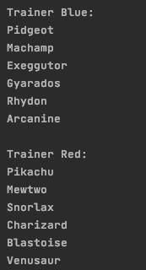

1. .

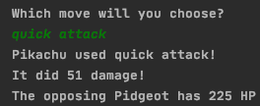

1. .

See tests 5-16 in the evidencing test results section of prototype 1

1. See tests 5-8 in the evidencing test results section of prototype 3
2. .

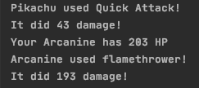

1. .

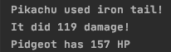

1. .

When red clicked:

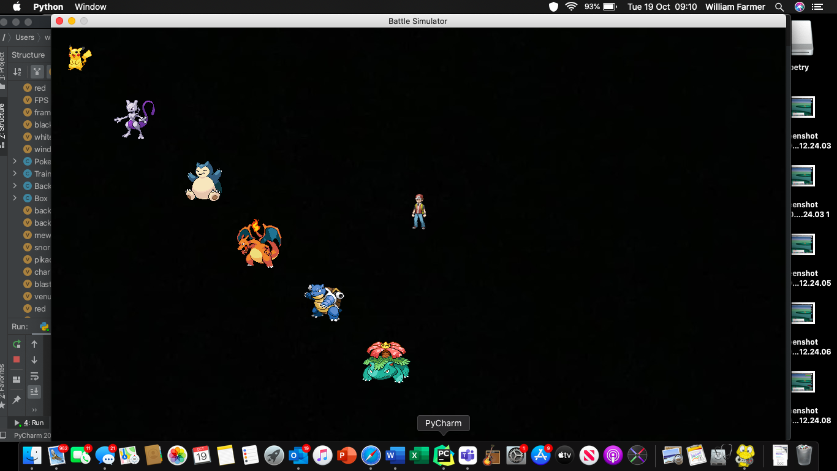

When blue clicked:

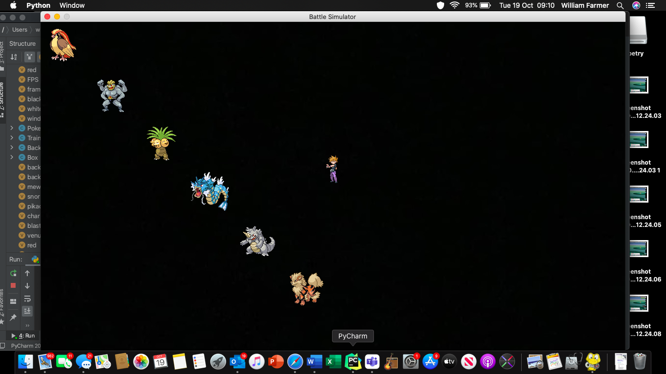

1. .

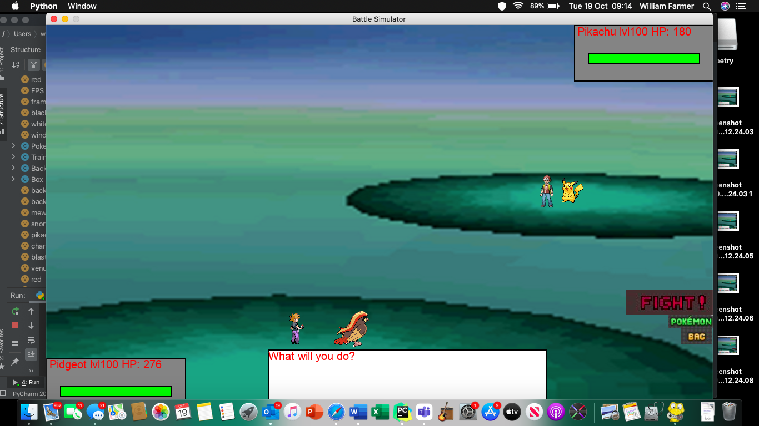

As previously mentioned, time constraints meant that I never implemented the sex of each Pokémon in to the game as it didn’t add anything to the functionality of the game. Hence, this test failed, but is not an error.

1. .



1. .



This shows the game outputting the damage Pidgeot’s move has inflicted upon pikachu.



And here shows the decrease in the health bar. You can see these two screenshots directly follow on from each other in the bottom right of the screen.

1. .

Test failed as code was never implemented

1. .

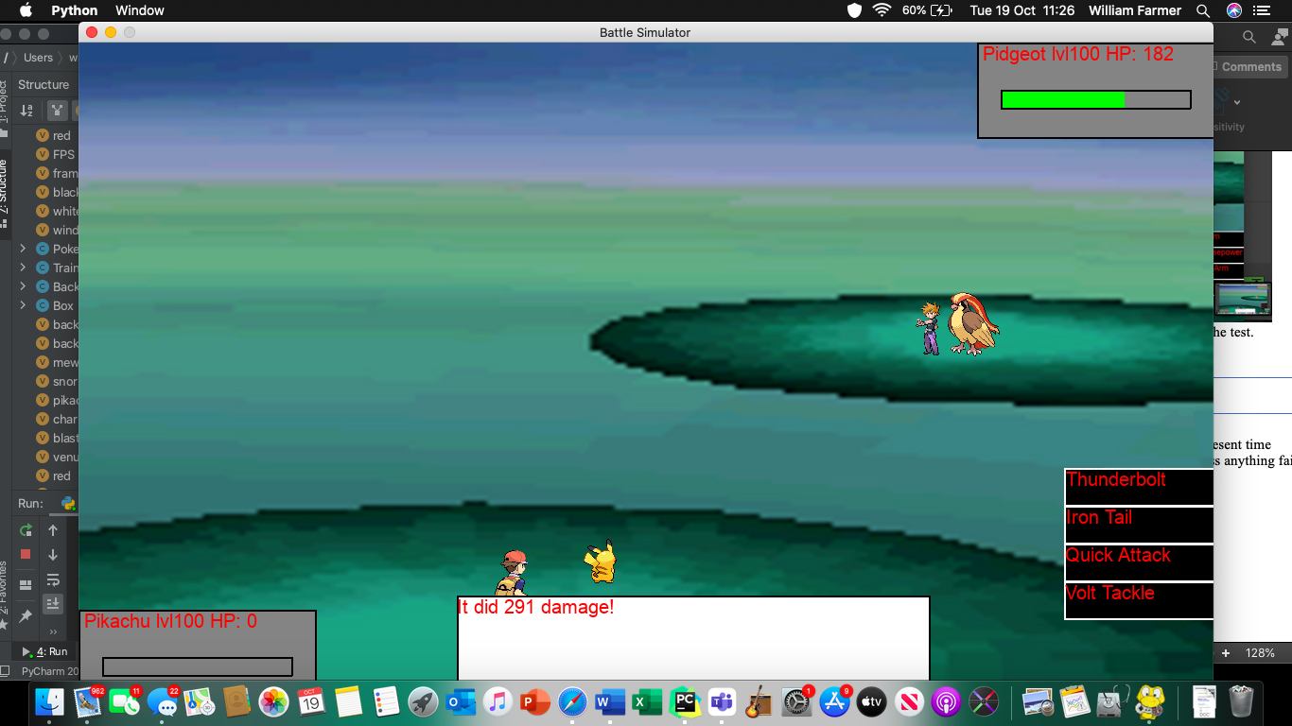

As you can see, the move inflicted upon Pikachu has caused its HP to decrease to zero, as 291 damage was inflicted and pikachu has less than 291 maxHP

1. .

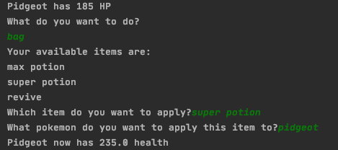

As can be seen, a 50 HP increase has been applied (from 185 to 235)

1. .



This is the damage being inflicted.

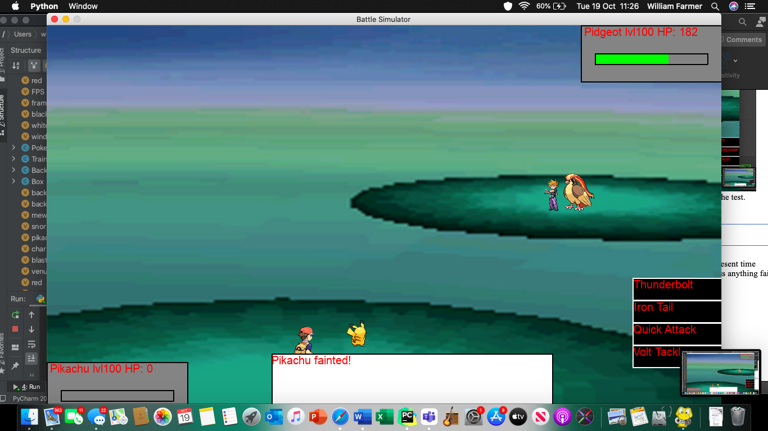

And this shows the fainted Pokémon. As you can see, the HP bar is empty but there is no animation happening for Pikachu fainting. This was never implemented due to time constraints.

1. .

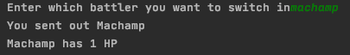

As can be seen, Machamp has 1HP and has not fainted.

1. .



1. .

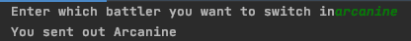

1. .

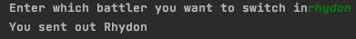

1. .

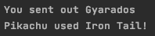

1. .

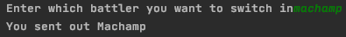

1. .

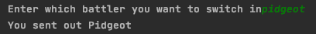

1. .



1. .

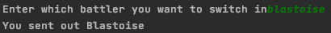

1. .



1. .



1. .

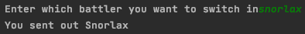

1. .

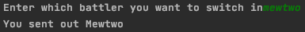

1. .

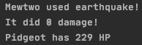

1. .

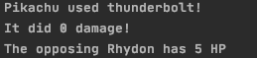

1. .

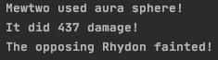

1. .

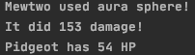

1. .

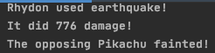

1. .

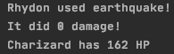

1. .

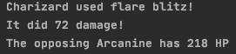

1. .

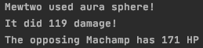

1. .

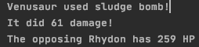

1. .

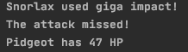

1. .

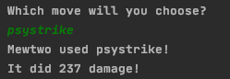

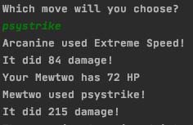

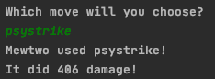  
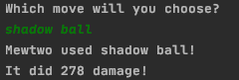

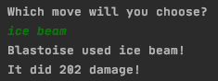

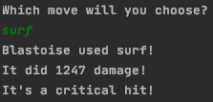

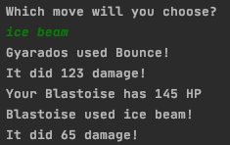

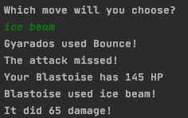

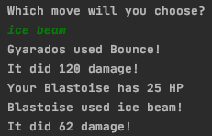

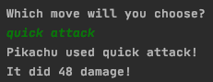

These were all selected in consecutive turns, and all 100% accurate moves. Hence, this passed the test

1. .

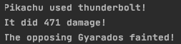

1. .

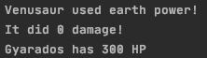

1. .

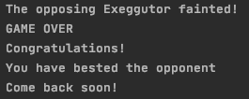

1. .

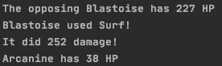

1. .

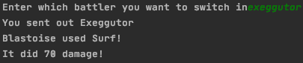

1. .



1. .

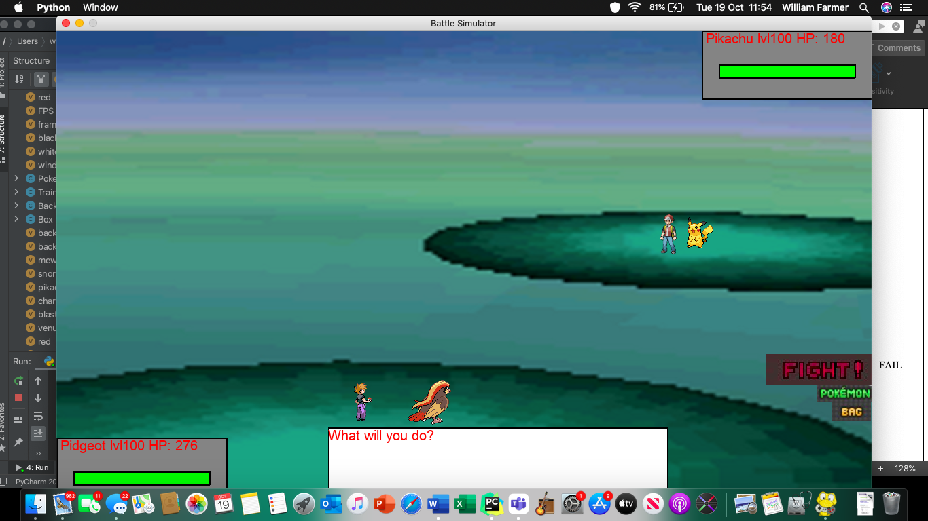

1. .

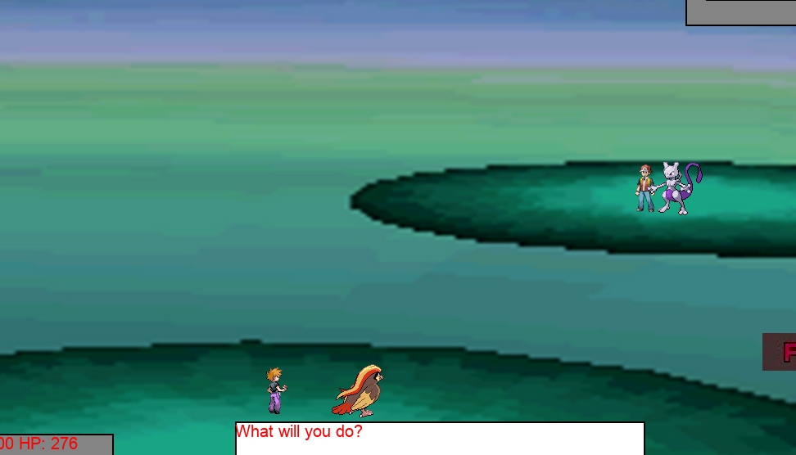

Mewtwo has been sent out to fight to Pidgeot, as pikachu is unable to battle now.

1. Never implemented
2. Never implemented
3. Never implemented
4. Never implemented
5. Never implemented
6. Never implemented
7. Never implemented

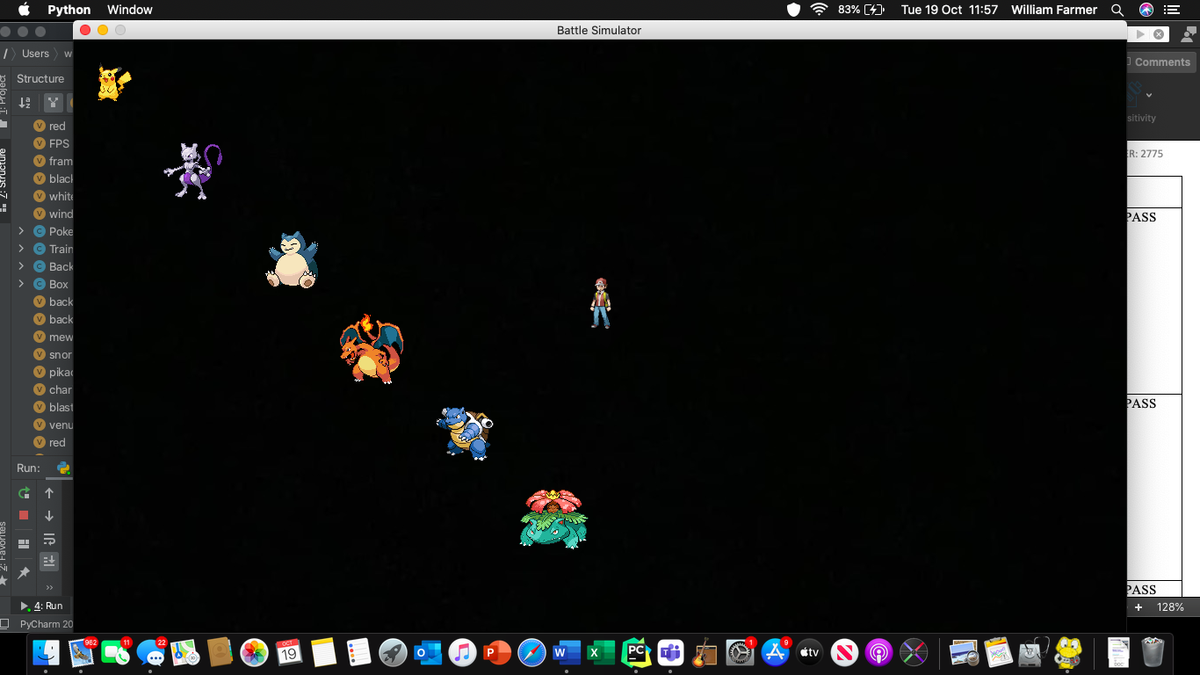

1. .

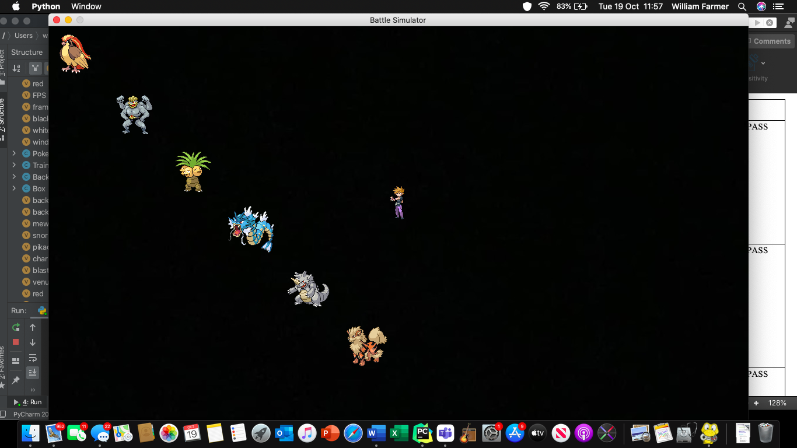

1. Never implemented
2. .

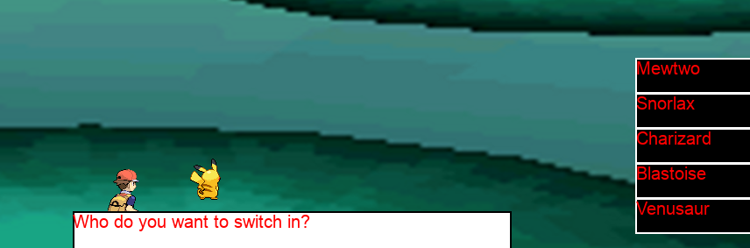

1. .

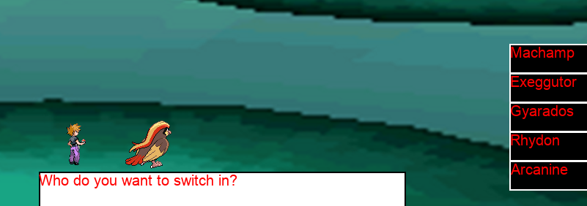

1. .

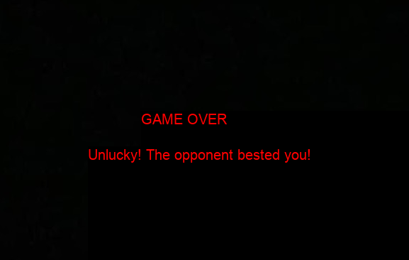

1. .

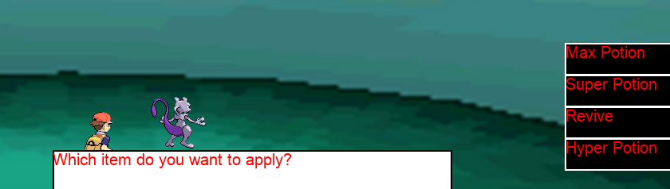

Bag appears, but no difficulty settings. Therefore the bag is always is use.

1. Never implemented
2. .

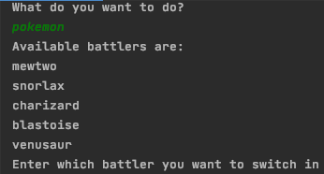

1. .

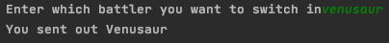

1. .

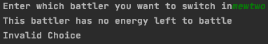

1. .

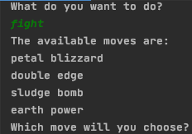

1. .

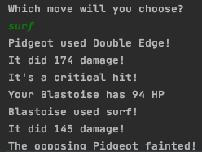

* This shows a non-critical move and a critical-hit

1. Upon right-clicking Blue on the following screen:

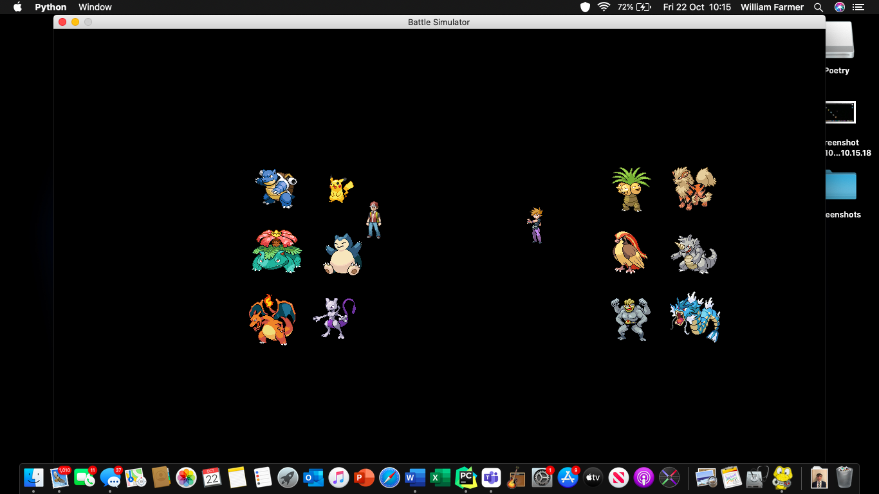

I received the following output:

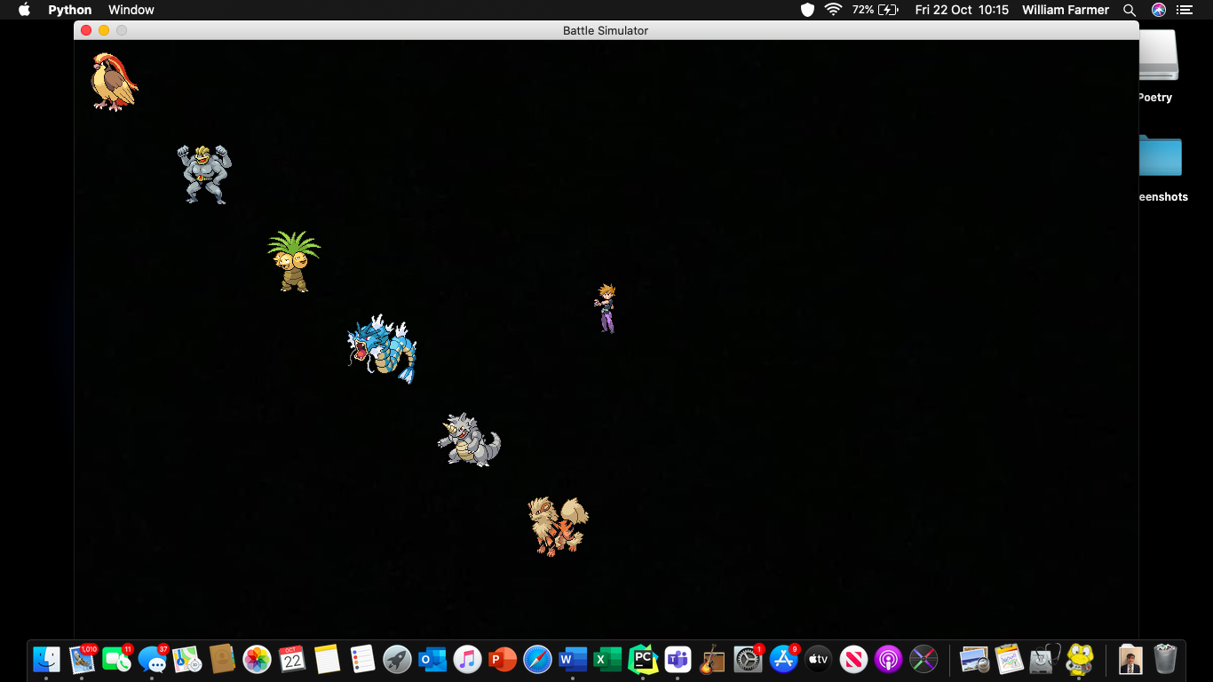

Ensuring that it was registered as a normal click. Hence, it passed

## Has the program met the success criteria?

What’s important about any project is that it meets the requirements outlined in the success criteria at the beginning of the project. There are some success criteria that have not been met, but those are the non-essential criteria that I did not have the time to implement, but most certainly will be at a later date.

|  |  |  |  |  |
| --- | --- | --- | --- | --- |
| Success Criterion | Was it met? | What test evidenced this? | How does the test show that this has been met? | If applicable, what can I do to fully meet this criterion? |
| 1.1.1 | Yes | 1 | The test shows that all of the name attributes of each have been properly instantiated | N/A |
| 1.1.2 | Yes | 2 | The test shows that the damage inflicted is in fitting with what it would be if the power and element of the move was correct. The output states that quick attack was used, which is the correct name as well. Hence the criterion has been fully met. | N/A |
| 1.1.3 | Yes | 3 | The test(s) show that all of the stats have been correctly instantiated and calculated | N/A |
| 2 | Yes | 4 | The test(s) show that all of the stats are correct because the damage inflicted would be different to the expected outputs if they were incorrect. However, as they match the expected outputs, it can be shown that the stats are correct | N/A |
| 2.2 | Yes | 5 and 6 | If the formula wasn't used, different outputs would be received than the expected ones. Given that the received outputs are within the boundaries of the expected, this has passed the test | N/A |
| 3.1 | Yes | 7 | The correct are displayed alongside their associated trainer, hence meeting the criterion | N/A |
| 3.2 | Partially | 8 | Shows that the name, level and HP are displayed, but not sex, hence it is only partially met | Add in the sex of each Pokémon. Was unable to fully complete due to time constraints |
| 3.3 | Yes | 9 | Shows the grassland background, which is as desired | N/A |
| 3.4 | Yes | 10 | Shows the four moves appearing | N/A |
| 3.5 | No | N/A | N/A | Code in animations for move when given more time |
| 3.6 | Yes | 12 and 13 | Shows that the health bar can increase and decrease | N/A |
| 3.7 | Partially | 14 and 15 | The HP turns to zero, but there is no animation for fainting, hence it is only partially met. The Pokémon doesn't faint if HP is not 0 | Add an animation when given more time |
| 3.8 | Partially | 18-27 | The Pokémon switch, but there is no animation. The sprite of the current Pokémon disappears, and is replaced by the new one. Hence, it is only partially met | Add an animation when given more time |
| 3.9 | Partially | 18-27 | The Pokémon switch, but there is no animation. The sprite of the current Pokémon disappears, and is replaced by the new one. Hence, it is only partially met | Add an animation when given more time |
| 3.10 | Yes | 28-39, 40 | Damage is inflicted, health bar goes down as down numerical value of health. The narrative box also outputs how much damage was inflicted; it also does no damage when the move doesn't affect the Pokémon | N/A |
| 4.1.1 | Yes | 41 | Shows the message output after beating the game. To get to this message, the game has to be beaten. Therefore, it has met the criterion | N/A |
| 4.1 | Yes | 42-44 | Ensures the AI chooses the optimum move in any given situation. This also shows that the AI chooses the best move against the Pokémon that it's currently battling, not the one that's going to replace it. This would be unfair on the user, and so the criterion has been met. | N/A |
| 4.2 | Yes | 45 and 46 | The AI sends out the best Pokémon to deal with the user's current battler | N/A |
| 5.1 | No | N/A | N/A | Add in difficulty settings given more time |
| 5.2 | No | N/A | N/A | Add in difficulty settings given more time |
| 5.3 | No | N/A | N/A | Add in difficulty settings given more time |
| 6 | Yes | 53-55 | Shows the trainers being displayed alongside their Pokémon. The video shows that nothing happens until one of them are clicked | N/A |
| 6.1 | Yes | 56 and 57 | Shows all of the user's Pokémon, which are the same Pokémon that are assigned to the trainer they selected | N/A |
| 6.2 | Yes | 53-55 | Shows the trainers being displayed alongside their Pokémon. The video shows that nothing happens until one of them are clicked | N/A |
| 7.1 | Yes | 41 | Shows the message output after beating the game. To get to this message, the game has to be beaten. Therefore, it has met the criterion | N/A |
| 7.2 | Yes | 58 | Shows the message output after losing the game. This can only be reached after losing the game | N/A |
| 8.1 | Partially | 59 and 60 | Partially met, as after clicking the bag the user can apply the displayed items. However, no difficulty settings were implemented due to time constraints, so only partially met | Add in difficulty settings given more time |
| 8.2 | Yes | 61-63 | This shows that the user is made to switch in a Pokémon when their current battler has fainted, and has the option to at the beginning of each turn as well | N/A |
| 8.3 | Yes | 64 and 65 | This shows that the user is able to click the fight button and see how much damage it did, how much HP the opponent has left and whether or not it was a critical hit | N/A |

## Stakeholder interview and Usability testing

### Stakeholder interviews

#### Questions

**Casual players using program as alternative**

1. Are you happy with the general display of the game? Is there anything you would like to change?
2. Is the difficulty of the game okay?
3. Are there any parts of the game that you would change?
4. Other than animations and difficulty settings, what else would you like to see added to the game?
5. Did you get what you wanted from this game?
6. Do you have any questions?

**Casual players using game to improve and enjoy game more**

1. Are you happy with the general display of the game?
2. Is the difficulty appropriate enough to help you achieve your goal?
3. Are there any parts of the game you would change?
4. Other than animations and difficulty settings, what else would you like to see added to the game?
5. Do you have any questions?

**Competitive player using game to edge ahead of competition**

1. Is the AI as intelligent as you were hoping?
2. Is the current “Best of all worlds” difficulty appropriate for your skill level
3. Are there any parts of the game you would change?
4. Other than animation and difficulty settings, what else would you like to see added to the game?
5. Are you happy with the general display of the game? Is there anything you would like to change?

##### Casual players using program as alternative

**Xander**

1. The sprites are too small, as are the buttons. Other than that I like it and it’s easy to understand
2. Yes, the AI is hard but I can use items to help me
3. More variety of teams
4. More variety of teams
5. Yes!
6. No, thank you!

**Bertie**

1. Yes
2. For a casual, it might be pretty tough
3. Considering I’m closer to the screen than the opponent, I should be bigger than them
4. Probably not, I think its pretty good
5. Yeah
6. No

**Cal**

1. Yes, the general display looks good and is easy to use and understand
2. This difficulty is at a good level for me as it is quite challenging which allows me to practice without winning too easily
3. There are few graphical things I would change such as the big white box telling me what’s happening is a bit big and could be made a more appropriate size
4. As mentioned above I would refine some of the graphical choices and maybe adjust the teams to be slightly more balanced
5. No I don’t have any questions

##### Competitive player using game to get ahead of competition

1. Yes
2. It was okay, but I would prefer to have a hard difficulty available, but I understand how you couldn’t make it in time
3. To be honest, no
4. Noise – sound
5. Yeah it was pretty good. It reminds me of my time spent playing older Pokémon games.

### Graphical Advisor interviews

#### Questions

1. Is it clear which Pokémon belong to which trainer in the beginning menu?
2. Are the buttons clear?
3. Does the narrative box aptly describe the occurrences in the game?
4. Are the sprites up to standard?
5. Is the background suitable?
6. Other than animations, what would you add to the game?
7. Is the information box containing name, HP and level appropriately designed?
8. Any questions?

**Annie**

1. Yes
2. Yes
3. Yes, it tells narrates the whole game really well
4. They’re a bit small, but the quality is good
5. It’s not very aesthetically pleasing, but it’s appropriate for a battle scene
6. Make it brighter and more colourful
7. Yes, it’s easy to see their level, health and name. It’s also very easy to tell which box belongs to which Pokémon.
8. Nope

**Sophie**

1. Yes, but I think the trainers should be symmetrical – one is closer than the other
2. Yes, and I like how they’re different colours
3. Yeah, I like how there are simple questions [for prompts] and how there’s not too much information at once
4. Yeah, they’re really high quality
5. Yes, it’s nice and simple. Doesn’t distract from the game
6. Yeah I think even brief music would be nice to add to the game. Maybe add a female character too.
7. Yes, and it’s very easy to tell who they belong to. The red is hard to read though
8. No, has this been helpful?
   1. *I let her know she was very helpful.*

### Usability Testing

|  |  |  |  |
| --- | --- | --- | --- |
| **Requirement** | **Was it met?** | **Justification for result** | **If appropriate, how could this be addressed in further development?** |
| Easy to tell which Pokémon belongs to which trainer | Yes | Both graphic advisors agreed | Make the trainers appear symmetrically on the screen |
| Sprites of a good quality | Yes | Both graphic advisors agreed | Make them larger; make the closer one larger than the one further away |
| Well-designed information box | Yes | Both graphic advisors agreed | Could change the font colour from red to black |
| Clear and easy-to-understand buttons | Yes | Both graphic advisors agreed | The FIGHT button could be moved to a more central location in order to emphasise it more |
| Suitable background | Yes | Both graphic advisors agreed | Could be changed to something more aesthetically pleasing, but would be hard as needs to be in-keeping with a battle area |
| Narrative box is well designed | Yes | Stakeholders and graphic designers agreed | Could try and make it use rolling text rather than wiping the previous output and replacing it with a new one and make it slightly smaller |
| Narrative box clearly describes what's happening | Yes | Both graphic advisors agreed | Use a font from the original games |
| Easy to tell between user and enemy battlers | Yes | Stakeholders and graphic designers agreed | N/A |

## Limitations and how they could be overcome

### Time Constraints

Towards the end of my project I started to realise how little time I had left. After creating every feature essential to the game (creating all Pokémon objects with associated attributes; allowing user to choose trainer; allowing user do make their move, apply an item, or switch Pokémon and implement the AI), I realised that I would not have enough time to create the game I originally designed. I knew I was going to implement the GUI, but I decided that the difficulty settings would have to be delayed and cosmetic features would have to be postponed too. Hence, there are no animations and the Pokémon’s sex is not displayed in the information box. These features will indefinitely be added into my program, but alas I do not have time to implement such additions before the deadline.

### Pygame

Having used the pygame library for my graphics, there were quite a few limitations to my solution. I was unable to have 3D graphics, for example, no 3D sprites for the Trainers and Pokémon. I could overcome this by using a different GUI framework that supports the use of 3D graphics.

## Maintainability

The main ways to make a program maintainable are:

* Adding comments
* Appropriately named variables
* Modularisation, with appropriately named modules
* Removing unnecessary code

My program has made use out of all of the above. As can be seen in the ‘The Program’ section of Prototype 8, all of my code has been commented, describing each functions purpose, what segments of code do, what variables are used for and explains why code is in the order it’s in. I made sure to comment in every new function at the end of each prototype, and when I finished the final prototype I went through the whole program and commented anything that could need describing or justifying, ensuring it was maintainable.

In addition, I have aptly named my variables, and have justified all of their uses in the design section. This is the same for my objects’ attributes. Furthermore, all of my variables are local, and are hence passed into every function they are used in. This means that when they are updated, they are returned to their native function and updated there too so that no inconsistencies occur. This also helps me keep track of where variables originate from, and where they are used.

Effectively all of my code for this project is located in a function or a procedure. Each function or procedure is used more than once in the program (except for the gameOver function, which ends the running of the program) and so means that not only is code needlessly duplicated, but is also very easy to change. The use of modules also made my game very easy to debug, as synt ax errors would output the module of which the error originated from. If I didn’t use modules, the game would be very difficult to debug. All modules are appropriately named and so it is very easy to work out what each function and procedure does (e.g. trainerSelect() is where you select the trainer, fight() is where you fight the opponent, gameOver is where the game ends).

The IDE I used to code this program was PyCharm. PyCharm has inbuilt debugging, which also happens to notify the user of any code that would either never be ran, or any variables that would never be used. This led me to remove the list unfaintedNames[], as it was unused in the graphical version of the game. There are a few segments of code that are very similar (but not the same) that I intend to turn into functions later, such as resetting the board and redrawing the narrative box and its border. This is also the reason that some objects draw themselves when instantiated; they never have to be moved and so it doesn’t make sense to have a separate method for displaying it on the screen: it would be unnecessary code.

Therefore, my belief is that my program is easily maintainable, due to my addition of comments, implementation of modules, use of appropriate variable names and removal of unnecessary code.

Furthermore, my use of object-oriented programming made coding certain parts of the game much easier than if I didn’t use it. Being able to have every single Pokémon be designed the exact same way really easily was massively useful throughout the program. The same can also be said for the Box class, with it being so multi-purpose (information box, health bar, narrative box, moves, items and Pokémon).

## Maintenance issues

It is very unlikely that my game will require any backups all the data used by the program is coded in the program itself – no external files, databases or websites are used. I will indefinitely make modifications to the game, but that will only be for animations, or adding more teams or difficulty settings, etc – the main part of the game has been successfully completed. This isn’t maintenance, just updates. No updates will ever be required to keep the game running, only to improve it.

The system is quite portable: I can compress the folder into a zip file and email it and access it via cloud storage on any device connected to the internet. The only requirements is that python 3.8 must be installed on the device, alongside with the pygame module, and the device must have some way of clicking, so touchscreen devices can be used, or devices that have a mouse or trackpad. The software and hardware requirements are very minimal.

As all of the data used by the system (effectively just the attributes of the Pokémon) are stored in the main python file. Hence, they do not need to be archived to backed up at any point, unless for some reason I remove the information from the file, which I see no reason to do.

If computers stop supporting pygame or python 3.8 then some changes would have to be made. This game should run on any version of python after 3.8 and so that shouldn’t be too much of an issue, however if pygame stops being supported then I would have to make some serious modifications to the game’s programming.

## Potential improvements

Given that I didn’t fully meet all of the success criteria, the first improvements I would make to the game would first be the addition of difficulty settings in order broaden the player-base. Then I will add in animations for moves, with them initially being very generic, and then much later being move-specific.

Before the move-specific animations are implemented, I will add in a third trainer called Leaf, based off of another character in the Pokémon games, who is female. Then I would implement more complex niche scenarios to the game, such as stat changes (decreasing or increasing a Pokémon attack, special attack, speed, defence or special defence), status conditions (making it so a Pokémon does less damage, is slower, or is unable to attack for a few turns), abilities (unique abilities that give each battler an enhancement from just their stats), the weather (e.g. sun boosting fire types moves, rain boosting water type moves) and certain move interactions (for example, earthquake deals more damage to Pokémon under the ground).

Adding all of this into the game will take some time, but after working on this project for over a year, I am committed to ensuring it will be the best it can.

## Final comments

After a year working on this project, I am going to make sure nothing remains unfinished. While I was unable to add in the animations and difficulty settings in time, they will most certainly be, as well as the other additions I mention in the section above. My own time management inevitably led to these unmet and partially met success criteria, but I was still very happy with how the game turned out.

## Bibliography

All images from this page taken from various sources via google source

2 All images from this section taken from various sources via google search

3 All images on this page taken from various sources via google search

4 All images in this section taken from various sources via google search

5 All images in this section taken from various sources via google search

6 Base = base HP, IV = 0 and EV = 0

7 Where Base = base stat, IV = 0 and EV = 0

8 Where level = the level of the attacking Pokémon

9 Where power = the power of the move

10 The attacker’s attack or special attack stat depending on type of move

11 The opponent’s defence or special defence stat depending on type of move

12 Where critical = 1.5 if a critical hit, else 1, chance of a critical hit in 12.5%

13 Where random = a random number between 0.85 and 1

14 Where STAB = 1.5 if the move is of the same element as the Pokémon, else 1

15 Where effectiveness is 4 if 4x effective, 2 if super effective, 1 is neutral, 0.5 if not very effective, 0.25 if 4x resisted and 0 if non-effecting

16 Assumption; I know that 7 is the minimum possible number of modules I will include

17 Every sprite is taken from the Bulbagarden archives

18 I got the image from <https://wallpapersafari.com/w/6lOBvr>

19 <https://stackoverflow.com/questions/19117062/how-to-add-text-into-a-pygame-rectangle>

1. All images from this page taken from various sources via google source
2.
3. 2 All images from this section taken from various sources via google search
4. All images on this page taken from various sources via google search
5. All images in this section taken from various sources via google search
6. All images in this section taken from various sources via google search
7. Base = base HP, IV = 0 and EV = 0, formula from <https://bulbapedia.bulbagarden.net/wiki/Damage>
8. Where Base = base stat, IV = 0 and EV = 0, formula from <https://bulbapedia.bulbagarden.net/wiki/Damage>
9. Where level = the level of the attacking Pokémon
10. Where power = the power of the move
11. The attacker’s attack or special attack stat depending on type of move
12. The opponent’s defence or special defence stat depending on type of move
13. Where critical = 1.5 if a critical hit, else 1, chance of a critical hit in 12.5%
14. Where random = a random number between 0.85 and 1
15. Where STAB = 1.5 if the move is of the same element as the Pokémon, else 1
16. Where effectiveness is 4 if 4x effective, 2 if super effective, 1 is neutral, 0.5 if not very effective, 0.25 if 4x resisted and 0 if non-effecting
17. Assumption; I know that 7 is the minimum possible number of modules I will include
18. Every sprite is taken from the Bulbagarden archives
19. I got the image from <https://wallpapersafari.com/w/6lOBvr>
20. <https://stackoverflow.com/questions/19117062/how-to-add-text-into-a-pygame-rectangle>